s./

Learning Report – Embedded C – Hardware + Programming + Testing

Course Code: <CODE>



|  |  |  |  |  |  |
| --- | --- | --- | --- | --- | --- |
| **Ver.Rel. No.** | **Release Date** | **Prepared. By** | **Reviewed By** | **Approved By** | **Remarks/Revision Details** |
| 1.0 | 26-12-20 | Joseph |  | Dr. Vivek K and Bhargav N |  |
| 1.1 | 03-01-21 | Joseph |  | Dr. Vivek K and Bhargav N |  |
|  |  |  |  |  |  |
|  |  |  |  |  |  |
|  |  |  |  |  |  |

**Document History**

Contents

1.0 Make Execution in GIT 4

1.1 Files after execution of Make 4

1.3 Header section of main.o 5

1.4 Git link: 5

2.0 Mini project 5

2.1 Main logic function 6

2.2 Mini project GIT link: 6

# 

# 1.0 Make Execution in GIT

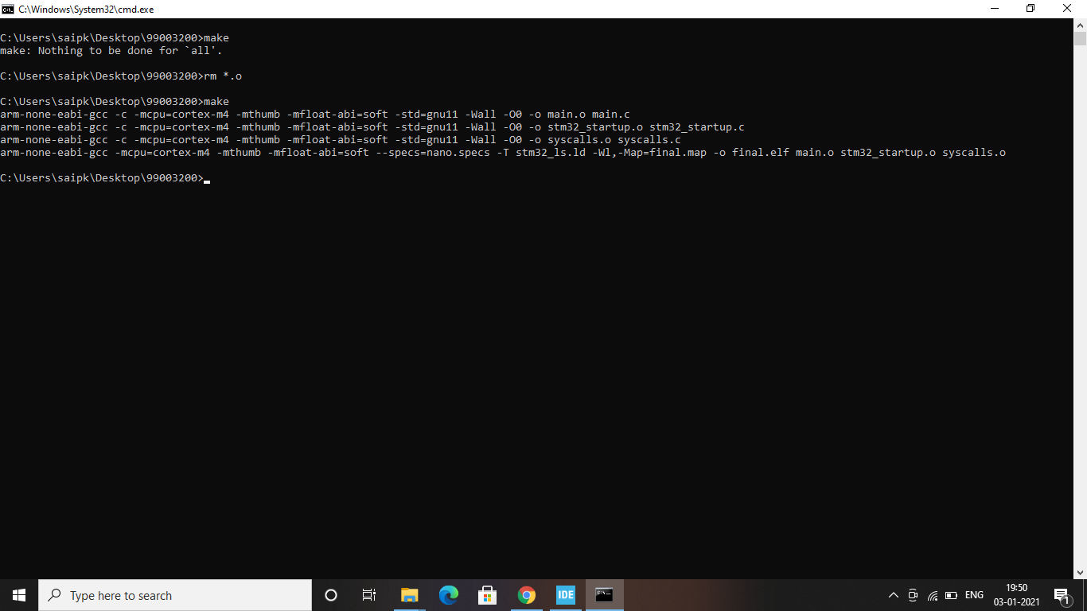

## 1.1 Files after execution of Make

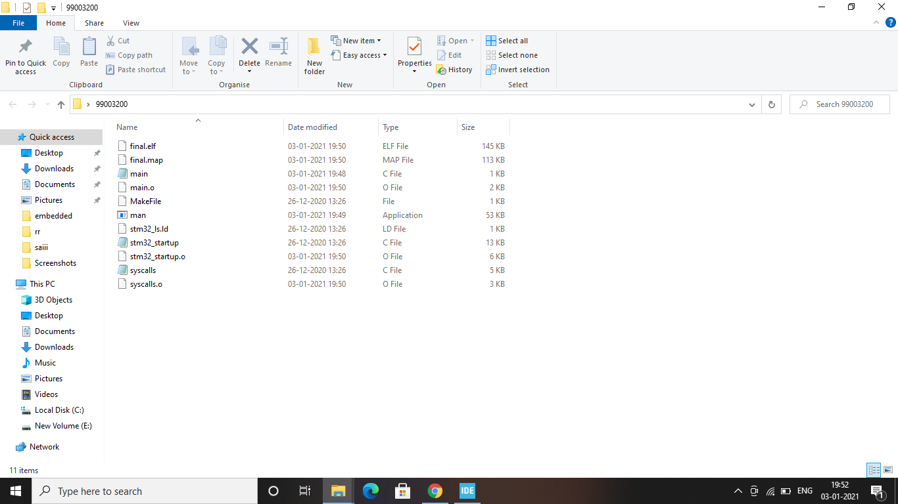

## 

## 1.3 Header section of main.o

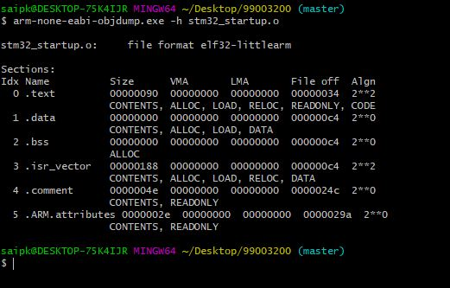

## 1.4 GIT link:

# 

# 2.0 Mini project

## 2.1 Main logic function

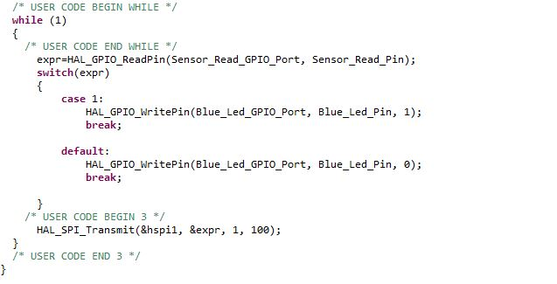

## 2.2 Mini project GIT link: