./

GENESIS – Advanced Python Project Report

CALENDAR



|  |  |  |  |  |  |
| --- | --- | --- | --- | --- | --- |
| **Ver. Rel. No.** | **Release Date** | **Prepared. By** | **Reviewed By** | **To be Approved** | **Remarks/Revision Details** |
| 1 | 12-12-2020 | Androthu Murali Satya Pavan |  |  |  |
|  |  |  |  |  |  |
|  |  |  |  |  |  |
|  |  |  |  |  |  |
|  |  |  |  |  |  |

**Details**

Contents

Contents 3

1.Python project Calendar 4

1.1 Code 4

1.2 pep8 snapshot 6

2.With implementing Inheritance & Oops concepts 7

2.1 Code 7

2.2 Pep8 Snapshot 9

3.GIT LINK 9

### 1.Python project Calendar

### 1.1 Code

import datetime

import calendar

import sys

class cal_end:

def __init__(self):

pass

def entire_year(self):

yy = int(input("enter year: "))

print(calendar.calendar(yy))

print(" ")

def month_year(self):

yy = int(input("Enter year: "))

mm = int(input("Enter month: "))

# display the calendar

print(" ")

print(calendar.month(yy, mm))

def week_day(self):

date = str(input("Enter the date(for example:09 02 2019) :"))

day_name = ['Mon', 'Tue', 'Wed', 'Thu', 'Fri', 'Sat', 'Sun']

day = datetime.datetime.strptime(date, '%d %m %Y').weekday()

print(day_name[day])

print("\n")

def leap_year(self):

year = int(input("Enter a year:- "))

# Here, you take the input from the user

if(((year % 4 == 0) and (year % 100 != 0)) or (year % 400 == 0)):

print("{0} is a leap year!!\n".format(year))

else:

print("{0} is not a leap year!!\n".format(year))

def cal_age(self):

birth_year = int(input("Enter your year of birth: "))

birth_month = int(input("Enter your month of birth: "))

birth_day = int(input("Enter your day of birth: "))

current_year = datetime.date.today().year

current_month = datetime.date.today().month

current_day = datetime.date.today().day

age_y = current_year - birth_year

age_m = abs(current_month-birth_month)

age_d = abs(current_day-birth_day)

print("Your age is: ", age_y, "Years", age_m, "months and", age_d,

"days\n")

cal_obj = cal_end()

while(1):

print("1.Printing the Entire year")

print("2.Printing the month of the year")

print("3.Printing the day")

print("4.Checking leap year or not")

print("5.Calculate age")

print("0.exit")

n = int(input("Enter your option: "))

if n == 1:

cal_obj.entire_year()

elif n == 2:

cal_obj.month_year()

elif n == 3:

cal_obj.week_day()

elif n == 4:

cal_obj.leap_year()

elif n == 5:

cal_obj.cal_age()

elif n == 0:

sys.exit()

else:

print("invalid option")

print("try again")

### 1.2 pep8 snapshot

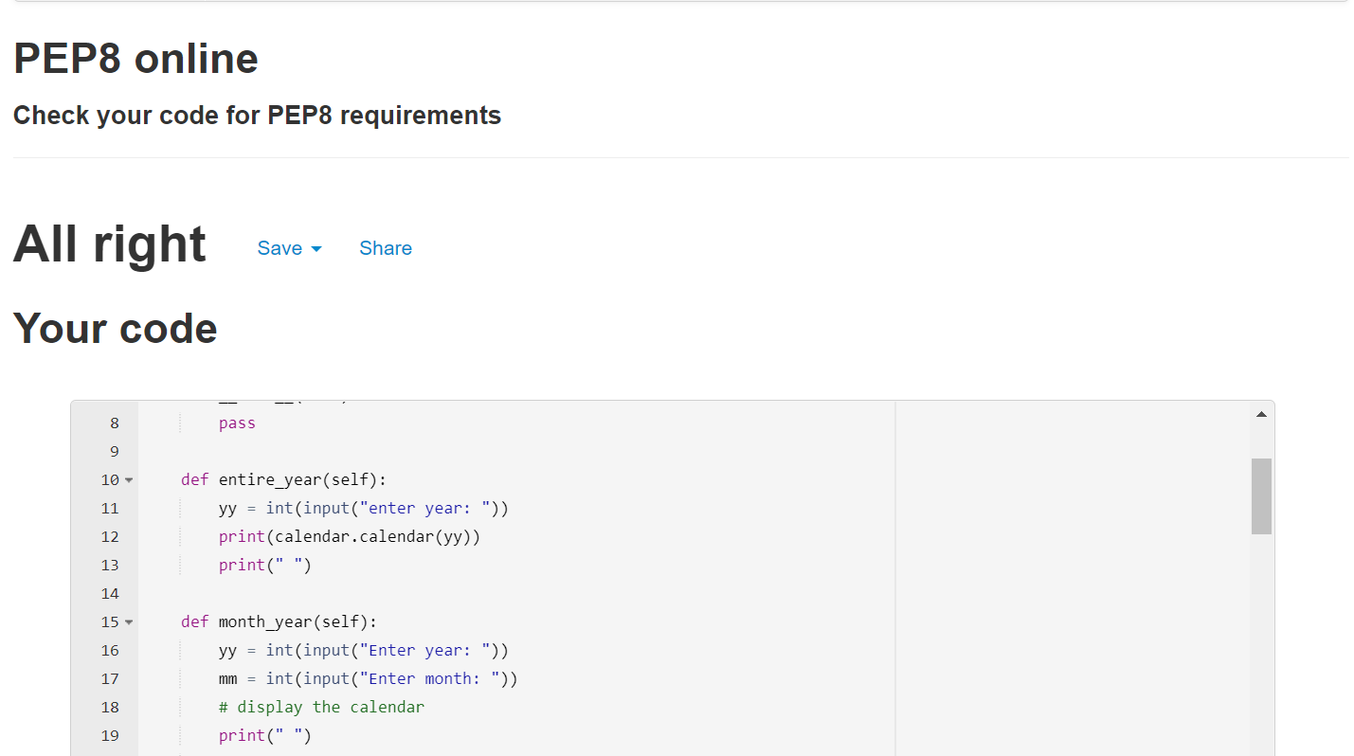

### 2.With implementing Inheritance & Oops concepts

### 2.1 Code

import datetime

import calendar

import sys

import re

class age():

def cal_age(self):

birth_year = int(input("Enter your year of birth: "))

birth_month = int(input("Enter your month of birth: "))

birth_day = int(input("Enter your day of birth: "))

current_year = datetime.date.today().year

current_month = datetime.date.today().month

current_day = datetime.date.today().day

age_year = current_year - birth_year

age_month = abs(current_month-birth_month)

age_day = abs(current_day-birth_day)

print("Your age is: ", age_year, "Years", age_month,

"months and", age_day, "days\n")

class cal_end(age):

def __init__(self):

pass

def entire_year(self):

yy = int(input("enter year: "))

print(calendar.calendar(yy))

print(" ")

class new_cal():

def month_year(self):

yy = int(input("Enter year: "))

mm = int(input("Enter month: "))

# display the calendar

print(" ")

print(calendar.month(yy, mm))

class new_cal2(new_cal, cal_end):

def week_day(self):

date = str(input("Enter the date(for example:09 02 2019) : "))

day_name = ['Monday', 'Tuesday', 'Wednesday', 'Thursday', 'Friday',

'Saturday', 'Sunday']

day = datetime.datetime.strptime(date, '%d %m %Y').weekday()

print(day_name[day])

print("\n")

class new_cal3(new_cal2, age):

def leap_year(self):

year = int(input("Enter a year: "))

# Here, you take the input from the user

if(((year % 4 == 0) and (year % 100 != 0)) or (year % 400 == 0)):

print("{0} is a leap year!!\n".format(year))

else:

print("{0} is not a leap year!!\n".format(year))

cal_obj = new_cal3()

print("Welcom..!")

while(1):

print("Please Select your Option")

print("1.Printing the Entire year")

print("2.Printing the month of the year")

print("3.Printing the day")

print("4.Checking leap year or not")

print("5.Calculate age")

print("0.Exit")

n = int(input("Enter your option: "))

if n == 1:

cal_obj.entire_year()

print(re.match("[a-z]{3}", "cal_obj.entire_year"))

elif n == 2:

cal_obj.month_year()

print(re.search("[a-z][1 2]", "cal_obj.month_year"))

elif n == 3:

cal_obj.week_day()

print(re.match("[a-z]", "cal_obj.week_day"))

elif n == 4:

cal_obj.leap_year()

print(re.findall("[1 4]", "cal_obj.leap_year"))

elif n == 5:

cal_obj.cal_age()

print(re.findall("[a-z]", "cal_obj.cal_age"))

elif n == 0:

sys.exit()

else:

print("Invalid option")

print("Try again")

print("\n")

### 2.2 Pep8 Snapshot

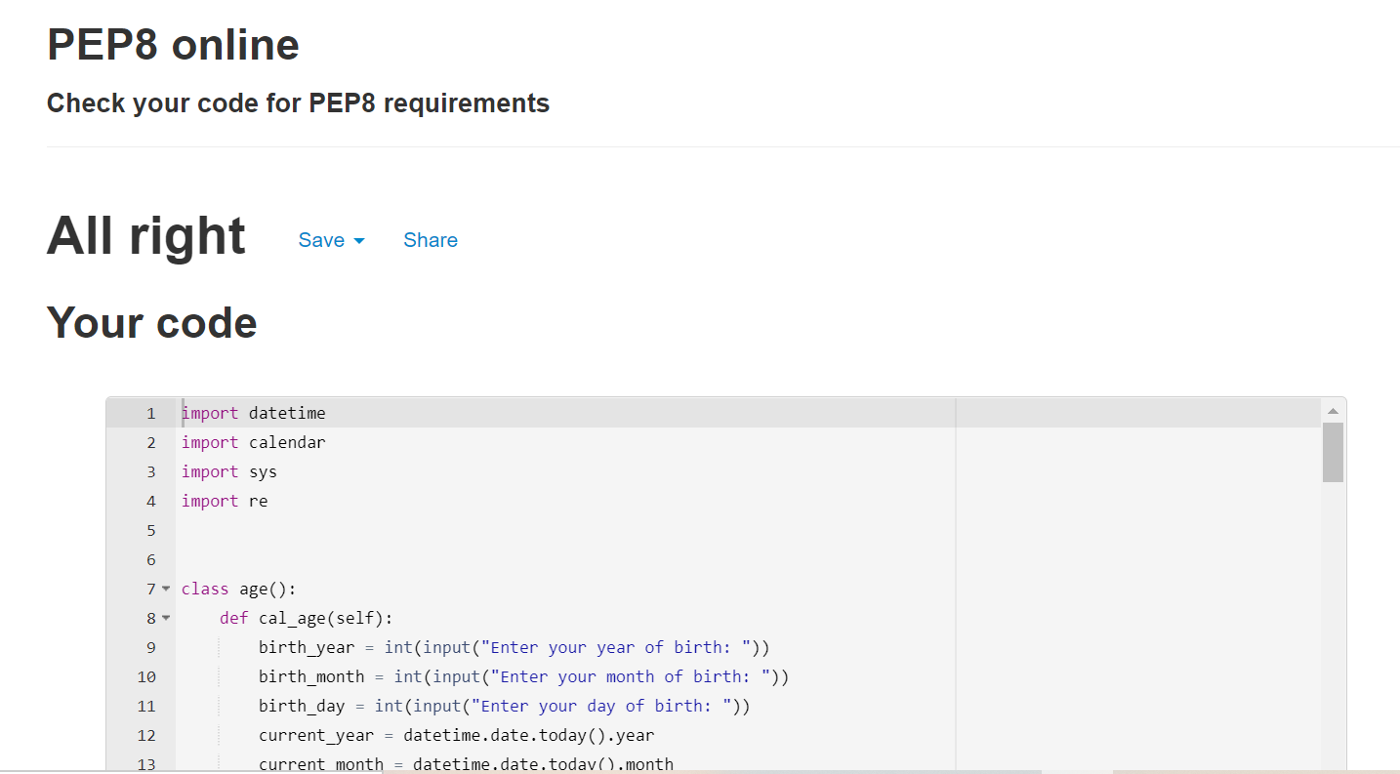

3.GIT LINK: <https://github.com/99003201/python_project>