**DESIGN AND IMPLIMENTATION**

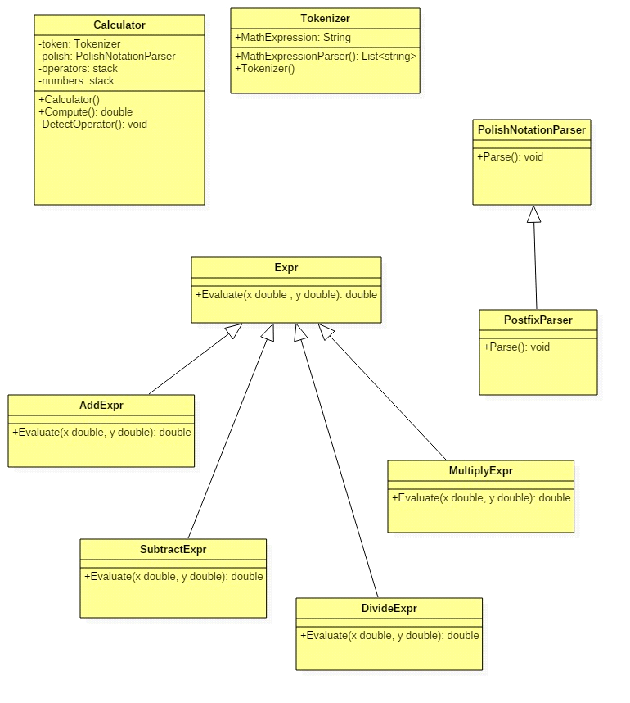

Figure2.Class diagram

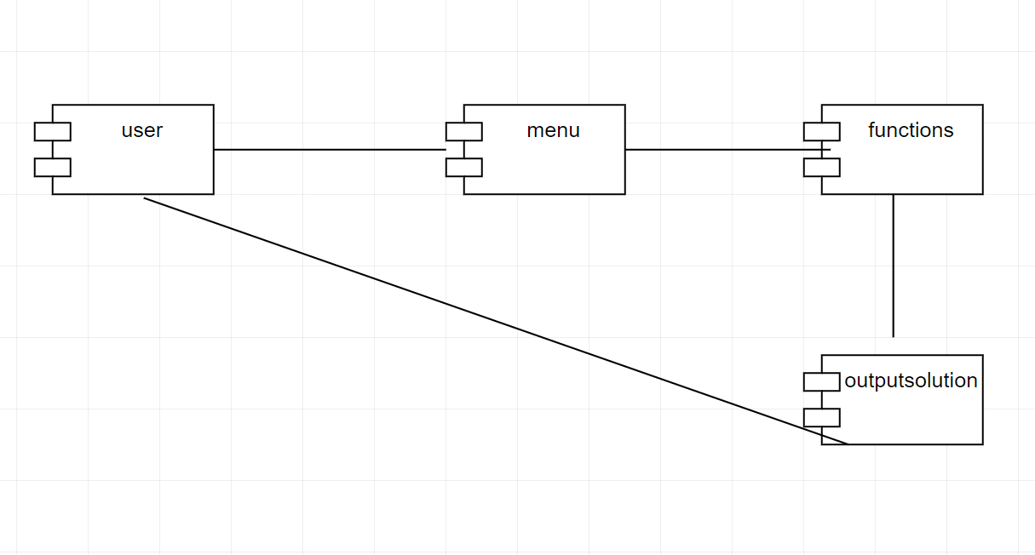

Figure3 Component diagram

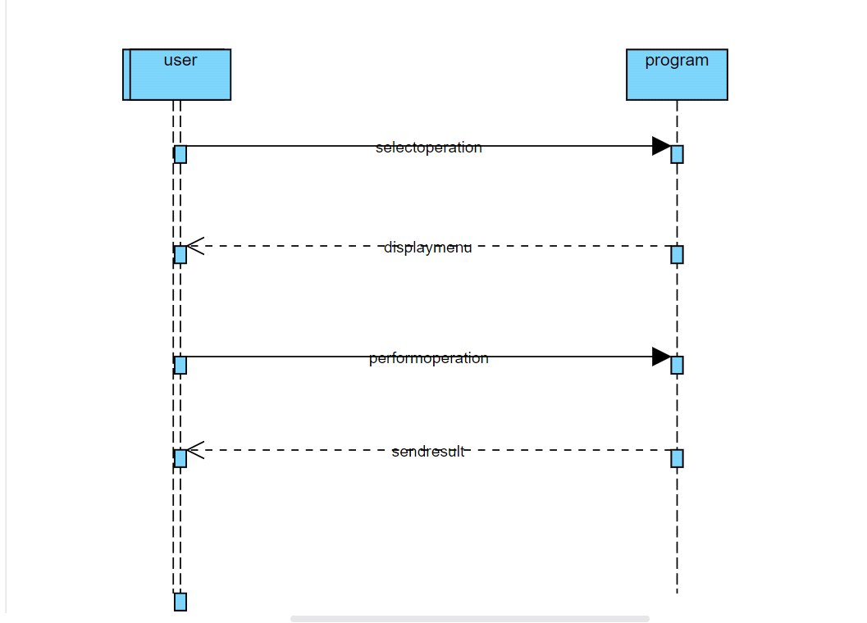

Figure4.sequence diagram

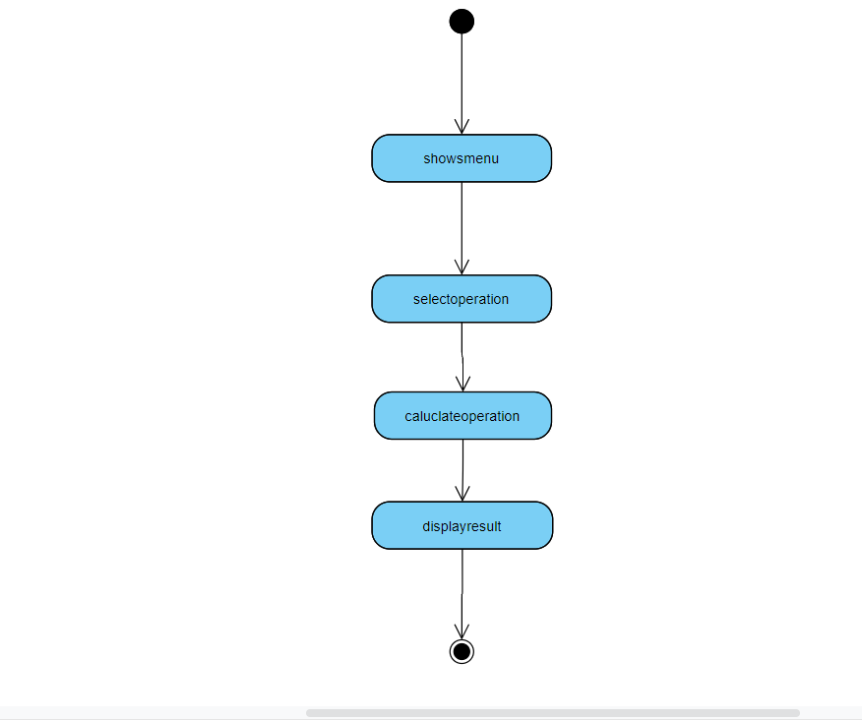

Figure 5 Activity diagram.