**BMI CALCULATOR**

**Python code**

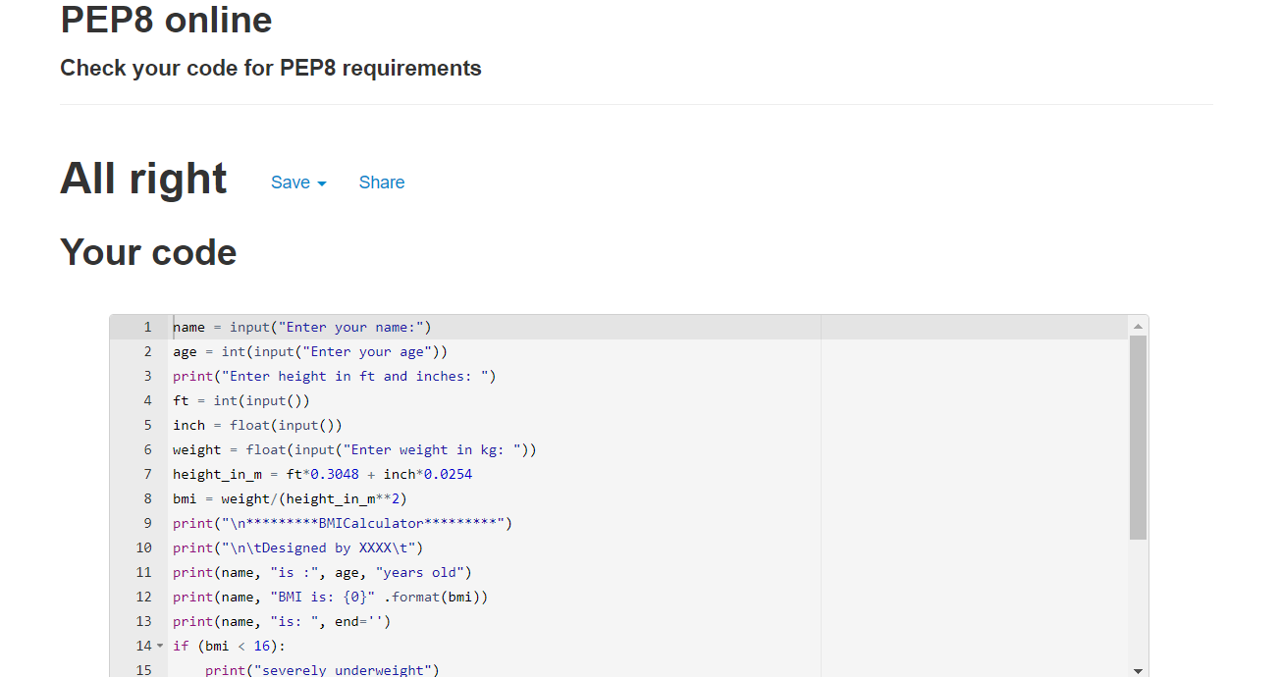

**BMI_INHERITANCE**

