./

GENESIS - Learning Outcome & Mini-project Summary Report



|  |  |  |  |  |  |
| --- | --- | --- | --- | --- | --- |
| **Ver. Rel. No.** | **Release Date** | **Prepared. By** | **Reviewed By** | **To be Approved** | **Remarks/Revision Details** |
| 1. | 13/12/2020 | NAVEEN KUMAR PAPPURU |  |  |  |
| 2. | 13/12/2020 | NAVEEN KUMAR PAPPURU |  |  |  |
|  |  |  |  |  |  |
|  |  |  |  |  |  |
|  |  |  |  |  |  |

**Details**

**BMI CALCULATOR**

name = input("Enter your name:")

age = int(input("Enter your age"))

print("Enter height in ft and inches: ")

ft = int(input())

inch = float(input())

weight = float(input("Enter weight in kg: "))

height_in_m = ft*0.3048 + inch*0.0254

bmi = weight/(height_in_m**2)

print("\n*********BMICalculator*********")

print("\n\tDesigned by XXXX\t")

print(name, "is :", age, "years old")

print(name, "BMI is: {0}" .format(bmi))

print(name, "is: ", end='')

if (bmi < 16):

print("severely underweight")

elif (bmi >= 16 and bmi < 18.5):

print("underweight")

elif (bmi >= 18.5 and bmi < 25):

print("Healthy")

elif (bmi >= 25 and bmi < 30):

print("overweight")

elif (bmi >= 30):

print("severely overweight")

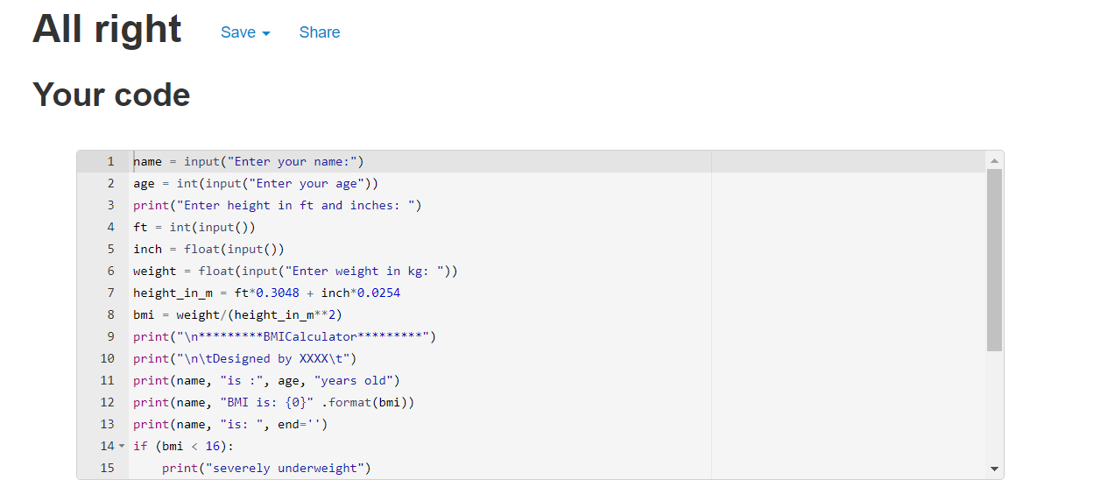

**OOPS CONCEPTS**

class ex:

def __init__(self):

self.firstname = input("Enter your firstname:")

self.lastname = input("Enter your lastname")

self.fullname = self.firstname+" "+self.lastname

self.age = int(input("Enter your age"))

print("Enter height in ft and inches: ")

self.ft = int(input())

self.inch = float(input())

self.weight = float(input("Enter weight in kg: "))

self.height_in_m = self.ft*0.3048 + self.inch*0.0254

self.bmi = self.weight/(self.height_in_m**2)

class ex2(ex):

def timer(self):

try:

if (self.bmi < 16):

print(self.fullname, "is", self.age, "years old")

print("you are severly underweight")

print("you have to gain weight")

elif (self.bmi >= 16 and self.bmi < 18.5):

print(self.fullname, "is ", self.age, "years old")

print("you are underweight")

print("you have to gain some weight")

elif (self.bmi >= 18.5 and self.bmi < 25):

print(self.fullname, "is", self.age, "years old")

print("you are Healthy")

print("stay healthy")

elif (self.bmi >= 25 and self.bmi < 30):

print(self.fullname, "is", self.age, "years old")

print("you are overweight")

print("you have to loss some weight")

except:

print(self.fullname, "is", self.age, "years old")

print("you are severely overweight")

print("you have to lose weight")

print("\n*********BMICalculator*********")

var = ex2()

var.timer()

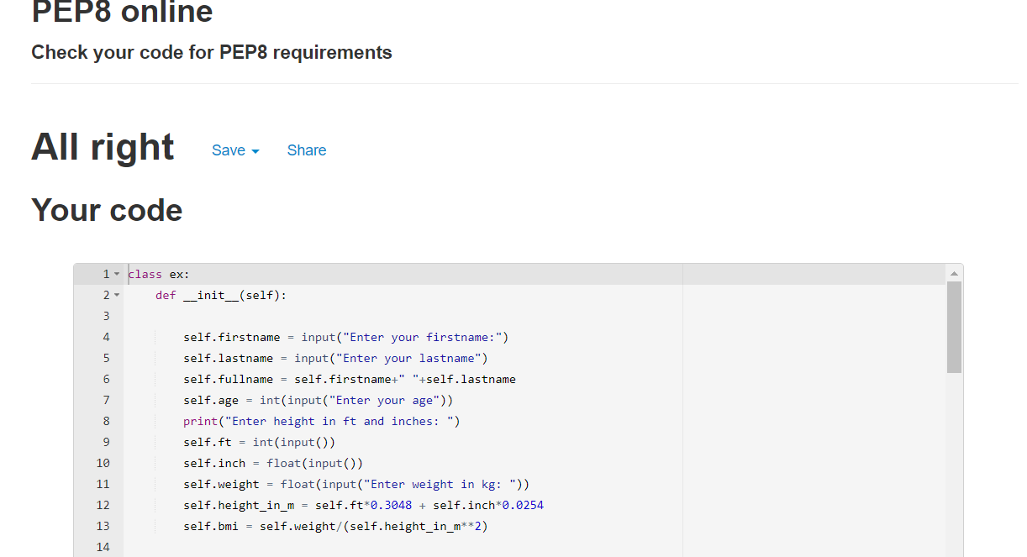

**Regular expression:**

Import re

Print(“[a-z]+.[a-z][+@[a-z]+.[a-z](mailto:+@[a-z]+.[a-z)]+”, ” [naveen.pappuru@ltts.com](mailto:naveen.pappuru@ltts.com)”)