./

Report – Guess My Number Game

Course Code: <CODE>



Version Number:

Team Members :

Team No:

Module: Model Based System Engineering

|  |  |  |  |  |  |
| --- | --- | --- | --- | --- | --- |
| **Ver. Rel. No.** | **Release Date** | **Prepared. By** | **Reviewed By** | **Approved By** | **Remarks/Revision Details** |
|  |  |  |  |  |  |
|  |  |  |  |  |  |
|  |  |  |  |  |  |
|  |  |  |  |  |  |
|  |  |  |  |  |  |

**Document History**

# 

**TABLE OF CONTENTS**

|  |  |  |
| --- | --- | --- |
| **CHAPTER No** | **CONTENTS** | **PAGE No** |
| 1 | Problem Statement | 3 |
| 2 | Description | 3 |
| 3 | Rules | 3 |
| 4 | Requirements | 4 |
| 5 | Test Plan | 5 |
| 6 | Test Cases and Results | 6 |
| 7 | References | 7 |

**CHAPTER 1**

**PROBLEM STATEMENT:**

To guess the correct number which is generated randomly.

**CHAPTER 2**

**DESCRIPTION:**

The Player has to guess the number which is generated randomly. The instructions for the game will be given. Hints will be provided during the game. A player is then prompted to enter a guess. If the player guesses wrong, then the prompt appears again. When the player has made a successful guess the computer will issue a message which says the score of the player. Also the player can print score and quit the game.

**CHAPTER 3**

**RULES:**

The player has to give his name as the input. He has to select the limit of the number range which he has to guess. The instructions of the game will be displayed.

While the guessed input is not equal to the correct number, of which is calculated with “!=” relational operator, the program will inform the user if the guessed number is higher or lower than the correct number. If the guess is not equal to random, the loop will continue to execute. If the guess is less than random, the program will print "Your guess is too low. Guess again." If the guess is more than random, the program will print "Your guess is too high. Guess again."

 When the player guessed the number correctly it will show how many tries they had to guess the correct number and how many seconds has passed since the beginning of the game. Options will be given to play again, print score or quit.

**CHAPTER 4**

**REQUIREMENTS:**

**Software Requirements:**

* Code::blocks version 20.03
* Windows Operating System.

**Data Requirements:**

* Limit of the number to be guessed.
* Choices in which the number is guessed.
* Number to be guessed.

**Random Function:**

The random number generator function srand () is included in the stdlib.h library, and is needed to spawn the number to be guessed. Max variable will be limiting the maximum number and is inputted by the user. After retrieving the max variable input from the user, the time will be initialized and the random number to be guessed with a lower bound of 1 and a confined upper bound of max variable.

**CHAPTER 5**

**TEST PLAN:**

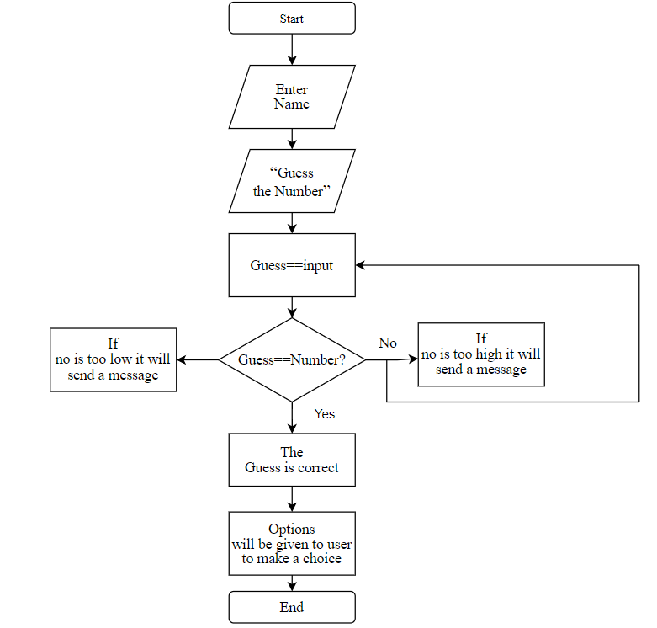

**CHAPTER 6**

**TEST CASES:**

|  |  |  |  |
| --- | --- | --- | --- |
| **TEST CASE** | **TEST SCENARIO** | **TEST DATA** | **RESULT** |
| 1 | * Enter Name | (Enter Player name)  Ex: Spoorthy | Hello Spoorthy,  Welcome to the Guess my number game. |
| 2 | * Enter choice | Enter 1,2 or 3. | Enter  1-Play Guessing Game.  2-Print Score.  3-Quit. |
| 3 | * Enter the limit of number | Ex- 100 | Limit of 100 is selected and the random no will be generated.(75) |
| 4a | * Guess the Number | 50 | The guessed number is less than the random number so the program will print "Your guess is too low. Guess again." |
| 4b | * Guess the Number | 80 | The guessed number is more than the random number so the program will print "Your guess is too high. Guess again." |

|  |  |  |  |
| --- | --- | --- | --- |
| 4c | * Guess the Number | 75 | If the guessed number is same as the random number then it says  You guessed correctly with 2 tries and 12 seconds.(it may vary due to random function)and prints current score. |
| 5 | * Print score | Enter 2 | The score will be printed. Ex - Your current score is 7. |

**CHAPTER 7:**

**REFERENCES:**

* Random function- <https://www.poftut.com/how-to-generate-random-numbers-with-rand-and-srand-functions-in-c-and-cpp/#:~:text=%20How%20To%20Generate%20Random%20Numbers%20with%20rand,to%20set%20some%20start%20and%20end...%20More%20>
* Time library- <https://www.tutorialspoint.com/c_standard_library/time_h.htm>

­­­­­­­­­­­