**REQUIREMENTS:**

**HIGH LEVEL REQUIREMENTS:**

|  |  |
| --- | --- |
| **ID** | **DESCRIPTION** |
| HL_01 | Check for valid inputs |
| HL_02 | Functions and operations mentioned below must be included:  01. Addition  02. Subtraction  03. Division  04. Multiplication  05. Exponential  06. Factorial  07. Modulo  08. Percentage  09. Permutation and Combination  10. Trigonometric functions  11. Conversions |
| Hl_03 | Check for different operations |
| HL_04 | Check for proper expression |
| HL_05 | Symbols for perform the required mathematical operations must be included |

**LOW LEVEL REQUIREMENTS:**

|  |  |
| --- | --- |
| **ID** | **DESCRIPTION** |
| LL_06_HL_02 ( i ) | Check for valid input |
| LL_06_HL_02 ( ii ) | Perform factorial operation |
| LL_06_HL_02 ( iii ) | The calculator has to produce the expected result as defined by the provided arithmetic rules |
| LL_06_HL_02 ( iv ) | The expected output must be displayed in user readable format. |
| LL_06_HL_02 ( v ) | In case of erroneous situation , the calculator has to display error message to alert the user . |

**TESTING:**

|  |  |  |  |
| --- | --- | --- | --- |
| ID | Description | Expected input or state | Expected output or State |
| T_01_LL_06_HL_02 | Check whether the input is less than 0 | N= -3 | Error message |
| T_02_ LL_06_HL_02 | Check whether the input is 0 | N= 0 | 1 |
| T_03_ LL_06_HL_02 | Check whether the input is 1 | N=1 | 1 |
| T_04_ LL_06_HL_02 | Check whether the input is greater than 0 | N= 8 | 40,320 |

**PRODUCT DEFINITION:**

“ Our product ensures easy calculations , conversions on the go and can easily be used by young and old alike”

Core purpose : To enable easy mathematical calculations and conversions on the go . Conversions like kmph to ms , operations like addition , subtraction ,trigonometric functions and many more can be achieved in few seconds with higher precision and accuracy , unlike the manual time consuming calculations.

Target audience : Students and working professionals

Top 5 product features :

1. Cost effective
2. Accurate , Reliable and effective
3. Handheld and hence can be used on the go
4. User friendly

**Uml diagrams**

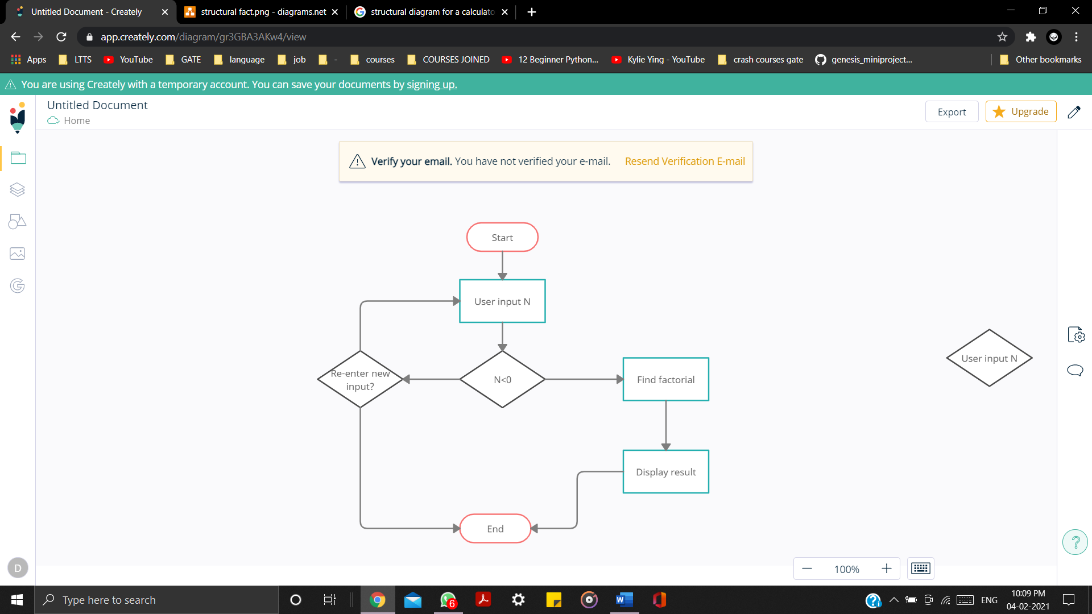

Fig : Behavioral diagram for factorial