./

Learning Report – Embedded Linux Miniproject



|  |  |  |  |  |  |
| --- | --- | --- | --- | --- | --- |
| **Ver. Rel. No.** | **Release Date** | **Prepared. By** | **Reviewed By** | **To be approved By** | **Remarks/Revision Details** |
| 1 |  | Harshitha R  (99003531) | Name/PS No | Module Owner Name | Comments |
| 2 |  | P Saikeerthi  (99003539) |  |  |  |
| 3 |  | Thummala Satyasindhu  (99003534) |  |  |  |
|  |  |  |  |  |  |
|  |  |  |  |  |  |

**Document History**

Table of Contents

Introduction 4

Features 4

Specifications 4

# Introduction

Beagleboneblack

The BeagleBoard is a low-power [open-source](https://en.wikipedia.org/wiki/Open-source_hardware) [single-board computer](https://en.wikipedia.org/wiki/Single-board_computer) produced by [Texas Instruments](https://en.wikipedia.org/wiki/Texas_Instruments) in association with [Digi-Key](https://en.wikipedia.org/wiki/Digi-Key) and Newark element14. The BeagleBoard was also designed with [open source software](https://en.wikipedia.org/wiki/Open_source_software) development in mind, and as a way of demonstrating the Texas Instrument's [OMAP3530](https://en.wikipedia.org/wiki/Texas_Instruments_OMAP) system-on-a-chip.[[8]](https://en.wikipedia.org/wiki/BeagleBoard#cite_note-8) The board was developed by a small team of engineers as an educational board that could be used in colleges around the world to teach open source hardware and software capabilities. It is also sold to the public under the [Creative Commons](https://en.wikipedia.org/wiki/Creative_Commons) [share-alike](https://en.wikipedia.org/wiki/Share-alike) license. The board was designed using [Cadence](https://en.wikipedia.org/wiki/Cadence_Design_Systems) [OrCAD](https://en.wikipedia.org/wiki/OrCAD) for schematics and Cadence Allegro for PCB manufacturing; no simulation software was used.

## Features

* The BeagleBoard measures approximately 75 by 75 mm and has all the functionality of a basic computer. The OMAP3530 includes an [ARM Cortex](https://en.wikipedia.org/wiki/ARM_architecture)-A8 [CPU](https://en.wikipedia.org/wiki/Central_processing_unit) (which can run [Linux](https://en.wikipedia.org/wiki/Linux), [Minix](https://en.wikipedia.org/wiki/Minix) [FreeBSD](https://en.wikipedia.org/wiki/FreeBSD),[]](https://en.wikipedia.org/wiki/BeagleBoard#cite_note-fbsd-11) [OpenBSD](https://en.wikipedia.org/wiki/OpenBSD), [RISC OS](https://en.wikipedia.org/wiki/RISC_OS), or [Symbian](https://en.wikipedia.org/wiki/Symbian); a number of unofficial [Android](https://en.wikipedia.org/wiki/Android_(operating_system)) ports exist)
* a [TMS320C64x+](https://en.wikipedia.org/wiki/Texas_Instruments_TMS320) [DSP](https://en.wikipedia.org/wiki/Digital_signal_processor) for accelerated video and audio decoding, and an [Imagination Technologies PowerVR SGX530](https://en.wikipedia.org/wiki/PowerVR#Series_5) [GPU](https://en.wikipedia.org/wiki/Graphics_processing_unit) to provide accelerated 2D and 3D rendering that supports [OpenGL ES 2.0](https://en.wikipedia.org/wiki/OpenGL_ES).
* Video out is provided through separate [S-Video](https://en.wikipedia.org/wiki/S-Video) and [HDMI](https://en.wikipedia.org/wiki/HDMI) connections. A single [SD](https://en.wikipedia.org/wiki/Secure_Digital)/[MMC](https://en.wikipedia.org/wiki/MultiMediaCard) card slot supporting [SDIO](https://en.wikipedia.org/wiki/MiniSDIO), a [USB On-The-Go](https://en.wikipedia.org/wiki/USB_On-The-Go) port, an [RS-232](https://en.wikipedia.org/wiki/RS-232) serial connection, a [JTAG](https://en.wikipedia.org/wiki/Joint_Test_Action_Group) connection, and two stereo 3.5 mm jacks for audio in/out are provided.
* Built-in storage and memory are provided through a [PoP](https://en.wikipedia.org/wiki/Package_on_package) chip that includes 256 MB of [NAND flash memory](https://en.wikipedia.org/wiki/NAND_flash_memory) and 256 MB of [RAM](https://en.wikipedia.org/wiki/Random-access_memory) (128 MB on earlier models).
* The board uses up to 2 W of power and can be powered from the USB connector, or a separate 5 V power supply.

## Specifications

Launched on April 23, 2013 at a price of $45. Among other differences, it increases RAM to 512 MB, the processor clock to 1 GHz, and it adds HDMI and 2 GB of [eMMC](https://en.wikipedia.org/wiki/EMMC) flash memory. The BeagleBone Black also ships with [Linux kernel](https://en.wikipedia.org/wiki/Linux_kernel) 3.8, upgraded from the original BeagleBone's Linux kernel 3.2, allowing the BeagleBone Black to take advantage of [Direct Rendering Manager](https://en.wikipedia.org/wiki/Direct_Rendering_Manager) (DRM).

BeagleBone Black Revision C (released in 2014) increased the size of the flash memory to 4 GB. This enables it to ship with [Debian](https://en.wikipedia.org/wiki/Debian) GNU/Linux installed. Previous revisions shipped with Ångström Linux.

## Components Used

1. Beaglebone Black(BBB)
2. Push button
3. Led
4. Active low Buzzer
5. Jumper wires
6. Breadboard

## Working Procedure

* Connect the BBB to the system, power up with the USB cable.
* Run sudo minicom in the linux terminal
* Enter BBB
* Set pin 49 of P9 header as input and 115 as output.
* Input from pin 49 is given to pushbutton and LED
* Output from pushbutton is given as input to the buzzer and pin 115.
* As soon as button is pressed the LED and buzzer will be ON state and if button is released both will be in OFF state.

## Application of the project:

* This project can be used in alarm system

## Images

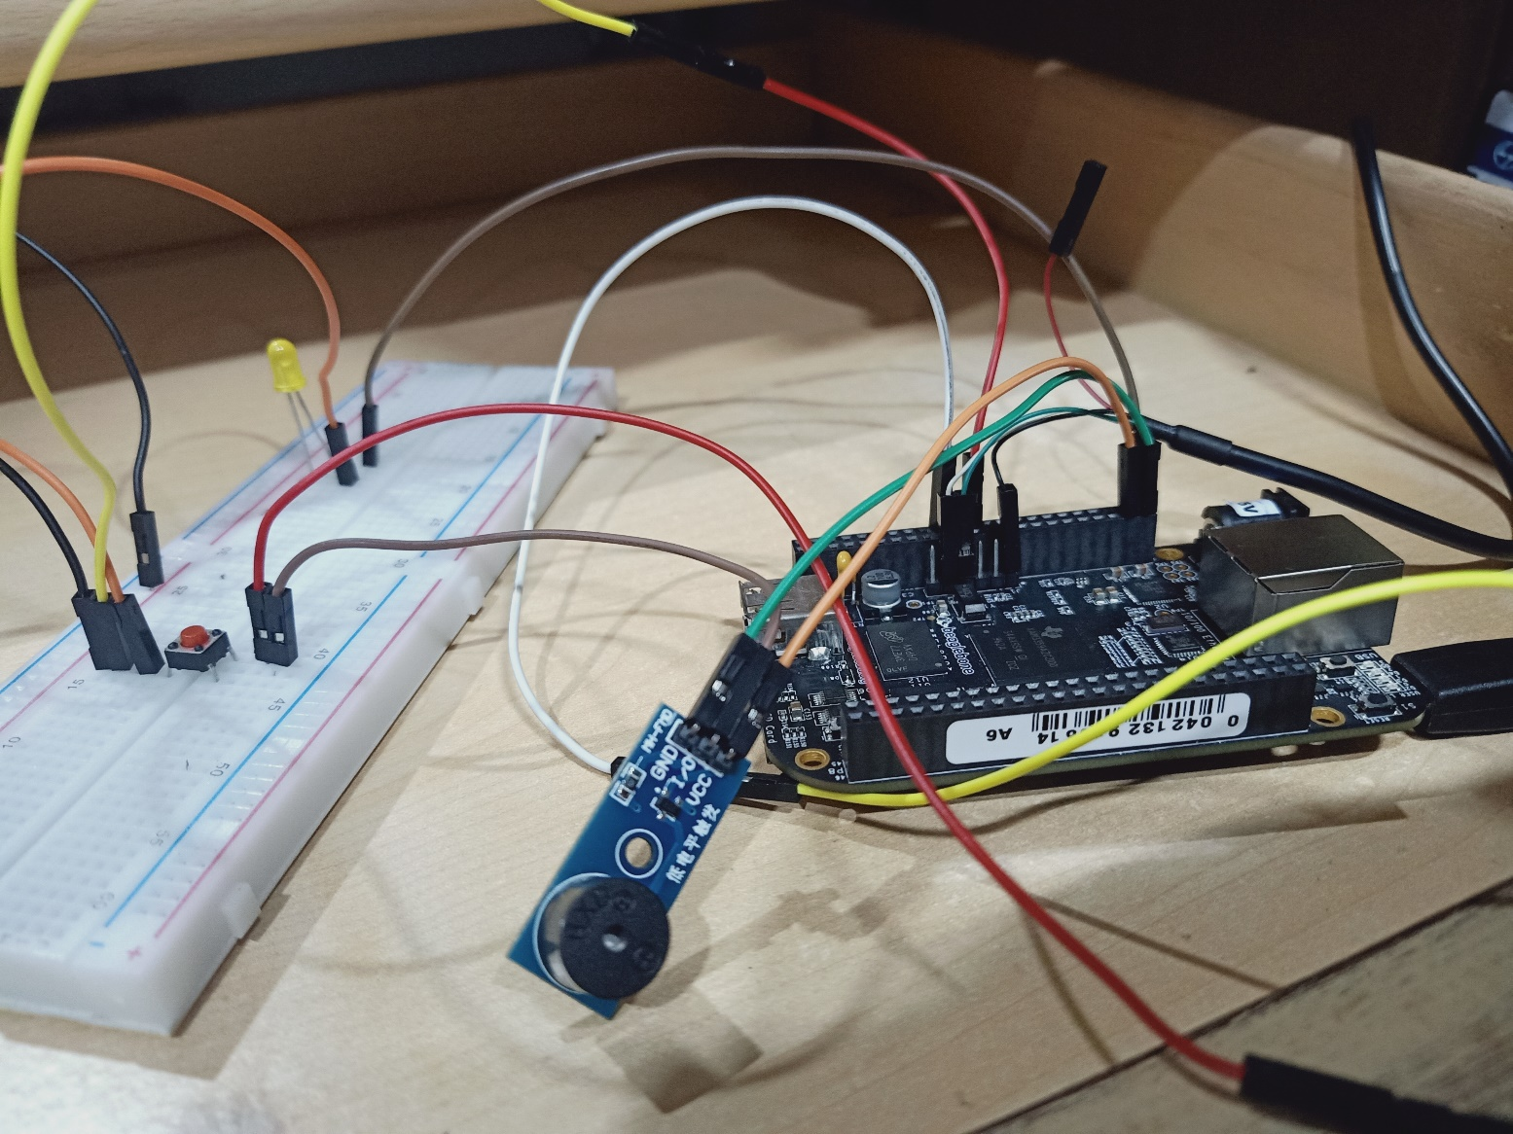

Figure 1: Circuit connections of the project

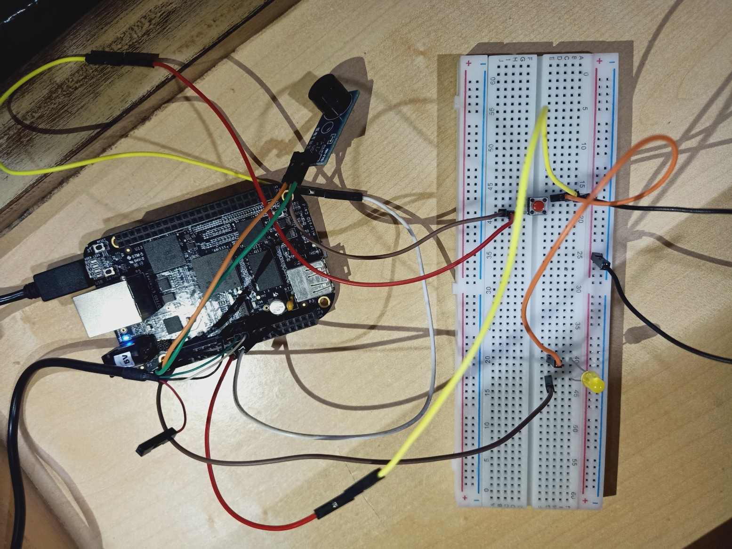

Figure 2: when the button is not pressed

## C:\Users\Training\AppData\Local\Microsoft\Windows\INetCache\Content.Word\IMG20210327153354.jpg

## Figure 3: when the button is pressed

## **Github link**: https://github.com/99003531/Beagleboneblack_miniproject.git