./

Programmable DC to AC inverter using ‘c’ programming

Course Code: <CODE>



*By*

*Sumit Ashok Bhamare*

*Track s2*

*SFID: 104974*

Version Number:

Team Members :

Team No:

Module: Model Based System Engineering

|  |  |  |  |  |  |
| --- | --- | --- | --- | --- | --- |
| **Ver. Rel. No.** | **Release Date** | **Prepared. By** | **Reviewed By** | **Approved By** | **Remarks/Revision Details** |
| 0.1 | 25-9-2020 | 104974 |  |  |  |
| 0.2 | 9-10-2020 | 104974 |  |  |  |
| 0.3 | 5-11-2020 | 104974 |  |  |  |
|  |  |  |  |  |  |
|  |  |  |  |  |  |

**Document History**

# 

* Problem statement

***“Improving*** *battery lifecycle of electric vehicle using programmable converter along with the super-capacitor”*

* description:

In case of electrical vehicles using DC motors as a primary drive for motion, different types of batteries are used. Main concern about batteries is their lifecycle (charging- discharging) and weight. As weight of batteries is directly proportional to power output needed from them, it is necessary to develop some alternative or solution on this issue. If we manage to use battery at constant discharging rate, then it will result in better performance, long life of battery and high efficiency. Now in case of sudden reverse torque on drive, driver motor takes more current than average current. In this case battery supplies the required load current but voltage drops significantly. Here super capacitors come into picture, super capacitor is known for its high energy density and high discharge rate. If we used super capacitor in controlled discharged mode in parallel with the battery, then excess load current will be supplied by super capacitor and battery life will increase. As super capacitors have high price as compared to batteries it is not economical to use it as direct replacement of battery.

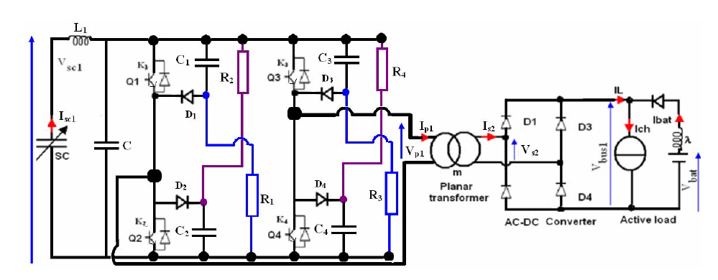

* working of CONVERTER:

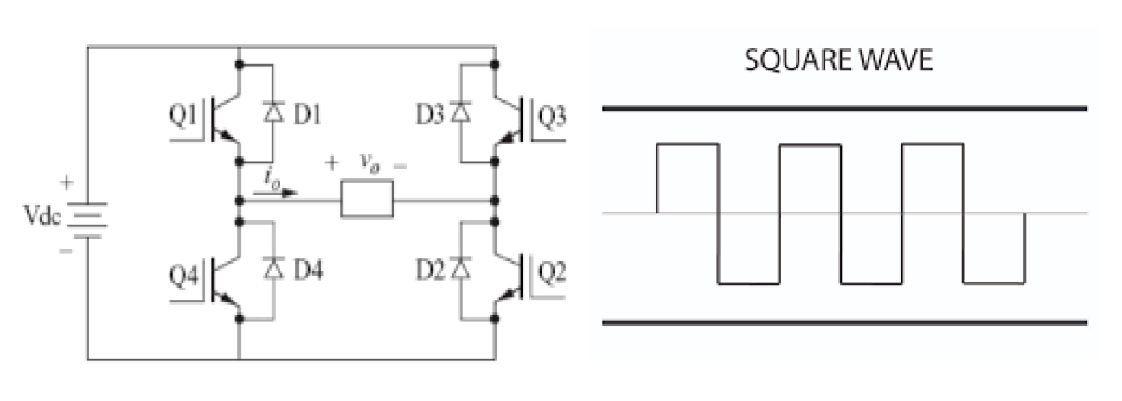

Figure : Working

Figure. 2 shows implementation diagram and output of converter. Simple bridge inverter uses switching signals which are periodic in nature to generate output which is also periodic in nature. To improve output

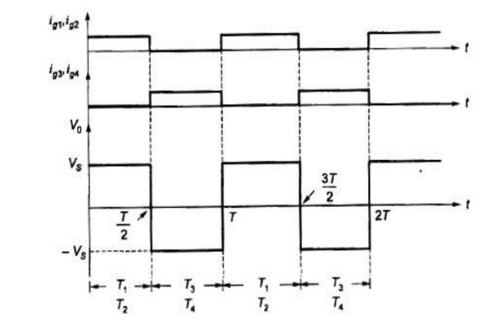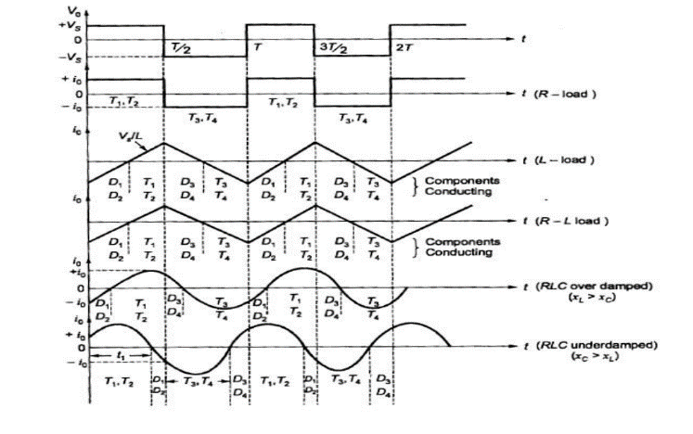

Figure 2: switching pattern Figure 3: output waveform

Output waveform totally depends on switching pattern of switches. power or output voltage totally depends upon switching.

**Note: when load current increases, duty cycle of converter is increased in order to supply excess current o load.**

* need of triggering circuit

In this project, as we are integrating different components hence to operate converter using Arduino microcontroller we need a triggering circuit. Arduino microcontroller (Atmega328) generate output signals of range 0-5 Volts which is not sufficient for power MOSFETS. By using voltage level converter or opto-coupler IC which converts the 0-5 Volts microcontroller output into 0-12 Volts of triggering voltage.

* Design:

Following chart shows basic components for actual implementation of converter.

Figure 5: basic components

* Flow of circuit

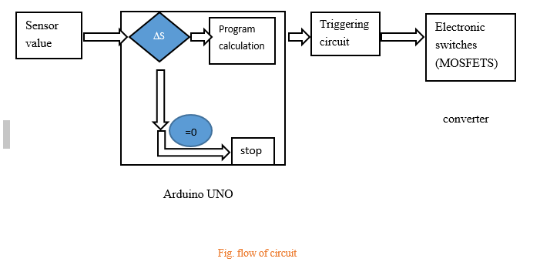

* Specification of components:

|  |  |  |  |
| --- | --- | --- | --- |
| Sr. no. | Name of component | specification | Nos. |
| 1. | MOSFET | F9540, Vdss:100v, RDss:0.117ohms | 4 |
| 2. | Opto-coupler | Forward current: 100mA, VCE: 30V max, ICmax: 50 mA | 4 |
| 3. | Micro-controller | Arduino UNO | 1 |
| 4. | DC source | 0-30 V | 1 |
| 5. | resistor | 10k ohm | 4 |
| 6. | Current sensors | ACS712 Imax: 30 A | 2 |

Table 2: specifications of components

* approach:

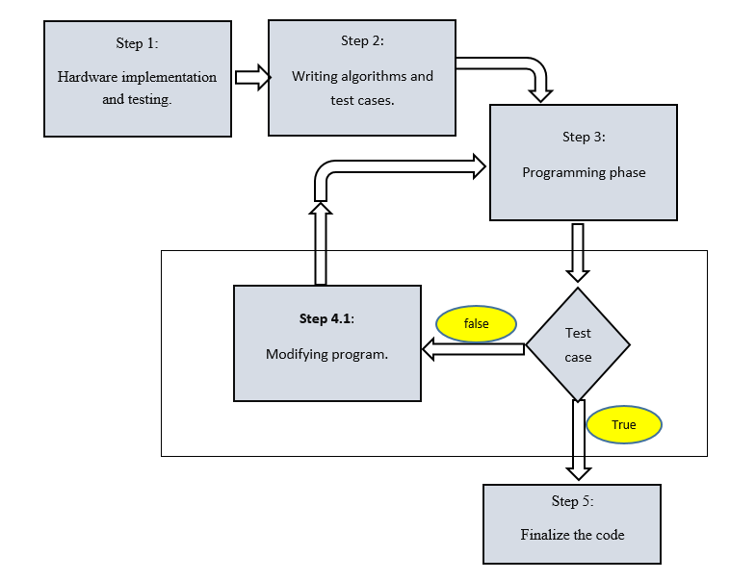

Figure 4:flowchart

* test cases:

**Load current= Iconv. + Ibat.**

**Ibat=100(average)**

|  |  |  |
| --- | --- | --- |
| **cases** | **description** | **result** |
| **Test case 1** | **Load current=0 A** | **Ibat=0 A**  **Iconv=0 A** |
| **Test case 2** | **Load current= 50 A** | **Ibat= 50 A**  **Iconv= 0 A** |
| **Test case 3** | **Load current= 150 A** | **Ibat= 100 A**  **Iconv= 50 A** |

* **Assumptions:**

1. **Battery provides constant current to load. (Ibat: 100 A)**
2. **Time lag between sensing current surge is negligible.**
3. **Voltage of super capacitors remains constant.**

* program:

Major functions:

float error_cal ();

void sequence(float m);

void delay (float fraction);

float Dutycycle (float error);

float set_iload (float i);

* GITHUB REPO.:

<https://github.com/stepin-104974-sumit/Programmable-inverter/tree/main/MiniProject_C>

* OUTPUT:

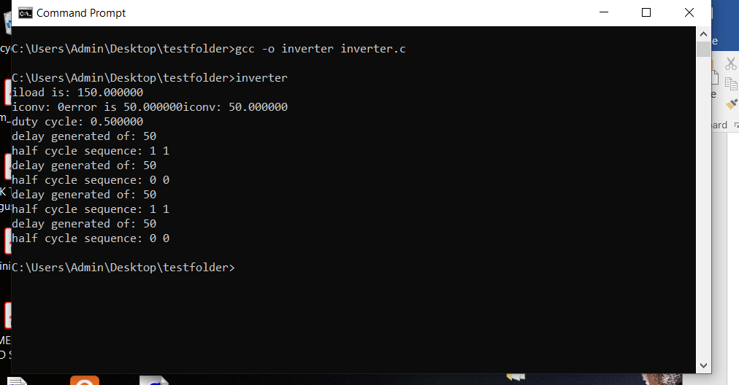

Figure 5:output

* test output:

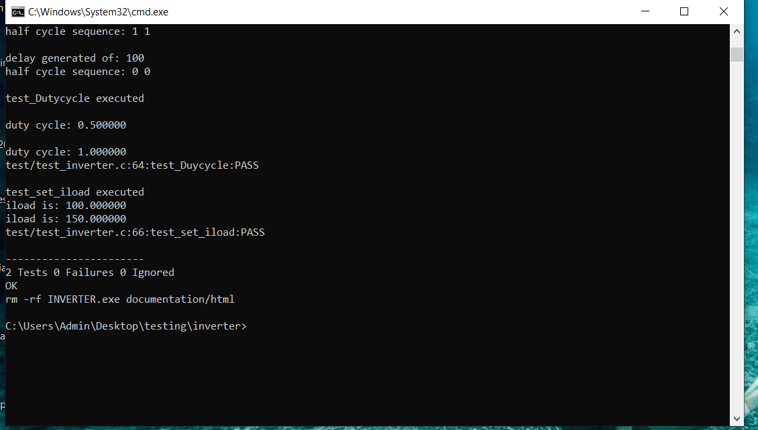

Figure 6: test output



Figure 7: html generated from makefile

* conclusion:

As per the design and program written in microcontroller converter uses sensor to check current supplied by battery and converts it into numerical value which is used to calculate duty cycle of output waveform of converter. Converter maintains constant current discharge through battery **indirectly**. Program and equipment can be upgraded to be used for different loads.

* References:
* **M.B.Camara, F. Gustin, H. Gualous, A. Berthon , “Supercapacitors and battery power management for hybrid vehicles applications “, 12th European conference on power electronics and applications , Denmark , Dt: 2-5 September 2007.**
* **Mamadou Bailo Camara, Hamid Gualous, Frederic Gustin, Alain Berthon , “DC/DC Converter Design for Supercapacitor and Battery Power Management in Hybrid Vehicle Applications—Polynomial Control Strategy “ , Article in IEEE Transactions on Industrial Electronics ,DOI: 10.1109/TIE.2009.2025283 · Source: IEEE Xplore Dt: March 2010.**
* **Yogesh Mahadik * and K. Vadirajacharya , “Battery Life Enhancement in a Hybrid Electrical Energy Storage System Using a Multi-Source Inverter “, Department of Electrical Engineering, Dr. Babasaheb Ambedkar Technological University, Lonere 402104, Maharashtra, India; kvadirajacharya@dbatu.ac.in * Correspondence:** [**yogi_maha@yahoo.co.in**](mailto:yogi_maha@yahoo.co.in) **Published: 12 April 2019**