The design of the game is simple, a game of chess uses an 8 by 8 chessboard, to the user’s convenience, there must be some kind of an index system. After referring to some common chessboards, I decided that the interface should look like this:

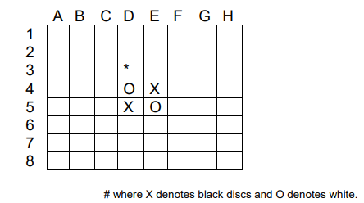

Using this system, the program will prompt the user for moves using this index. For instance, if the user would like to place a disc on the * position, the user can enter D3.

**User Input & Error Handling**

To prevent users from getting program errors with their input, it is necessary to create a mechanism to avoid such error from user input. This can be achieved by checking if the moves they entered are within the range of the chess board array and if the moves are valid. So every time they enter a move, the program will check if the desired position is available, once validated, it will write the move to the chess board array.

**When does the game end?**

As stated earlier, the game ends in either condition:

1. *If no legal move is available for both players, it is a draw game.*
2. *ii.) All positions are occupied.*

So, I wrote a function to check every single position of the chessboard before the user input, to see if there are any legal moves for both players, if there is none, the game ends. If there are no legal moves available for the current player, it will display a message and tell the current player that he has no moves.