1. **Requirements**
   1. Cost and Aging Scale
      1. **Evolution of the calculators**
2. 1623: First Adding Machine

CALCULATING CLOCK by WILHELM SCHICKARD

The calculating clock was composed of multiplying device, a mechanism for recording intermediate results and a 6-digit decimal adding.

1. 1773: First Functional Calculator

PHILIP MATTHÄUS HAHN

Featured by a set of twelve drums in an orbicular arrangement that could be activated by a lever positioned in the axis of the drums.

1. 1820: First Commercially Produced Mechanical Calculator

ARITHMOMETER by CHARLES XAVIER THOMAS DE COLMAR

The arithmometer was the primary commercially successful calculating device to perform all four basic operations — addition, subtraction, multiplication and division.

1. 1954: First all-transistor Calculator

IBM 608 by IBM

The IBM 608 was the initial calculating tool that uses solid-state transistors instead of vacuum tubes. The instrument was housed in various large cabinets.

1. 1961: First All-Electronic Desktop Calculator

ANITA MK-8 by BELL PUNCH

The machine emphasized almost 170 cold cathode vacuum tubes, a Dekatron decade counter tube and Numerator indicator tubes.

1. 1967: First Handheld Calculator

 CAL TECH by TEXAS INSTRUMENTS (TI)

The 45-ounce abacus was a small keyboard with 18 latchkeys and a visual output that displayed up to 12 decimal digits.

1. 1971: First Truly Pocket-Sized Electronic Calculator to use LED Display

BUSICOM LE-120A “HANDY” by BUSICOM

The Busicom LE-120A, identified as the HANDY, is the first handheld calculator to do a “calculator on a chip” integrated circuit. Featured with a 12-digit display in red LED and cost $395. The calculator was so expensive, it came with a wrist band appended at its base to guard it against dropped.

1. 1974: First Handheld Programmable Calculator

HP-65 by HEWLETT-PACKARD

A “Personal Computer,” the calculator allowed users to either buy programs on pre-programmed cards or communicate programs up to 100 lines large and record them on blank cards.

1. 1985: First Graphing Calculator

CASIO FX-7000G by CASIO

It was acquired with 422 bytes of memory and could store up to ten programs in 10 program slots. It allowed 82 scientific functions, and its display could toggle between 8 lines of 16 characters each or a 64x96 dot matrix graphical display.

1. 2003: First Graphing Calculator with Touch Functionality

SHARP EL-9650 by SHARP

People think of touch devices, they think of using their fingers, but Sharp revealed the model by debuting the first stylus-based graphing calculator.

1. 2010: First Colour Graphing Calculator

CASIO PRIZM by CASIO

The world of mobile devices swiftly moved to full-colour screens in the early 2000s, it took a while for graphing calculators to grab up. Casio’s PRIZM calculator, with its exceptional, 216x384 resolution, full-colour vanity.

* + 1. **Cost**

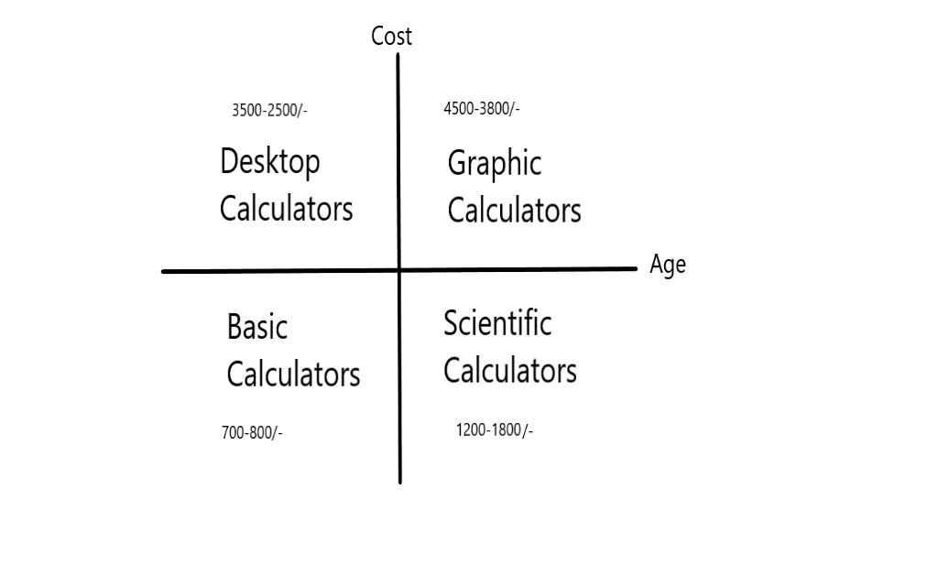

1. **Problem Statement**

• To develop an enhanced model of calculator which will perform multipurpose functions.

• The main aim of this model is to perform all mathematical, logical, and arithmetic operations.

1. **Consolidating Features**

Pros –

* Calculators can avoid the computational time required for calculations
* Calculators can help to improve the specialized knowledge of a student to operate them properly
* Computations done via calculators are precise then ones done by humans

Cons –

* Calculators can support a lot in cheating
* Calculators help to encourage complacency
* Calculators aren’t reasonable
* Calculators result in independence. Students may find themselves in situations that they won’t be able to perform even the easiest calculations of all without a calculator.