./

**COVID-19 TRACKER**

* SF ID: 104890

Course Code: <CODE>



Version Number:

Team Members :

Team No:

Module: Model Based System Engineering

|  |  |  |  |  |  |
| --- | --- | --- | --- | --- | --- |
| **Ver. Rel. No.** | **Release Date** | **Prepared. By** | **Reviewed By** | **Approved By** | **Remarks/Revision Details** |
| 1.0 | 21/09/2020 | Theres Mary Jose |  |  |  |
| 1.1 | 25/09/2020 | Theres Mary Jose |  |  |  |
|  |  |  |  |  |  |
|  |  |  |  |  |  |

**Document History**

# 

Table of Contents

1 INTRODUCTION 4

1.1 Problem Statement: 4

1.2 ProjectDescription**:** 4

2 REQUIREMENTS: 4

2.1 Software requirements: 4

2.2 Hardware requirements: 5

2.3 Functional requirements: 5

3 DESIGN: 5

4 TEST PLAN: 6

5 TEST CASES: 6

6 expected results: 7

7 CONCLUSION: 8

**Table of figures**

Figure 1: Use case Diagram 6

# ****INTRODUCTION****

## **Problem Statement:**

The COVID-19 pandemic in India is part of the worldwide pandemic of coronavirus disease 2019. The number of new cases is increasing day by day around the world. India currently has the second-highest number of confirmed cases in the world and holds single day record for largest increase in cases. Therefore, it is important to track the spread of pandemic in the country. The participants can use this Tracker system to get the latest covid updates from different states of India.

## Project Description**:**

COVID-19 Tracker is a program to track the number of confirmed COVID19 cases in various states across the Country. This will help the users to easily search and track the spread of the pandemic. C programming, a most powerful & efficient language is used to develop this system. The basic concepts of C like Functions, Structures & File handling are used here. This program allows to insert, update, search and delete records of different states in the database.

The homepage of the program contains the main menu which has basic functions of the COVID-19 Tracker system. When adding a new record, the system will ask for information such as the state name, active, recovered, deceased & other cases. Other cases include the migrated cases or non-COVID deaths. The system also calculates the total no of confirmed cases till date based on the data provided. After inserting the data, you can update, search and delete these records.

# REQUIREMENTS:

## Software Requirements:

* Operating System: **Ubuntu**
* Language: **C**
* IDE: **Visual Studio Code**
* Compiler: **MINGW Compiler**

## Hardware Requirements:

* System: **CPU - 2.0 GHZ**
* RAM: **1 GB**
* Hard Disk: **40 GB**

## Functional Requirements:

* **Add new record:** The user inputs the information such as the state name, active, recovered, deceased & other cases. Other cases include the migrated cases or non-COVID deaths.
* **Display record:** All existing records are displayed along with state name, active, recovered, deceased & other cases. The total no of confirmed cases are also calculated and displayed.
* **Search record:** State name is given as input to retrieve records of the respective state.
* **Update record:** This function is used to modify the existing records with latest updates of number of cases.
* **Delete record:** This function is used to delete the existing record by entering the name of state.

# DESIGN:

The program contains a main menu which has the basic functions of the COVID-19 Tracker system such as :

* void add() – It adds a new state record.
* void update() – It is used to modify added records.
* void delete() – It deletes existing records from the file.
* void search() – It searches for added record by state name.
* void display() – It is used to display the entire records in the file.

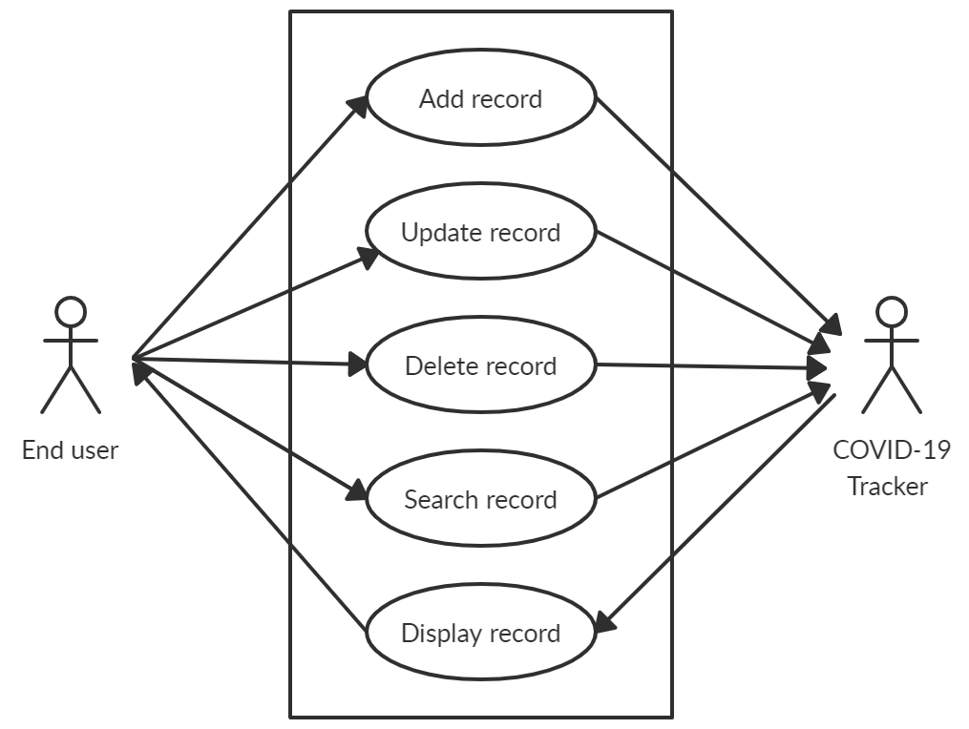

# TEST PLAN:

* To check if the user can add a new record with the same name.
* To check if the user can remove the record which does not exist in the database.
* To check if the user can search the record which does not exist in the database.
* To check if the user can modify the record which does not exist in database.
* To check if the user can exit from the menu.

# TEST CASES:

The test cases are designed for all the possible cases of the project and are tested for all the conditions.

|  |  |  |
| --- | --- | --- |
| **SI.No** | **Test Cases** | **Result** |
| 1 | User selecting valid option from main menu | User directed to the corresponding option |
| 2 | User selecting invalid option from main menu | Message “Invalid selection” displayed |
| 3 | User adding a new state | Record stored and data displayed |
| 4 | User selecting display option | Entire record displayed |
| 5 | User selecting display option with empty records | Message “No Records Exists!” displayed |
| 6 | User searching a valid state | The status of searched state displayed |
| 7 | User searching a invalid state | Message “No Records Exists!” displayed |
| 8 | User updating an existing state | Modified Record stored |
| 9 | User updating a state which does not exist | Message “No Records Exists!” displayed |
| 10 | User deleting an existing state | The record which has to be deleted will be displayed and deleted from the file. |
| 11 | User deleting a state which does not exists | Message “No Records Exists!” displayed |

# EXPECTED RESULTS:

* Latest updates of each state are tracked onto the file and total no of confirmed cases calculated.
* Display the output as per design.
* Pass all the test cases mentioned above.
* Users should exit from the console successfully .

# CONCLUSION:

A COVID-19 Tracker system has been developed using c programming to obtain the latest updates on the rising covid cases across the country. Current status of each state is tracked onto the file and displayed to the user. The system enables users to easily track the spread of pandemic in different states of the country. Further enhancements can be made to the system to make it more functional.