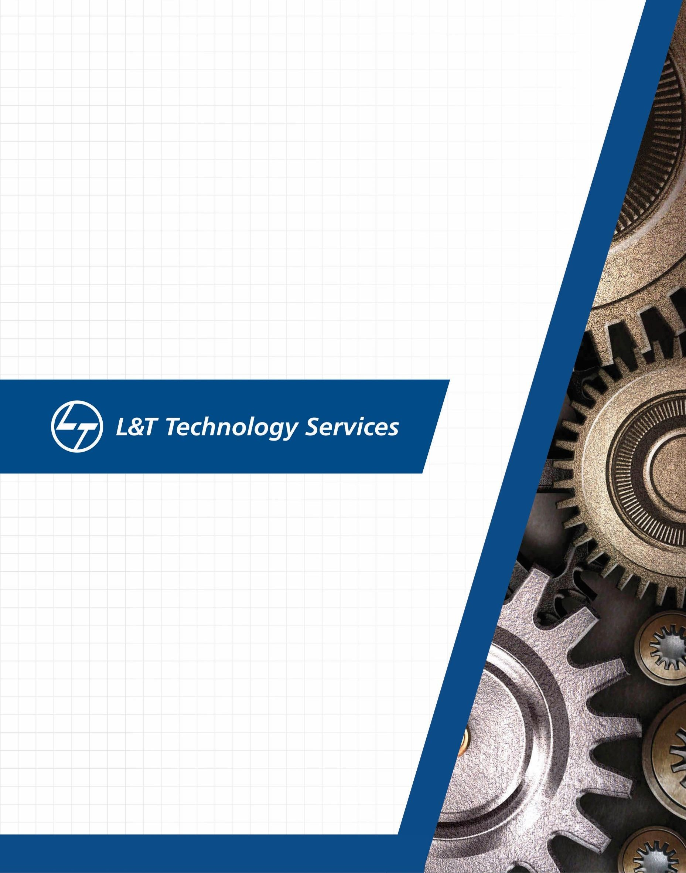

Linux OS & Programming

**Document History**

|  |  |  |  |  |  |
| --- | --- | --- | --- | --- | --- |
| **Ver. Rel.**  **No.** | **Release Date** | **Prepared. By** | **Reviewed By** | **To be Approved By** | **Remarks/Revision Details** |
| 1 | 1-03-21 | Vikram Hegde | Bharath |  |  |
|  |  |  |  |  |  |
|  |  |  |  |  |  |
|  |  |  |  |  |  |
|  |  |  |  |  |  |

# Contents

# GitHub link………………………………………………………………………………………..4

ASSIGNMENT-1 5

CASE STUDY – DESIGN & LINK WITH LIBRARIES 6

GITHUB LINK FOR THE CODES 5

COMMANDS LEARNED 5

MAKEFILE 6

ASSIGNMENT-2 7

ASSIGNMENT-3 8

# Github repo link (all activity) :

# <https://github.com/99003597/linuxtask1>

# Github Assessment1 link : <https://github.com/99003597/linuxtask1/tree/main/Activity1>

# Github Assessment2 link : <https://github.com/99003597/linuxtask1/tree/main/Activity2>

# Github Assessment3 link : https://github.com/99003597/linuxtask1/tree/main/Activity3

# Assignment-1

# Case study – Design & Link with Libraries

Step 0 - Preparation

Step-1A - Simple Make file

Step-1B- Simple Make file with Inc and Src Folders Step 2- Static Libraries

Step 3- Dynamic Libraries

Commands Learned:

* Creating .out and object files(.o files)

>> gcc dep1.c dep2.c dep3.c

* Executing the output considering a.out is the executable file

>> ./a.out

* Creating libraries

**>>** ar rc libsimple.a dep1.o dep2.o

**>>** gcc -L. dep1.o s1.out -lsimple

* Dynamic Library Linking:

>>gcc -L. dep1.o -o d1.out -lsample

* Makefile

>> Target : Dependencies

<Tab>gcc dependencies

Run : Target

<Tab> ./a.out

Makefile:

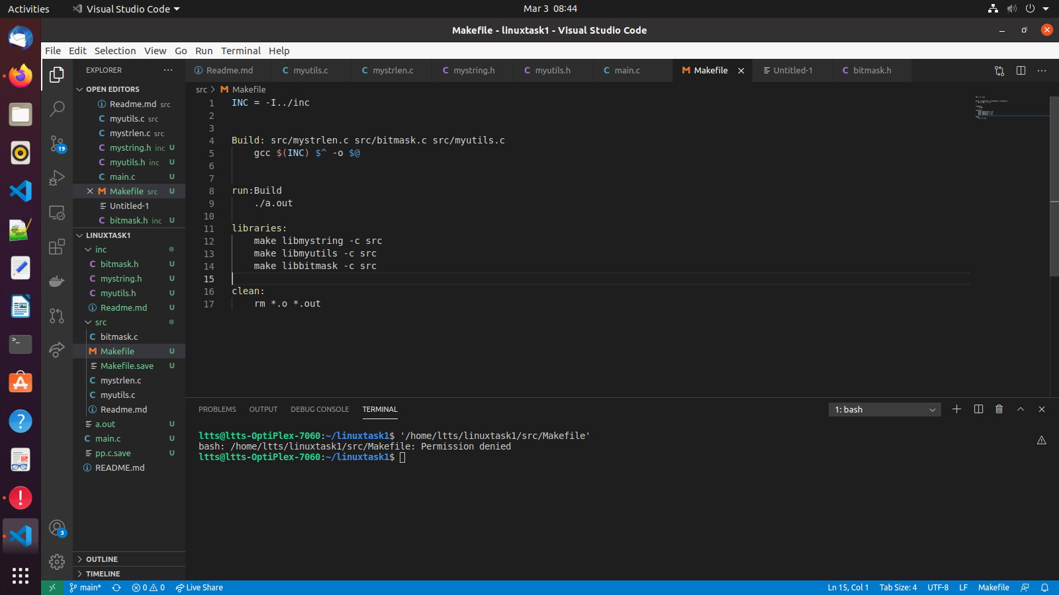

link :https://github.com/99003597/linuxtask1/tree/main/Activity1

14

# Assignment2

Description: Worked on system call, process and Threads

Learning Outcome:

1. learned about the how threads work, Process Hierarchy and how system takes calls
2. and also about testing with unity.

Challenges:

* difficulty in understanding threads .
* unable to do proper testing.

Link:

https://github.com/99003597/linuxtask1/tree/main/Activity2

# Assignment 3:

Description: Concepts on Scheduling, Race conditioning, IPC, Semaphore, Pipe and Message queue.

Learning Outcome:

* learned about using ipc , where we can Semaphone and mutex
* learned about how to use pipe
* Deadlocks and message queues

Challenges:

* how to send signals using ipc
* deadlock conditions
* Implementation of concepts to code

link : https://github.com/99003597/linuxtask1/tree/main/Activity3