# Design & Planning

## a. Structural -

### 1. High level -

### 

### 2. Low level -

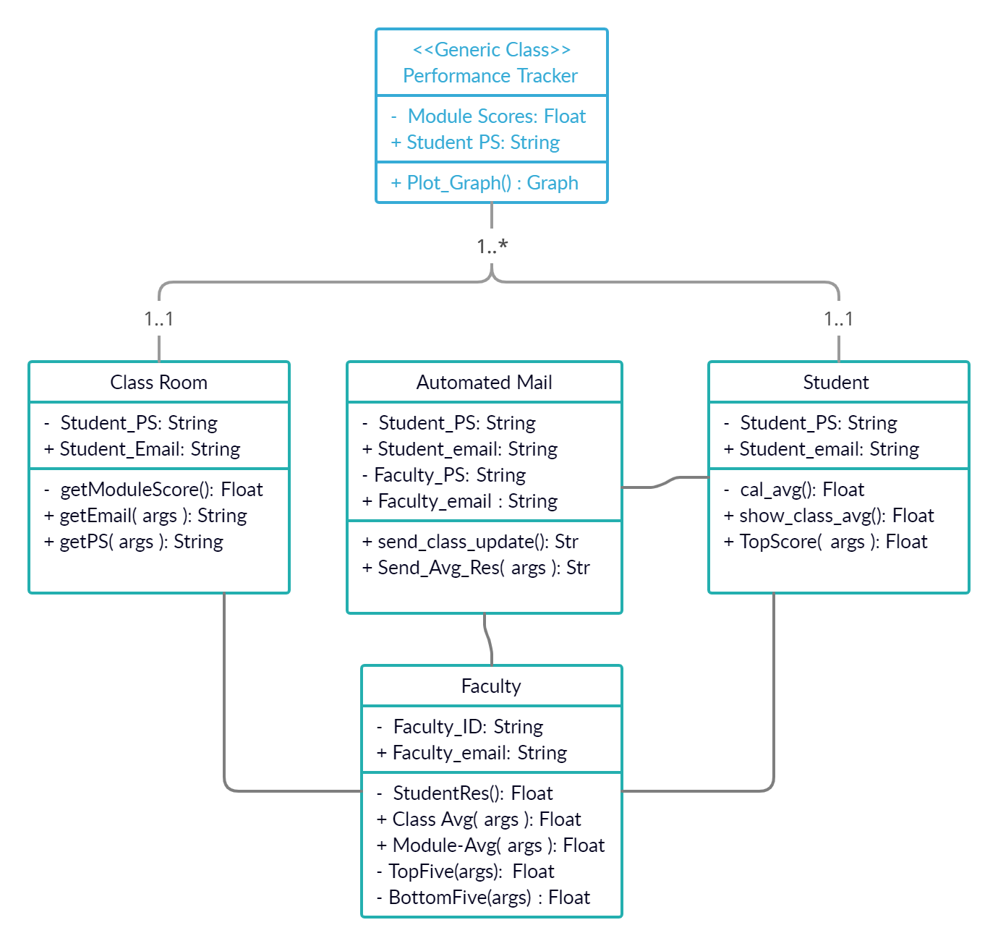

## 2 . Behavioural :-

### a. High level :-

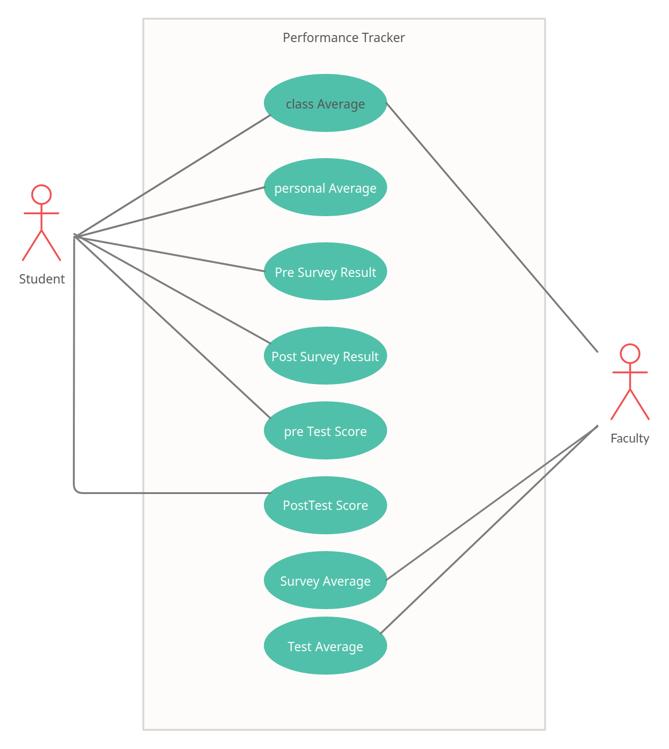

### b. Low Level -

#### 1. Faculty

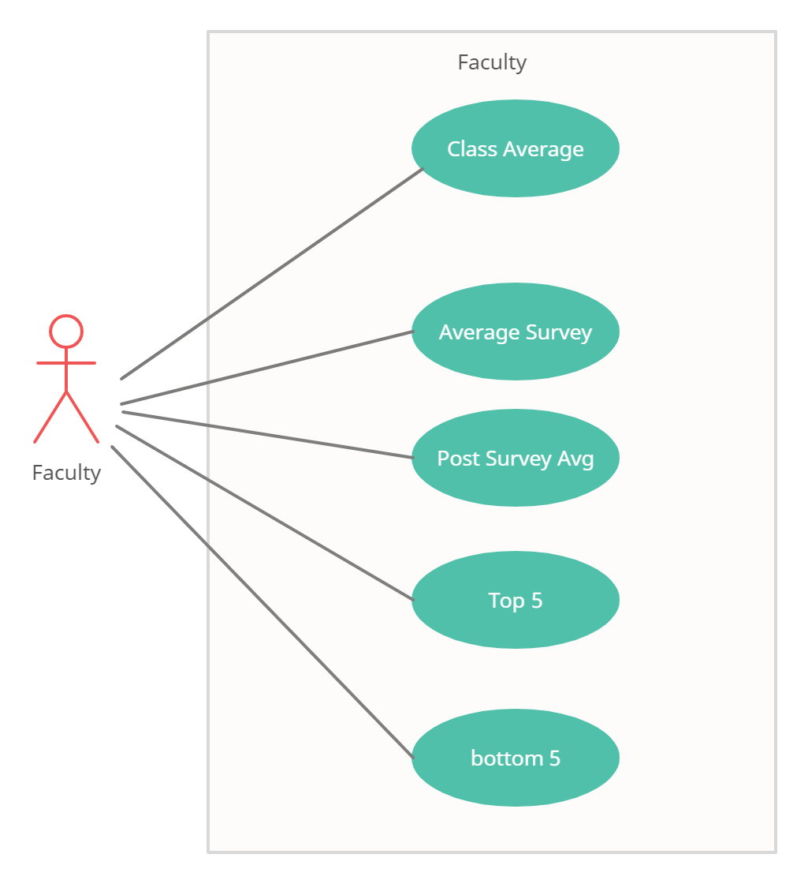

#### 

#### 2. Student

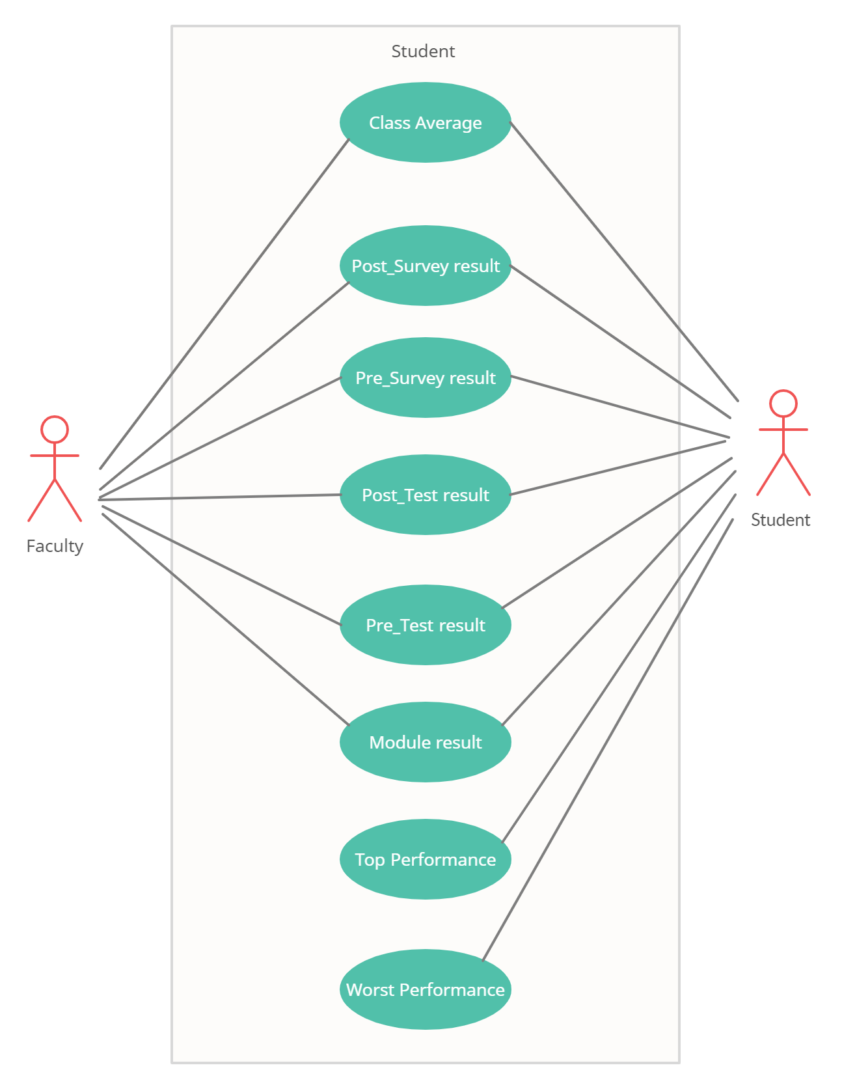

#### 3. ClassRoom

