

./

Learning Report – Applied System Development Life Cycle and Software Testing



|  |  |  |  |  |  |
| --- | --- | --- | --- | --- | --- |
| **Ver. Rel. No.** | **Release Date** | **Prepared. By** | **Reviewed By** | **To be approved By** | **Remarks/Revision Details** |
| 1 | 01/03/2021 | 99003706 | Name/PS No | Lalit Bhardwaj | Comments |
| 2 | 01/03/2021 | 99003651 | Name/PS No | Deepak Pradhan | Comments |
| 3 | 01/03/2021 | 99003651 | Name/PS No | Ashish Pareek | Comments |
| 4 | 01/03/2021 | 99003608 | Name/PS No | Ashish Nayak | Comments |
|  |  |  |  |  |  |

**Document History**

**Table of Contents**

Need of Analysis of Student Result 2

1.Introduction 2

2.Feasibility Analysis 2

2.1Market Analysis 2

2.2Technical analysis 2

3.SWOT ANALYSIS 3

4. 4W's and 1'H 3

4.1 Who is the user of the system? 3

4.2 What is the product? 3

4.3 When is the product used? 3

4.4 Where can we use the product? 4

4.4 How can we use the product? 4

5. Detail requirements 4

5.1 High Level Requirements: 4

5.2 Low level Requirements: 4

6. Planning 5

6.1 Gantt Chart 5

7. Design & Architecture 6

7.1 Structural UML (High level Diagram) 6

7.2 Structural UML (Low level Diagram) 6

7.3 Behavioural UML (High level Diagram) 6

7.4 Behavioural UML (Low level Diagram) 6

8. Test Plans 7

8.1 High level Test Plans 7

8.2 Low level Test Plans 7

**Table of Figures**

Figure 1 SWOT Analysis 3

Figure 2 High Level Requirements 4

Figure 3 Low level Requirements 5

Figure 4 Gantt chart 5

Figure 5 Structural UML (High level diagram) 6

Figure 6 5 Structural UML (Low level diagram) 7

Figure 7 Behavioural UML (Low level Diagram) 8

Figure 8 High level Test plans 8

Figure 9 Low level Test plans 9

# Need of Analysis of Student Result

To identify performance of individual student in assessments we need report card so that teacher can track the performance of student and student can also track their performance so to make report card you need to do detailed analysis of Pre-survey, Post-survey, Pre-test marks and post-test marks.

## 1.Introduction

In this project, we are doing analysis of Pre-survey, Post-survey, Pre-test marks and post-test marks. And after that we will send this detailed analysis of assessment as a feedback to student on his/her given email. As a feedback student will get his/her marks, average marks of class, Top 5 performer and bottom 5 student’s mark. And teacher will also get these details but she will get performance of whole class like average marks of class, Top 5 performer and bottom 5 student’s mark. By using this feedback, she can contact bottom 5 student whether they need help or not.

# 2.Feasibility Analysis

During this step of system development life cycle as we have considered different aspect associated with this project like whether is this project economically feasible to us or not whether this project is technically feasible or not, whether we have known to the technologies we are using or not that any risk is associated with these things can be considered and resolve accordingly or if there is a need of change in the strategy or plan. We have tried to find out the answers of following questions.

• What are the needs of the users of the system and how our system will fulfil those needs?

• What are the services provided to user by this system?

• How our system will impact the users?

• Whether our system can generate and send individual report card to student?

## 2.1Market Analysis

• Analysis of student performance gives a simple and user-friendly view of the performance of the individual trainee.

• Trainees can improve performance in Training by using a Performance tracker.

• It can be used by any trainee who wants to keep track of their performance.

• Spider chart will help students as well as faculty to understand the overall growth and performance of the class.

## 2.2Technical analysis

During this step, we are tried to find out whether the project is technically feasible to us or not and whether we will be completing this project by using the discussed technologies or not. At this step, we find out that we all ready to work on the technology and complete the project.

• We use excel to store a data.

• We use VS Code software for implementation of project.

• We use some python libraries for data analysis. Some libraries are pandas, NumPy, Matplotlib, seaborn etc.

# 3.SWOT ANALYSIS

[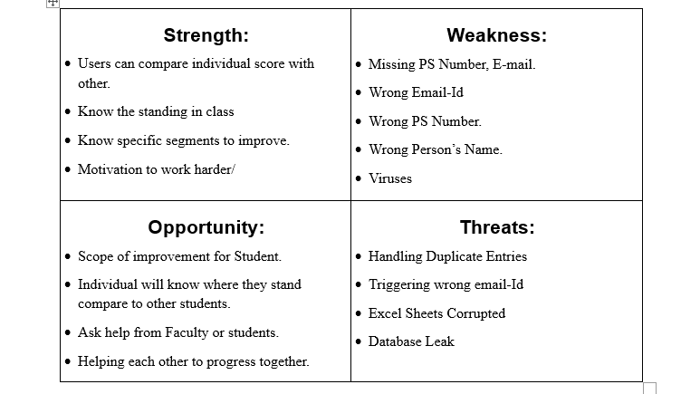](https://github.com/99003655/AppliedSDLC_C4/blob/main/SWOT%20Analysis.png)

Figure 1 SWOT Analysis

# 4. 4W's and 1'H

## Who is the user of the system?

The program is used by the students and the faculty to review the students before and after the course started. How much have the student improved and how much difference is there from that student to the average class.

## What is the product?

The program is a visual report of the marks received by the students and also the self-rating before and after the module starts and sends the combined report to the teacher with all the average rating, top performer and the last 10 % of the class. The students will receive an individual report on how he or she have done and how is their report in comparison with the class average with the help of the spider chart. Both stakeholders will receive the update with the help of the triggered email.

## When is the product used?

The program is used when you require an individual or group report between the students and the teacher and it will be automatically triggered to the respective emails.

## Where can we use the product?

The product can be used in a corporate training where the employer can review the individual based on ratings and scores received.

## 4.4 How can we use the product?

• The product can be used by the students to see where they stand in class in comparison to the average marks and the top performer marks.

• The product can be used by the teacher to see the group result of the class and the students who require more attention and the top performers.

# 5. Detail requirements

## 5.1 High Level Requirements:

[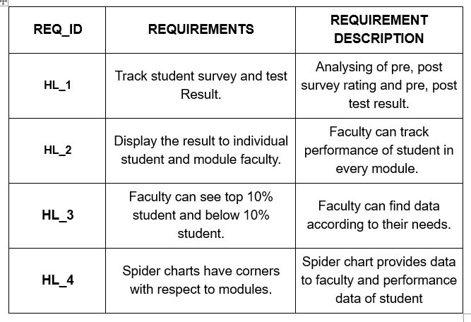](https://github.com/99003655/AppliedSDLC_C4/blob/main/HighLevelReqt.JPG)

Figure 2 High Level Requirements

## 5.2 Low level Requirements:

[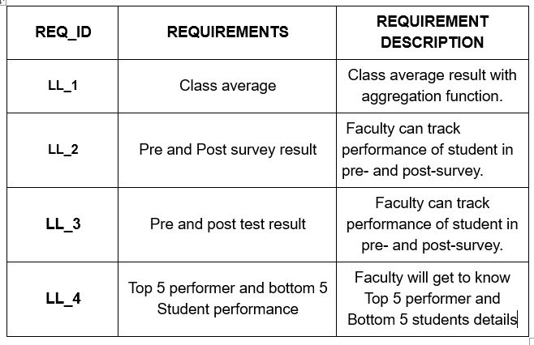](https://github.com/99003655/AppliedSDLC_C4/blob/main/lowlevelreqt.JPG)

Figure 3 Low level Requirements

# 6. Planning

## 6.1 Gantt Chart

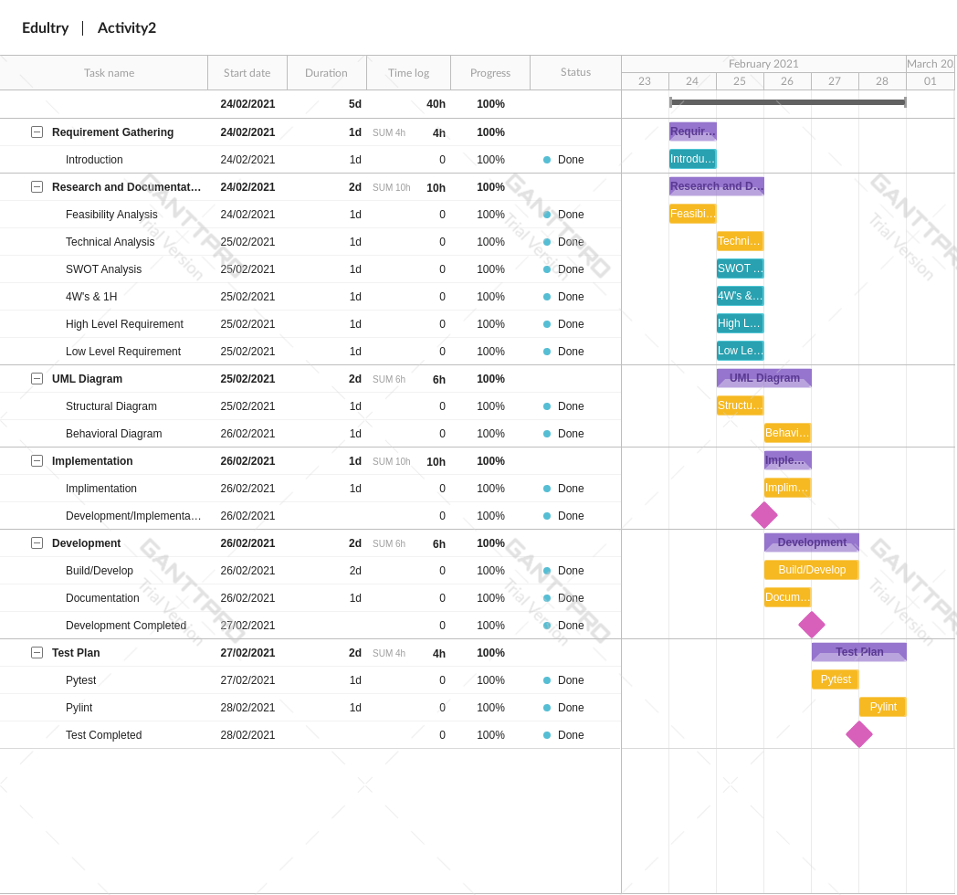

Figure 4 Gantt chart

# 7. Design & Architecture

## 7.1 Structural UML (High level Diagram)

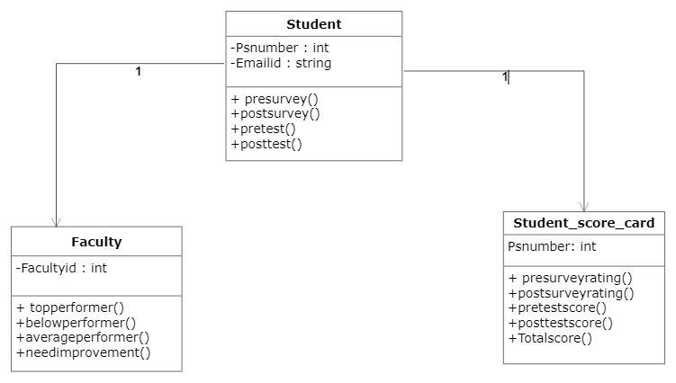

Figure 5 Structural UML (High level diagram)

## 7.2 Structural UML (Low level Diagram)

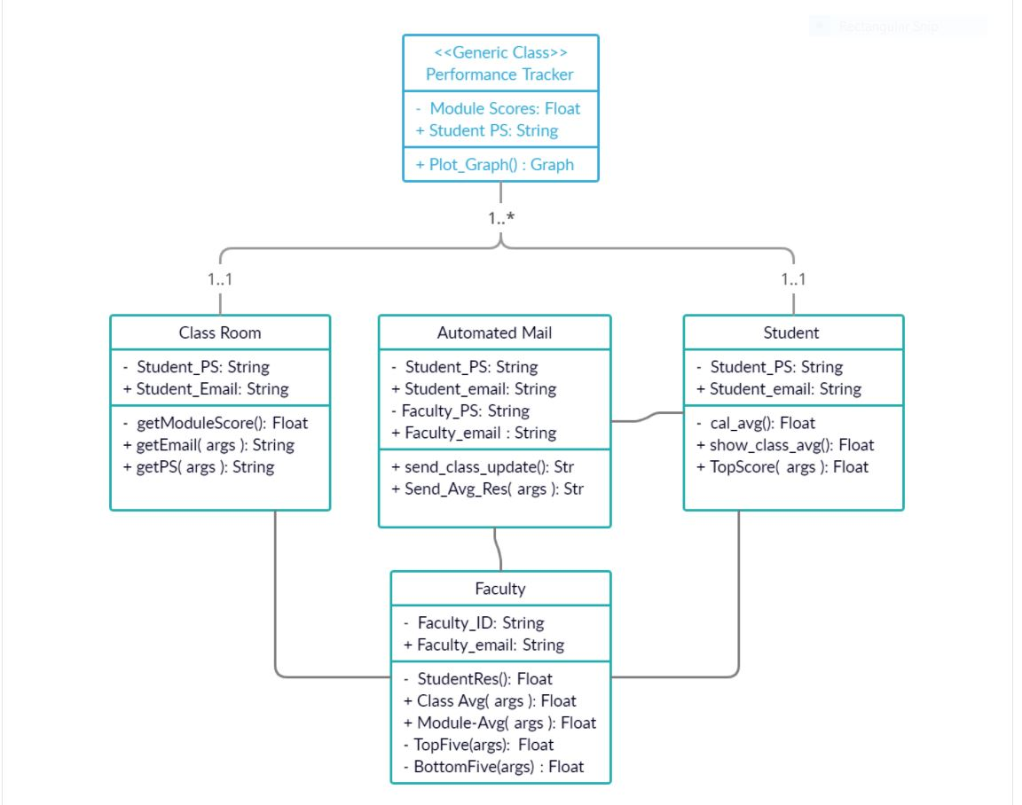

Figure 6 Structural UML (Low level Diagram)

## 7.3 Behavioural UML (High level Diagram)

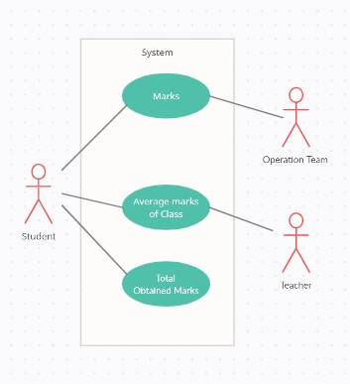

Figure 7 Structural UML (Low level diagram)

## 7.4 Behavioural UML (Low level Diagram)

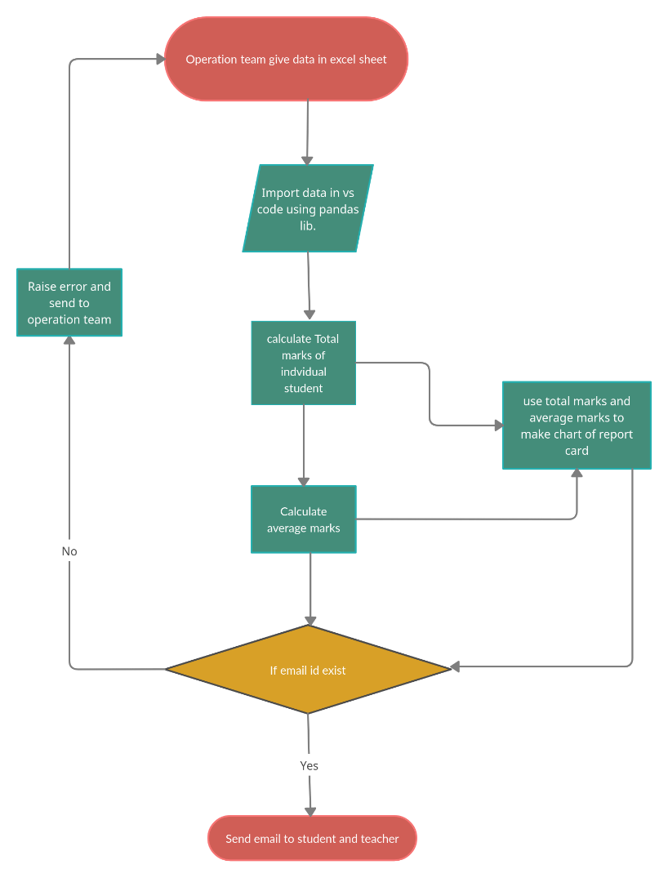

Figure 8 Behavioural UML (Low level Diagram)

# 8. Test Plans

## 8.1 High level Test Plans

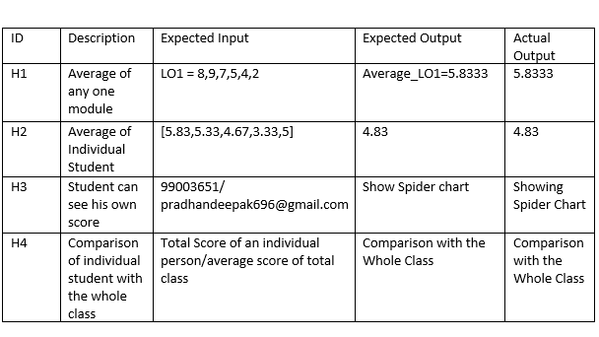

Figure 9 High level Test plans

## 8.2 Low level Test Plans

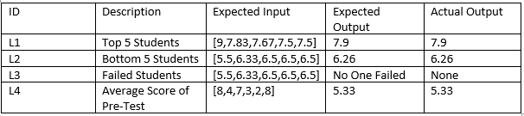

Figure 10 Low level Test plans