./

**Learning Report**

Linux OS & Programming



Version Number:

Team Members :

Team No:

Module: Model Based System Engineering

|  |  |  |  |  |  |
| --- | --- | --- | --- | --- | --- |
| **Ver. Rel. No.** | **Release Date** | **Prepared. By** | **Reviewed By** | **To be Approved By** | **Remarks/Revision Details** |
| 1 | 03-03-21 | Devraj Sen | Manisha Chandra,  Vishaal Balaji N |  |  |
| 2 | 04-03-21 | Devraj Sen | Kamran Akhtar,  Vinay Shirol |  |  |
|  |  |  |  |  |  |
|  |  |  |  |  |  |
|  |  |  |  |  |  |

**Document History**

# 

Contents

|  |  |  |
| --- | --- | --- |
| Activity | Topic | Page number |
| 1 | Designing and Linking of Library files(Static and Dynamic). | 4-7 |
| 2 | Process, System Calls and Threads Handling | 8 |
| 3 | Semaphores and Mutex | 9 |
| 4 |  |  |

# Activities

# Activity 1 – Design & Link with Libraries

# 

**Part A - Preparation**

**Part B - Simple Make file**

**Part C- Simple Make file with Inc and Src Folders**

**Part D- Static Libraries**

**Part E- Dynamic Libraries**

**GitHub Link for the codes: https://github.com/99003690/Activity1_Linux.git**

**Commands History:**

* For producing .out and .o files (dep = dependencies)

>> gcc dep1.c dep2.c dep3.c

* For executing the output considering a.out is the executable file

>> ./a.out

* For creating a new file and editing

>> nano file_name

* For creating libraries

**>>** ar rc libsimple.a dep1.o dep2.o

**>>** gcc -L. dep1.o s1.out -lsimple

**>>** gcc -L. dep1.o -o s1.out -lsimple

>> gcc -L. dep1.o -o s2.out -lsimple -static

* Dynamic Library Linking:

>>gcc -L. dep1.o -o d1.out -lsample

* Makefile:

>> Target : Dependencies

<Tab>gcc dependencies

Run : Target

<Tab> ./a.out

**Makefile :**

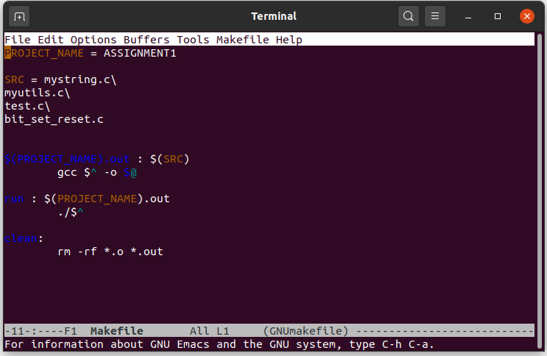

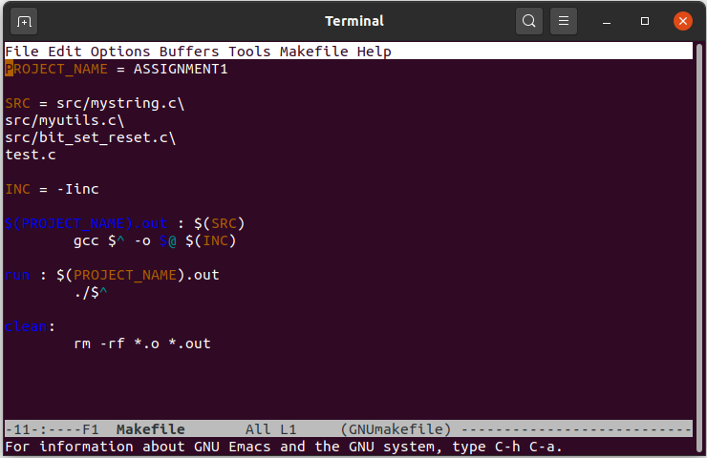

**Makefile when .c and .h files are in separate folders**

**Output (on windows cmd):**

**Activity 2 - Process, System Calls and Threads Handling**

To do write simple programs using to execute Process, Systems Calls and Thread Handling, and to get familiarized with the unit testing using unity testing. In the program we need to code the given programs according to the Linux OS. Also we need to implement the concept of parent class and about zombie functions along with threads.

**Leaning Outcome:**

* Got to know how to make mini-shell, linking parent class and child class and threads.
* Getting familiarized with terminal usage and using of manuals in terminals.

**Challenges:**

* Implementing the concepts into working code.

**Git Link :**

<https://github.com/99003690/1_Activity_LINUX.git>

# Activity 3: Semaphores and Mutex

**Type of Activity**: Individual

**Goal of Activity**: Implement producer consumer problem

**Topics Covered:**

* Mutex Lock
* Semaphores- Named and unnamed
* Race condition
* Deadlock
* Pipes
* Shared memory
* Message queue

**Learning Outcomes:**

* Learnt to implement sequencing and mutual exclusion.
* Prioritizing or locking a particular process for sequencing the flow of program.
* Working with named and unnamed semaphores, and using named semaphores in shared memory.
* Analyzing the return type for mutex to check for success or failure.
* Using threads for working with producer and customer.
* Handling context switching in order to avoid deadlocks.
* Using pipes and fifo to overcome limitations of semaphores and mutex.
* Using operations on shared memory such as read write and update.

**Challenges:** Understanding the race condition

**Git link :** https://github.com/99003690/Assignment2.git

**References:**

1. <https://www.tutorialspoint.com/gnu_debugger/index.htm>
2. <https://www3.ntu.edu.sg/home/ehchua/programming/cpp/gcc_make.html>
3. <https://tutorialspoint.com/operating_system/os_linux.htm>