Samsungm51_TC01_1:

Samsungm51_TC01_2.1:

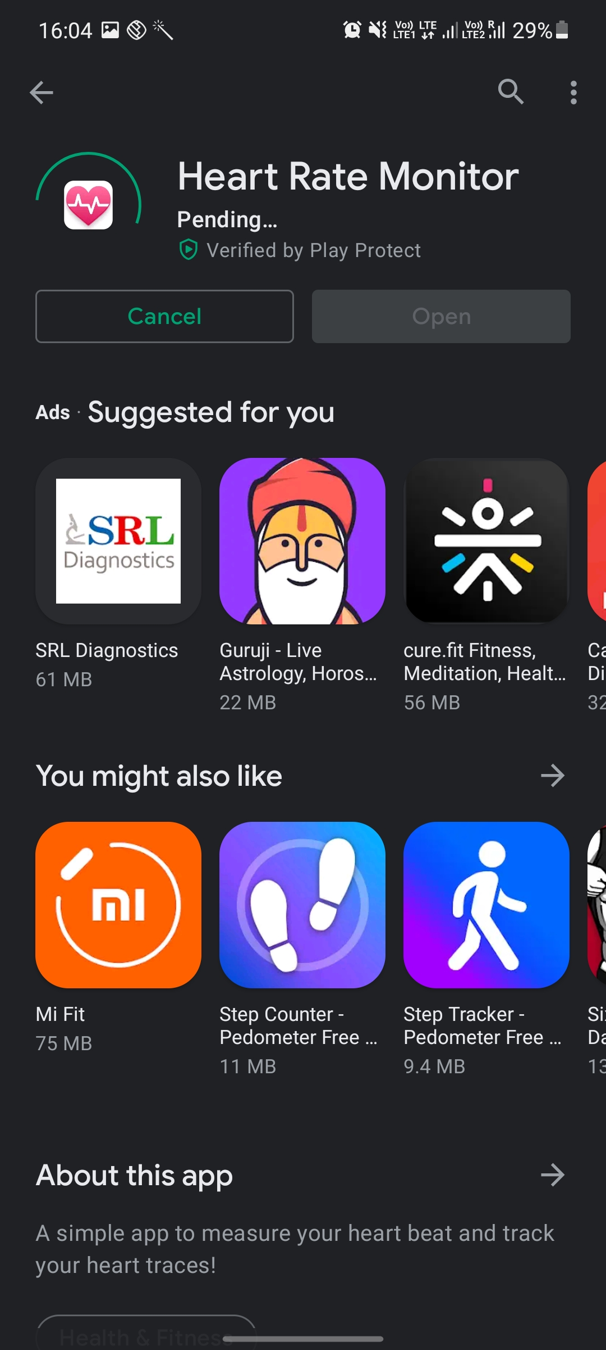

Samsungm51_TC01_2.2:

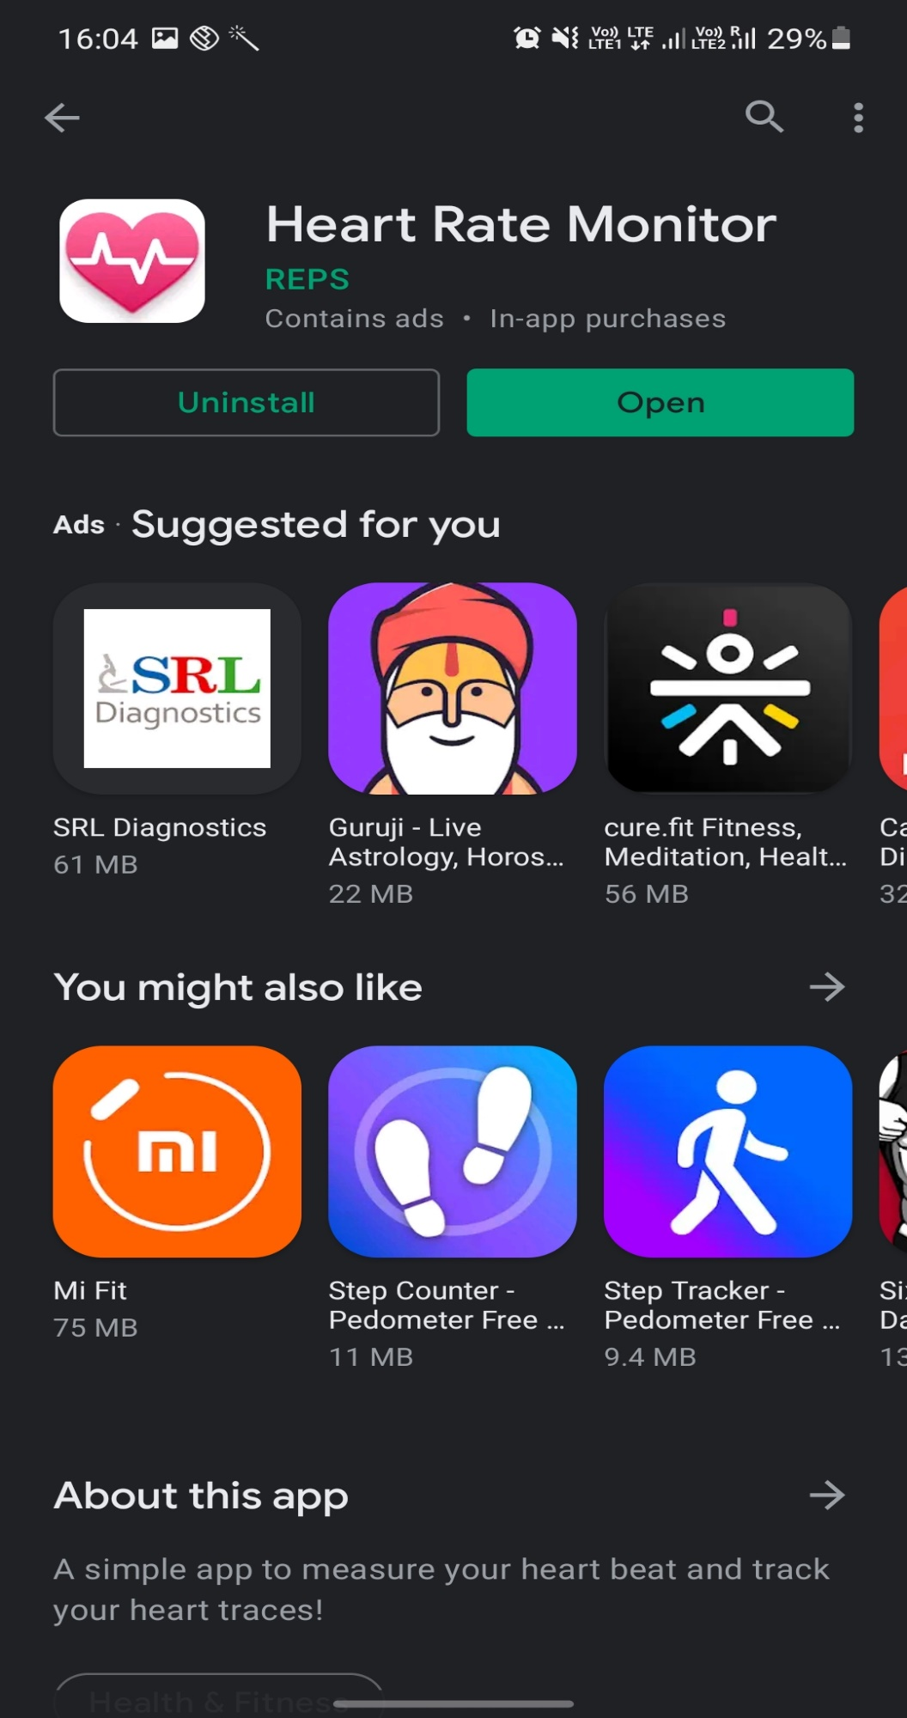

Samsungm51_TC01_3:

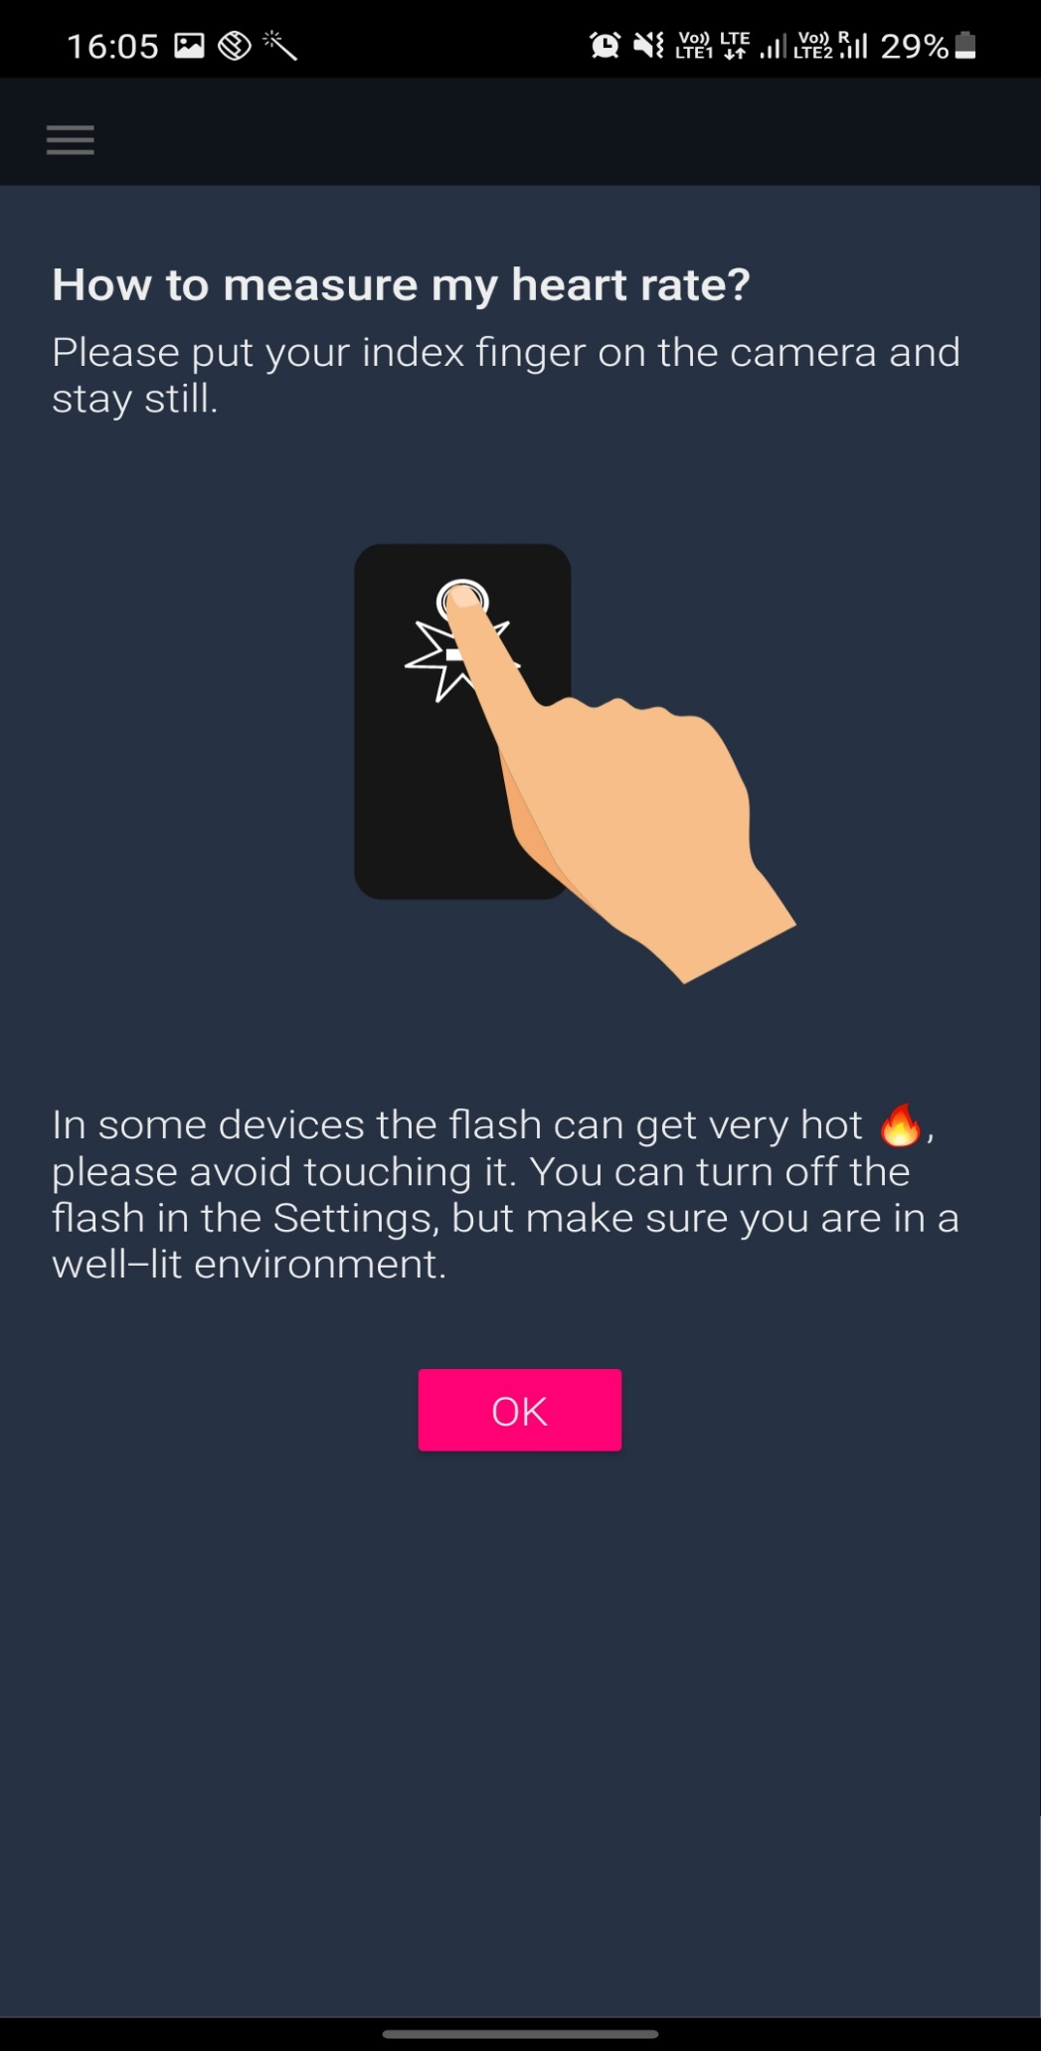

Samsungm51_TC01_4:

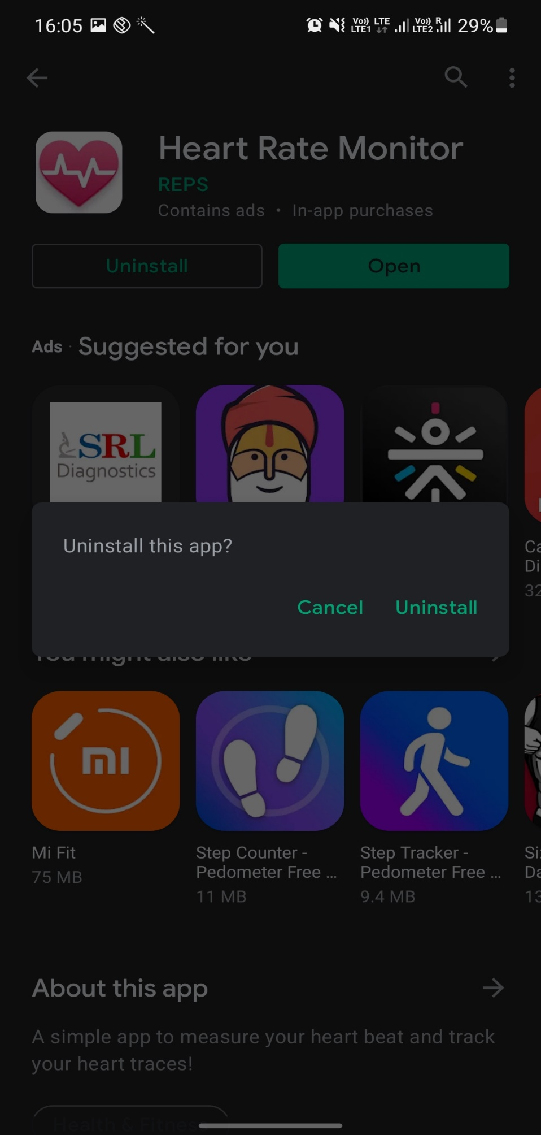

Samsungm51_TC01_5:

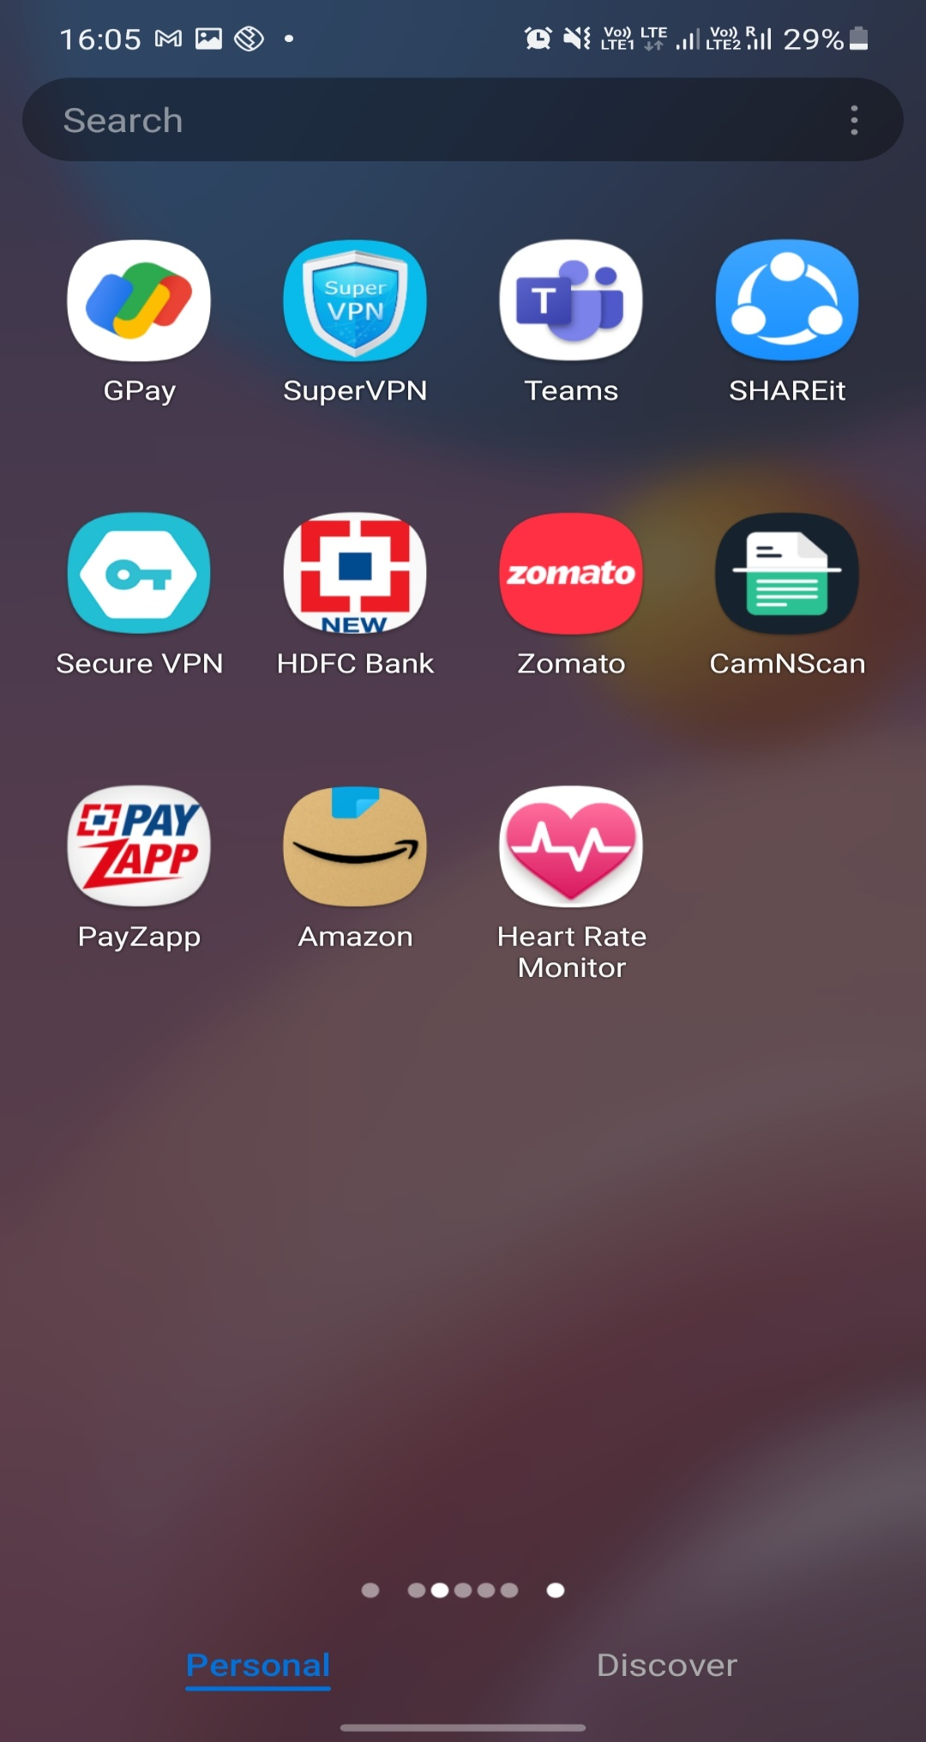

Samsungm51_TC01_6:

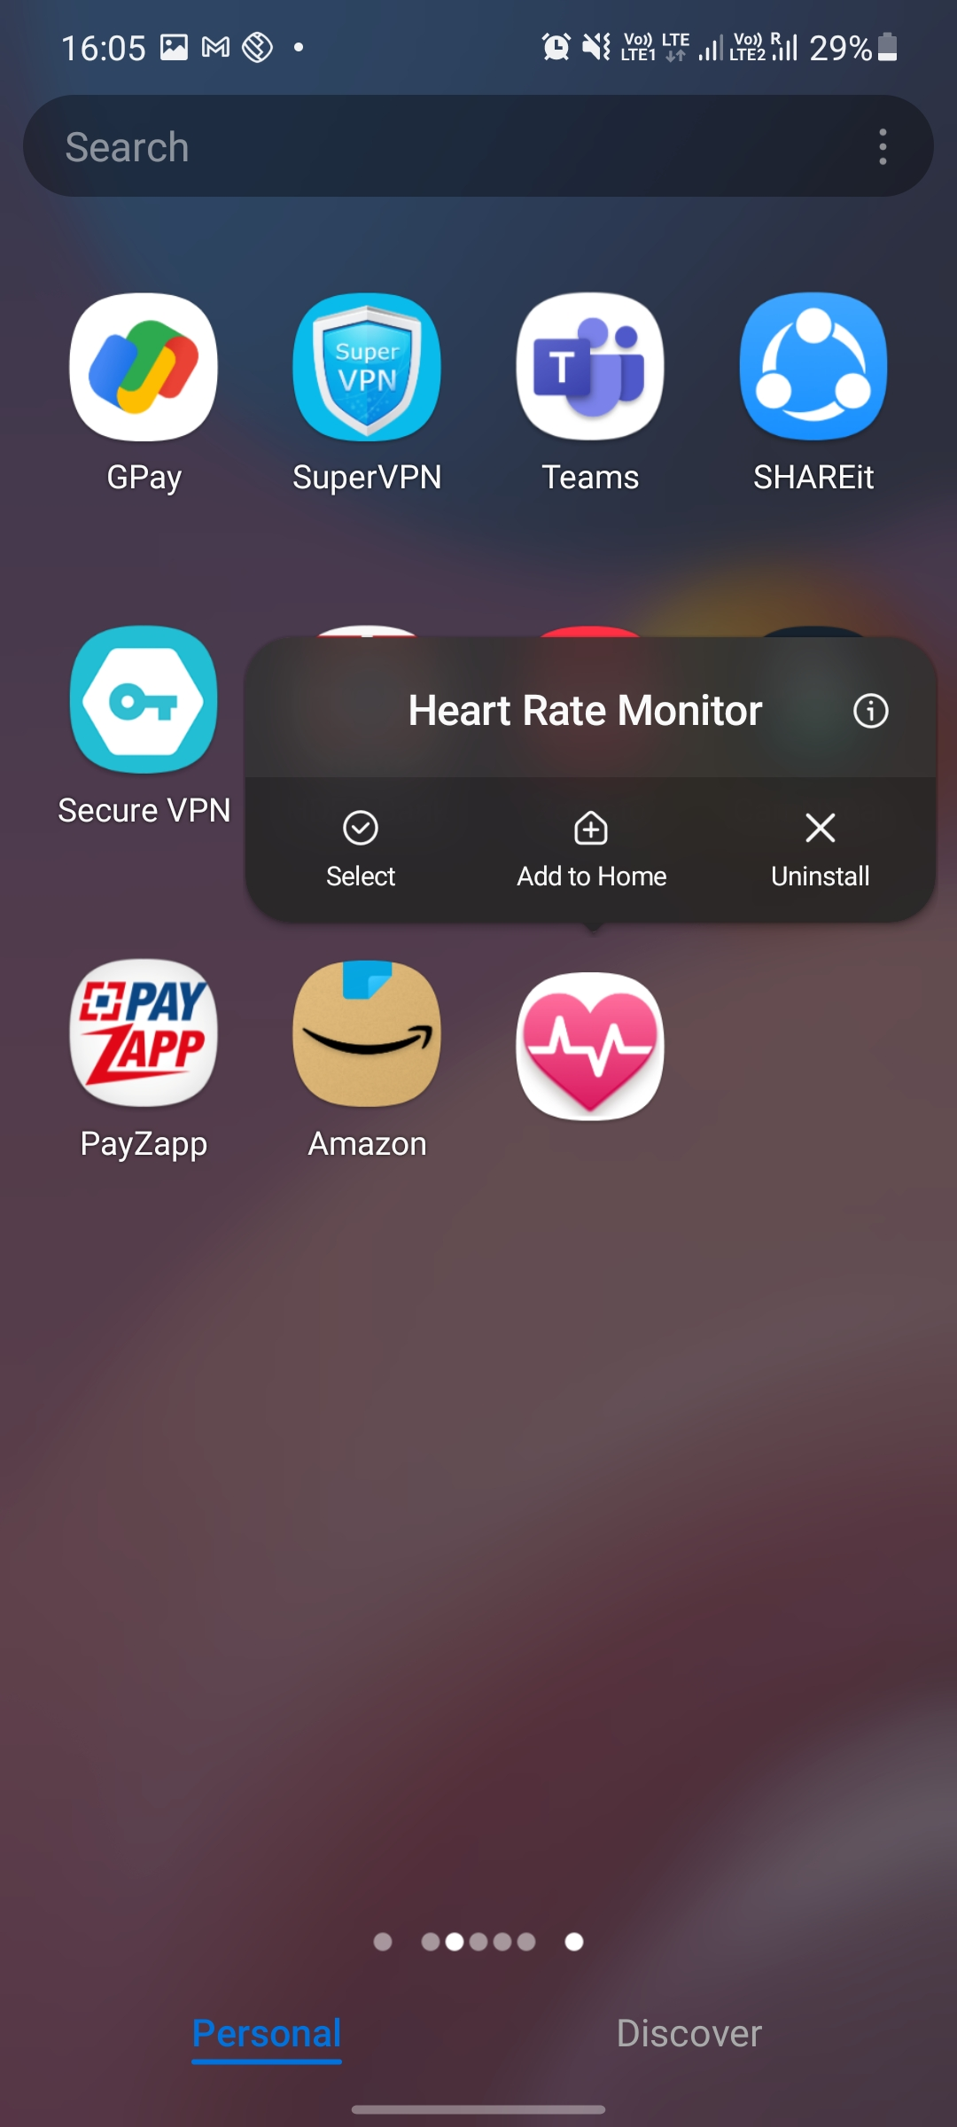

Samsungm51_TC01_7:

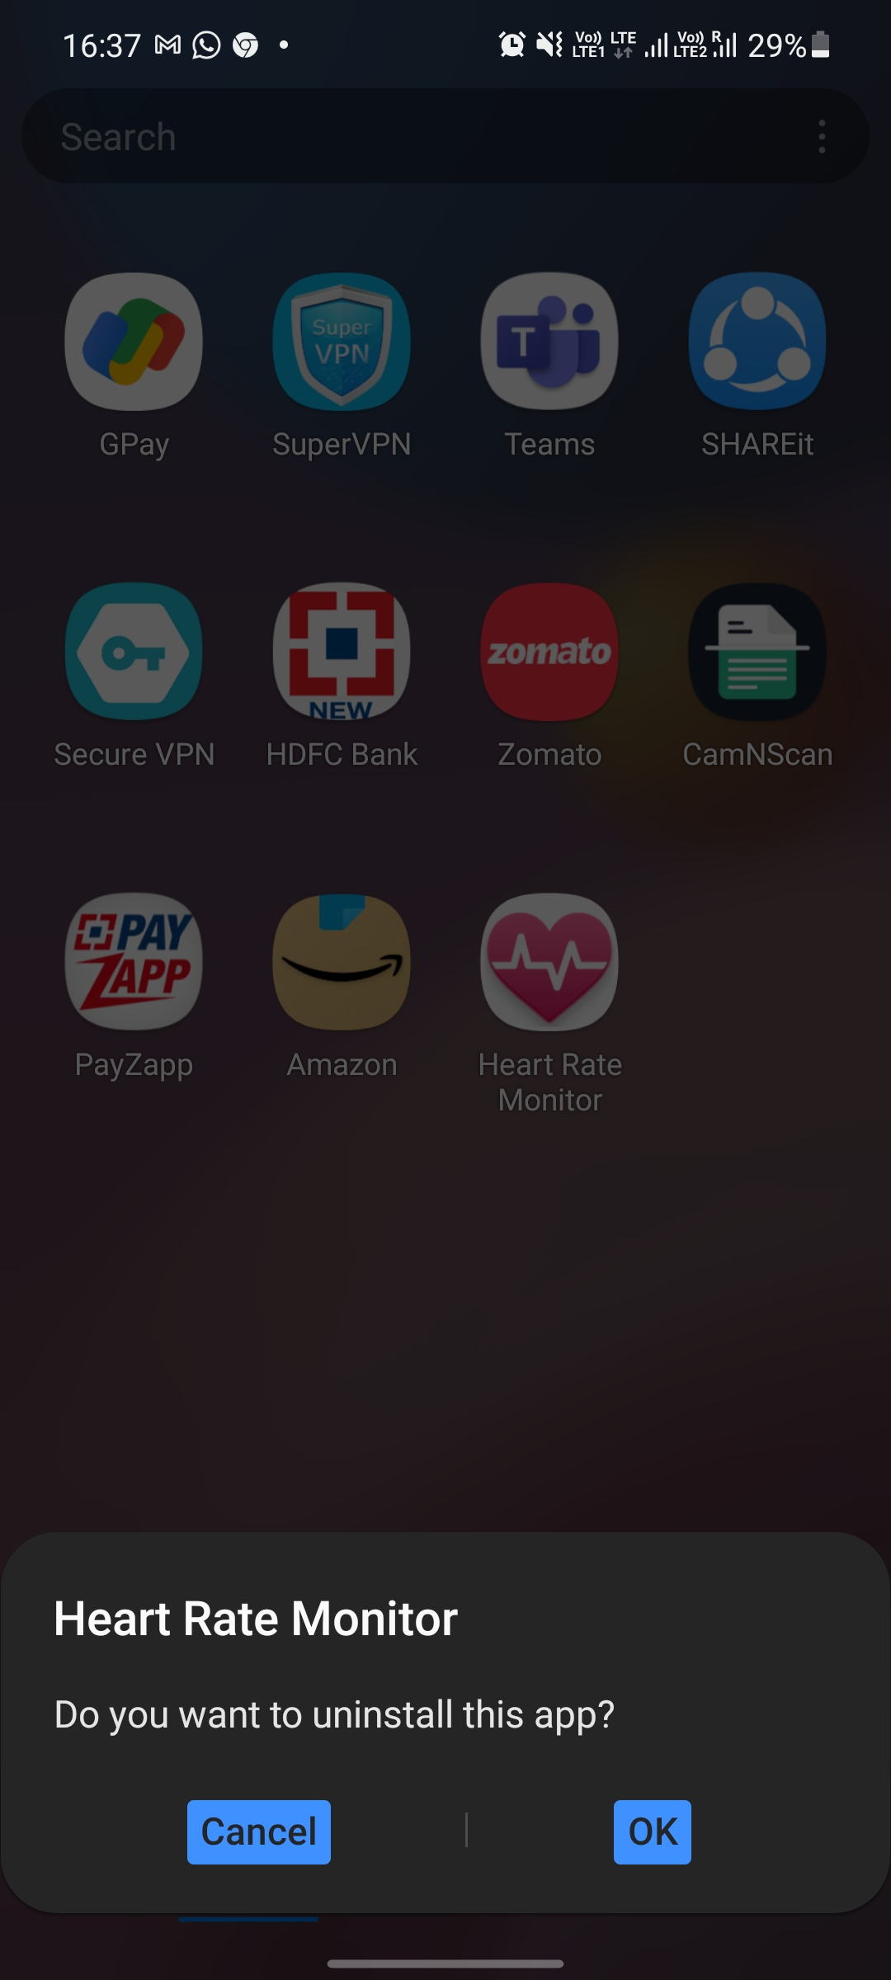

Samsungm51_TC01_8:

