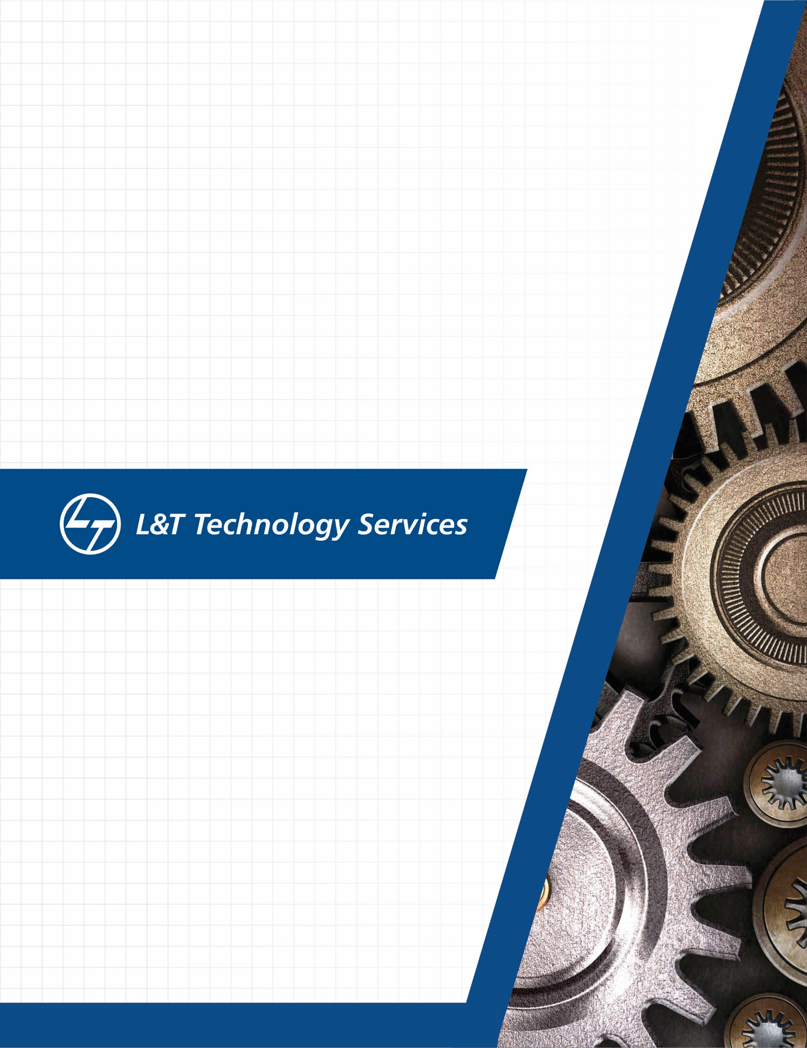
./
Learning Report – Applied System Development Life Cycle and Software Testing


Ver. Rel. No. | Release Date | Prepared. By | Reviewed By | To be approved By | Remarks/Revision Details
 |  | Name/PS No | Name/PS No | Module Owner Name | Comments
1 | 15/2/21 | 99003720-Jasleen Kaur Sethi
Document History

Table of Contents
Table of Figures 3
Table of Tables 4
ACTIVITY 1: SYSTEM/ SOFTWARE DEVELOPMENT 4
INTRODUCTION 4
MY PRODUCT: “Semi-engineering calculator ” 4
Research 4
SWOT ANALYSIS 5
REQUIREMENTS 6
DESIGN 8
HIGH LEVEL DESIGN 9
LOW LEVEL DESIGN 11
TEST PLANS 13
REFERENCES 14
ACTIVITY 2: AGILE METHODOLOGY 15
THEME 15
EPIC 15
USER STORY 15
REFERENCES 16

Table of Figures
Figure 1 COST VS FEATURES 5
Figure 2 SWOT ANALYSIS 5
Figure 3 COMPONENT DIAGRAM (HIGH LEVEL) 8
Figure 4 ACTIVITY DIAGRAM (LOW LEVEL) 9
Figure 5 OBJECT DIAGRAM (LOW LEVEL) 9
Figure 6 ACTIVITY DIAGRAM(LOW LEVEL) 10
Figure 7 CLASS DIAGRAM (LOW LEVEL) 11
Figure 8 TIMING DIAGRAM (LOW LEVEL) 12
Figure 9 CLASS DIAGRAM (LOW LEVEL) 12
Figure 10- ACTIVITY DIAGRAM (LOW LEVEL) 12
Figure 13 GIT ISSUES 14
Figure 14 GIT COMMITS 14

Table of Tables
Table 1 HIGH LEVEL REQUIREMENTS 6
Table 2 LOW LEVEL REQUIREMENTS- PRECEDENCE 7
Table 3 LOW LEVEL REQUIREMENTS- STORE AND RECALL 7
Table 4 LOW LEVEL REQUIREMENTS- PERMUTATION AND COMBINATION 8
Table 5 TEST PLAN-PRECEDENCE 13
Table 6 TEST PLAN-PERMUTATION AND COMBINATION 13
Table 7 TEST PLAN-STORE AND RECALL 13

ACTIVITY 1: SYSTEM/ SOFTWARE DEVELOPMENT

Introduction
We have attempted to build the software development cycle of a semi-engineering calculator. It includes the numerous high-level and low-level requirements of the various features involved in semi-engineering such as log, antilog, exponents roots and polynomial functions. It then explores about the various test cases that should be taken in consideration such that all requirements are taken care of. In the end, we build the codes that follow all the requirements and design efficiently as per them.

My product: “Semi-Engineering Calculator”
Our system is more or less semi advanced which basically able to do desirable calculations of daily basis from bottom to top level i.e. it includes every basic operations which eats lots of time in scheduled timings.

Research

There are different types of calculators with respect to the cost and its features. It is plotted in the graph shown below which shows the range of calculators for highest cost and lowest feature and vice versa. The range we have chosen is for a medium range cost and feature. It is similar to a programmable scientific calculator. It will be more efficient for the multipurpose use.

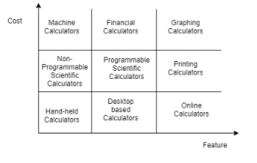
Figure1: Cost vs Features

SWOT Analysis:
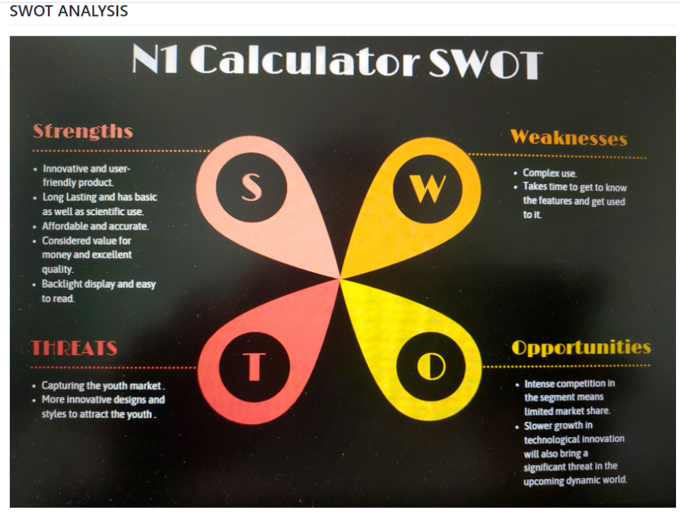
Figure2: SWOT Analysis

Requirements:

The calculator build by us includes basic arithmetic functions, trigonometric functions and exponential functions. It also consists of some other functions including power, log, antilog, permutation and combination functions.
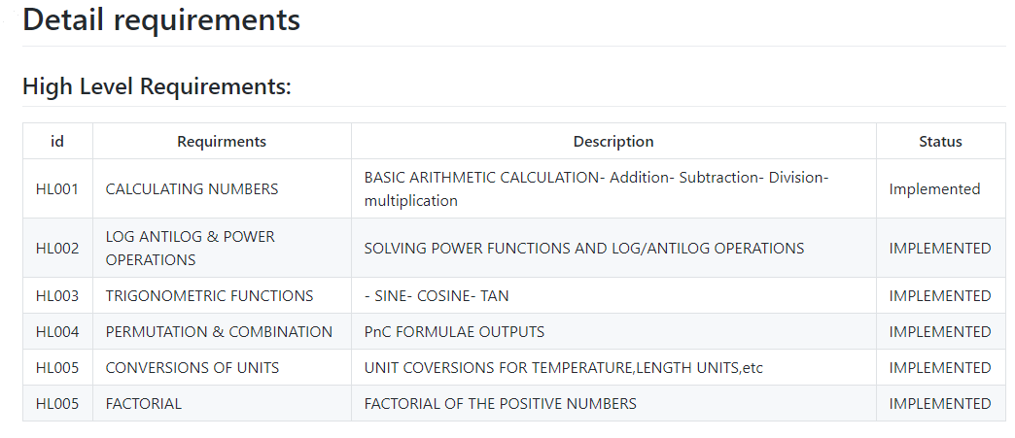

Low level Requirements:
Precedence
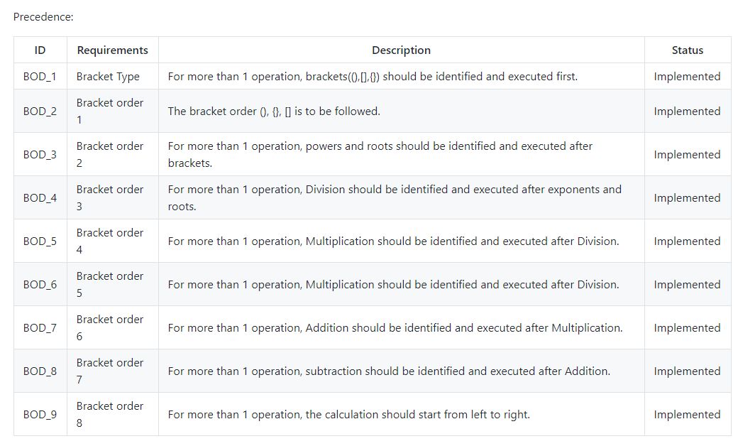
Store and Recall
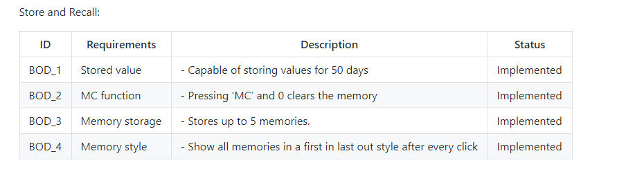
Permutation and combination
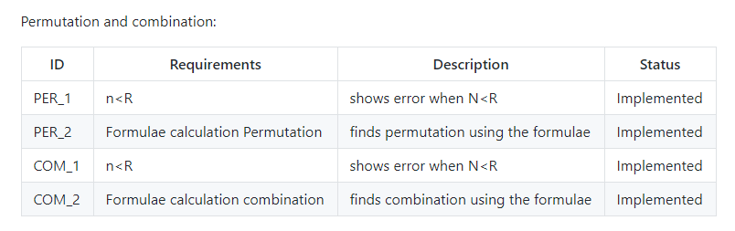

Design:

HIGH LEVEL DESIGN
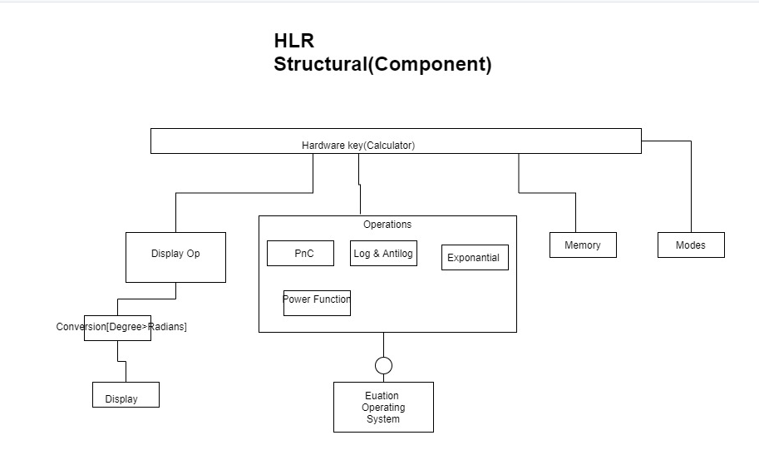
Figure3: Component Diagram

LOW LEVEL DESIGN

Precedence
Behavioral Diagram

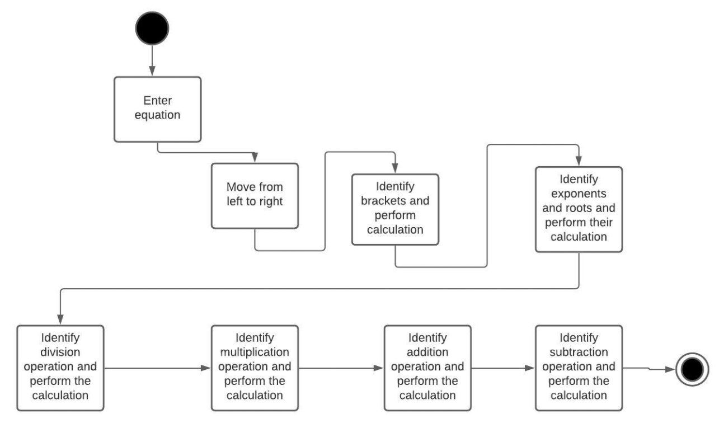
Figure4: Activity Diagram

Structural Diagram
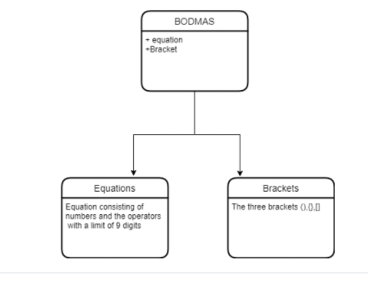
Figure5: Object Diagram

Store and Recall
Behavioral

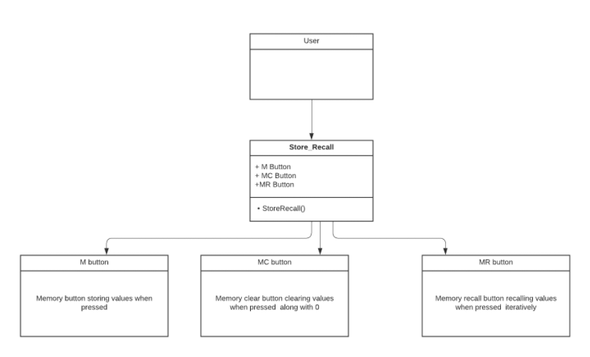

Figure6: Activity Diagram
Structural
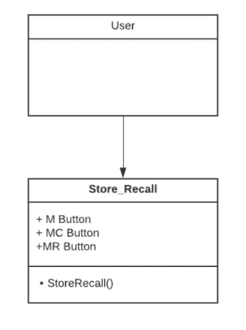
Figure7: Class Diagram

Permutation and Combination
Behavioral
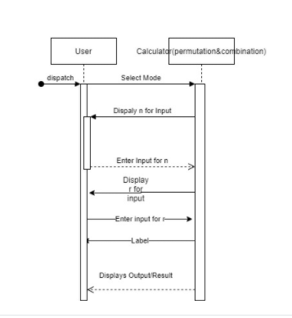

Figure8: Timing Diagram
Structural

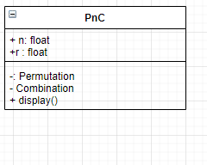
Figue9: Class diagram

Test Plans:
Precedence
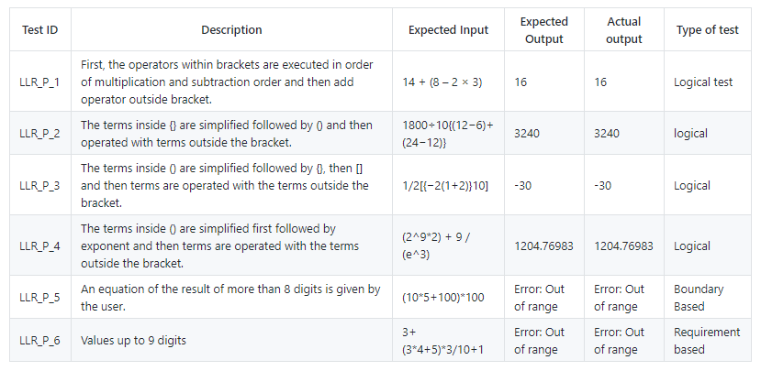
Permutation And combination
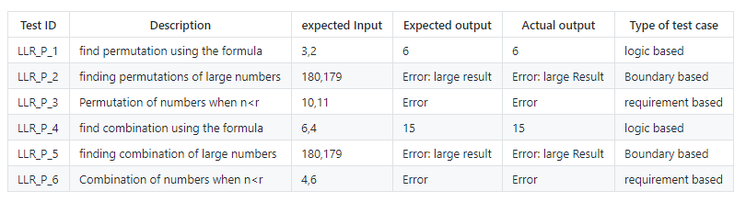
Store and recall
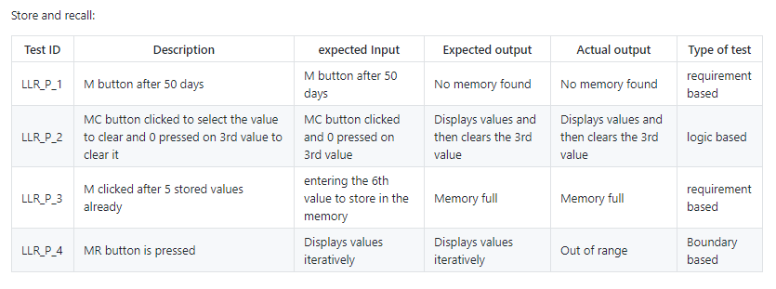
GIT Commit
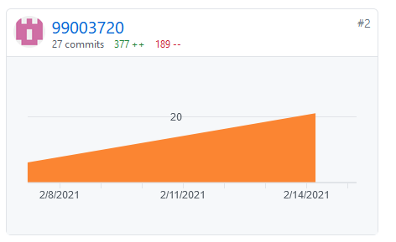
Figure
GIT Issues
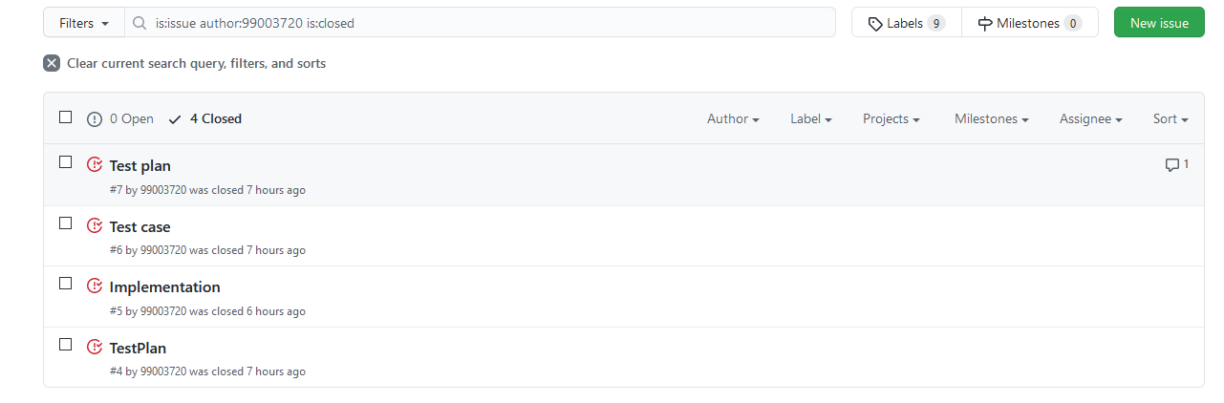

References:
https://stackedit.io/app#
https://github.com/
https://github.com/adam-p/markdown-here/wiki/Markdown-Cheatsheet
https://guides.github.com/features/mastering-markdown/
https://github.com/ejwa/gitinspector
https://docs.github.com/en/github
https://code.visualstudio.com/docs/introvideos/basics

ACTIVITY 2: AGILE METHODOLOGY

Theme-Calculator

The theme is designing a calculator with certain features according to the specific requirements.
The target customers for the calculator are school and college going students for semi-engineering and various other branches.

Epic

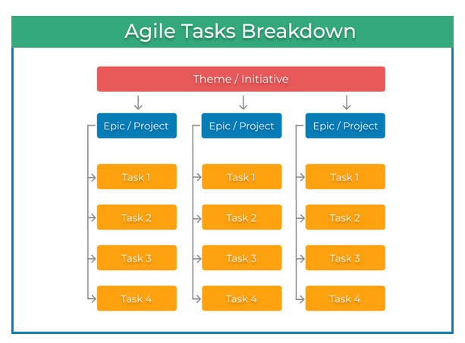

Epic according to the requirements provided are:
- Precedence
- Permutation and Combination
- Store and Recall

User Story

Precedence:
- Following the BODMAS rule.
- Taking in consideration the 3 types of brackets.
- Answer in less than 8 digits
- Less than 8-digit input

Permutation and Combination

- Ensuring n>r
- Output should be less than 8 digits
- N and r should not be large numbers

Store and Recall

- Memory is stored for up to 50 days
- Pressing MC and 0 clears the value
- Memory stores up to 5 values
- MR recalls the value
- M button stores the values

References

- https://kanbanize.com/agile/project-management/tasks-epics-initiatives-themes
- https://geekbot.com/blog/epics-stories-themes-tasks/
- https://www.atlassian.com/agile/project-management/epics-stories-themes

