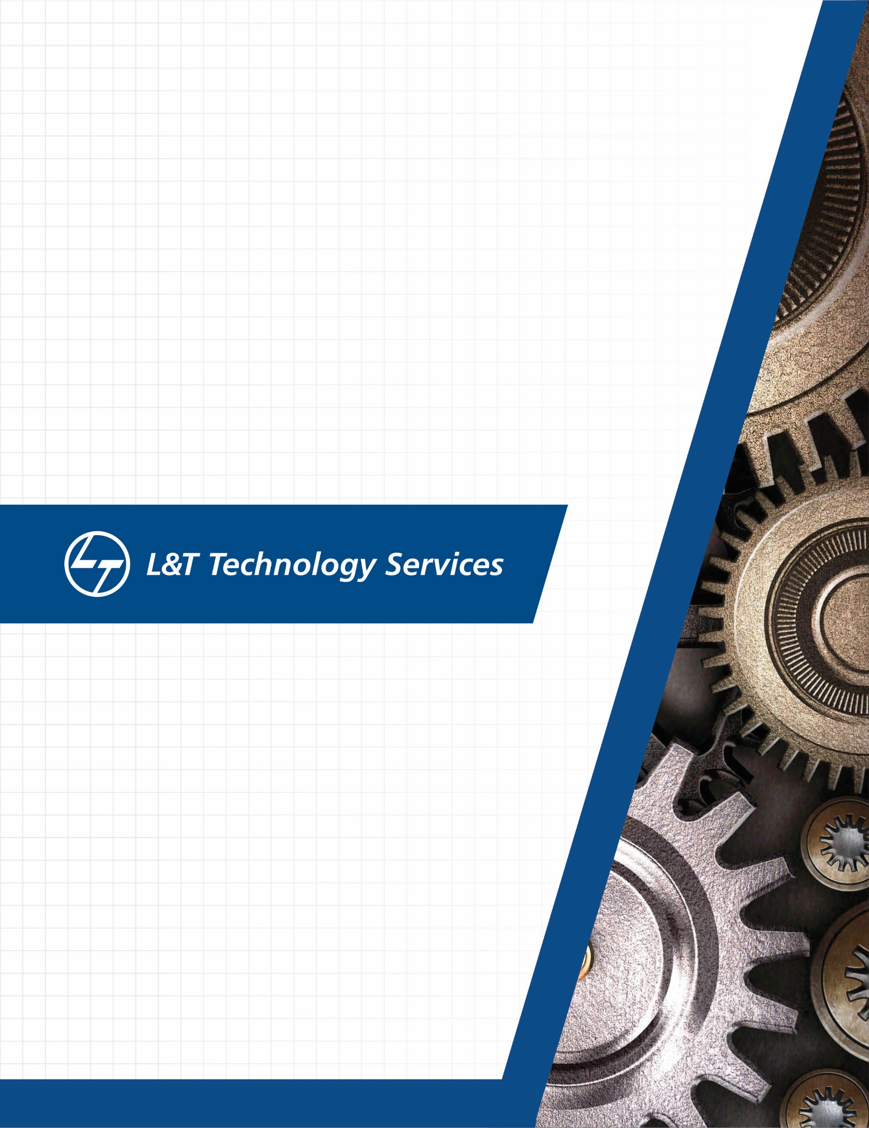
./
Learning Report – Networking


Ver. Rel. No. | Release Date | Prepared. By | Reviewed By | To be approved By | Remarks/Revision Details
1 |  | Name/PS No | Name/PS No | Module Owner Name | Comments
2 | 25/03/21 | Jasleen Kaur Sethi/99003720
3
Document History

Table of Contents
Table of Figures 3
Table of Tables 4
ACTIVITY 1: SYSTEM/ SOFTWARE DEVELOPMENT 4
INTRODUCTION 4
MY PRODUCT: “Name ” 6
SWOT ANALYSIS 7
REQUIREMENTS 7
DESIGN 8
HIGH LEVEL DESIGN 8
LOW LEVEL DESIGN 11
TEST PLANS 13
REFERENCES 15
ACTIVITY 2: AGILE METHODOLOGY 15
THEME 15
EPIC 15
USER STORY 16
REFERENCES 17
APPENDIX: 17

Table of Figures
Figure 1 CLASS DIAGRAM(HIGH LEVEL) 10
Figure 2 USE CASE DIAGRAM (HIGH LEVEL) 11
Figure 3 ACTIVITY DIAGRAM (HIGH LEVEL) 12
Figure 4 USE CASE DIAGRAM (LOW LEVEL) 12
Figure 5 ACTVITY DIAGRAM (LOW LEVEL) 13
Figure 6 BLOCK DIAGRAM 13
Figure 7 COMPONENT DIAGRAM (HIGH LEVEL) 22
Figure 8 ACTIVITY DIAGRAM (high level) 23
Figure 9 ACTIVITY DIAGRAM (LOW LEVEL) 24
Figure 10- ACTIVITY DIAGRAM (LOW LEVEL) 24
Figure 11 TEST PLAN 25
Figure 12 GIT 27
Figure 13 GIT ISSUES 28
Figure 14 GIT COMMITS 1 28
Figure 15 GIT COMMIT 2 29
Figure 16 GIT 30
Figure 17 GIT MAKE 31
Figure 18 GIT MAKE 2 31
Figure 19 GIT BUILD 32
Figure 20 GIT CODE QUALITY 32

Table of Tables
Table 1 AGING 6
Table 2 GRADING COST 6
Table 3 REQUIREMENTS 8
Table 4 HIGH LEVEL TEST PLAN 15
Table 5 LOW LEVEL TEST PLAN 16
Table 6 USER STORIES 17
Table 7 AGING 19
Table 8 GRADING COST 19
Table 9 REQUIREMENTS 21
Table 10 USER STORIES 27

Data Network:

A network refers to a communication between two or more interfaces and transfer of information through it. The information can be voice or data.
Data network is the transfer from one or more network access points. It helps in sharing of information between individuals and organizations to several nodes simultaneously, and point-to-point networks, in which each sender communicates with one receiver.

Wireline vs Wireless network:

Wireline | Wireless
Uses cables, or data lines, for communication | Allows devices to stay connected to the network
Device is tethered to a router | Roaming untethered to any wires
require additional wiring for expansion of network | easily expand wireless networks with existing equipment
Used to connect few numbers of desktop or laptop computers | Used for wireless networking such as in satellites, TV Remotes GSM and other cellular technologies.

Communication networks:
Communication of networking can be done in the following types:

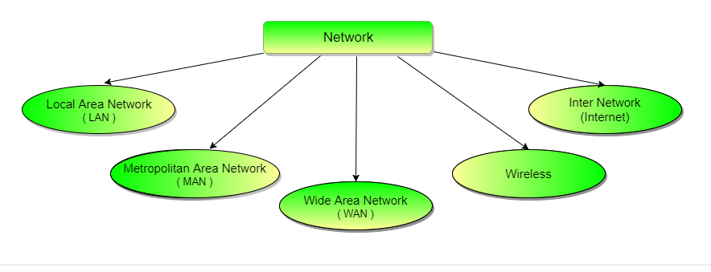

LAN

Local Area Network consists of group of computers and associated devices that share a common communications line or wireless link. Typically, connected devices share the resources of a single processor or server within a small geographic area.
LAN can be used to share resources like printers or faxes in the same geographical area.
LAN must have three elements:

- Hardware components
Some of basic hardware components of LAN’s are Hub, switch, station, power supply, access point, connector and peripheral devices.

- Software components
Software is needed for devices to function cooperatively and effectively on the LAN such as the operating system and the server on the operator system.

- Users creating and managing files
Makes use of the network resources and maintains the LAN

WAN

Wide area network is a network communication that facilitates communication with multiple devices around the world through WAN provider. This technology is used in businesses, schools and government. The communication can happen through any location provided they have access via different links such as Virtual Private Network, wireless or cellular network.

MAN
Metropolitan area Network is a computer network connecting computers within a metropolitan area. Its range is more than a LAN but lesser than WAN. These are more efficient than WANs since the data does not travel through large distances.
Most MANs user fiber optic cables for connections between LANs. Devices used for transmission of data through MAN are: Modem and Wire/Cable.

WiFi

Wireless Fidelity or Wifi is a communication network where we can access network or connect with other computers or mobile using a wireless medium. The WiFi works using Physical and data link layers of the OSI model. The data is Wifi is transferred over radio frequencies in a circular range.
The communication is established from the access point to the client within a specific range depending on the router with which radio frequency through WiFi is provided. These frequencies operate on 2 types of bandwidth at present, 2.4 GHz and 5 GHz. 2.4 GHz is the default bandwidth supported by all the devices.

WiMax

IEEE 802.16 and ETSI HIPERMAN standards.

WiMax, an acronym for Worldwide Interoperability for Microwave Access is a standardized wireless version of Ethernet, an alternative to wire technologies such as modems or DSL links for providing broadband access certifying compatibility and interoperability. It is based on wireless MAN technology.
It is similar to WiFi but with higher speed, great distances and more number of users.
It is used in areas which undergo physical limitations to construct a network infrastructure.
WiMax supports voice, video and internet data.It is deployed in variety of spectrum bands: 2.3GHz, 2.5GHz, 3.5GHz, and 5.8GHz. It supports high bandwidth large spectrum deployments that are greater than 10 MHz.
WiMAX can provide wide area coverage and quality of service capabilities for applications from VoIP to real time and non real time streaming videos.

Devices for networking:

Hub:

A hub is a networking device in the physical layer of the OSI model. It is connected to multiple devices in a network. It has many ports on which multiple computers can be connected. When the data is present, the hub sends data across to all the ports irrespective of the destination required for sending the data. It is primarily used for broadcasting messages. It’s transmission mode is half duplex. It does not have a software associated with it. They generally have fewer ports of 4/12.
Switch:
A switch is a networking device in the Datalink layer of the OSI model. It uses packet switching to send and receive data over the network.
A switch has many ports. When the data is transmitted, the switch examines its destination address and sends the data frame to the corresponding destination. It thus supports unicast, multicast and broadcast communications. It’s transmission mode is full duplex. They are active devices, equipped with network software. The number of ports is higher – 24/48.
Router:
A switch is a networking device part of the network layer of the OSI model. It is responsible for receiving, analyzing, and forwarding data packets among the connected computer networks. When the data packets are transmitted, the router inspects the destination address, iterates through the routing tables and thus transfer packets to the smallest route to transfer the data packet. It is used in both LANs and WANs. The data in a router is transferred in the form of IP packets. It sends data to the IP address of the destination with reference to the routing table which stores the routes for sending the data.
A routing table typically contains the following entities −
- IP addresses and subnet mask of the nodes in the network
- IP addresses of the routers in the network
- Interface information among the network devices and channels
Router are manufactured by companies like Cisco, D-Link, HP and Juniper.
Repeaters:
Repeater operates at the physical layer. It regenerates the signal over the network before it becomes weak or corrupted thus extending the length of the network.
Bridges:
A bridge operates at data link layer. It connects two or more LANs with similar protocol and provide communication between the devices. It thus helps in multiplying the network capacity of a single LAN. On receiving a data frame, the bridge consults a database to decide whether to pass, transmit or discard the frame.
Bridges looks at the MAC address for switching, thus No major hardware, software or architectural changes should be required for their installation.
Gateways:
Gateways is a passage between two networks that are operating with different transmission protocols. all traffic that flows across the networks except the internal traffic of the nodes of a LAN should pass through a gateway. Gateways can act in any layer of the OSI model.
Access Point:
Wireless Access point is a hardware networking device that part of the physical layer of the OSI model. It allows other wifi devices to connect to the wired network. It may have a wired connection to the router or integrated in the router itself. It determines if the dataframe is from the same or connected network and thus passes or forward the frame to the particular network.
An AP is connected to a wired LAN and thus provides seamless wireless communication through the LAN technology. Thus multiple wireless devices are supported with one single connection.
Connector:
Connectors generally used as physical networking devices are RJ45 connectors. A registered jack (RJ) is a standardized physical network interface that connects telecommunications or data equipments. These are twisted pair 8-position, 8-contact modular plug connectors. 8P8C refers to the total array of pins. Each plug has eight positions that are spaced approximately 1 mm apart. Individual wires are then inserted into these 8 positions.
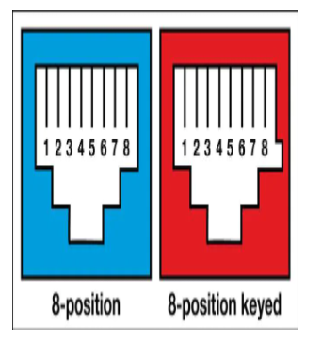
Server:
Servers are computers that transfer the resources data, services, or programs to other computers, known as clients, over a network. There are different types of servers such as web servers, mail servers, and virtual servers.
OSI Layer
The OSI Model, acronym for Open Systems Interconnection Model) is a conceptual framework that is used to describe the functions performed by the networking system. was developed by the International Organization for Standardization (ISO) in 1984, and it is now considered as an architectural model for the inter-computer communications. It characterizes certain rules and requirements to support interoperability between different nodes and software. It thus describes how the information from a software application moves via a physical medium to a software application of another computer.
The OSI Model consists of 7 layers that are assigned different levels of tasks to communicate between two or more computers. The task assigned to each layer can be performed independently.
The OSI layer is divided into two layers:
- Upper Layer
- Lower Layer
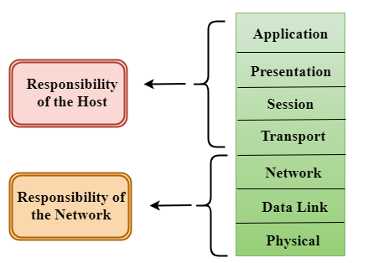
https://www.javatpoint.com/osi-model
The lower layer of the OSI model deals with the data transport issues implemented in hardware and software while the upper layer of the OSI model mainly deals with the application related issues, and they are implemented only in the software.
Physical Layer:
Physical layer is responsible for the transmission - establishing, maintaining and deactivating of the data packets from one node to another. It also defines how the network devices are arranged. And the type of signal to the generated to transit information. The hardware components like switches, Access points are a part of the physical layer.
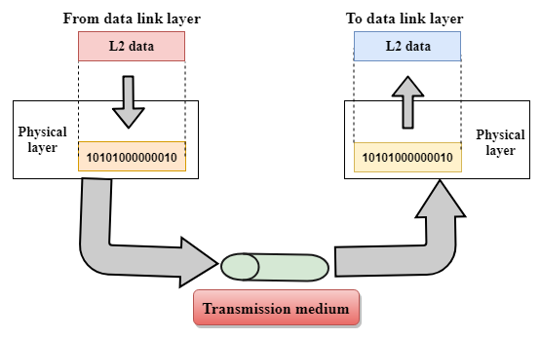
Data-Link Layer
The data-link layer is responsible for ensuring error free transfer of the data frames and thus provides reliable and efficient communication between two or more devices. It provided an unique identity to each devide residing on a local network.
It has two sub Layers:
Media Access Control Layer
This layer is in between LLC and Network’s physical layer used for transferring packets over network.
Logical Link Control Layer
LLC layer identifies the address of the network layer from header and transfers the data packets to the receiver of the network layer. It provides the flow control in the L3 layer.
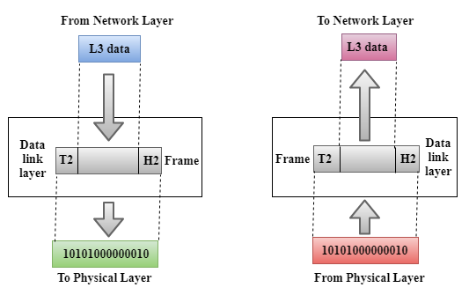
Functions:
The L2 layer translates the physical's raw bits into packets known as Frames. It adds a header and trailer to the data packet which has the information about the destination of the packet.
It maintains the flow control by ensuring that the server high processing speed matches the receiving speed of the receiving station preventing data corruption.
Error control is achieved by calculating CRC (Cyclic Redundancy Check) and adding to the message frame thus leading to retransmission of the corrupted frames.
It controls what device will have the link accessible at a particular time.
Network Layer
Layer 3 is responsible for the management of device addressing of the data on the network. It tells about the best path to transfer data in the given network conditions. It helps in providing the routing devices within an internetwork.
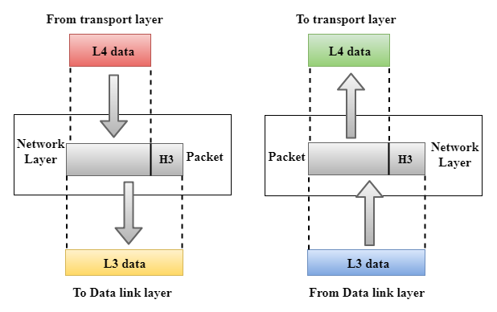
Functions:
To provide logical connections between different devices in the given internetwork.
Adding the source and destination address to the header of the frame for identifying device on the internet.
It receives the packets from the upper layer and converts them into packets. This process is known as Packetizing. It is achieved by the internet protocol (IP).
Transport Layer:
Layer 4 is responsible for ensuring that the data packets transmitted are transferred completely and there is no duplication of data. After receiving data from the upper layer, it converts them into smaller units known as segments. It provides point-to-point connection between source and destination for reliable communication.
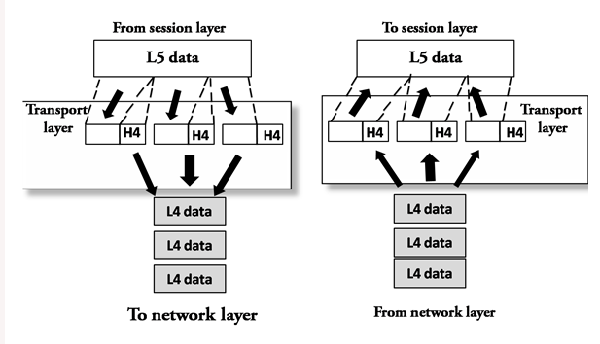
Functions:
The transmission of the data from source to the destination from one computer to another is done by adding the header that contains the address as a service-point address or port address.
After receiving the message, it divides the message into multiple segments. Each segment is assigned with a sequence number uniquely identifying it. After the data packet is received, the layer reassembles it on the basis of sequence numbers. A connection-oriented service makes a connection with the transport layer at the destination machine before delivering the packets.
The two protocols used in this layer are:
- Transmission Control Protocol
  - It is a standard protocol that allows the systems to communicate over the internet.
  - It establishes and maintains a connection between hosts.
  - When data is sent over the TCP connection, then the TCP protocol divides the data into smaller units known as segments. Each segment travels over the internet using multiple routes, and they arrive in different orders at the destination. The transmission control protocol reorders the packets in the correct order at the receiving end.
- User Datagram Protocol
  - User Datagram Protocol is a transport layer protocol.
  - It is an unreliable transport protocol as in this case receiver does not send any acknowledgment when the packet is received, the sender does not wait for any acknowledgment. Therefore, this makes a protocol unreliable.
Session Layer:
This layer is used for establishing maintaining and synchronization the intraction between the communicating devices.
It allows communication between two processes which can be either half-duplex or full-duplex.
When the data is transmitted, the session layer adds some checkpoints. In case of any error while transmission, it will take place again from the checkpoint known as Synchronization and recovery.
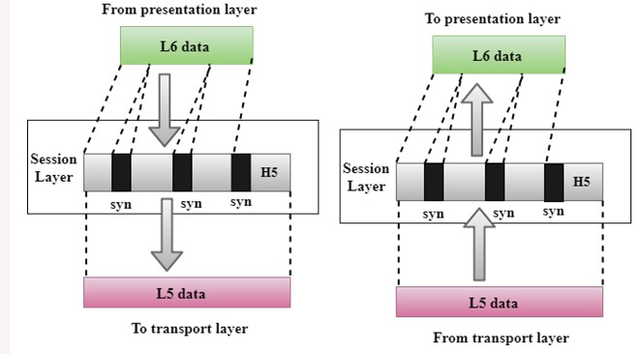
Presentation Layer:
This layer is concerned with the a syntax and semantics of the information exchanged between the two systems.It is a part of the operating system that converts the data from one presentation format to another format.
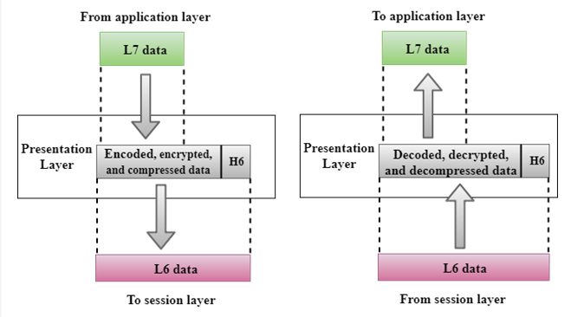
Functions:
Different processes exchange information using different encoding methods. The layer handles the interoperability between these computers and translate it to a common format and then to the receiver-dependent format at the receiving end.
Encryption of the transmitted data in order to maintain privacy.
Data compression of the data is done by this layer.
Application Layer:
Application layer serves as a window for the user and application process to access the network service.
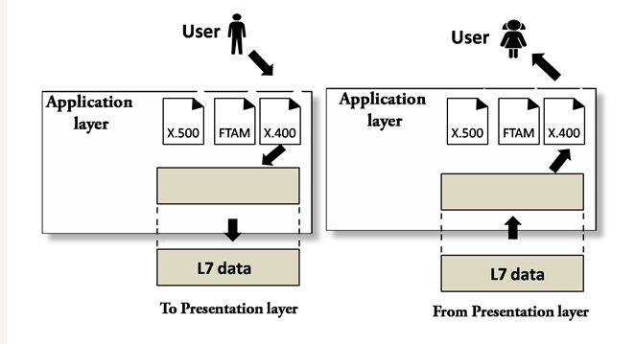
Functions:
It allows user to access data in their remote computers and manage them by it.
It also provides distributed database sources and provide information about the various entities.
TCP/IP Protocol
TCP
The Transmission Control Protocol (TCP) is a communications standard protocol which enables the devices and applications to exchange data packets over a network. It is designed to send packets across the internet and ensure that the correct data is transmitted successfully over networks.
The TCP transmits data between a server and a client. TCP establishes a connection between a source and its destination before transmission of data.
TCP transmits data from high level protocols like File Transfer Protocol (FTP), Secure Shell (SSH), and Telnet.
IP
IP is the most common protocol that is a method for sending data from one device to another across the internet. It identifies the IP address of each device and enables it communicate with and exchange data with other devices connected to the internet.
TCP and IP work together for transmitting the data to its destination. IP obtains and identifies the address. TCP is then responsible for transporting data and ensuring it gets delivered to the destination application.
The TCP/IP model breaks messages into packets for avoiding resending of messages and sends them on to other devices on the network, such as routers, security gateways, and switches. Packets are reassembled once they reach their destination. Each packet takes the best route as per availability.
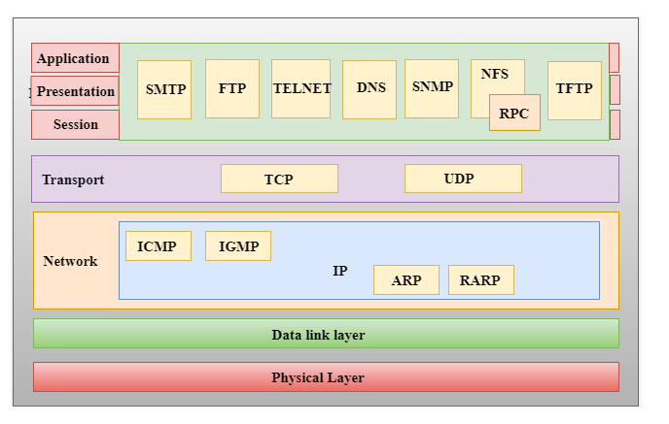
TCP/IP divides communication tasks into 4 layers:
Network Access Layer:
The network layer is the combination of the Physical layer and Data Link layer of the OSI model. It determines how the data is sent physically through the network. It is responsible for the transmission of the data between two devices on the same network. This layer encapsulates the IP datagram into frames that is transmitted by the network and IP addresses are mapped into physical addresses.
- The protocols used by this layer are ethernet, token ring, FDDI, X.25, frame relay.
Internet Layer
This layer is responsible to send the packets from any network. They must arrive at the destination required irrespective of the route they take.
Protocols used –
IP Protocol is responsible for:
IP addressing: It implements IP addresses which are used by the internet to identify a particular device and provide internetwork routing.
Host-to-host communication: Determines the through which data is transmitted.
Encapsulation and Formatting: The data transmitted by the Transport layer is accepted by the protocol and ensures that it is sent and received securely. It also encapsulates the data into message known as IP datagram.
Fragmentation and Reassembly: There is a limit on the size of the IP datagram by data link layer protocol called as Maximum Transmission unit (MTU). If the size is of the IP datagram is greater than the MTU, the IP protocol splits the datagram into smaller units so that they can travel over the local network. Fragmentation is done by the sender or intermediate router and all the fragments are reassembled to form an original data packet.
Routing: When the source and destination of the data are present in distant network, the IP datagram is routed through various devices through the protocol.
ARP Protocol
Address Resolution Protocol is a network layer protocol which is used to find the physical address from the IP address. When the sender wants the physical address, it broadcasts the ARP request to the network and every device then accepts the ARP request and the required client recognizes the IP address and sends back its physical address as ARP reply. The recipient adds the physical address both to its cache memory and to the datagram header.
ICMP Protocol
Internet Control Message Protocol is used by the hosts or routers to send notifications regarding datagram problems back to the sender. If a router is unable to route the data because of some unusual conditions such as disabled links or network congestion, this protocol is used to inform the sender.
- ICMP Test: ICMP Test is used to test whether the destination is reachable or not.
- ICMP Reply: ICMP Reply is used to check whether the destination device is responding or not.
Transport Layer
This layer is responsible for the correction of data, flow control and reliability of the data sent through the network.
Protocol used: *TCP, IP, UDP
User Datagram Protocol (UDP)
UDP is an unreliable and connectionless protocol. In case of errors in the data, it discovers the errors but not specify it. After it discovers the error, the ICMP protocol intimates the user about the damaged data. This protocol is more efficient in terms of both latency and bandwidth. Thus, the real time services where high speed is required, where the delayed packets are dropped instead of processing, we use UDP services.
UDP Header
TCP
Unlike UDP, TCP is a reliable protocol . As error is detected in the message, the protocol retransmits the damaged frames and gives an acknowledgement as soon as the data is received.
Application Layer
This layer is responsible for handling high-level protocols, issues of representation and communicating and interacting with the user or application.
When the application layer wants to communicate with another application layer, it forwards its data to the transport layer.
Protocols used:
- HTTP: Hypertext transfer protocol is a protocol that allows us to access the data over the world wide web. It transfers the data in the form of plain text, audio, video. The documents that are scrolled through are in the form of rapid jumps as in hypertext.
- SNMP: SNMP stands for Simple Network Management Protocol. It is a framework used for managing the devices on the internet by using the TCP/IP protocol suite.
- SMTP: SMTP stands for Simple mail transfer protocol. It is supported by the TCP/IP protocol.
- DNS: DNS stands for Domain Name System. People prefer to use the names instead of IP addresses. Therefore, the system that maps the name to the address which is known as Domain Name System.
- TELNET: Terminal Network establishes the connection between the local computer and remote computer in a way that the local terminal appears to be a terminal at the remote system.
- FTP: File Transfer Protocol is a standard internet protocol used for transmitting the files from one to another computer.
L2 and L3 Protocols:
L2 Protocols:

