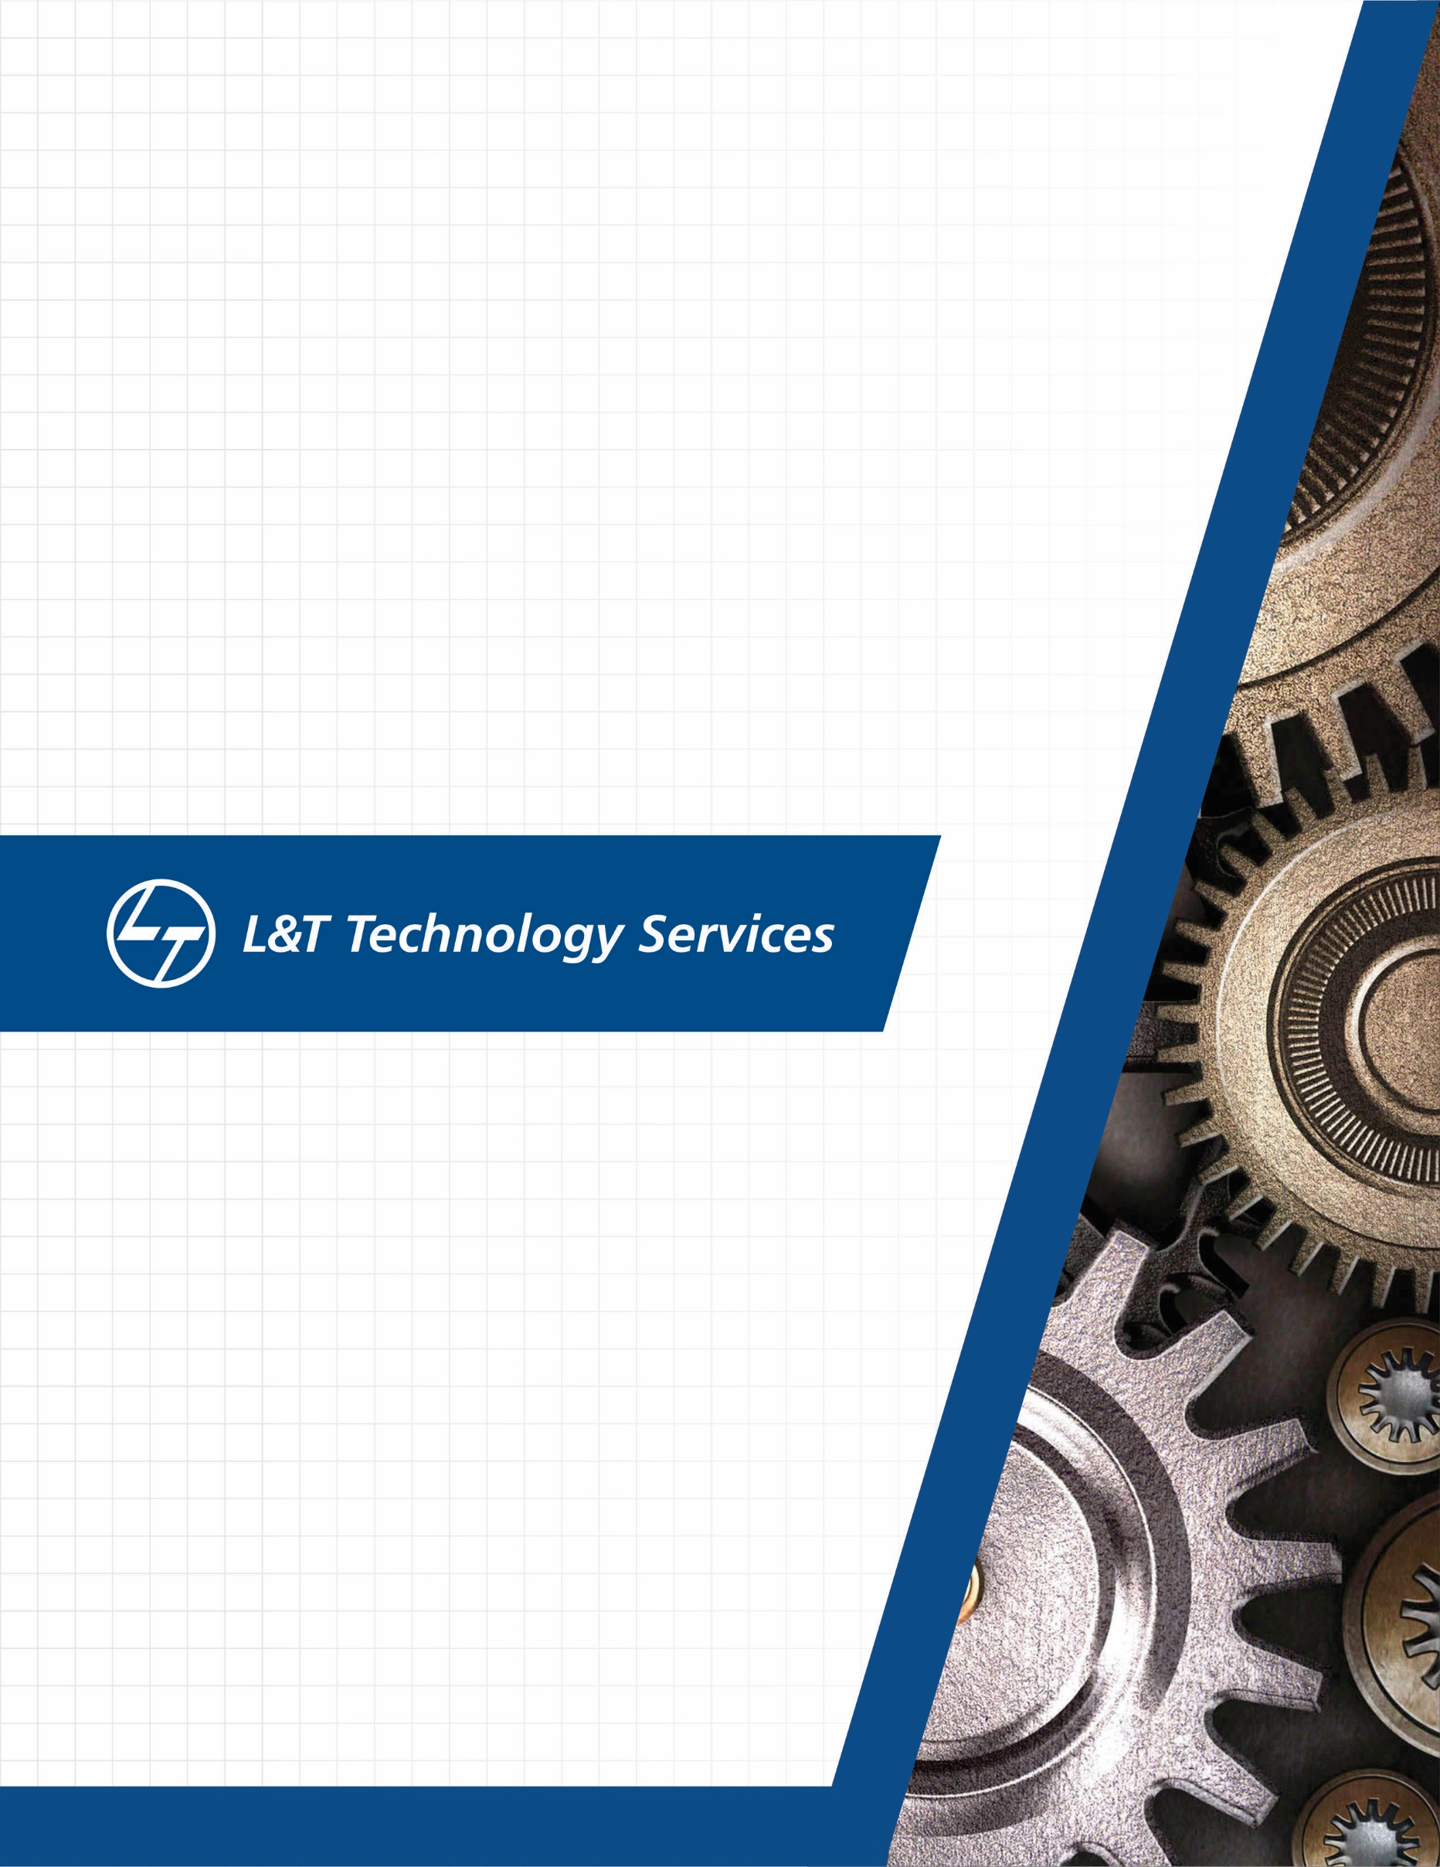
./
Learning Report – Embedded Linux


Ver. Rel. No. | Release Date | Prepared. By | Reviewed By | To be approved By | Remarks/Revision Details
 |  | Name/PS No | Name/PS No | Module Owner Name | Comments
1 | 12/04/21 | Jasleen Kaur Sethi/99003720
Document History

Table of Contents
Table of Figures 3
1. INTRODUCTION 4
2. Linux Architecture 5
2.1 Kernel 5
2.2 Device Drivers 6
2.3 Libraries 6
2.4 Utilities 7
3. Cross Tool Chain: 7
3.1 Qemu Based Emulation 8
4. Boot Process 9
5. Device Tree Binary 10

Table of Figures
Figure 1 LINUX ARCHITECTURE 10
Figure 2 BOOTING PROCESS 11
Figure 3 FILE MANAGEMENT:BOOTING PROCESS 12
Figure 4 DEVICE TREE BINARY FILES 12

INTRODUCTION

Embedded Linux is a type of Linux operating system where the kernel is designed to be installed and used within embedded devices and appliances. It is a compact version of Linux that offers features and services in line with the operating and application requirement of the embedded system.
In this module, we work on
- Building and working on our customized kernel with the help of cross compilation
- How to make our own libraries in the kernel space
- The attributes required for the cross compilation such as its rootfs image and device tree binary file
- The booting processes
- The device tree binary file
- The various memory mapping and scheduling techniques

Linux Architecture

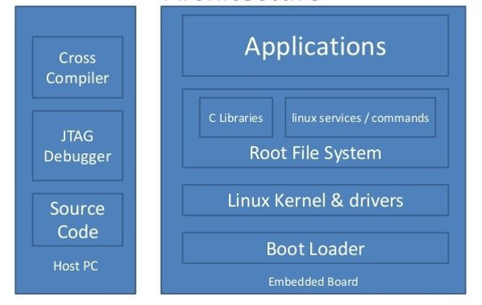
Figure 1: Linux Architecture

The Linux architecture consists of
- Kernel
- Device Drivers
- Libraries
- Utilities

These help in forming a software interface to an input/output.

2.1 Kernel

Linux kernel is the core part of the operating system. It establishes communication between devices and software. Moreover, it manages system resources. It has the following responsibilities:

- Manage RAM memory, so that all programs and running processes can work.
- Manage the processor time, which is used by running processes.
- Manage access and use of the different peripherals connected to the computer.

2.2 Device Drivers

Device Driver in computing refers to a special kind of software program or a specific type of software application which controls a specific hardware device that enables different hardware devices for communication with the computer’s Operating System
A device driver communicates with the computer hardware by computer subsystem or computer bus connected to the hardware.
Types of device drivers:
For almost every device associated with the computer system there exist Device Driver for the particular hardware. But it can be broadly classified into two types i.e.,
- Kernel-mode Device Driver – This Kernel-mode device driver includes some generic hardware which loads with operating System as part the OS these are BIOS, motherboard, processor and some other hardware which are part of kernel software. These includes the minimum system requirement device drivers for each operating system.
- User-mode Device Driver - Other than the devices which are brought by kernel for working of the system the user also bring some devices for use during the using of a system that devices need device drivers to functions those drivers falls under User mode device driver. For example, user needs any plug and play action that comes under this.

2.3 Libraries

A library is a collection of pre-compiled pieces of code called functions. The library contains common functions and together, they form a package called — a library.

A library is not executable and that is a key difference from processes and applications. Libraries play their role at run time or compile time.

There are 2 types of libraries:

2.3.1 Static Libraries

At compile time, static libraries stay locked into a program. It contains the file’s programs holding a copy of the library’s files at compile time.

2.3.2 Dynamic Libraries

Dynamic or shared libraries occur as separate files outside of the executable files. Thus, it only needs one copy of the library’s files at runtime.

2.4 Utilities

Utility software usually focuses on how the computer infrastructure (including the computer hardware, operating system, application software and data storage) operates. Due to this focus, utilities are often rather technical and targeted at people with an advanced level of computer knowledge - in contrast to application software, which allows users to do things like creating text documents, playing video games, listening to music or viewing websites.

Cross Tool Chain:

A toolchain is a set of distinct software development tools that are linked or chained together by specific stages such as GCC, binutils and glibc (a portion of the GNU Toolchain). A toolchain may contain other tools such as a debugger or a compiler for a specific programming language, such as C, C++. The toolchain used for embedded development is a cross toolchain, or more commonly known as a cross compiler. All the programs (like GCC) run on a host system of a specific architecture (such as x86), but they produce binary code (executables) to run on a different architecture (for example, ARM). This is called cross compilation and is the typical way of building embedded software. It is possible to compile natively, running GCC on your target.
We use Qemu as our target for emulation for cross compilation.

3.1 Qemu Based Emulation

QEMU is a hosted virtual machine monitor, it emulates the machine's processor through dynamic binary translation and provides a set of different hardware and device models for the machine, enabling it to run a variety of quest operating systems QEMU can also do emulation for user-level processes, allowing applications compiled for one architecture to run on another.
Qemu is quick it's a hypervisor that allows you to run virtual machines with complete operating systems that operate like any other program on your desktop. This can be useful for general purpose computing and black box testing. The software is open-source and cross-platform. It targets a range of computer architectures beyond standard IBM PCs such as ARM and PowerPC. On Linux, it also has user-mode emulation where standard executables of one architecture can seamlessly run on another.

Boot Process

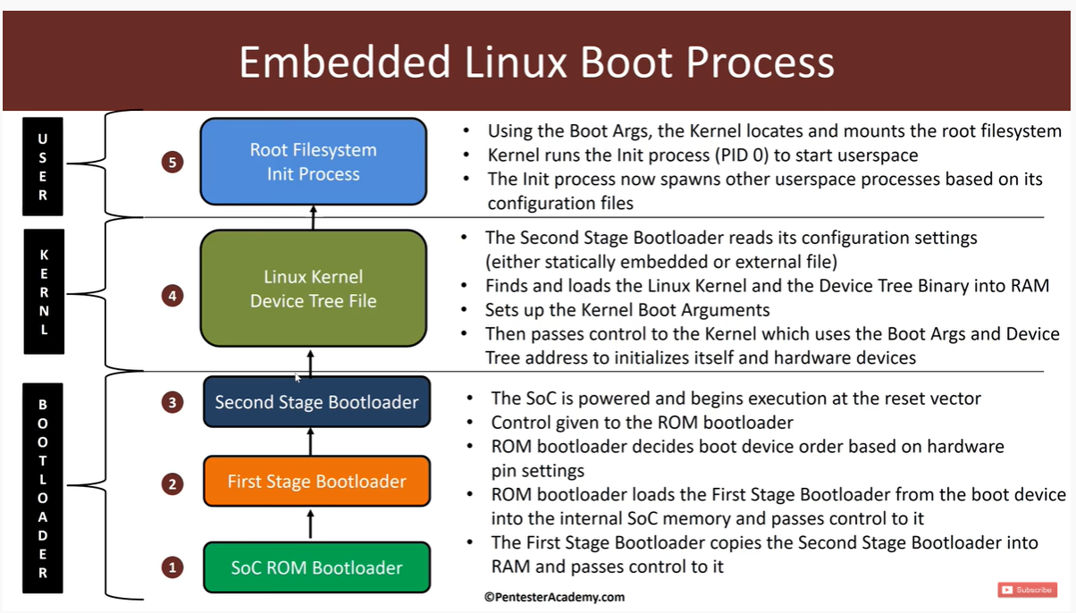
Figure 2: Booting Process

The way the different files are present in memory can be represented as follows:

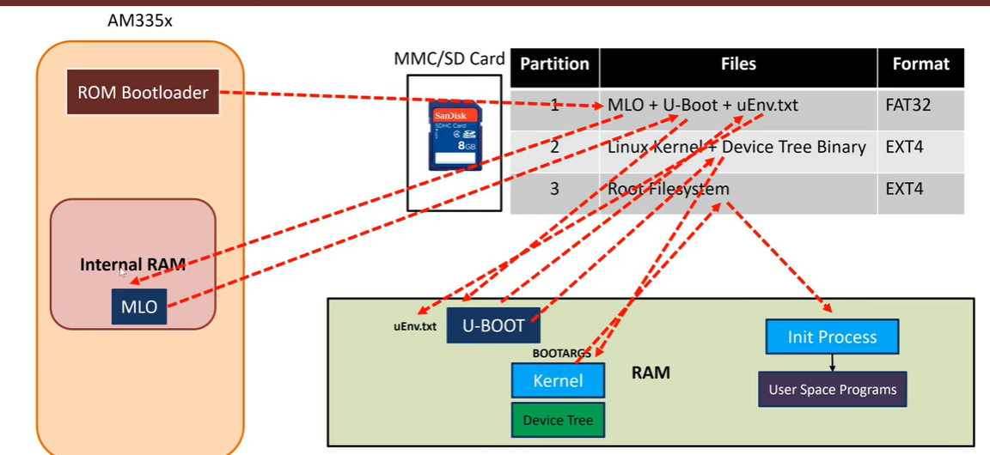
Figure 3: file management: Boot process

Device Tree Binary

- The primary purpose of Device Tree in Linux is to provide a way to describe non-discoverable hardware. This information was previously hard coded in source code.
- Device Tree data can be represented in several different formats. It is derived from the device tree format used by Open Firmware to encapsulate platform information.
- The device tree data is typically created and maintained in a human readable format in .dts source files and .dtsi source include files. The Linux build system pre-processes the source with cpp.
- The device tree source is compiled into a binary format contained in a .dtb blob file. The format of the data in the .dtb blob file is commonly referred to as a Flattened Device Tree (FDT).
- The Linux operating system uses the device tree data to find and register the devices in the system. The FDT is accessed in the raw form during the very early phases of boot, but is expanded into a kernel internal data structure known as the Expanded Device Tree (EDT) for more efficient access for later phases of the boot and after the system has completed booting.
- Currently the Linux kernel can read device tree information in the ARM, x86, Microblaze, PowerPC, and Sparc architectures. There is interest in extending support for device trees to other platforms, to unify the handling of platform description across kernel architectures.
It describes a machine hardware configuration. It is derived from the device tree format used by Open Firmware. The format is expressive and able to describe most board design aspects including:
- the number and type of CPUs
- base addresses and size of RAM
- busses and bridges
- peripheral device connections
- interrupt controllers and IRQ line connections
- pin multiplexing
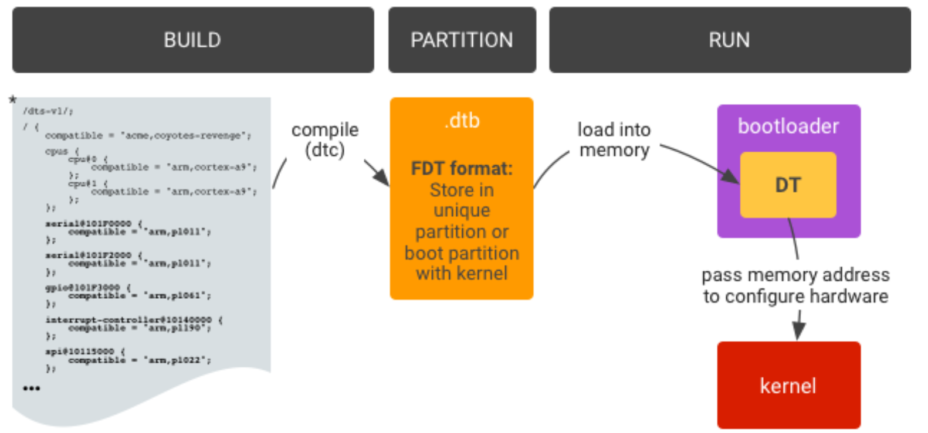
Figure 4: Device tree binary files

