Introduction:
Data Network:
A network refers to a communication between two or more interfaces and transfer of information through it. The information can be voice or data.
Data network is the transfer from one or more network access points. It helps in sharing of information between individuals and organizations to several nodes simultaneously, and point-to-point networks, in which each sender communicates with one receiver.
Transfer of data can be done in two ways
Wireline vs Wireless
Wireline | Wireless
uses cables, or data lines, for communication | allows devices to stay connected to the network roaming untethered to any wires
available anywhere, anytime
Easily compatible with other office equipment
device is tethered to a router
require additional wiring | easily expand wireless networks with existing equipment, whereas a wired network might

Communication of networking can be done in the following types:
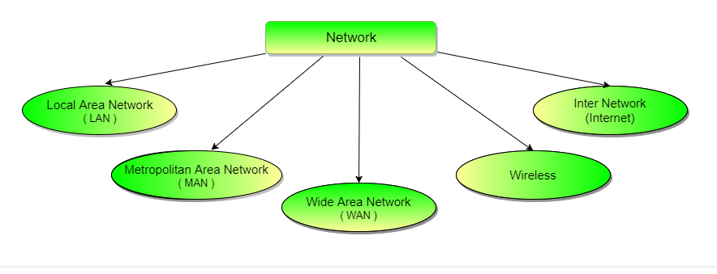
https://www.studytonight.com/computer-networks/types-of-networks
LAN
group of computers and associated devices that share a common communications line or wireless link. Typically, connected devices share the resources of a single processor or server within a small geographic area.
Devices for networking:
NIC:
It is a circuit board installed in the computer for connection to the network. It can be installed in a slot or it might be built in in the motherboard.
Server:
It is a computer that processes and delivers data to the client of other computer over a local area network
File
Print
Communication
Station:
Computer that connects to the server computer for communicating with devices connected to it.
Hub:
Access point:
Connector:
Router
Switch
Shared peripheral devices
A peripheral device is any device—such as a printer, hard disk drive, CD-ROM drive or modem—that is connected to and controlled by a computer. Any or all of these devices can be accessed by multiple users when connected to a LAN in the proper manner.
LAN can be used to share resources like printers.. in the same geographical area.
LAN must have three elements:
- Hardware components
Some of basic hardware components of LAN’s are Hub, switch, station, power supply, access point, connector and peripheral devices.
- Software components
Software is needed for devices to function cooperatively and effectively on the LAN such as the operating system and the server on the operator system.
- Users creating and managing files
who makes use of the network resources and maintains the LAN

- initial cost of installing Local Area Networks is quite high.
- Admin has access to each LAN user, thus, it does not offer good privacy.
- Unauthorized users can access critical data of an organization in case LAN admin is not able to secure centralized data repository.
- Local Area Network requires a constant LAN administration as there are issues related to software setup and hardware failures
The three major types of LAN configurations, or topologies, are the star, the bus, and the ring. You can also create hybrid topologies by combining features of these configurations.
Examples
- Ethernet LAN (Star Topology)- Connection to an ethernet switch using an ethernet (typically RJ-45) connection.
- Wifi (2.4GHz or 5 GHz) connection to a switch, clients are often also afforded LAN interaction with the ethernet switch, at least in most home router/switches. Even in business environments, the WiFi infrastructure connects into an ethernet switch used by those with ethernet cables to the same switch.
- Token Ring networks (Ring Topology) - Token because a client has to obtain the token in order to communicate with other devices, ring because, when the token is not in use, it is release to a (logically at least) ring on which the token circulates.
- FDDI (Fiber Distributed Data Interface - Ring Topology) = Uses the token ring protocol as the previous entry but connects via fiber cables rather than ethernet=like cables. Allows for a larger network of computers attached.
Ethernet is most widely used LAN Technology, which is defined under IEEE standards 802.3. The reason behind its wide usability is Ethernet is easy to understand, implement, maintain and allows low-cost network implementation. Also, Ethernet offers flexibility in terms of topologies which are allowed.
WAN

