./

Learning Report – MBSE

Course Code: <CODE>



Version Number:

Team Members :

Team No:

Module: Model Based System Engineering

|  |  |  |  |  |  |
| --- | --- | --- | --- | --- | --- |
| **Ver. Rel. No.** | **Release Date** | **Prepared. By** | **Reviewed By** | **Approved By** | **Remarks/Revision Details** |
|  | 17-03-21 | Patamsetti Sai Kalki |  |  |  |

# AC SUBSYSTEM IN AUTOMOTIVES

## INTRODUCTION

Air conditioning is the technology for indoor and automotive ambient comfort. AC facilitates in managing the pleasant climate inside the cabin by controlling the degree of coolness.

To understand this just consider the one model of car and go into how it works. I’m taking GMC sierra to explain how the AC system works.

**RESEARCH:**

### HOW THE INTERFACE WILL LOOK LIKE:

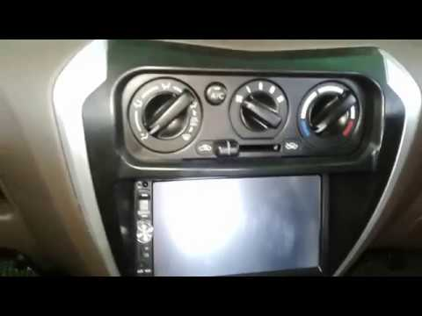

### How does it work

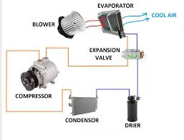

### Inputs that required

#### **Manual inputs**:

1.Ac on-off switch.

2.Temperature control knob.

3.Fan speed control.

4.Recirculation button.

5.Direction of air control.

#### **Sensors required:**

1.Temperature sensor of inside cabins.

2. Temperature sensor of inside cabins

3.Humidity sensor.

Temperature sensors used in this ac sub system are

1.LM20

Wide Temperature Range: – -40 to 125

Supply Voltage (min) v – 2.4

Supply Voltage (max) v – 5.5

Datasheet of lm20 - lm20.pdf

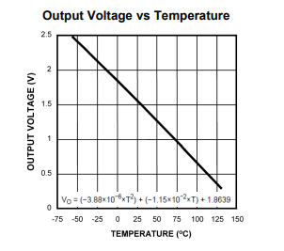

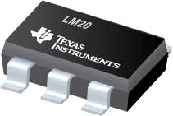

2.TMT235

Wide Temperature Range: – 40°C to +150°C

Wide operating voltage range - 2.3 V to 5.5 V

Data sheet for TMT235:tmp235.pdf

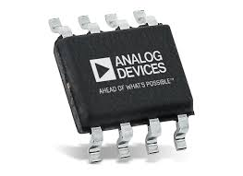

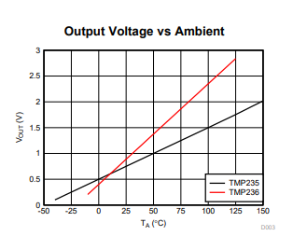

3.DHT11 sensor

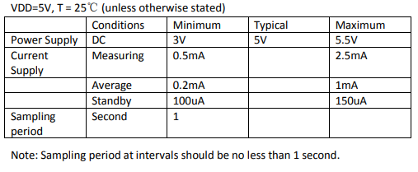

Dht11 data sheet:DHT11-Technical-Data-Sheet-Translated-Version-1143054.pdf 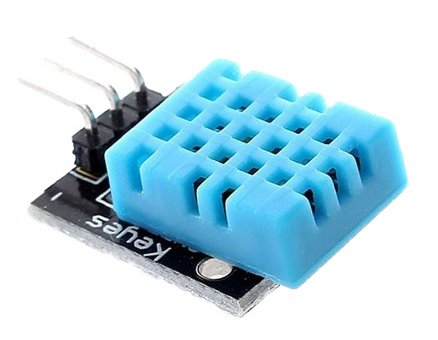

ALGORITHM

IF IGN IS ON

SWITCH AC ON AND SELECT THE FAN SPEED

true

false

AC OFF

TEMPERATURE SENSOR SENSES

HUMIDITY SENSOR SENSES HUMIDIY

Driver unit

IF (Temp and humidity)>desired level

MCU unit

Blower only will on

Direction of air flow switch and recirculation

false

Ac unit

Flaps and actuators

Outputs:

1.Temperature and humidity readings on display.

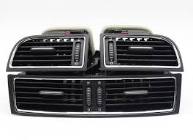 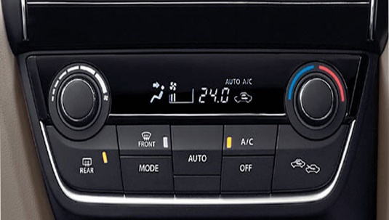

2. It makes ambient temperature control which user required.

**SWOT ANALYSIS:**

|  |  |
| --- | --- |
| Strengths:  1.provide comfortable ambient atmosphere.  2.Make user not to affect his drive to the  outside atmosphere. | Weakness:  1.Fuel consumption increases  2. |
| Opportunities:  1. | Threats:  1.pollution will increase.  2.Fuel scarcity. |

**HIGH LEVEL REQUIREMENTS:**

Main requirement is to provide comfort for the people on the vehicle cabin. This feature includes the process of controlling the temperature based on which user comfortable.

**LOW LEVEL REQUIREMENTS:**

1.what we need to do is based on the user and his comfort level or based on the exterior conditions he do on AC.

2.when AC switch is on then fan will be on and ac will be on based on the temperature that given by the user.

3.Temperature sensor senses the temperature and humidity sensor senses humidity if they are not greater than the desired level then only fan will be on and compressor will be off. If not both will on.

4. we can also control the speed of the fan also and the direction of the airflow and

recirculation of air also.

**IMPLEMENTATION**

Implementation of BCM Module using MATLAB simulink 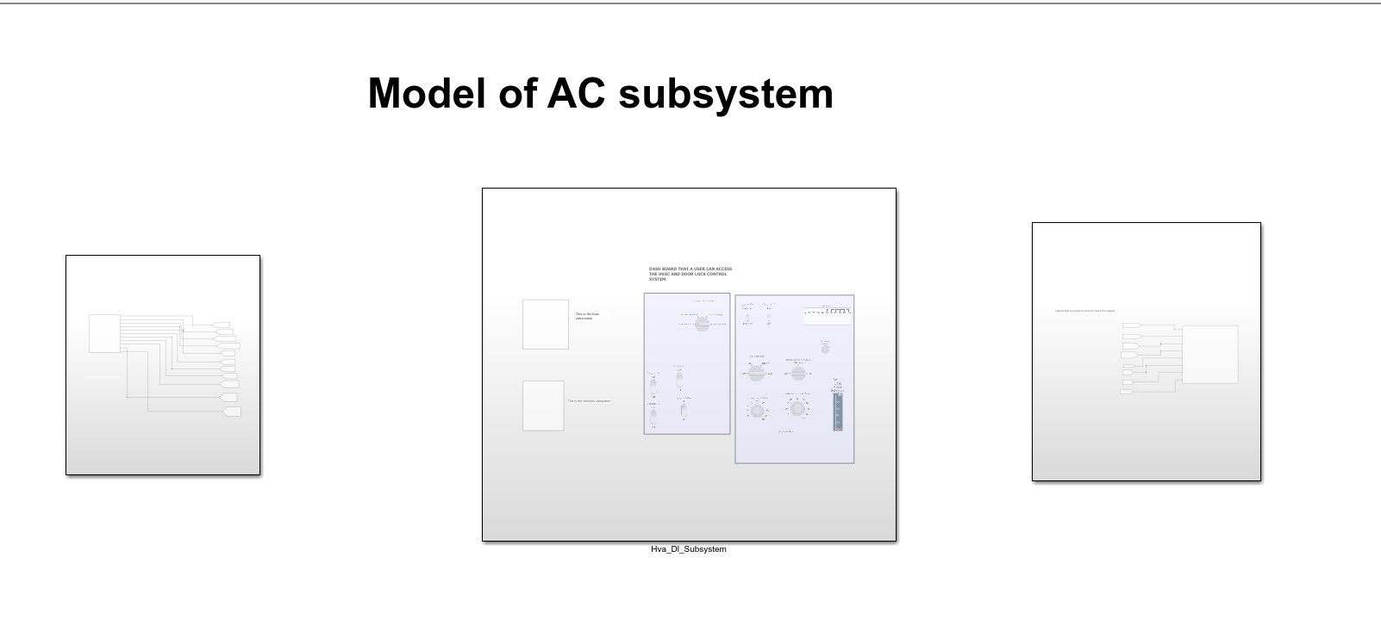

**TEST PLAN**

|  |  |  |  |
| --- | --- | --- | --- |
| Test id | Test description | expected out | actual output |
|  | to set the temperature to 20 and medium speed fan speed | 20 dig  medium |  |
|  |  |  |  |