./

Learning Report – Control System(Team4)

MOTOR CONTROL **ANALYSIS**



Version Number:

Team Members :

Team No:

Module: Model Based System Engineering

|  |  |  |  |  |  |
| --- | --- | --- | --- | --- | --- |
| **Ver. Rel. No.** | **Release Date** | **Prepared. By** | **Reviewed By** | **Approved By** | **Remarks/Revision Details** |
| 1 | 15-04-2021 | ShivaKumar Naga Vankadhara(99003727) |  | Dr.Pagala Prithvi S |  |
| 2 | 15-04-2021 | Sharath Neelappa Saunshi(99003765) |  | Dr.Pagala Prithvi S |  |
| 3 | 15-04-2021 | Darpan Patil(99003767) |  | Dr.Pagala Prithvi S |  |
| 4 | 15-04-2021 | Mohammed Ijaz(99003728) |  | Dr.Pagala Prithvi S |  |
|  |  |  |  |  |  |

**Document History**

# 

Contents

Introduction: 4

1. Brushless DC Motor with PID Controller Transfer Function: 4

1.1-Brushless DC Motor with PID Controller: 5

Pole-Zero Map and Analysis: 6

Output Graph: 7

2. Permanent Magnet Synchronous Motor with PID Controller: 7

2.1- Permanent Magnet Synchronous Motor with PID Controller Model: 8

Pole-Zero map and Analysis: 9

Output Graph: 10

3. Induction Motor with PID Controller Transfer function and Equations: 11

3.1-Induction Motor with PID Controller: 11

Pole-Zero Map and Analysis: 12

Output Graph: 13

4) PMSM Motor with PWM Controller: 14

Output Graph: 15

5.Comparison Analysis of all systems: 16

**MOTOR CONTROL ANALYSIS**

# Introduction:

Here we have taken 4 systems to analyze they are BLDC with PID controller, PMSM with PID controller, Induction motor with PID controller and PMSM with PWM controller.

# 1. Brushless DC Motor with PID Controller Transfer Function:

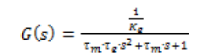

Tm=mechanical constant

Te=Electrical time constant





Kt=Torque constant

Ke=electrical torque

## 1.1-Brushless DC Motor with PID Controller:

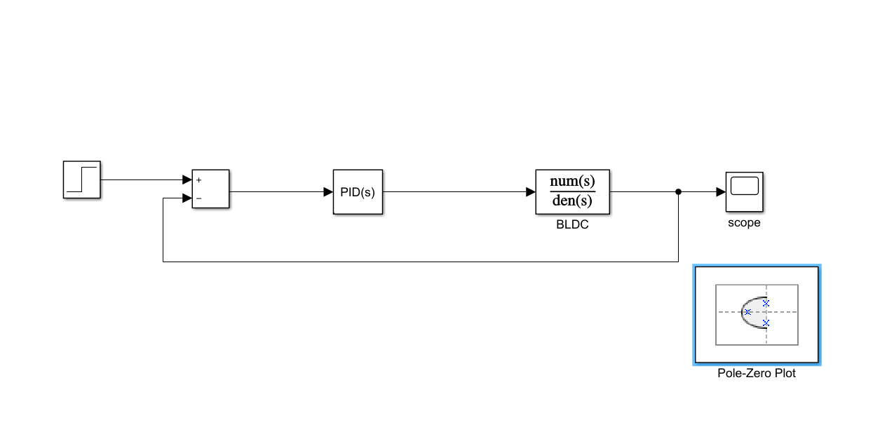

Fig1.BLDC Motor Model(Simulink)

In this system, we will be analyzing the poles and zeros of the system when the PID controller is added to the system.

* We got 1 pair of complex conjugate pole, 1 pole pair on the horizontal axis and 2 zeroes.
* We got 3 poles and 2 zeroes on the left side of the imaginary axis

So, 2 zeroes and 2 poles will nullify their effect and 1 pole will be on the left side so that we can say that system is stable.

### Pole-Zero Map and Analysis:

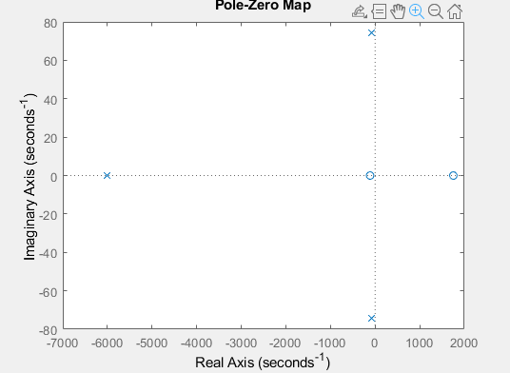

Fig2. Zero-pole plot of BLDC

Poles of BLDC system:

1.0e+03 *

-6.0172 + 0.0000i

-0.0882 + 0.0744i

-0.0882 - 0.0744i

Zeroes of BLDC system:

1.0e+03 *

1.7536

-0.1128

### Output Graph:

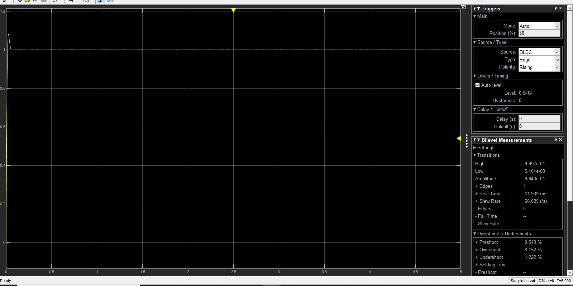

Fig3. Step Response of BLDC motor

After PID tuning we got the rise time as 11.9ms and overshoot is 8.152% as the tuning made the system parameters to adjust accordingly to get the stable system.

# 2. Permanent Magnet Synchronous Motor with PID Controller:

Transfer Function and Equation:

Equations:

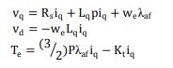

Transfer Function:



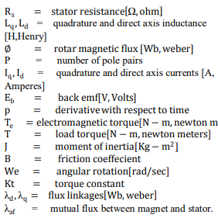

## 2.1- Permanent Magnet Synchronous Motor with PID Controller Model:

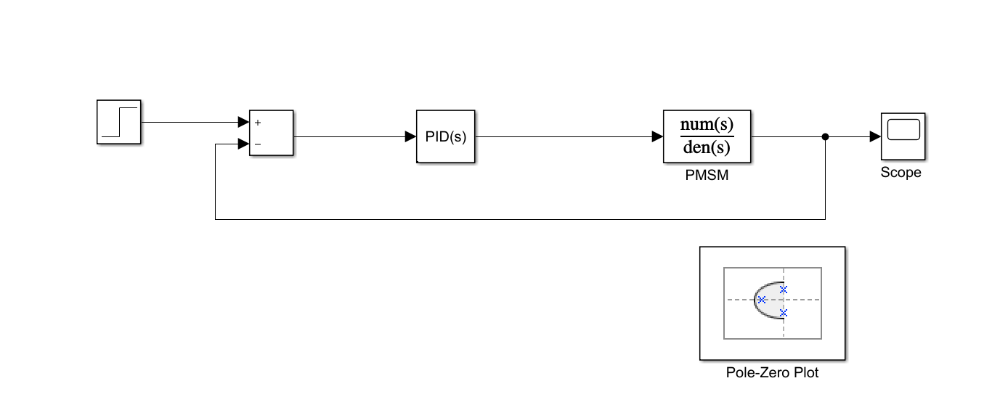

Fig4. PMSM with PID controller model

In this system, we will be analyzing the poles and zeros of the system when the PID controller is added to the system.

* We got 1 pair of complex conjugate pole, 1 pole pair on the horizontal axis and 3 zeroes.
* We got 3 poles and 2 zeroes on the left side of the imaginary axis and 1 pole and 1 zero on right side of the plane.

So, 2 zeroes and 2 poles will nullify their effect and 1 pole will be on the left side so that we can say that system is stable.

### Pole-Zero map and Analysis:

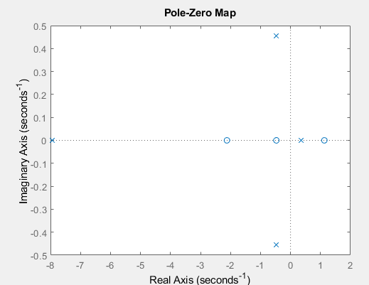

Fig5. Pole zero plot of PMSM

Poles of PMSM system:

-7.9492 + 0.0000i

-0.4733 + 0.4552i

-0.4733 - 0.4552i

0.3446 + 0.0000i

Zeroes of PMSM system:

-2.1189

1.1288

-0.4716

### Output Graph:

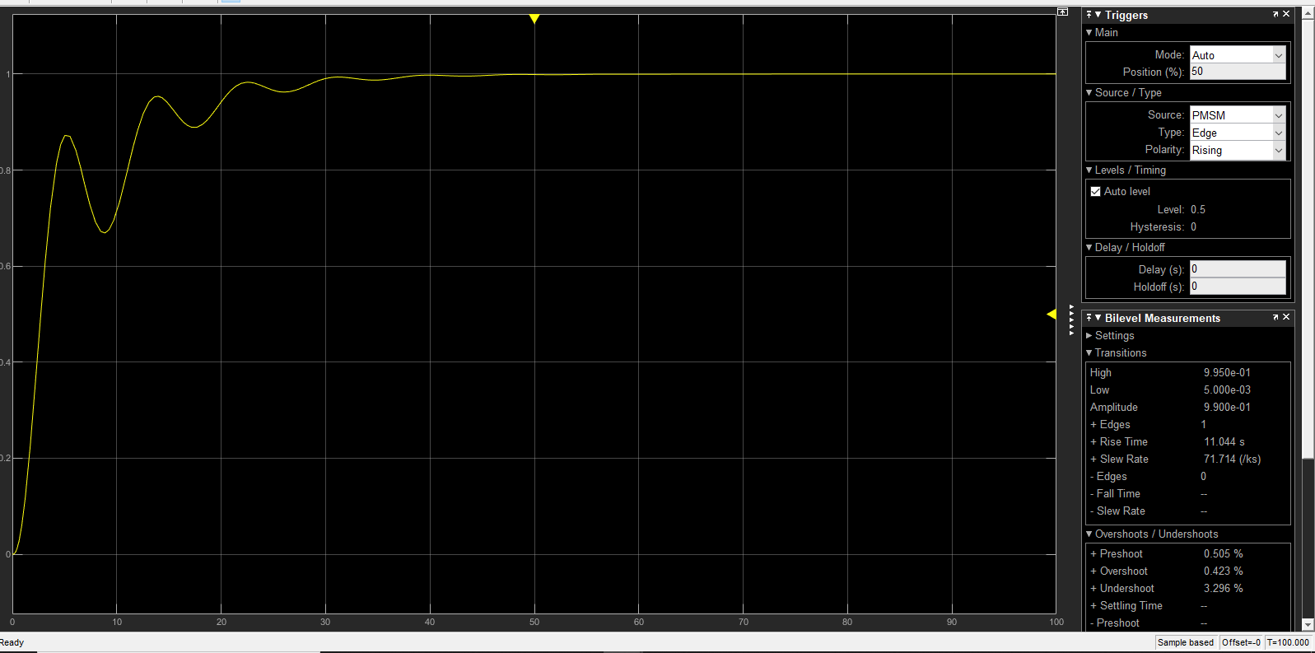

Fig6. PMSM Step Response

After PID tuning we got the rise time as 11.044ms and overshoot is 0.423% as the tuning made the system parameters to adjust accordingly to get the stable system.

# 3. Induction Motor with PID Controller Transfer function and Equations:

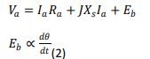

Transfer Equation:



Parameters:

 -Electrical Torque

Tm=Mechanical Torque

## 3.1-Induction Motor with PID Controller:

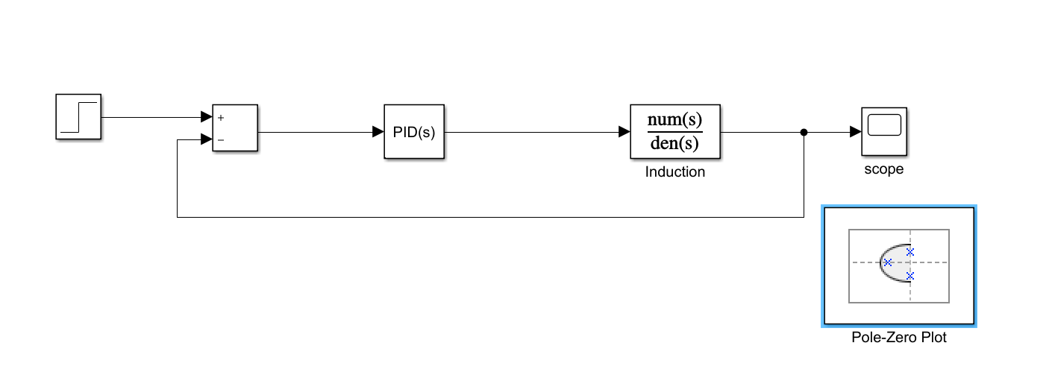

Fig7. Induction motor with PID model

In this system, we will be analyzing the poles and zeros of the system when the PID controller is added to the system.

* We got 1 pair of complex conjugate pole, 1 pole pair on the horizontal axis and 2 zeroes.
* We got 3 poles and 2 zeroes on the left side of the imaginary axis

So, 2 zeroes and 2 poles will nullify their effect and 1 pole will be on the left side so that we can say that system is stable.

### Pole-Zero Map and Analysis:

In this system, we will be analyzing the poles and zeros of the system when the PID controller is added to the system.

* We got 4 poles and 3 zeroes on the left side of the imaginary axis .

So, 3 zeroes and 3 poles will nullify their effect and 1 pole will be on the left side so that we can say that system is stable.

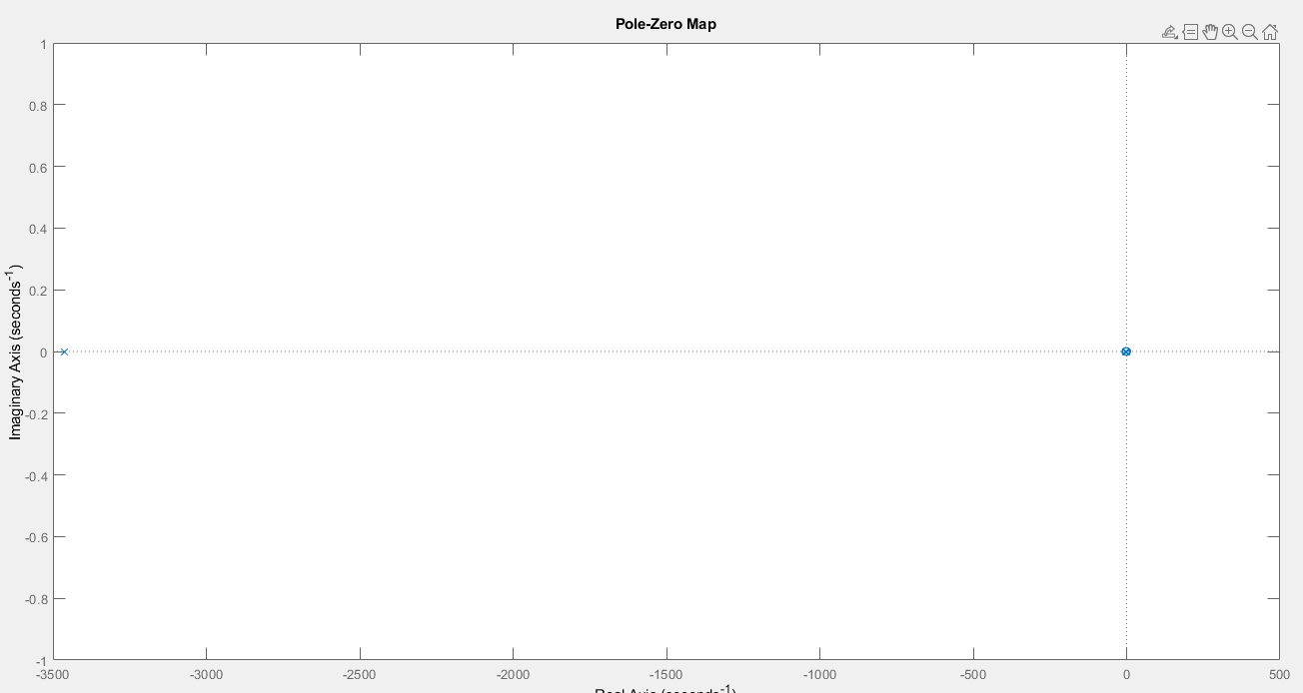

Fig8. Pole-plot of Induction motor with PID model

Poles of Induction Motor:

1.0e+03

-3.4615

-0.0023

0.0000

Zeroes of Induction Motor:

0

-2.7374

0.0118

### Output Graph:

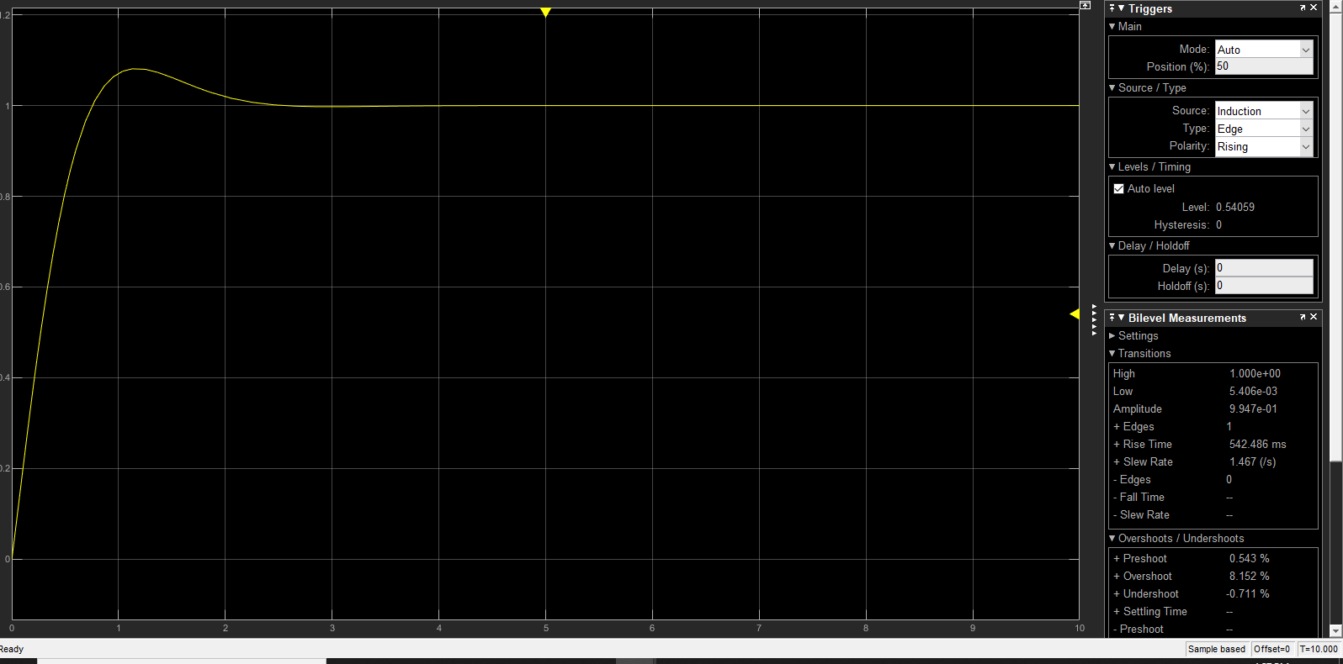

Fig9. Step Response of the PMSM after tuning

After PID tuning we got the rise time as 542.46ms and overshoot is 8.152% as the tuning made the system parameters to adjust accordingly to get the stable system.

# 4) PMSM Motor with PWM Controller:

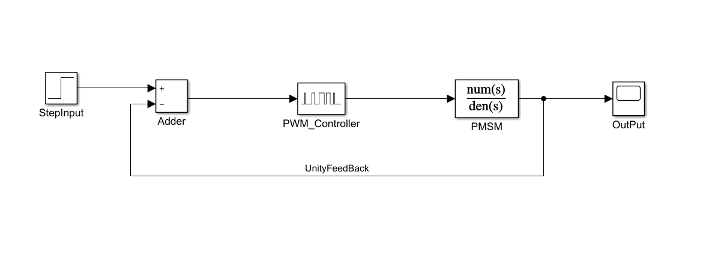

Fig10.PMSM Motor with PWM controller model

## Output Graph:

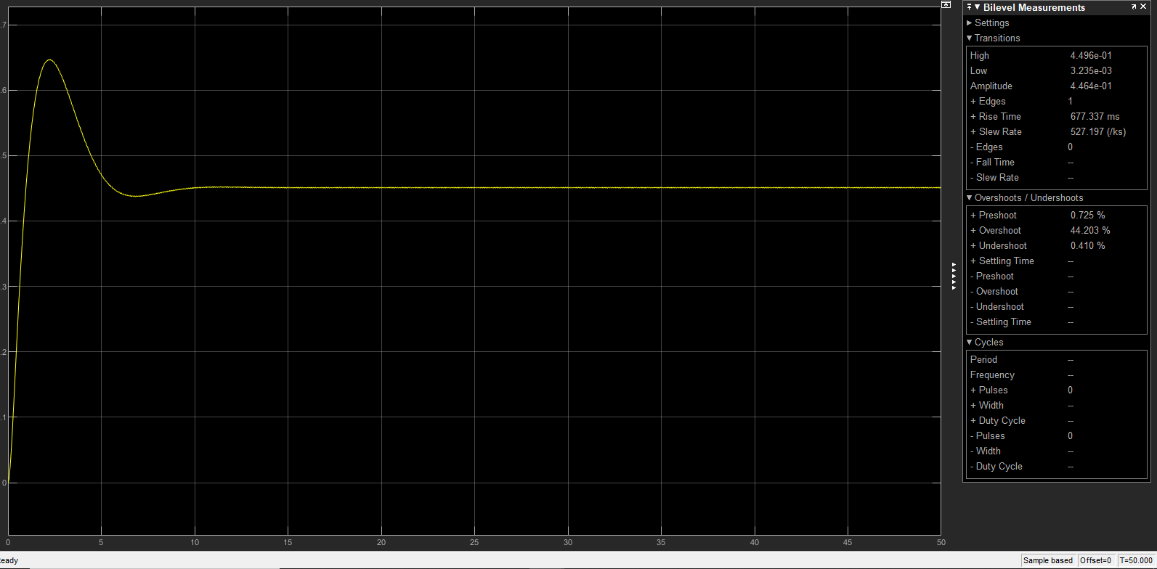

Fig11.PMSM Step Response with PWM controller

After PID tuning we got the rise time as 677.46ms and overshoot is 44% as the tuning made the system parameters to adjust accordingly to get the stable system.

# 5.Comparison Analysis of all systems:

By comparing the output graphs which includes Rise time, settling time, Over shoot of all the 4 above mentioned systems and by analyzing time domain of all the systems we can come to a conclusion that Permanent magnet synchronous motor with PID controller is more stable than any other systems mentioned above.