Title:Control System-First Order System: Analysis by poles and parameters 1
This Document has equation for motion differential system 1
Math analysis 1
IVT 1
IVT 3
IVT 4
Poles plotting 6
Response analysis (SAS) 8

Title:Control System-First Order System: Analysis by poles and parameters
%Author:ShivaKumar Naga Vankadhara
%PS No:99003727
%Date:10/04/2021
%Version:1.7

This Document has equation for motion differential system
%Equation:mdv/dt+bv=u

Math analysis
%dependent variables:v
%independent variables:t,u
%constant:m,b
%Root:-b/m

IVT
%for impulse is 1/m=0.002
%for step is 0
%%FVT
%for impulse is 0;
%for step is 1/b=0.00028
m1=500;
b1=3500;
Tau=m1/b1;
TF=tf([0,1/b1],[Tau,1])
T_R=4*Tau
subplot(3,3,1),plot(impulse(TF))
title("Impulse response 1")
subplot(3,3,2),plot(step(TF))
title("Step response 1")
S = stepinfo(TF)
TF =
0.0002857
------------
0.1429 s + 1
Continuous-time transfer function.
T_R =
0.5714
S =
struct with fields:
RiseTime: 0.3139
SettlingTime: 0.5589
SettlingMin: 2.5843e-04
SettlingMax: 2.8571e-04
Overshoot: 0
Undershoot: 0
Peak: 2.8571e-04
PeakTime: 1.5065
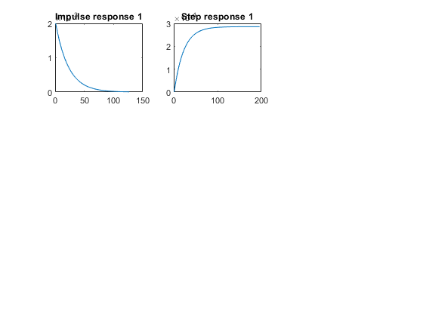

IVT
%for impulse is 1/m=0.00166
%for step is 0
%%FVT
%for impulse is 0;
%for step is 1/b=0.001111
m2=600;
b2=900;
Tau=m2/b2;
T_R=4*Tau
TF=tf([0,1/b2],[Tau,1])
subplot(3,3,3),plot(impulse(TF))
title("Impulse response 2")
subplot(3,3,4),plot(step(TF))
title("Step response 2")
S = stepinfo(TF)
T_R =
2.6667
TF =
0.001111
------------
0.6667 s + 1
Continuous-time transfer function.
S =
struct with fields:
RiseTime: 1.4647
SettlingTime: 2.6080
SettlingMin: 0.0010
SettlingMax: 0.0011
Overshoot: 0
Undershoot: 0
Peak: 0.0011
PeakTime: 7.0306
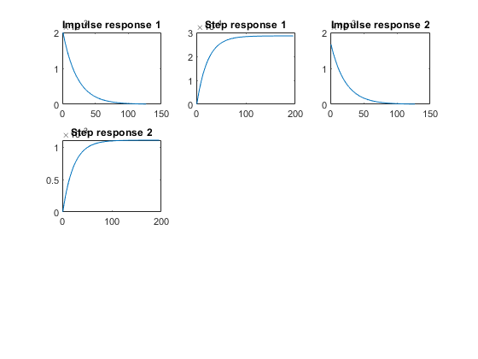

IVT
%for impulse is 1/m=0.00125
%for step is 0
%%FVT
%for impulse is 0;
%for step is 1/b=0.025
m3=800;
b3=40;
Tau=m3/b3;
T_R=4*Tau
TF=tf([0,1/b3],[Tau,1])
subplot(3,3,5),plot(impulse(TF))
title("Impulse response 3")
subplot(3,3,6),plot(step(TF))
title("Step response 3")
S = stepinfo(TF)
T_R =
80
TF =
0.025
--------
20 s + 1
Continuous-time transfer function.
S =
struct with fields:
RiseTime: 43.9401
SettlingTime: 78.2415
SettlingMin: 0.0226
SettlingMax: 0.0250
Overshoot: 0
Undershoot: 0
Peak: 0.0250
PeakTime: 210.9168
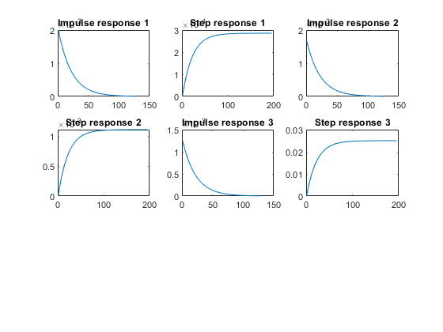

Poles plotting
hold on
subplot(3,3,7)
[z1,p1,k1]= tf2zp([0,1/b1],[m1/b1,1])
zplane(z1,p1)
hold on
subplot(3,3,7)
[z2,p2,k2]= tf2zp([0,1/b2],[m2/b2,1])
zplane(z2,p2)
hold on
subplot(3,3,7)
[z3,p3,k3]= tf2zp([0,1/b3],[m3/b3,1])
zplane(z3,p3)
z1 =
0×1 empty double column vector
p1 =
-7
k1 =
0.0020
z2 =
0×1 empty double column vector
p2 =
-1.5000
k2 =
0.0017
z3 =
0×1 empty double column vector
p3 =
-0.0500
k3 =
0.0013
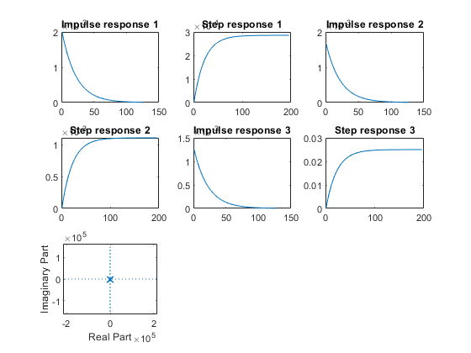

Response analysis (SAS)
Rise time
%T1=0.3139
%T2=1.4647
%T3=43.9401
%System 1 has the least rise time so the speed of system is greatest
%System 3 has the greatest rise time so the speed of system is least
% Settling time
%S1=0.5589
%S2=2.6080
%S3=78.2415
%System 1 is taking least time to get settled so the system is accurate
%System 3 is taking most time to get settled so the system is least accurate
% Pole position
%P1=-7.0
%P2=-1.5000
%P3=-0.0500
% system 1 pole is farthest away from pole:best stabilty among 3
% system 1 pole is farthest away from pole:worst stablity among 3
Published with MATLAB® R2021a

