Title:Control System-First Order System: adding P,I,D controllers 1
This Document has equation for motion differential system 1
Math analysis 1
Negative feedback 1
Positive feedback 4

Title:Control System-First Order System: adding P,I,D controllers
%Author:ShivaKumar Naga Vankadhara
%PS No:99003727
%Date:10/04/2021
%Version:1.7

This Document has equation for motion differential system
%Equation:mdv/dt+bv=u

Math analysis
%dependent variables:v
%independent variables:t,u
%constant:m,b
%Root:-b/m

Negative feedback
m1=1000;
b1=5;
Tau=m1/b1;
CF=10;
TF=CF*tf([0,1/b1],[Tau,1]);
%S = stepinfo(TF)
NCTF1=feedback(TF,1);
subplot(3,2,1),plot(impulse(NCTF1))
title("Impulse with Negative Feedback")
subplot(3,2,2),plot(step(NCTF1))
title("Step with Negative Feedback")
S1 = stepinfo(NCTF1)
p1=pole(NCTF1)
m1=1000;
b1=5;
Tau=m1/b1;
CF=tf([0,1],[1,0]);
TF=CF*tf([0,1/b1],[Tau,1]);
NCTF2=feedback(TF,1);
subplot(3,2,3),plot(impulse(NCTF2))
title("Impulse with integrator")
subplot(3,2,4),plot(step(NCTF2))
title("Step with integrator")
S2 = stepinfo(NCTF2)
p2=pole(NCTF2)
z2=zero(NCTF2)
m1=1000;
b1=5;
Tau=m1/b1;
CF=tf([1,0],[1]);
TF=CF*tf([0,1/b1],[Tau,1]);
T_R=4*Tau;
NCTF3=feedback(TF,1);
T_R=4*Tau;
subplot(3,2,5),plot(impulse(NCTF3))
title("Impulse with diff")
subplot(3,2,6),plot(step(NCTF3))
title("Step with diff")
p3=pole(NCTF3)
S3 = stepinfo(NCTF3)
%%Analysis:
%1. Rise time of the system increases on adding the integartor.
%2. Rise time of the system decreases on adding the diffrentiator.
%3. settling time of the system increases on adding integrator system is
%taking some time to settle and operate.
%4. accuracy of system decreases on adding differentiator
%5. overshoot increase is greater on adding differentiator than integrator
%6. Peak increase is greater on adding integrator than differentiator
%7. all the poles of negative feedback present in left side of plane
S1 =
struct with fields:
RiseTime: 146.4671
SettlingTime: 260.8050
SettlingMin: 0.6030
SettlingMax: 0.6666
Overshoot: 0
Undershoot: 0
Peak: 0.6666
PeakTime: 703.0560
p1 =
-0.0150
S2 =
struct with fields:
RiseTime: 35.0513
SettlingTime: 1.5129e+03
SettlingMin: 0.3925
SettlingMax: 1.7794
Overshoot: 77.9429
Undershoot: 0
Peak: 1.7794
PeakTime: 99.3459
p2 =
-0.0025 + 0.0315i
-0.0025 - 0.0315i
z2 =
0×1 empty double column vector
p3 =
-0.0050
S3 =
struct with fields:
RiseTime: 439.8407
SettlingTime: 783.1973
SettlingMin: 2.6276e-08
SettlingMax: 9.5404e-05
Overshoot: 4.6071e+17
Undershoot: 0
Peak: 9.9900e-04
PeakTime: 0
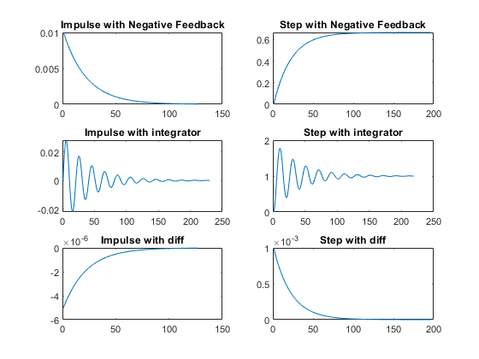

Positive feedback
figure
m1=1000;
b1=5;
Tau=m1/b1;
CF=10;
TF=CF*tf([0,1/b1],[Tau,1]);
%S = stepinfo(TF)
PCTF1=feedback(TF,-1);
subplot(3,2,1),plot(impulse(PCTF1))
title("Impulse with Positive feedback")
subplot(3,2,2),plot(step(PCTF1))
title("Step with Positive feedback")
S = stepinfo(PCTF1)
p4=pole(PCTF1)
m1=1000;
b1=5;
Tau=m1/b1;
CF=tf([0,1],[1,0]);
TF=CF*tf([0,1/b1],[Tau,1]);
PCTF2=feedback(TF,-1);
subplot(3,2,3),plot(impulse(PCTF2))
title("Impulse with integrator")
subplot(3,2,4),plot(step(PCTF2))
title("Step with integrator")
p5=pole(PCTF2)
S = stepinfo(PCTF2)
m1=1000;
b1=5;
Tau=m1/b1;
CF=tf([1,0],[1]);
TF=CF*tf([0,1/b1],[Tau,1]);
T_R=4*Tau;
PCTF3=feedback(TF,-1);
T_R=4*Tau;
subplot(3,2,5),plot(impulse(PCTF3))
title("Impulse with diff")
subplot(3,2,6),plot(step(PCTF3))
title("Step with diff")
p6=pole(PCTF3)
z2=zero(PCTF3)
S = stepinfo(PCTF3)
%%Analysis:
%1. on adding differentiator to positive feedback system, system is
% becoming stable and poles got shifted to left side
%2. The system is unstable in case of positive feedback with gain
% and integrator
%3. As the system is unstable in case of gain and integrator we are not
% getting parameters, also the peak is infinite
%4. Parameters can be obtained in differentiator as differentiator making
% the system stable
%5. positive feedback unstable system poles lies in right side of plane
S =
struct with fields:
RiseTime: NaN
SettlingTime: NaN
SettlingMin: NaN
SettlingMax: NaN
Overshoot: NaN
Undershoot: NaN
Peak: Inf
PeakTime: Inf
p4 =
0.0050
p5 =
-0.0342
0.0292
S =
struct with fields:
RiseTime: NaN
SettlingTime: NaN
SettlingMin: NaN
SettlingMax: NaN
Overshoot: NaN
Undershoot: NaN
Peak: Inf
PeakTime: Inf
p6 =
-0.0050
z2 =
0
S =
struct with fields:
RiseTime: 438.9619
SettlingTime: 781.6325
SettlingMin: 2.6329e-08
SettlingMax: 9.5595e-05
Overshoot: Inf
Undershoot: 0
Peak: 0.0010
PeakTime: 0
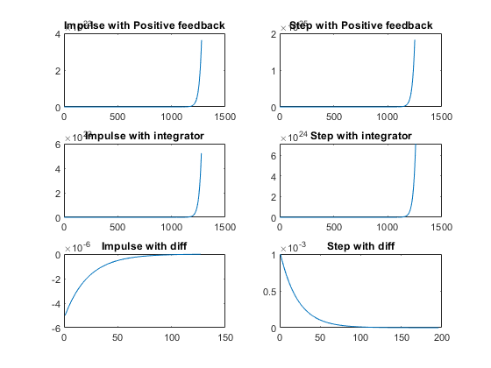
figure
hold on
pzmap(NCTF1)
pzmap(NCTF2)
pzmap(NCTF3)
pzmap(PCTF1)
pzmap(PCTF2)
pzmap(PCTF3)
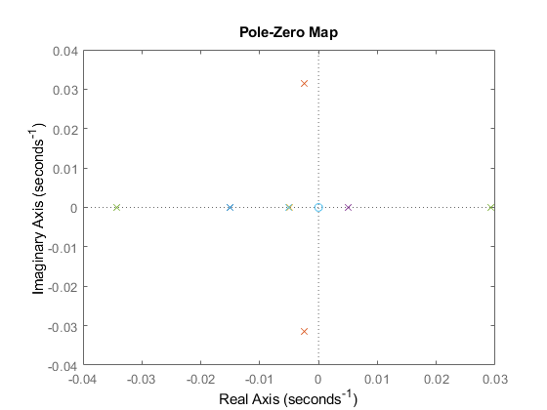
Published with MATLAB® R2021a

