Title:Control System-Second Order System: Horizontal shifting 1
Analysis: Horizontal movement of pole analysis: 2

Title:Control System-Second Order System: Horizontal shifting
%Author:ShivaKumar Naga Vankadhara
%PS No:99003727
%Date:10/04/2021
%Version:1.4
First set of poles
zeros = 0;
poles = [-10+20i -10-20i];
gain = 1;
sys1 = zpk(zeros,poles,gain);
hold on
pzmap(sys1)
[wn,zeta]=damp(sys1)
% Second set of poles
zeros = 0;
poles = [-20+20i -20-20i];
gain = 1;
sys2 = zpk(zeros,poles,gain);
hold on
pzmap(sys2)
[wn,zeta]=damp(sys2)
% Third set of poles
zeros = 0;
poles = [-5+20i -5-20i];
gain = 1;
sys3 = zpk(zeros,poles,gain);
pzmap(sys3)
[wn,zeta]=damp(sys3)
wn =
22.3607
22.3607
zeta =
0.4472
0.4472
wn =
28.2843
28.2843
zeta =
0.7071
0.7071
wn =
20.6155
20.6155
zeta =
0.2425
0.2425
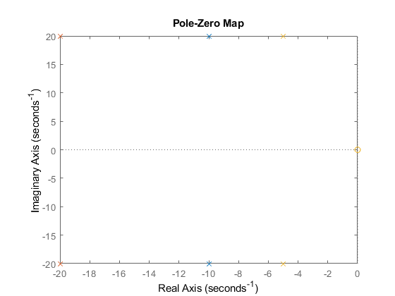

Analysis: Horizontal movement of pole analysis:
1.The Pole pair which is nearer to the imaginary axis have lesser damping ratio which says that it must not more stable. 2.The pole pair which is far away to the imaginary axis have higher damping ratio which shows the system stability. 3.When the pole pair is far away from the imaginary axis(i.e.leftside) the system has higher frequency when compared to the other two set of poles which is nearer to the imaginary axis 4.As all the set of poles have zeta values lying in the range of [0-1] so they have a complex conjugate roots. 5.The overshoot,damping of all the pole pairs are inversly proportional to each other in the given range of poles. 6.If overshoot is high rise time is less that means the system is fast.
Published with MATLAB® R2021a

