Title:Control System-Second Order System: diagonal shifting 1
This Document has movement of poles for Second Order System 1
Analysis of movement of poles in the diagonal Direction. 2

Title:Control System-Second Order System: diagonal shifting
%Author:ShivaKumar Naga Vankadhara
%PS No:99003727
%Date:7/04/2021
%Version:1.0

This Document has movement of poles for Second Order System
zeros = 0;
poles = [-10+10i -10-10i];
gain = 1;
sys = zpk(zeros,poles,gain);
hold on
pzmap(sys)
[wn1,zeta1]=damp(sys)
zeros = 0;
poles = [-100+100i -100-100i];
gain = 1;
sys = zpk(zeros,poles,gain);
hold on
pzmap(sys)
[wn2,zeta2]=damp(sys)
zeros = 0;
poles = [-300+300i -300-300i];
gain = 1;
sys = zpk(zeros,poles,gain);
pzmap(sys)
[wn3,zeta3]=damp(sys)
wn1 =
14.1421
14.1421
zeta1 =
0.7071
0.7071
wn2 =
141.4214
141.4214
zeta2 =
0.7071
0.7071
wn3 =
424.2641
424.2641
zeta3 =
0.7071
0.7071
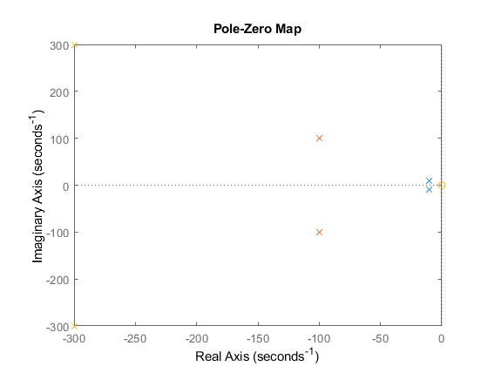

Analysis of movement of poles in the diagonal Direction.
1. Overshoot remains same at the different location of poles. 2. Frequency gets increased when the pole is moved upwards. 3. Frequency gets decreased when the pole moves downwards. 4. As the zeta is in between [0-1] the poles are complex conjugate roots.
Published with MATLAB® R2021a

