Title:Control System-Second Order System:vertical shifting 1
This Document has movement of poles for Second Order System 1
Analysis of vertical movement of poles: 2

Title:Control System-Second Order System:vertical shifting
%Author:Shivakumar Naga Vankadhara
%PS No:99003727
%Date:11/04/2021
%Version:1.7

This Document has movement of poles for Second Order System
zeros = 0;
poles = [-10+20i -10-20i];
gain = 1;
sys1 = zpk(zeros,poles,gain);
hold on
pzmap(sys1)
[wn,zeta]=damp(sys1)
zeros = 0;
poles = [-10+10i -10-10i];
gain = 1;
sys2 = zpk(zeros,poles,gain);
hold on
pzmap(sys2)
[wn,zeta]=damp(sys2)
zeros = 0;
poles = [-10+30i -10-30i];
gain = 1;
sys3 = zpk(zeros,poles,gain);
pzmap(sys3)
[wn,zeta]=damp(sys3)
wn =
22.3607
22.3607
zeta =
0.4472
0.4472
wn =
14.1421
14.1421
zeta =
0.7071
0.7071
wn =
31.6228
31.6228
zeta =
0.3162
0.3162
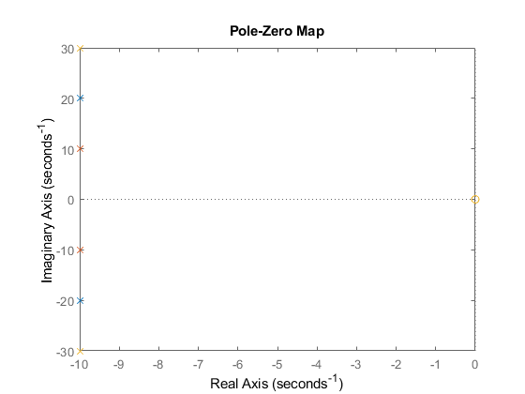

Analysis of vertical movement of poles:
1.for the upward movement of the pole Overshoot increases, frequency increases , Damping gets reduced so the system is becoming stable when it is moving upward. 2.So for the Downward movement of the pole Overshoot decreases, frequency decreases, Damping gets increased so thr system is getting less stable.
Published with MATLAB® R2021a

