Title:Control System-Second Order System:open loop with different values 1
This Document has equation for DC Motor 1
Math analysis 1
IVT 1
Analysis 5

Title:Control System-Second Order System:open loop with different values
%Author:ShivaKumar Naga VAnkadhara
%PS No:99003727
%Date:11/04/2021
%Version:1.7

This Document has equation for DC Motor
%Equation:Ldi/dt+Ri+Kw=V
% Jdw/dt+bw=Ki
%T(s)=(K/LJ)/(s^2+((b/J)+(R/L)s+(R*b)/(L*J)+(K*K)/(L*J)

Math analysis
%dependent variables:w
%independent variables:t
%constant:K,R,L,J,b
%Roots:0.5*(-(b/J)-(R/L))+sqrt((((b*b)/(J*J))+((R*R)/(L*L))-((2*R*b)/(L*J))-((4*K*K)/(L*J)))
% 0.5*(-(b/J)-(R/L))-sqrt((((b*b)/(J*J))+((R*R)/(L*L))-((2*R*b)/(L*J))-((4*K*K)/(L*J)))

IVT
%for impulse is 0
%for step is 0
%%FVT
%for impulse is K/((b*L)+(R*J))=0.1667
%for step is K/((R*b)+(K*K))=0.0999001
J = 0.01;
b = 0.1;
K = 1;
R = 1;
L = 0.5;
%TF=tf([K/(J*L)],[1,((b/J)+(R/L)),(((K*K)+(R*b))/(L*J))]);
sys = tf([K/(J*L)],[1,((b/J)+(R/L)),(((K*K)+(R*b))/(L*J))])
subplot(3,3,1)
step(sys)
subplot(3,3,2)
impulse(sys)
subplot(3,3,3)
%S = stepinfo(sys)
[z,p,k]= tf2zp([K/(J*L)],[1,((b/J)+(R/L)),(((K*K)+(R*b))/(L*J))])
zplane(z,p)
S = stepinfo(sys)
J = 0.1;
b = 1;
K = 0.1;
R = 10;
L = 5;
%TF=tf([K/(J*L)],[1,((b/J)+(R/L)),(((K*K)+(R*b))/(L*J))]);
sys = tf([K/(J*L)],[1,((b/J)+(R/L)),(((K*K)+(R*b))/(L*J))])
subplot(3,3,4)
step(sys)
subplot(3,3,5)
impulse(sys)
subplot(3,3,6)
%S = stepinfo(sys)
[z2,p2,k2]= tf2zp([K/(J*L)],[1,((b/J)+(R/L)),(((K*K)+(R*b))/(L*J))])
zplane(z2,p2)
S = stepinfo(sys)
J = 0.01;
b = 0.01;
K = 0.1;
R = 0.1;
L = 0.05;
%TF=tf([K/(J*L)],[1,((b/J)+(R/L)),(((K*K)+(R*b))/(L*J))]);
sys = tf([K/(J*L)],[1,((b/J)+(R/L)),(((K*K)+(R*b))/(L*J))])
subplot(3,3,7)
step(sys)
subplot(3,3,8)
impulse(sys)
subplot(3,3,9)
%S = stepinfo(sys)
[z1,p1,k1]= tf2zp([K/(J*L)],[1,((b/J)+(R/L)),(((K*K)+(R*b))/(L*J))])
zplane(z1,p1)
S = stepinfo(sys)
sys =
200
----------------
s^2 + 12 s + 220
Continuous-time transfer function.
z =
0×1 empty double column vector
p =
-6.0000 +13.5647i
-6.0000 -13.5647i
k =
200
S =
struct with fields:
RiseTime: 0.0993
SettlingTime: 0.5669
SettlingMin: 0.8527
SettlingMax: 1.1356
Overshoot: 24.9123
Undershoot: 0
Peak: 1.1356
PeakTime: 0.2303
sys =
0.2
------------------
s^2 + 12 s + 20.02
Continuous-time transfer function.
z2 =
0×1 empty double column vector
p2 =
-9.9975
-2.0025
k2 =
0.2000
S =
struct with fields:
RiseTime: 1.1351
SettlingTime: 2.0652
SettlingMin: 0.0090
SettlingMax: 0.0100
Overshoot: 0
Undershoot: 0
Peak: 0.0100
PeakTime: 3.6758
sys =
200
--------------
s^2 + 3 s + 22
Continuous-time transfer function.
z1 =
0×1 empty double column vector
p1 =
-1.5000 + 4.4441i
-1.5000 - 4.4441i
k1 =
200
S =
struct with fields:
RiseTime: 0.2882
SettlingTime: 2.3810
SettlingMin: 8.0006
SettlingMax: 12.2393
Overshoot: 34.6325
Undershoot: 0
Peak: 12.2393
PeakTime: 0.7061
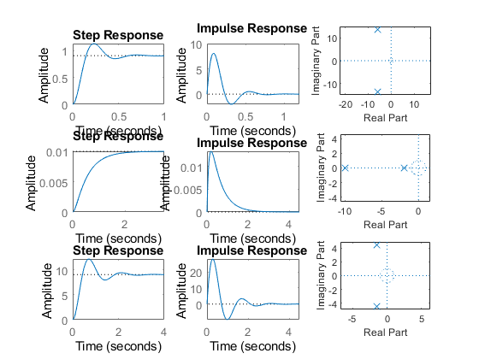

Analysis
1.If rise time is less the system is not much stable and its speed 2.If the rise time is high the system may behave more stable its not speed in nature. 3.If the Over shoot is less the system is kind of stable. 4.If the Over shoot is more the system may behave less stable. 5.If settling time is less accuracy is high. 6.If the settling time is high accuracy is less. 7.In the above systems system 2 is more stable because overshoot is 0. 8.Peak time is inversly proportional to overshoot. so if peak time is more system is stable. 9.when we add proportional to the open loop no parameters get changed only peak time and overshoot changes.
Published with MATLAB® R2021a

