Title:Control System-Second Order System:varying zeta value open system 1
This Document has equation for Second Order System 1
Analysis based on zeta 10

Title:Control System-Second Order System:varying zeta value open system
%Author:ShivaKumar Naga Vankadhara
%PS No:99003727
%Date:10/04/2021
%Version:1.0

This Document has equation for Second Order System
%w=1
jeta=1;
TF=tf([1],[1,(2*jeta),1])
sys = tf([1],[1,(2*jeta),1])
figure
subplot(2,3,1)
S = stepinfo(sys)
[z,p,k]= tf2zp([1],[1,(2*jeta),1])
zplane(z,p)
jeta=0.7;
TF=tf([1],[1,(2*jeta),1])
sys = tf([1],[1,(2*jeta),1])
%hold on
subplot(2,3,2)
S = stepinfo(sys)
[z,p,k]= tf2zp([1],[1,(2*jeta),1])
zplane(z,p)
jeta=1.5;
TF=tf([1],[1,(2*jeta),1])
sys = tf([1],[1,(2*jeta),1])
subplot(2,3,3)
S = stepinfo(sys)
[z,p,k]= tf2zp([1],[1,(2*jeta),1])
zplane(z,p)
jeta=-1;
TF=tf([1],[1,(2*jeta),1])
sys = tf([1],[1,(2*jeta),1])
subplot(2,3,4)
S = stepinfo(sys)
[z,p,k]= tf2zp([1],[1,(2*jeta),1])
zplane(z,p)
jeta=-0.5;
TF=tf([1],[1,(2*jeta),1])
sys = tf([1],[1,(2*jeta),1])
subplot(2,3,5)
S = stepinfo(sys)
[z,p,k]= tf2zp([1],[1,(2*jeta),1])
zplane(z,p)
jeta=-1.5;
TF=tf([1],[1,(2*jeta),1])
sys = tf([1],[1,(2*jeta),1])
subplot(2,3,6)
S = stepinfo(sys)
[z,p,k]= tf2zp([1],[1,(2*jeta),1])
zplane(z,p)
figure
jeta=0;
TF=tf([1],[1,(2*jeta),1])
sys = tf([1],[1,(2*jeta),1])
S = stepinfo(sys)
[z,p,k]= tf2zp([1],[1,(2*jeta),1])
zplane(z,p)
TF =
1
-------------
s^2 + 2 s + 1
Continuous-time transfer function.
sys =
1
-------------
s^2 + 2 s + 1
Continuous-time transfer function.
S =
struct with fields:
RiseTime: 3.3579
SettlingTime: 5.8339
SettlingMin: 0.9000
SettlingMax: 0.9994
Overshoot: 0
Undershoot: 0
Peak: 0.9994
PeakTime: 9.7900
z =
0×1 empty double column vector
p =
-1
-1
k =
1
TF =
1
---------------
s^2 + 1.4 s + 1
Continuous-time transfer function.
sys =
1
---------------
s^2 + 1.4 s + 1
Continuous-time transfer function.
S =
struct with fields:
RiseTime: 2.1268
SettlingTime: 5.9789
SettlingMin: 0.9001
SettlingMax: 1.0460
Overshoot: 4.5986
Undershoot: 0
Peak: 1.0460
PeakTime: 4.4078
z =
0×1 empty double column vector
p =
-0.7000 + 0.7141i
-0.7000 - 0.7141i
k =
1
TF =
1
-------------
s^2 + 3 s + 1
Continuous-time transfer function.
sys =
1
-------------
s^2 + 3 s + 1
Continuous-time transfer function.
S =
struct with fields:
RiseTime: 5.8584
SettlingTime: 10.6547
SettlingMin: 0.9012
SettlingMax: 0.9999
Overshoot: 0
Undershoot: 0
Peak: 0.9999
PeakTime: 25.9983
z =
0×1 empty double column vector
p =
-2.6180
-0.3820
k =
1
TF =
1
-------------
s^2 - 2 s + 1
Continuous-time transfer function.
sys =
1
-------------
s^2 - 2 s + 1
Continuous-time transfer function.
S =
struct with fields:
RiseTime: NaN
SettlingTime: NaN
SettlingMin: NaN
SettlingMax: NaN
Overshoot: NaN
Undershoot: NaN
Peak: Inf
PeakTime: Inf
z =
0×1 empty double column vector
p =
1
1
k =
1
TF =
1
-----------
s^2 - s + 1
Continuous-time transfer function.
sys =
1
-----------
s^2 - s + 1
Continuous-time transfer function.
S =
struct with fields:
RiseTime: NaN
SettlingTime: NaN
SettlingMin: NaN
SettlingMax: NaN
Overshoot: NaN
Undershoot: NaN
Peak: Inf
PeakTime: Inf
z =
0×1 empty double column vector
p =
0.5000 + 0.8660i
0.5000 - 0.8660i
k =
1
TF =
1
-------------
s^2 - 3 s + 1
Continuous-time transfer function.
sys =
1
-------------
s^2 - 3 s + 1
Continuous-time transfer function.
S =
struct with fields:
RiseTime: NaN
SettlingTime: NaN
SettlingMin: NaN
SettlingMax: NaN
Overshoot: NaN
Undershoot: NaN
Peak: Inf
PeakTime: Inf
z =
0×1 empty double column vector
p =
2.6180
0.3820
k =
1
TF =
1
-------
s^2 + 1
Continuous-time transfer function.
sys =
1
-------
s^2 + 1
Continuous-time transfer function.
S =
struct with fields:
RiseTime: NaN
SettlingTime: NaN
SettlingMin: NaN
SettlingMax: NaN
Overshoot: NaN
Undershoot: NaN
Peak: Inf
PeakTime: Inf
z =
0×1 empty double column vector
p =
0.0000 + 1.0000i
0.0000 - 1.0000i
k =
1
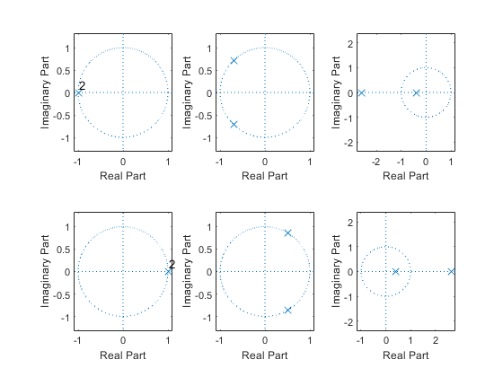
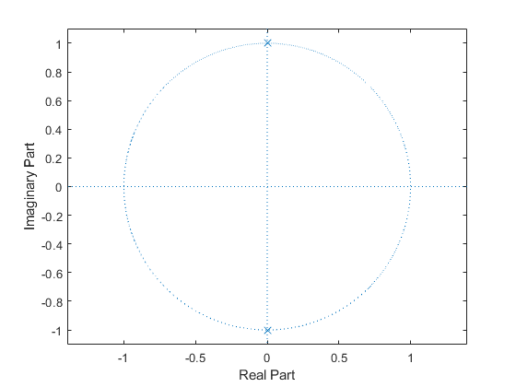

Analysis based on zeta
1. If zeta>0 we may get the roots on the left side of the imaginary axis. 2. If zeta<0 we may get the roots on the right side of the imaginary axis. 3. If zeta lies in the range of [0-1] we get complex conjugate roots. 4. If zeta ranges greater than 1 we get real roots and distinct. 5. If zeta is equal to 1 we get real roots. 6. If zeta is zero poles lies on the imaginary axis like complex conjugate roots system is undamped.
Published with MATLAB® R2021a

