Title:Control System-Second Order System 1
This Document has equation for DC Motor 1
Math analysis 1
Negtaive Feedback 1
Positive Feedback 6
Analysis 12

Title:Control System-Second Order System
%Author:ShivaKumar Naga Vankadhara
%PS No:99003727
%Date:10/04/2021
%Version:1.4

This Document has equation for DC Motor
%Equation:Ldi/dt+Ri+Kw=V
% Jdw/dt+bw=Ki
%T(s)=(K/LJ)/(s^2+((b/J)+(R/L)s+(R*b)/(L*J)+(K*K)/(L*J)

Math analysis
%dependent variables:w
%independent variables:t
%constant:K,R,L,J,b
%Roots:0.5*(-(b/J)-(R/L))+sqrt((((b*b)/(J*J))+((R*R)/(L*L))-((2*R*b)/(L*J))-((4*K*K)/(L*J)))
% 0.5*(-(b/J)-(R/L))-sqrt((((b*b)/(J*J))+((R*R)/(L*L))-((2*R*b)/(L*J))-((4*K*K)/(L*J)))

Negtaive Feedback
J = 0.01;
b = 0.1;
K = 1;
R = 1;
L = 0.5;
TF=tf([K/(J*L)],[1,((b/J)+(R/L)),(((K*K)+(R*b))/(L*J))]);
CF=10
sys = CF*TF
NCTF1=feedback(sys,1)
subplot(3,2,1)
step(NCTF1)
title("Step with negative")
subplot(3,2,2)
impulse(NCTF1)
title("impulse with negative")
S = stepinfo(NCTF1)
[wn,zeta]=damp(NCTF1)
J = 0.01;
b = 0.1;
K = 1;
R = 1;
L = 0.5;
TF=tf([K/(J*L)],[1,((b/J)+(R/L)),(((K*K)+(R*b))/(L*J))]);
CF=tf([1,0],[1])
sys = CF*TF
NCTF2=feedback(sys,1)
subplot(3,2,3)
step(NCTF2)
title("Step with diff")
subplot(3,2,4)
impulse(NCTF2)
title("impulse with diff")
S = stepinfo(NCTF2)
[wn,zeta]=damp(NCTF2)
J = 0.01;
b = 0.1;
K = 1;
R = 1;
L = 0.5;
TF=tf([K/(J*L)],[1,((b/J)+(R/L)),(((K*K)+(R*b))/(L*J))]);
CF=tf([1],[1,0])
sys = CF*TF
NCTF3=feedback(sys,1)
subplot(3,2,5)
step(NCTF3)
title("Step with integrator")
subplot(3,2,6)
impulse(NCTF3)
title("impulse with integrator")
S = stepinfo(NCTF3)
[wn,zeta]=damp(NCTF3)
CF =
10
sys =
2000
----------------
s^2 + 12 s + 220
Continuous-time transfer function.
NCTF1 =
2000
-----------------
s^2 + 12 s + 2220
Continuous-time transfer function.
S =
struct with fields:
RiseTime: 0.0245
SettlingTime: 0.6206
SettlingMin: 0.4993
SettlingMax: 1.5026
Overshoot: 66.7860
Undershoot: 0
Peak: 1.5026
PeakTime: 0.0667
wn =
47.1169
47.1169
zeta =
0.1273
0.1273
CF =
s
Continuous-time transfer function.
sys =
200 s
----------------
s^2 + 12 s + 220
Continuous-time transfer function.
NCTF2 =
200 s
-----------------
s^2 + 212 s + 220
Continuous-time transfer function.
S =
struct with fields:
RiseTime: 0
SettlingTime: 3.7813
SettlingMin: 6.5963e-04
SettlingMax: 0.9234
Overshoot: Inf
Undershoot: 0
Peak: 0.9234
PeakTime: 0.0253
wn =
1.0429
210.9571
zeta =
1
1
CF =
1
-
s
Continuous-time transfer function.
sys =
200
--------------------
s^3 + 12 s^2 + 220 s
Continuous-time transfer function.
NCTF3 =
200
--------------------------
s^3 + 12 s^2 + 220 s + 200
Continuous-time transfer function.
S =
struct with fields:
RiseTime: 2.2719
SettlingTime: 4.1463
SettlingMin: 0.9044
SettlingMax: 0.9993
Overshoot: 0
Undershoot: 0
Peak: 0.9993
PeakTime: 7.6683
wn =
0.9549
14.4725
14.4725
zeta =
1.0000
0.3816
0.3816
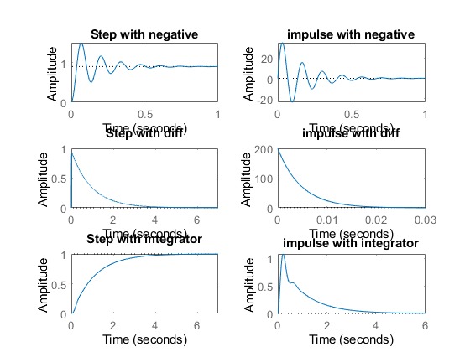

Positive Feedback
figure
J = 0.01;
b = 0.1;
K = 1;
R = 1;
L = 0.5;
TF=tf([K/(J*L)],[1,((b/J)+(R/L)),(((K*K)+(R*b))/(L*J))]);
CF=10
sys = CF*TF
PCTF1=feedback(sys,-1)
subplot(3,2,1)
step(PCTF1)
title("Step with positive")
subplot(3,2,2)
impulse(PCTF1)
title("impulse with positive")
S = stepinfo(PCTF1)
[wn,zeta]=damp(PCTF1)
J = 0.01;
b = 0.1;
K = 1;
R = 1;
L = 0.5;
TF=tf([K/(J*L)],[1,((b/J)+(R/L)),(((K*K)+(R*b))/(L*J))]);
CF=tf([1,0],[1])
sys = CF*TF
PCTF2=feedback(sys,-1)
subplot(3,2,3)
step(PCTF2)
title("Step with diff")
subplot(3,2,4)
impulse(PCTF2)
title("impulse with diff")
S = stepinfo(PCTF2)
[wn,zeta]=damp(PCTF2)
J = 0.01;
b = 0.1;
K = 1;
R = 1;
L = 0.5;
TF=tf([K/(J*L)],[1,((b/J)+(R/L)),(((K*K)+(R*b))/(L*J))]);
CF=tf([1],[1,0])
sys = CF*TF
PCTF3=feedback(sys,-1)
subplot(3,2,5)
step(PCTF3)
title("Step with integrator")
subplot(3,2,6)
impulse(PCTF3)
title("impulse with integrator")
S = stepinfo(PCTF3)
[wn,zeta]=damp(PCTF3)
CF =
10
sys =
2000
----------------
s^2 + 12 s + 220
Continuous-time transfer function.
PCTF1 =
2000
-----------------
s^2 + 12 s - 1780
Continuous-time transfer function.
S =
struct with fields:
RiseTime: NaN
SettlingTime: NaN
SettlingMin: NaN
SettlingMax: NaN
Overshoot: NaN
Undershoot: NaN
Peak: Inf
PeakTime: Inf
wn =
36.6146
48.6146
zeta =
-1
1
CF =
s
Continuous-time transfer function.
sys =
200 s
----------------
s^2 + 12 s + 220
Continuous-time transfer function.
PCTF2 =
200 s
-----------------
s^2 - 188 s + 220
Continuous-time transfer function.
S =
struct with fields:
RiseTime: NaN
SettlingTime: NaN
SettlingMin: NaN
SettlingMax: NaN
Overshoot: NaN
Undershoot: NaN
Peak: Inf
PeakTime: Inf
wn =
1.1776
186.8224
zeta =
-1
-1
CF =
1
-
s
Continuous-time transfer function.
sys =
200
--------------------
s^3 + 12 s^2 + 220 s
Continuous-time transfer function.
PCTF3 =
200
--------------------------
s^3 + 12 s^2 + 220 s - 200
Continuous-time transfer function.
S =
struct with fields:
RiseTime: NaN
SettlingTime: NaN
SettlingMin: NaN
SettlingMax: NaN
Overshoot: NaN
Undershoot: NaN
Peak: Inf
PeakTime: Inf
wn =
0.8653
15.2030
15.2030
zeta =
-1.0000
0.4231
0.4231
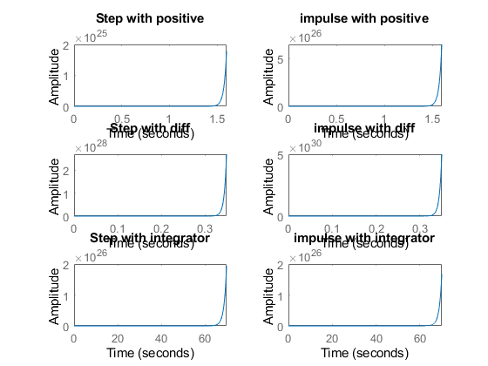
figure
hold on
pzmap(NCTF1)
pzmap(NCTF2)
pzmap(NCTF3)
pzmap(PCTF1)
pzmap(PCTF2)
pzmap(PCTF3)
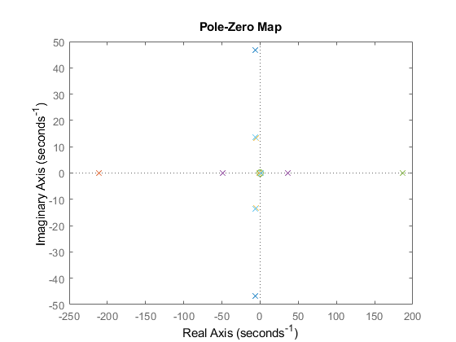

Analysis
%1. Positive feedback system when P,I,D are added system becomes unstable.
%2. Rise time will decrease when you add a differentiator because over
%shoot increases, Ts also increases.
%3. When we add an integrator to this system rise time bacame higher and
%overshoot became zero this says that system is getting towards stable.
%4. Adding the positive feed back makes the zeta value change.
Published with MATLAB® R2021a

