Title:Control System-Second Order System 1
This Document has equation for DC Motor 1
Math analysis 1
Basic 1
With Gain 3
With PI 4
With PD 6
With PID 8
Analysis 15
With POsitive feedback 15
Analysis 26
With Negative feedback 26
Analysis 39

Title:Control System-Second Order System
%Author:ShivaKumar Naga Vankadhara
%PS No:99003727
%Date:12/04/2021
%Version:1.0

This Document has equation for DC Motor
%Equation:Tdm/dt+m=tem
%T_F=1/Ts+1

Math analysis
%dependent variables:m,temp
%independent variables:t
%constant:T
%Roots:-1/T

Basic
T=1
sys1 = tf([1],[T,1])
subplot(5,2,1)
step(sys1)
subplot(5,2,2)
impulse(sys1)
S = stepinfo(sys1)
p1=pole(sys1)
z1=zero(sys1)
T =
1
sys1 =
1
-----
s + 1
Continuous-time transfer function.
S =
struct with fields:
RiseTime: 2.1970
SettlingTime: 3.9121
SettlingMin: 0.9045
SettlingMax: 1.0000
Overshoot: 0
Undershoot: 0
Peak: 1.0000
PeakTime: 10.5458
p1 =
-1
z1 =
0×1 empty double column vector
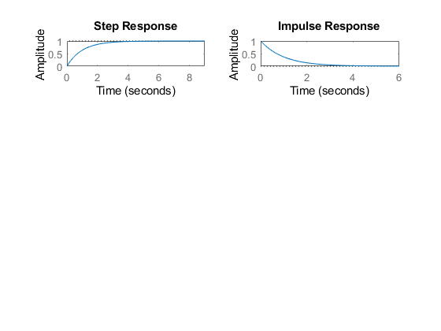

With Gain
T=1;
k=5;
sys_G = k*tf([1],[T,1])
subplot(5,2,3)
step(sys_G)
subplot(5,2,4)
impulse(sys_G)
S = stepinfo(sys_G)
p_g=pole(sys_G)
z_g=zero(sys_G)
sys_G =
5
-----
s + 1
Continuous-time transfer function.
S =
struct with fields:
RiseTime: 2.1970
SettlingTime: 3.9121
SettlingMin: 4.5225
SettlingMax: 4.9999
Overshoot: 0
Undershoot: 0
Peak: 4.9999
PeakTime: 10.5458
p_g =
-1
z_g =
0×1 empty double column vector
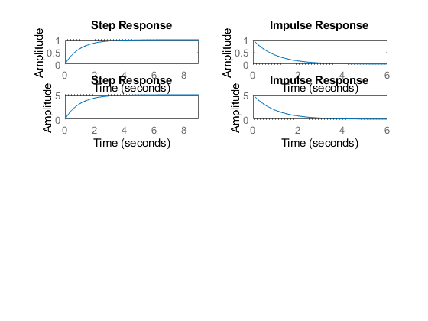

With PI
T=1;
k=5;
Kp=10;
I=tf([10],[1,0]); %Ki
PI=Kp+I;
sys_PI = PI*tf([1],[T,1])
subplot(5,2,5)
step(sys_PI)
subplot(5,2,6)
impulse(sys_PI)
S = stepinfo(sys_PI)
p_pi=pole(sys_PI)
z_pi=zero(sys_PI)
sys_PI =
10 s + 10
---------
s^2 + s
Continuous-time transfer function.
S =
struct with fields:
RiseTime: NaN
SettlingTime: NaN
SettlingMin: NaN
SettlingMax: NaN
Overshoot: NaN
Undershoot: NaN
Peak: Inf
PeakTime: Inf
p_pi =
0
-1
z_pi =
-1
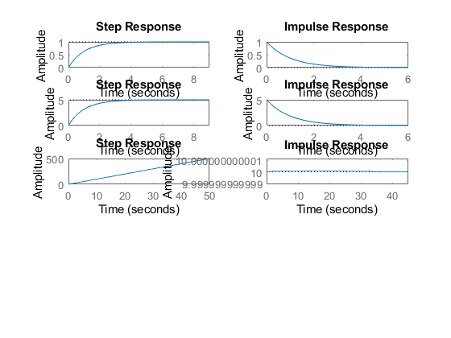

With PD
T=1;
k=5;
Kp=10;
D=tf([10,1],[0,1]); %Kd
PD=Kp+D;
sys_PD = PD*tf([1],[T,1])
subplot(5,2,7)
step(sys_PD)
subplot(5,2,8)
impulse(sys_PD)
S = stepinfo(sys_PD)
p_pd=pole(sys_PD)
z_pd=zero(sys_PD)
sys_PD =
10 s + 11
---------
s + 1
Continuous-time transfer function.
S =
struct with fields:
RiseTime: 2.1970
SettlingTime: 3.9121
SettlingMin: 10.9045
SettlingMax: 11.0000
Overshoot: 0
Undershoot: 0
Peak: 11.0000
PeakTime: 10.5458
p_pd =
-1
z_pd =
-1.1000
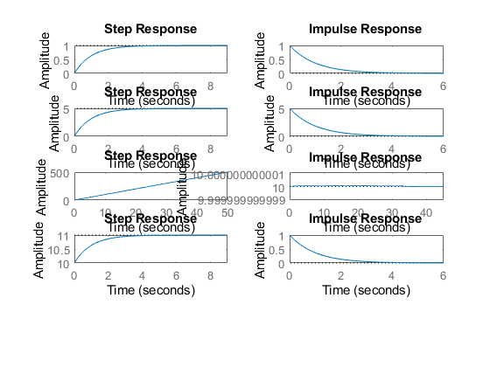

With PID
T=1;
k=5;
Kp=10;
D=tf([10,1],[0,1]); %Kd
I=tf([10],[1,0]); %Ki
PID=Kp+D+I;
sys_PID = PID*tf([1],[T,1])
subplot(5,2,9)
step(sys_PID)
subplot(5,2,10)
impulse(sys_PID)
S = stepinfo(sys_PID)
p_pid=pole(sys_PID)
z_pid=zero(sys_PID)
sys_PID =
10 s^2 + 11 s + 10
------------------
s^2 + s
Continuous-time transfer function.
S =
struct with fields:
RiseTime: NaN
SettlingTime: NaN
SettlingMin: NaN
SettlingMax: NaN
Overshoot: NaN
Undershoot: NaN
Peak: Inf
PeakTime: Inf
p_pid =
0
-1
z_pid =
-0.5500 + 0.8352i
-0.5500 - 0.8352i
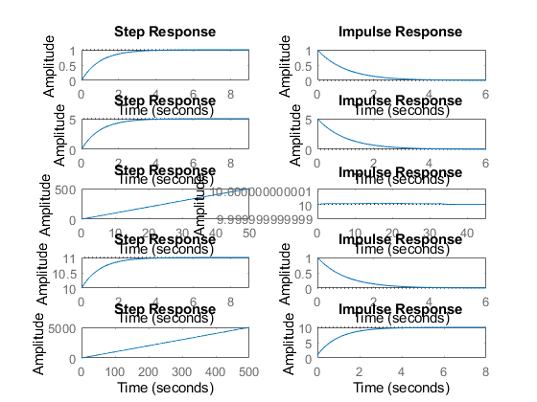
figure
pzmap(sys1)
pzmap(sys_G)
pzmap(sys_PI)
pzmap(sys_PD)
pzmap(sys_PID)
pidTuner(sys1)
pidTuner(sys_G)
pidTuner(sys_PI)
pidTuner(sys_PD)
pidTuner(sys_PID)
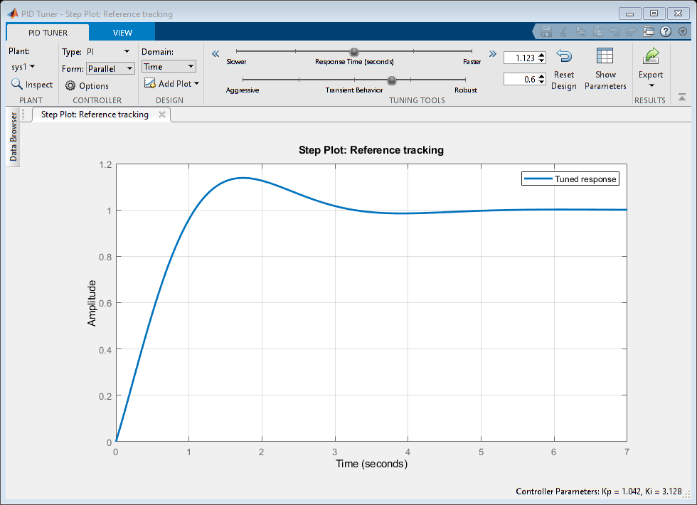
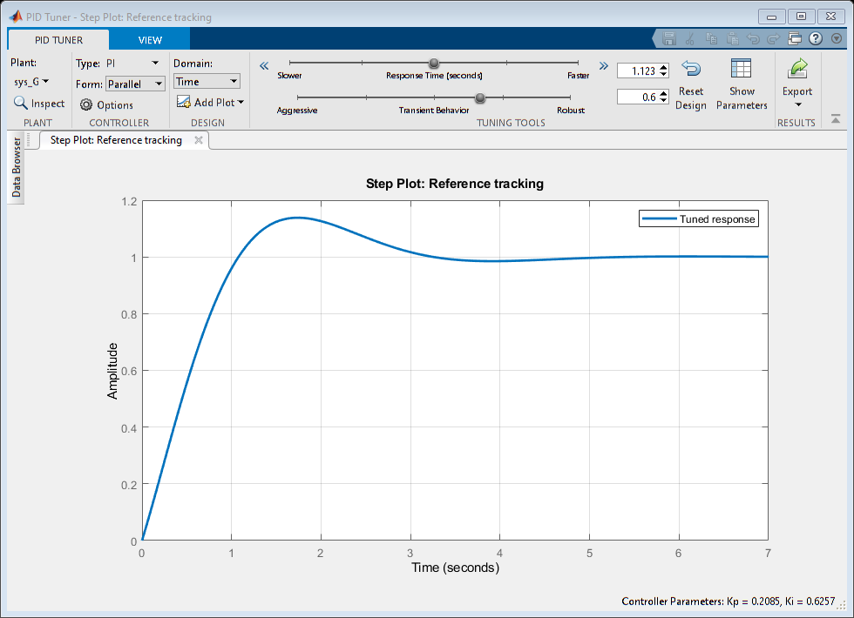
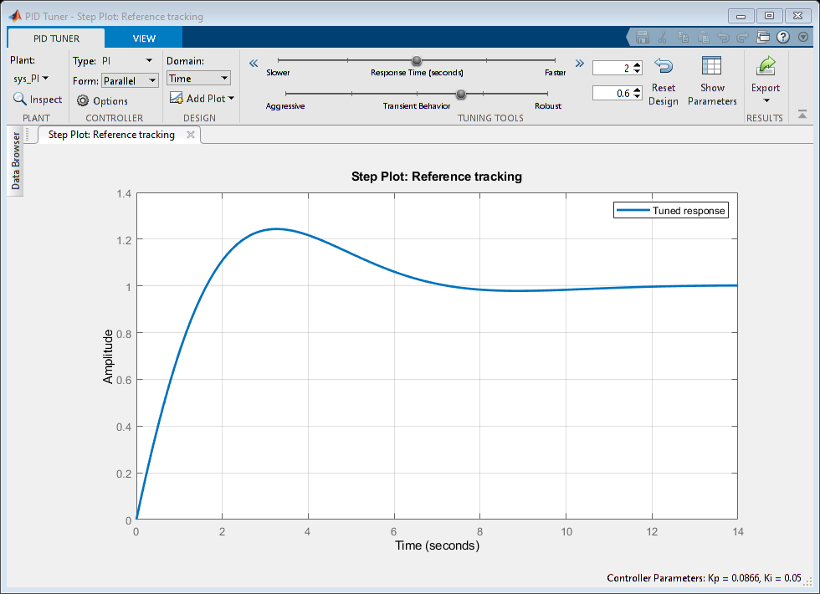
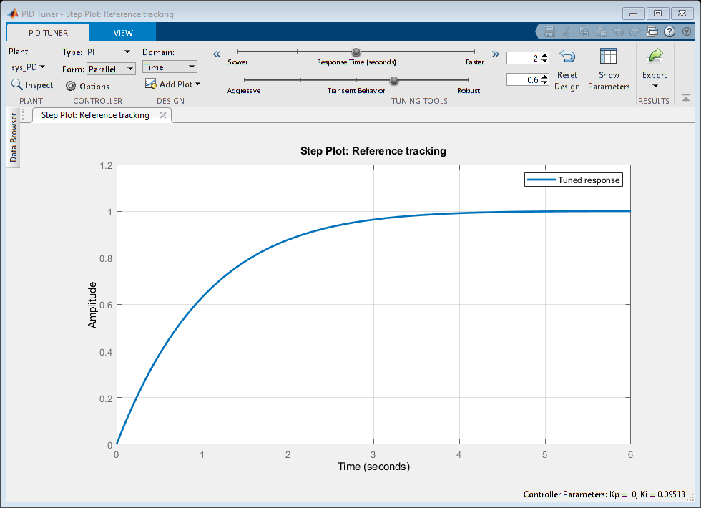
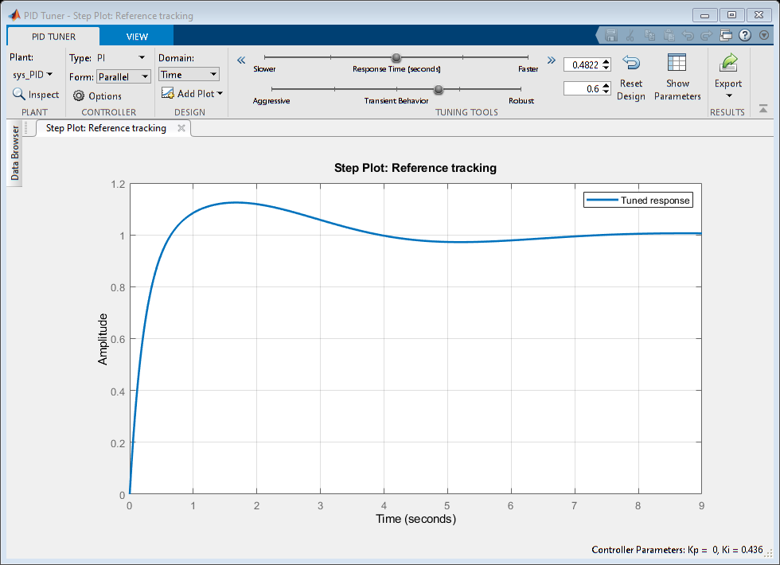
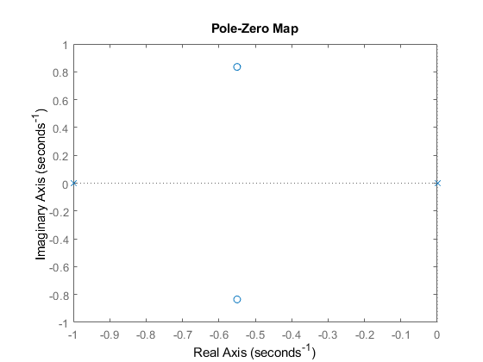

Analysis
%1.For the Basic the root lies on the left side of the imaginary axis that
% means the system is stable.
%Rise time is : 2.1970
%settling time is:3.9121 & Overshoot=0 for the basic
%2. For the system with gain also the root lies on the left side of the
%imaginary axis that means the system is stable.
%Rise time is:2.1970, settling time:3.9121, overshoot=0 for the gain. poles
%is also same only there is a change of amplitude.
%3. For the system with PI we got 2 poles one pole is at p1=0, p2=-1 and
%one zero is at z=-1 so we can say that 1 pole will nullify the effect of
%zero and we will be remained with 1 pole left on the left side so we can
%say that system is stable.
%4. For the system with PD we got 1 pole at -1 and 1 zero at -1.10000 on
%the left side of imaginary axis the settling time is 2.1970, R_t is 3.9121
%5. For the system with PID controller we got 2 poles and 2 zeroes p1=0,
%p1=-1 and z1=-0.5500+0.8352i,z2=-0.5500-0.8352i the poles and zeores le on
%the left side of the imaginary axis again the system is stable again here
%also.

With POsitive feedback
figure
T=1
sys = tf([1],[T,1])
sys_P=feedback(sys,-1)
subplot(5,2,1)
step(sys_P)
subplot(5,2,2)
impulse(sys_P)
S = stepinfo(sys_P)
p1=pole(sys_P)
z1=zero(sys_P)
T=1;
CF=10;
sys = CF*tf([1],[T,1]);
sys_G_P=feedback(sys,-1);
subplot(5,2,3)
step(sys_G_P)
subplot(5,2,4)
impulse(sys_G_P)
S = stepinfo(sys_G_P)
p_g=pole(sys_G_P)
z_g=zero(sys_G_P)
T=1;
Kp=10;
I=tf([10],[1,0]); %Ki
PI=Kp+I;
sys = PI*tf([1],[T,1]);
sys_PI_P=feedback(sys,-1);
subplot(5,2,5)
step(sys_PI_P)
subplot(5,2,6)
impulse(sys_PI_P)
S = stepinfo(sys_PI_P)
p_pi=pole(sys_PI_P)
z_pi=zero(sys_PI_P)
T=1;
Kp=10;
D=tf([10,1],[0,1]); %Kd
PD=Kp+D;
sys = PD*tf([1],[T,1]);
sys_PD_P=feedback(sys,-1);
subplot(5,2,7)
step(sys_PD_P)
subplot(5,2,8)
impulse(sys_PD_P)
S = stepinfo(sys_PD_P)
p_pd=pole(sys_PD_P)
z_pd=zero(sys_PD_P)
T=1
Kp=10;
D=tf([10,1],[0,1]); %Kd
I=tf([10],[1,0]); %Ki
PID=Kp+D+I;
sys = PID*tf([1],[T,1]);
sys_PID_P=feedback(sys,-1);
subplot(5,2,9)
step(sys_PID_P)
subplot(5,2,10)
impulse(sys_PID_P)
S = stepinfo(sys_PID_P)
p_pid=pole(sys_PID_P)
z_pid=zero(sys_PID_P)
T =
1
sys =
1
-----
s + 1
Continuous-time transfer function.
sys_P =
1
-
s
Continuous-time transfer function.
S =
struct with fields:
RiseTime: NaN
SettlingTime: NaN
SettlingMin: NaN
SettlingMax: NaN
Overshoot: NaN
Undershoot: NaN
Peak: Inf
PeakTime: Inf
p1 =
0
z1 =
0×1 empty double column vector
S =
struct with fields:
RiseTime: NaN
SettlingTime: NaN
SettlingMin: NaN
SettlingMax: NaN
Overshoot: NaN
Undershoot: NaN
Peak: Inf
PeakTime: Inf
p_g =
9
z_g =
0×1 empty double column vector
S =
struct with fields:
RiseTime: NaN
SettlingTime: NaN
SettlingMin: NaN
SettlingMax: NaN
Overshoot: NaN
Undershoot: NaN
Peak: Inf
PeakTime: Inf
p_pi =
10
-1
z_pi =
-1
S =
struct with fields:
RiseTime: 1.9773
SettlingTime: 3.5209
SettlingMin: -1.1011
SettlingMax: -1.1000
Overshoot: 1.0101
Undershoot: 0
Peak: 1.1111
PeakTime: 0
p_pd =
-1.1111
z_pd =
-1.1000
T =
1
S =
struct with fields:
RiseTime: 1.5943
SettlingTime: 7.1081
SettlingMin: -1.0101
SettlingMax: -0.9841
Overshoot: 11.1111
Undershoot: 0
Peak: 1.1111
PeakTime: 0
p_pid =
-0.5556 + 0.8958i
-0.5556 - 0.8958i
z_pid =
-0.5500 + 0.8352i
-0.5500 - 0.8352i
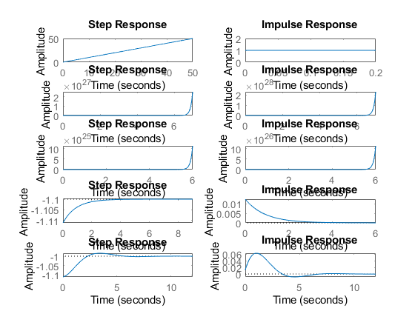
figure
hold on
pzmap(sys_P)
pzmap(sys_G_P)
pzmap(sys_PI_P)
pzmap(sys_PD_P)
pzmap(sys_PID_P)
pidTuner(sys_P)
pidTuner(sys_G_P)
pidTuner(sys_PI_P)
pidTuner(sys_PD_P)
pidTuner(sys_PID_P)
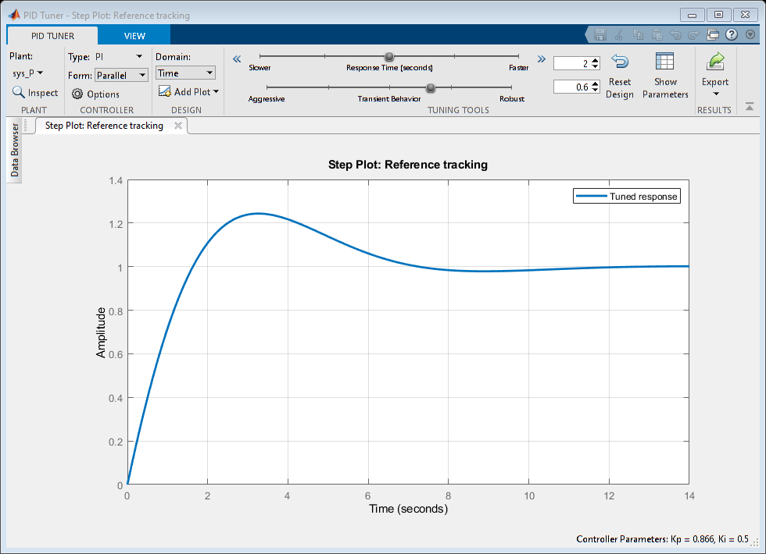
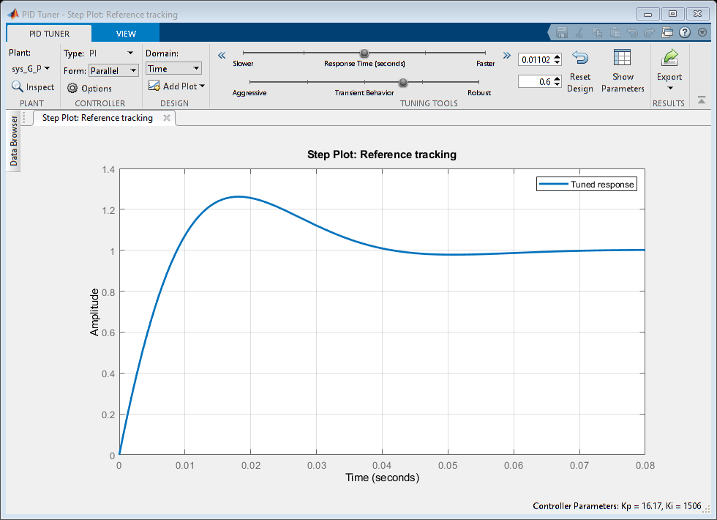
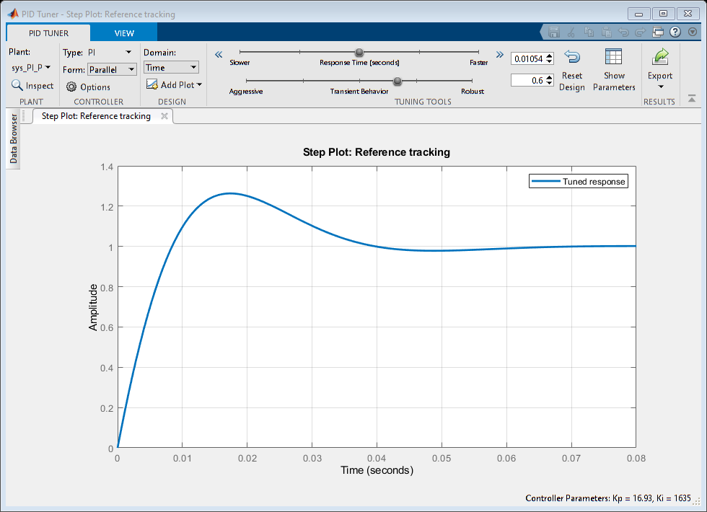
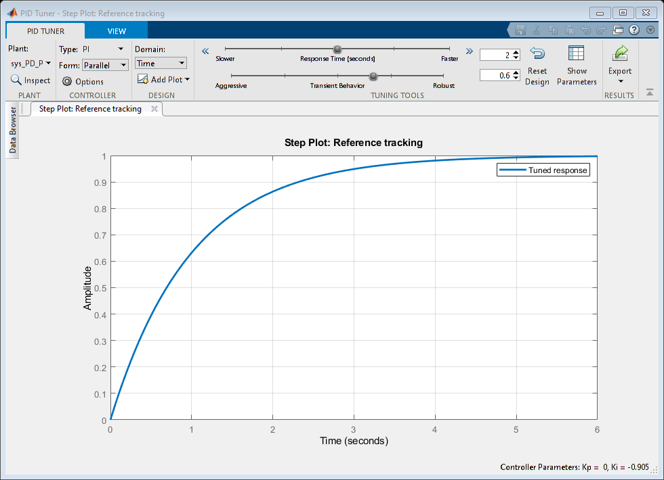
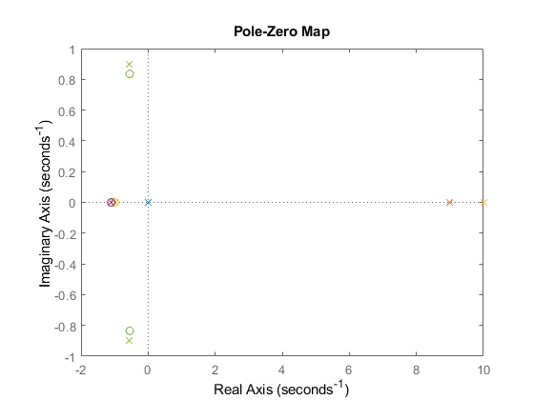
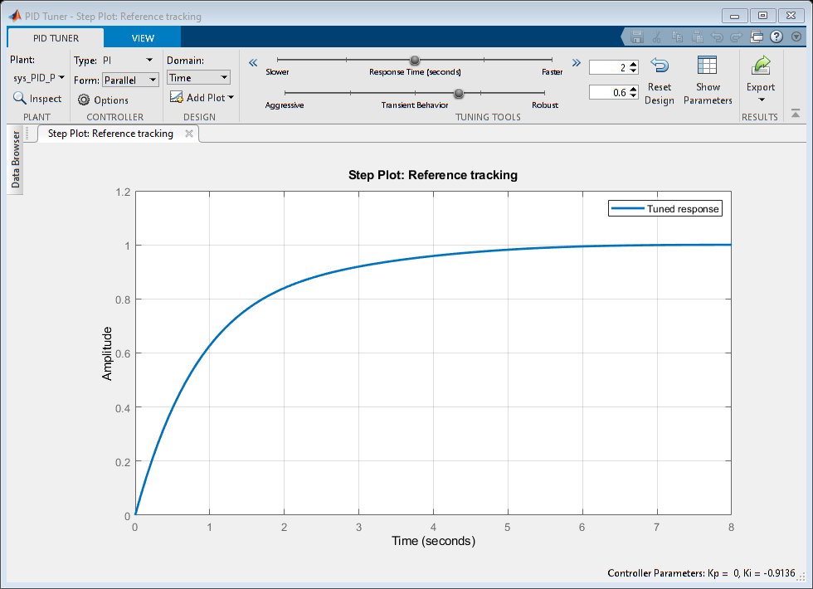

Analysis
1.With the positive feed back system by giving the gain as 10 we got a
%pole at p=9 that says that system is unstable.
% 2.with the Positive feed back system by givng the PI controller we got 2
% poles 1 at p1=10,p2=-1 and 1 zero at z1=-1 so the pole and one zero
% nullify each other and left a pole on the left side of imaginary axis
% making the system stable.
% 3.With the Pd controller we can see that 1 zero is getting added, and 1
% pole is getting fixated at -1.1111 and a zero at -1.10000 as pole is
% located at the left side of the imaginary axis the system is stable with
% a rise time 1.9773, and settling time of 3.5209 with a overshoot of 1.010
% 4.With the PID controller we can see that w eare getting complex
% conjugate poles and pair. p1=-0.5556+0.8958i,p2=-0.5556-0.8958i and
% zeroes arwe z1=-0.5500+0.8352i, z2=-0.5500-0.8352i anfd the s_t=7.1081,
% R_t=1.5943
% 5.So By observing the above mentioned settling time and rise time of the
% different controllers we are getting a stable system with PID controller.

With Negative feedback
figure
T=1;
sys = tf([1],[T,1])
sys_N=feedback(sys,1)
subplot(5,2,1)
step(sys_N)
subplot(5,2,2)
impulse(sys_N)
S = stepinfo(sys_N)
p_n=pole(sys_N)
z_n=zero(sys_N)
T=1;
CF=10;
sys = CF*tf([1],[T,1])
sys_G_N=feedback(sys,1)
subplot(5,2,3)
step(sys_G_N)
subplot(5,2,4)
impulse(sys_G_N)
S = stepinfo(sys_G_N)
p_gn=pole(sys_G_N)
z_gn=zero(sys_G_N)
T=1;
Kp=10;
I=tf([10,0],[1,0]); %Ki
PI=Kp+I;
sys = PI*tf([1],[T,1])
sys_PI_N=feedback(sys,1)
subplot(5,2,5)
step(sys_PI_N)
subplot(5,2,6)
impulse(sys_PI_N)
S = stepinfo(sys_PI_N)
p_npi=pole(sys_PI_N)
z_npi=zero(sys_PI_N)
T=1;
Kp=10;
D=tf([10,1],[0,1]); %Kd
PD=Kp+D;
sys = PD*tf([1],[T,1])
sys_PD_N=feedback(sys,1)
subplot(5,2,7)
step(sys_PD_N)
subplot(5,2,8)
impulse(sys_PD_N)
S = stepinfo(sys_PD_N)
p_npd=pole(sys_PD_N)
z_npd=zero(sys_PD_N)
T=1;
Kp=10;
D=tf([10,1],[0,1]) %Kd
I=tf([10],[1,0]) %Ki
PID=Kp+D+I
sys = PID*tf([1],[T,1])
sys_PID_N=feedback(sys,1)
subplot(5,2,9)
step(sys_PID_N)
subplot(5,2,10)
impulse(sys_PID_N)
S = stepinfo(sys_PID_N)
p_npid=pole(sys_PID_N)
z_npid=zero(sys_PID_N)
sys =
1
-----
s + 1
Continuous-time transfer function.
sys_N =
1
-----
s + 2
Continuous-time transfer function.
S =
struct with fields:
RiseTime: 1.0985
SettlingTime: 1.9560
SettlingMin: 0.4523
SettlingMax: 0.5000
Overshoot: 0
Undershoot: 0
Peak: 0.5000
PeakTime: 5.2729
p_n =
-2
z_n =
0×1 empty double column vector
sys =
10
-----
s + 1
Continuous-time transfer function.
sys_G_N =
10
------
s + 11
Continuous-time transfer function.
S =
struct with fields:
RiseTime: 0.1997
SettlingTime: 0.3556
SettlingMin: 0.8223
SettlingMax: 0.9091
Overshoot: 0
Undershoot: 0
Peak: 0.9091
PeakTime: 0.9587
p_gn =
-11
z_gn =
0×1 empty double column vector
sys =
20 s
-------
s^2 + s
Continuous-time transfer function.
sys_PI_N =
20 s
----------
s^2 + 21 s
Continuous-time transfer function.
S =
struct with fields:
RiseTime: 0.1046
SettlingTime: 0.1863
SettlingMin: 0.8614
SettlingMax: 0.9524
Overshoot: 0
Undershoot: 0
Peak: 0.9524
PeakTime: 0.5022
p_npi =
0
-21
z_npi =
0
sys =
10 s + 11
---------
s + 1
Continuous-time transfer function.
sys_PD_N =
10 s + 11
---------
11 s + 12
Continuous-time transfer function.
S =
struct with fields:
RiseTime: 2.0139
SettlingTime: 3.5861
SettlingMin: 0.9159
SettlingMax: 0.9167
Overshoot: 0
Undershoot: 0
Peak: 0.9167
PeakTime: 9.6670
p_npd =
-1.0909
z_npd =
-1.1000
D =
10 s + 1
Continuous-time transfer function.
I =
10
--
s
Continuous-time transfer function.
PID =
10 s^2 + 11 s + 10
------------------
s
Continuous-time transfer function.
sys =
10 s^2 + 11 s + 10
------------------
s^2 + s
Continuous-time transfer function.
sys_PID_N =
10 s^2 + 11 s + 10
------------------
11 s^2 + 12 s + 10
Continuous-time transfer function.
S =
struct with fields:
RiseTime: 1.8654
SettlingTime: 6.0686
SettlingMin: 0.9929
SettlingMax: 1.0102
Overshoot: 1.0208
Undershoot: 0
Peak: 1.0102
PeakTime: 3.8837
p_npid =
-0.5455 + 0.7820i
-0.5455 - 0.7820i
z_npid =
-0.5500 + 0.8352i
-0.5500 - 0.8352i
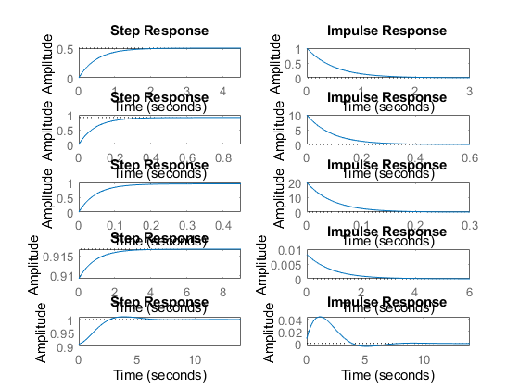
figure
hold on
pzmap(sys_N)
pzmap(sys_G_N)
pzmap(sys_PI_N)
pzmap(sys_PD_N)
pzmap(sys_PID_N)
pidTuner(sys_N)
pidTuner(sys_G_N)
pidTuner(sys_PI_N)
pidTuner(sys_PD_N)
pidTuner(sys_PID_N)
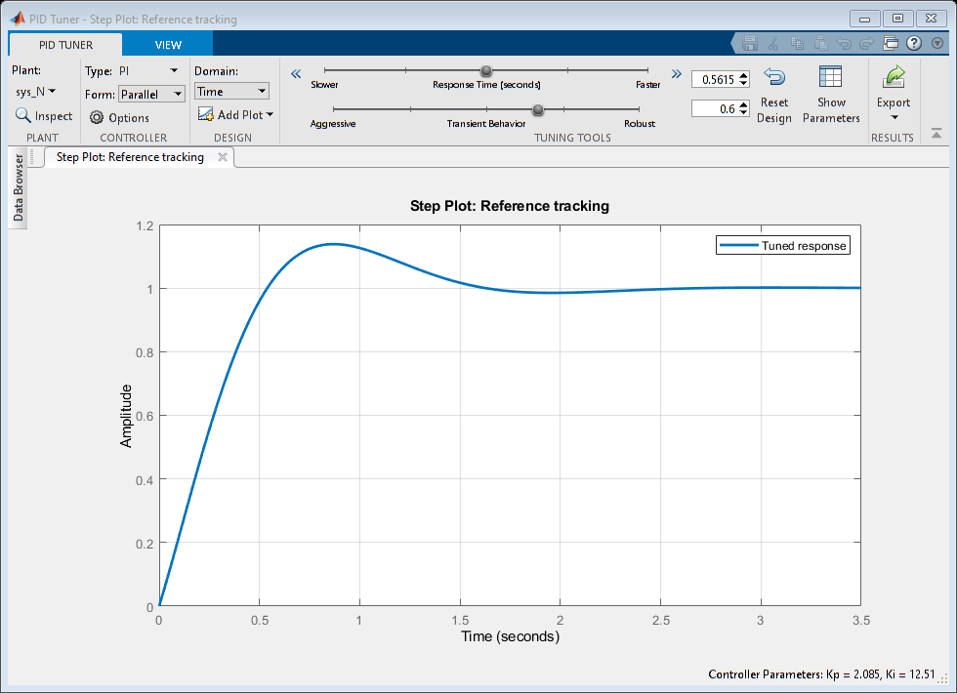
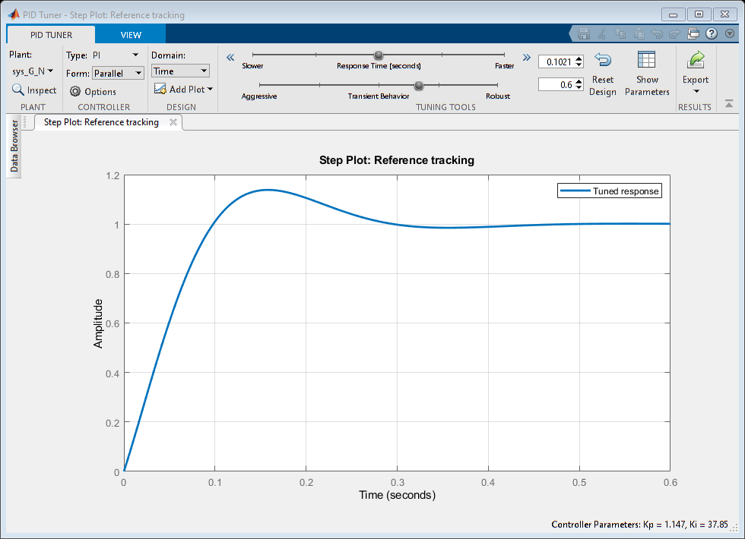
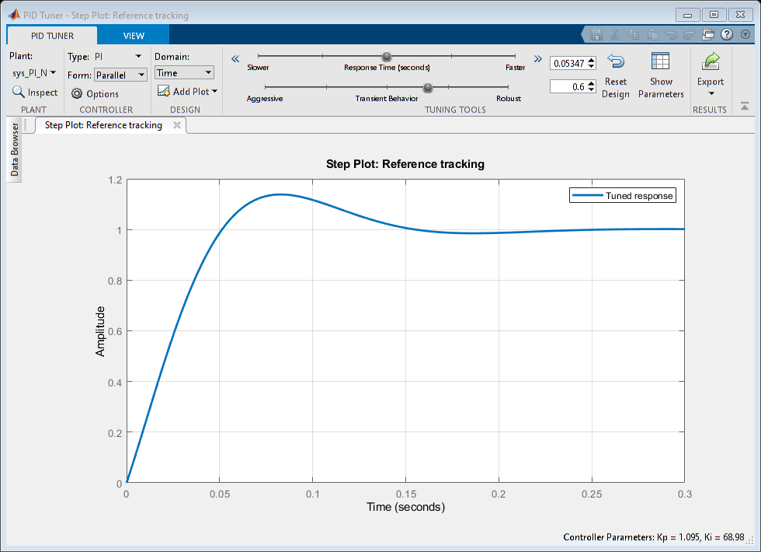
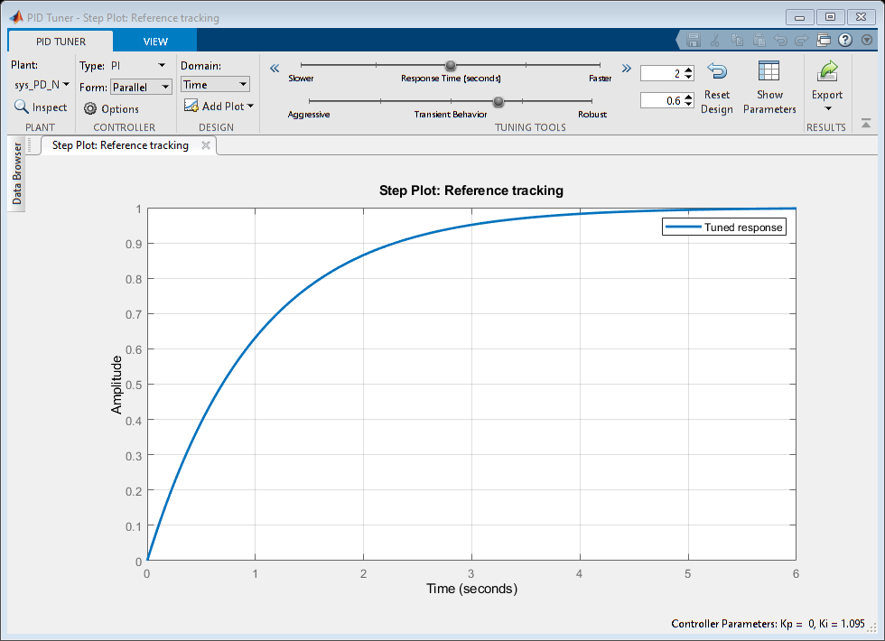
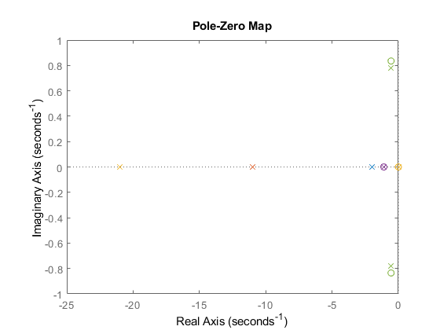
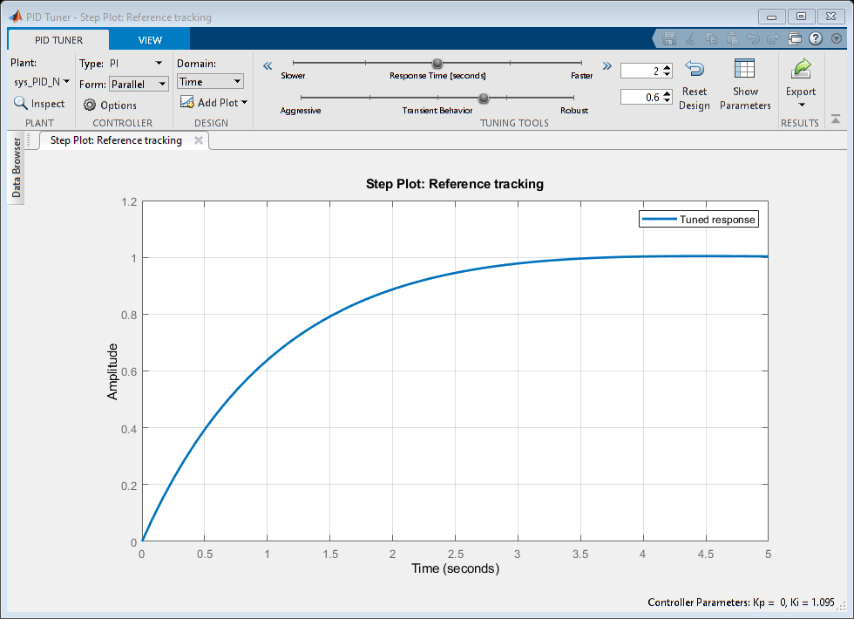

Analysis
1.with negaitve feed back gain we get 1 pole at p1=-11 which has a rise time of 0.1997, settling time of 0.3556 the system is stable. 2.with negative feed back Pi controller we get 2 poles at p1=-10,p2=-1 and a zero at z=-1, because of integrator in PI controller we are getting an extra pole in it now Risetime=0.2197,settling time=0.3912 as the poles are on the left side of imaginary axis we can say that system is stable. 3.with a negative feed back PID controller we are getting complex conjugate poles and zeroes which are z1=-0.5500+0.8352i,z2=-0.5500-0.8352i,p1=-0.5455+0.7820i, p2=-0.5455+0.7820i the settling time is 1.8654 and the rise time is6.0686 so we can say that PID controller can not make the system more stable than PI and PD controllers did.
Published with MATLAB® R2021a

