./

Learning Report – MBSE

Course Code: <CODE>



Version Number:

Team Members :

Team No:

Module: Model Based System Engineering

|  |  |  |  |  |  |
| --- | --- | --- | --- | --- | --- |
| **Ver. Rel. No.** | **Release Date** | **Prepared. By** | **Reviewed By** | **Approved By** | **Remarks/Revision Details** |
|  | 19-03-21 | ShivaKumar Naga Vankadhara |  |  |  |
|  |  |  |  |  |  |
|  |  |  |  |  |  |
|  |  |  |  |  |  |
|  |  |  |  |  |  |

**Document History**

# 

Contents

Team Work 3

**Activity 1** – Understanding Different MBSE Workflows Based on Business Domain 4

**Activity 2** – Modelling – Collective Learning (use any UML online tools: eg:- draw.io) 4

**Activity 3** – Explore the below resources and share learning and critical comments on the same 4

**Activity 4** – Complete Matlab Onramp 5

**Activity 5** – Complete Simulink Onramp 5

INTRODUCTION:

In automotive electronics, **body control module** or 'body computer' is a generic term for an electronic control unit responsible for monitoring and controlling various electronic accessories in a vehicle's body. Typically, in a car the BCM controls the power windows, power mirrors, air conditioning, immobilizer system, central locking, etc. The BCM communicates with other on-board computers via the car's vehicle bus, and its main application is controlling load drivers – actuating relays that in turn perform actions in the vehicle such as locking the doors or dimming the interior lighting

RESEARCH:

STEP1:

Car brand chosen Mercedes BENZ

STEP2:

Interface of the feature has a button on the door and 2 buttons on the back door.

Working:

It opens or closes if the user presses the button on the driver door and can hold the position of it by pressing the pause kind of button on the back of door and can resume the operation by pressing the stop button on the door which is present down the door and works with the sensor when the user places his leg near the sensor.

STEP3:

Input types: User inputs and Sensor input

Characteristics:

|  |  |  |  |  |
| --- | --- | --- | --- | --- |
| ProximitySensors | range | i/p range | o/p response | o/p current |
| Capacitive | 7.2mm-8.8mm(<1cm) | <=200mA | <35ms | <0.3mA |
| Optical | 50mm-100mm(1cm-10cm) | (2.3 V to 3.6 V)  Response(200ms) | <35ms | <0.3mA |
| Inductive | 30mm | <10ms&(10v-36v) | <=0.3mss | <0.3mA |

REFERRENCES:

* <https://www.onsemi.cn/pdf/datasheet/noa3302-d.pdf>
* <https://www.gavazzionline.com/pdf/CA12CLC0.pdf>
* <https://docs.rs-online.com/e8de/0900766b80274a6e.pdf>

Sensor chosen is Optical proximity sensor NOA3302 because the other sensors do need metal objects to get detection and the other sensors work only for short range of distance.

A servo motor is used to open the door and works with 3 different pulse widths to 3 different ranges 0to90degrees, 90to180degrees, in between 0 to 180 with milliseconds duration.

Flowchart:

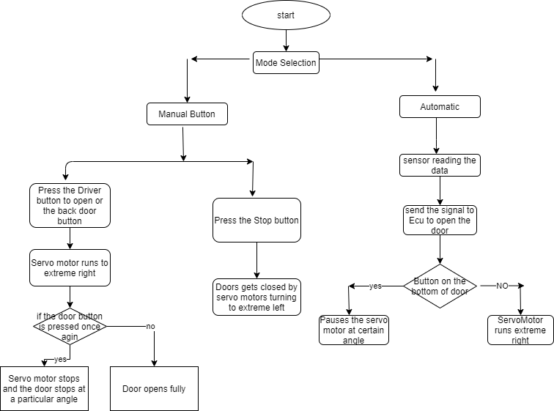

FEATURES:

Hatch opening

SWOT ANALYSIS:

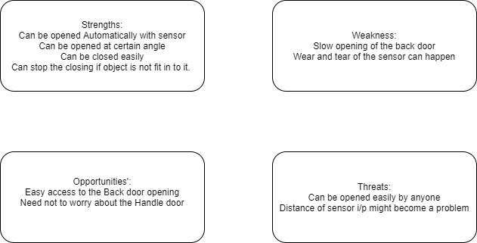

DETAILED REQUIREMNETS:

High Level Requirements:

Opening of the Back door through Physical switch and through Proximity sensor.

Low Level Requirements:

* Stopping of the door opening through a button located on the bottom such that the door servo motor stops at certain angle with the pulse width.
* Servomotor should go extreme right when there is no handle door button pressed. (i.e. Door will open)
* Servomotor should go extreme left when the user presses the stop button on the bottom of the door. (i.e. Door will close)
* Driver can open and close the back door from the door switch which is next to him.
* Door should not close when there is an object in the way (i.e. it should stop closing and should go back) for this pressure sensor is used.

Test Plans:

|  |  |  |  |  |  |  |
| --- | --- | --- | --- | --- | --- | --- |
| Test ID | Description | Exp IN | Exp OUT | Actual Out |  |  |
|  |  |  |  |  |  |  |
|  |  |  |  |  |  |  |
|  |  |  |  |  |  |  |
|  |  |  |  |  |  |  |
|  |  |  |  |  |  |  |