./

Learning Report – Automotive systems and overview

Course Code: <CODE>



Version Number:

Team Members :

Team No:

Module: Model Based System Engineering

|  |  |  |  |  |  |
| --- | --- | --- | --- | --- | --- |
| **Ver. Rel. No.** | **Release Date** | **Prepared. By** | **Reviewed By** | **Approved By** | **Remarks/Revision Details** |
| 1 | 19/03/2021 | Pushkar Antony |  |  |  |

**Document History**

# 

Table of Contents

**ACTIVITY 1**- ON RAMP CERTIFICATES………………………………………………………………………………………………………...4

**ACTIVITY 2**- DIFFERENCE EQUATIONS………………………………………………………………………………………………...….….7

**ACTIVITY 3**- DIFFERENTIAL EQUATIONS.…………………………………………………………………………………………………....9

Table of Figures

**FIGURE 1.1**- MATLAB ONRAMP CERTIFICATE..……………..……………………………….……………………………………….…..4

**FIGURE 1.2**- SIMULINK ONRAMP CERTIFICATE.....……………………………………………………………………………………....5

**FIGURE 1.3**- STATEFLOW ONRAMP CERTIFICATE…………………………………………………………………………………........6

**FIGURE 2.1**- DIFFERENCE EQUATION SIMULINK BLOCKS.…………………………………………………………………………...7

**FIGURE 2.2**- DIFFERENCE EQUATION OUTPUT GRAPH..……………………………………………………………………………...8

**FIGURE 3.1**- DIFFERENTIAL EQUATION SIMULINK BLOCKS..………………………………………………………………………..9

**FIGURE 3.2**- DIFFERENTIAL EQUATION OUTPUT GRAPH……………………………………………………………………………..9

1. INTRODUCTION:
   1. MY FEATURE:

Cruise control is a system that automatically controls the speed of a motor vehicle. The system is a servomechanism that takes over the throttle of the car to maintain a steady speed as set by the driver. The model selected for this project is 2020 GMC Sierra Denali.

Cruise control system provides automatic speed incrementation and decrementation of vehicle without the usage of gas pedal. Vehicles with wire drive systems use the same actuator to operate the cruise control. The actuator unit is connected to the throttle valve and controls the throttle butterfly position under the command of the cruise control ECU. Actuator mechanisms normally use either a permanent magnet DC motor assembly or a vacuum diaphragm powered by a motor-driven pneumatic pump and controlled by solenoid valves or, in many cases, a vacuum operated diaphragm controlled by three simple valves.

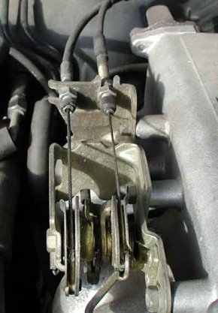

Fig1: One wire from actuator and another from gas pedal.

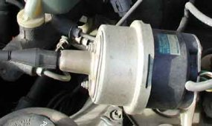

Fig2: Cruise control Actuator

* 1. REASEARCH & LITERATURE SURVEY:
     1. LITERATURE SURVEY:
     2. INPUTS:
        1. USER INPUT:
        + Cruise control on/off: Press to turn cruise control on or off.
        + +RES: If there is a set speed in memory, press the control up briefly to resume to that speed or press and hold to accelerate. If cruise control is already engaged, use to increase vehicle speed.
        + SET-: Press the control down briefly to set the speed and activate cruise control. If cruise control is already engaged, use to decrease the vehicle speed.
        + Disengage cruise with set memory: It disengages the cruise control without erasing the set speed from memory.

This user input is achieved using push buttons.

Full Datasheet Link: <https://cdn.dealereprocess.org/cdn/servicemanuals/gmc/2020-sierra1500.pdf>

Ex: Waytek round push button switch 44102

Characteristics:

* + - * Supply voltage: 14VDC
      * Supply current: 20A
      * IP65
      1. SENSOR INPUT:

Throttle Position sensor(TPS): The throttle is a valve mechanism allowing to modify the amount of gas flow into the cylinders of a gasoline internal combustion engine. The throttle is actuated directly by the driver through the gas pedal, and accordingly there was a mechanical connection between the two. The throttle position is mapped with the speed of the vehicle.

Input to the Sensor: Voltage (typically <25V, varies from sensor to sensor).

Sensor Output: Voltage (the peak voltage varies based on the sensor type and is proportional to the speed).

There are 3 types of TPS:

* + - * Potentiometric TPS Measurement: Potentiometers are widely used as a cheap means for measuring rotational positions.

Example: PC-PTN

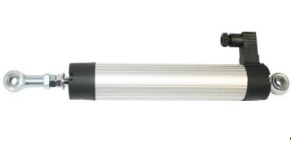

Fig3: Potentiometric TPS

Full Datasheet Link: <https://www.position-control.de/wpcontent/uploads/2016/09/Datasheet_PC_PTN.pdf>

Characteristics:

* Supply Voltage: 24VDC
* Output Voltage: 0-10VDC
* Output Current: 4-20mA
* Temperature range: -30°C to +100°C
* Life: 100 million movements
  + - * Inductive TPS Measurement: One way of measuring a rotational position in a contactless way is by using an inductive principle. Transmit coils send a signal, which is coupled back through a rotor into receiver coils.

Example: LX3302

Full Datasheet Link: <http://static6.arrow.com/aropdfconversion/b3010cd8c0c5ab0b28a10c4470af4a9918099493/7527135720-lx3302-datasheet.pdf>

Characteristics:

* Supply Voltage: 20V
* Operating Temperature: -40°C to +150°C
* Supply Current: 10mA
* Operating humidity: 0-95
* Frequency: 8.4 MHz
  + - * Magnetic TPS measurement: Hall-effect based magnetic sensors, fully integrated on silicon, have since achieved a considerable share in this application.

Example: 981 HE

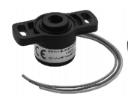

Fig4: Hall-effect TPS

Full Datasheet Link: [https://docs.rs-online.com/68d1/0900766b80fe81c1.pdf](https://docs.rs-online.com/68d1/0900766b80fe81c1.pdf%20)

Characteristics:

* Supply Voltage: 5VDC
* Supply Current: 10mA
* Weight: 19g
* Linearity: 1%
* Mechanical travel: 360°
  + 1. ALGORITHM (Flow Chart):

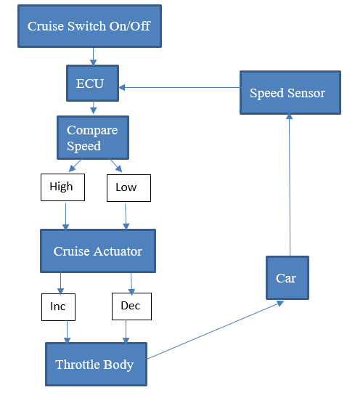

* + 1. OUTPUT:

The throttle position sensor sends the voltage values to the ECU, which translates the voltages into speeds and displays the speed in the speedometer.

Ex: 85mm Car Boat GPS Speedometer

Characteristics:

* Working Voltage: 9-32V
* Dimension: 85mm
* Range: 0-35knots/0-40miles per hour

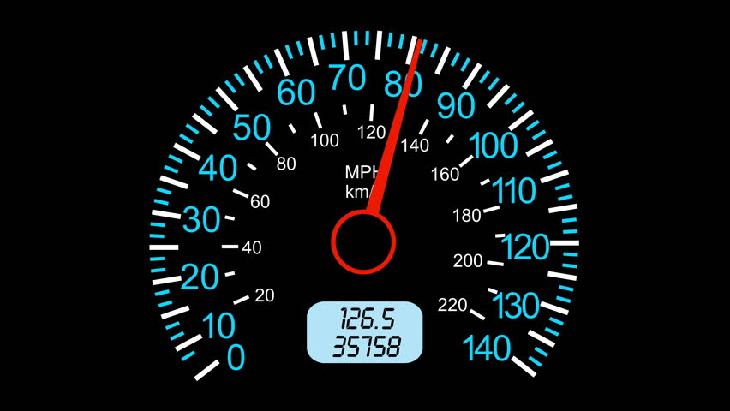

Fig5: Speedometer

* + 1. SWOT ANALYSIS:

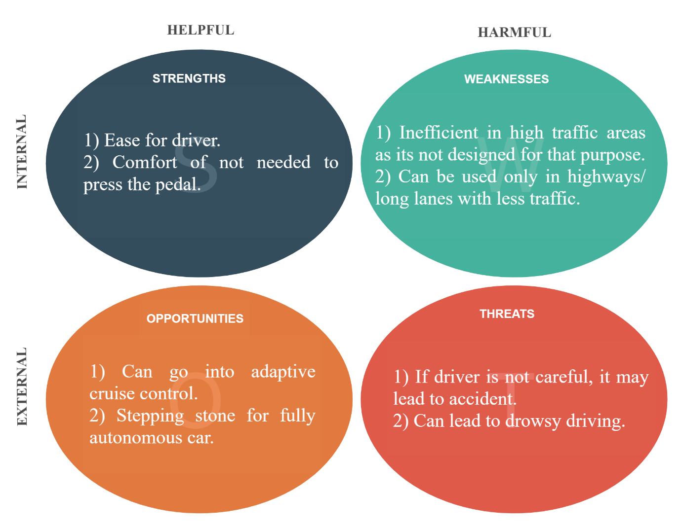

* + 1. DETAILED REQUIREMENTS:
       1. HIGH LEVEL REQUIREMENTS:
       2. LOW LEVEL REQUIREMENTS:
  1. HIGH LEVEL REQUIREMENTS:

Cruise control subsystem- The Cruise system was introduced to reduce the driver fatigue for long drives. It is a closed loop control system.

* 1. LOW LEVEL REQUIREMENTS:

The following is the list of functional requirements for a good cruise control system:

* Cruise control should turn on only if vehicle speed is >40kmph.
* It should hold the vehicle speed at the selected value.
* Hold the speed with minimum surging.
* Allow the vehicle to change speed.
* Deactivate the control immediately after the brakes are applied.
* Store the last set speed.

1. DESIGN & IMPLEMENTATION:
   1. HIGH LEVEL DESIGN:

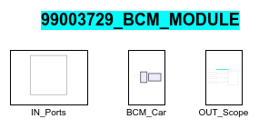

Fig6: HLR of my design

* 1. LOW LEVEL DSEIGN:

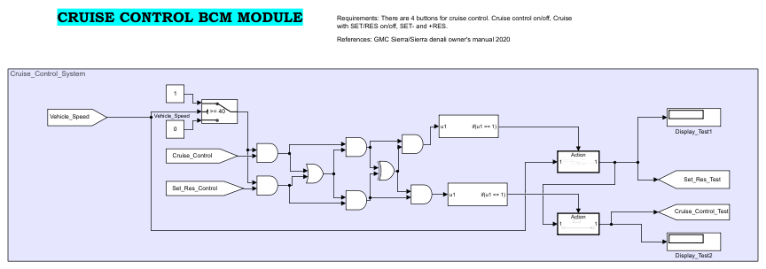

Fig7: Cruise Control design

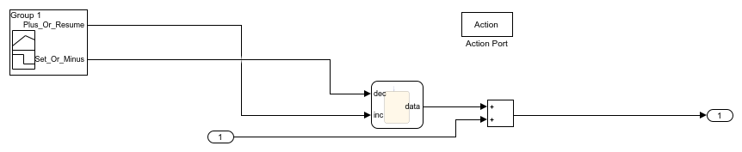

Fig8: SET- and +RES block

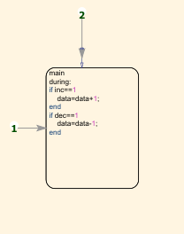

Fig9: Inside the chart of Fig8

1. TEST PLAN:

3.1 HIGH LEVEL TEST PLAN:

|  |  |  |  |  |
| --- | --- | --- | --- | --- |
| Test ID | Description | Input given | Output expected | Actual output |
| H_01 | A speed of 60kmph with cruise control switch in On state is given as input. | 60, Cruise On | 60 | 60 |

3.2 LOW LEVEL TEST PLAN:

|  |  |  |  |  |
| --- | --- | --- | --- | --- |
| Test ID | Description | Input given | Output expected | Actual output |
| L_01 | A speed of 39kmph given as input. | 39 | Cruise mode should not get activated | Cruise mode doesn’t get activated |
| L_02 | A speed of 45kmph given and “+RES” button is pressed 5 times. | 45, +RESx5 | 50 | 50 |
| L_03 | A speed of 67kmph given and “SET-” button is pressed 4 times | 67, SET-x4 | 63 | 63 |
| L_04 | Previous set cruise control is 55kmph, user turns on the cruise control and presses “SET-”. | SET- | 55 | 55 |