./

Learning Report – MBSE

Course Code: <CODE>



Version Number:

Team Members :

Team No:

Module: Model Based System Engineering

|  |  |  |  |  |  |
| --- | --- | --- | --- | --- | --- |
| **Ver. Rel. No.** | **Release Date** | **Prepared. By** | **Reviewed By** | **Approved By** | **Remarks/Revision Details** |
| 1 | 16/03/2021 | Pushkar Antony |  |  |  |

**Document History**

# 

Table of Contents

**ACTIVITY 1**- ON RAMP CERTIFICATES………………………………………………………………………………………………………...4

**ACTIVITY 2**- DIFFERENCE EQUATIONS………………………………………………………………………………………………...….….6

**ACTIVITY 3**- DIFFERENTIAL EQUATIONS.…………………………………………………………………………………………………....6

Table of Figures

**FIGURE 1.1**- MAKE FILE………………………………………………………………………………………………………………………….…..4

**FIGURE 2.1**- START-UP COMMAND…………………………………………………………………………………………………………....5

**FIGURE 3.1**- LINKER SCRIPT…………………………………………………………………………………………………………………........6

**FIGURE 5.1**- GPIO PIN CONFIG…………………………………………………………………………………………………………………...7

**FIGURE 5.2**- LED TOGGLE…………………………………………………………………………………………………………………………...8

**FIGURE 5.3**- GREEN LIGHT BLINKING…………………………………………………………………………………………………………..8

**FIGURE 5.4**- EXTI PIN CONFIG……………………………………………………………………………………………………………………..9

**FIGURE 5.5**- EXTI CODE………………………………………………………………………………………………………………….............10

**FIGURE 5.6**- ADC PIN CONFIG…………………………………………………………………………………………………………….........10

**FIGURE 5.7**- ADC CODE……………………………………………………………………………………………………………………...........11

**FIGURE 5.8**- SPI PIN CONFIG……………………………………………………………………………………………………………...........11

**FIGURE 5.9**- SPI CODE…………………………………………………………………………………………………………………….............12

**FIGURE 5.10**- UART PIN CONFIG………………………………………………………………………………………………………………...12

**FIGURE 5.11**- UART CODE…………………………………………………………………………………………………………………………..13

# ACTIVITY 1- ONRAMP CERTIFICATES:

MATLAB ON RAMP CERTIFICATE:

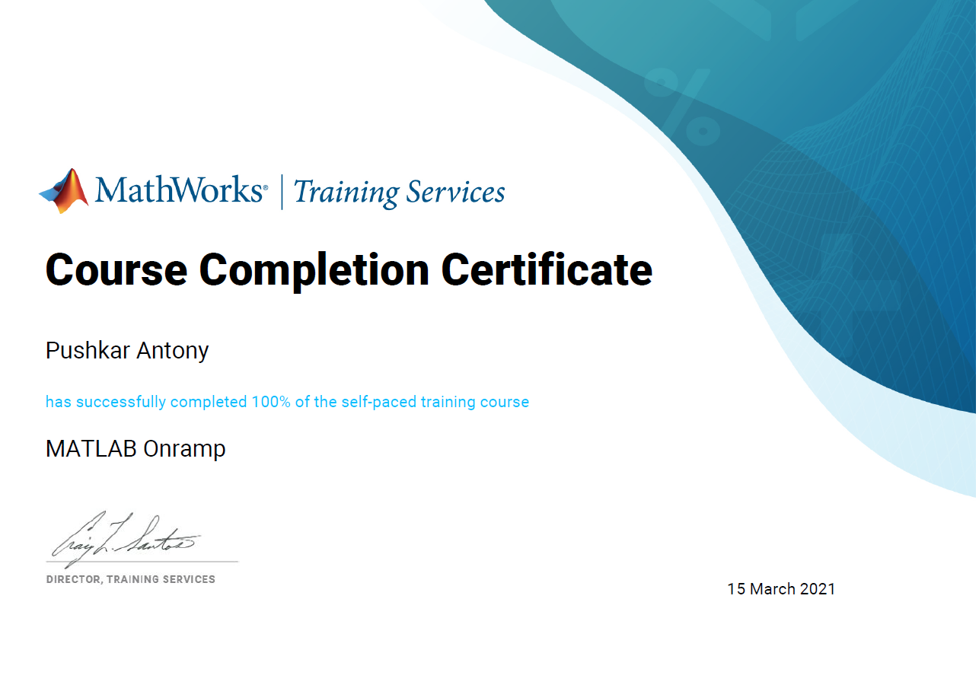

SIMULINK ONRAMP CERTIFICATE:

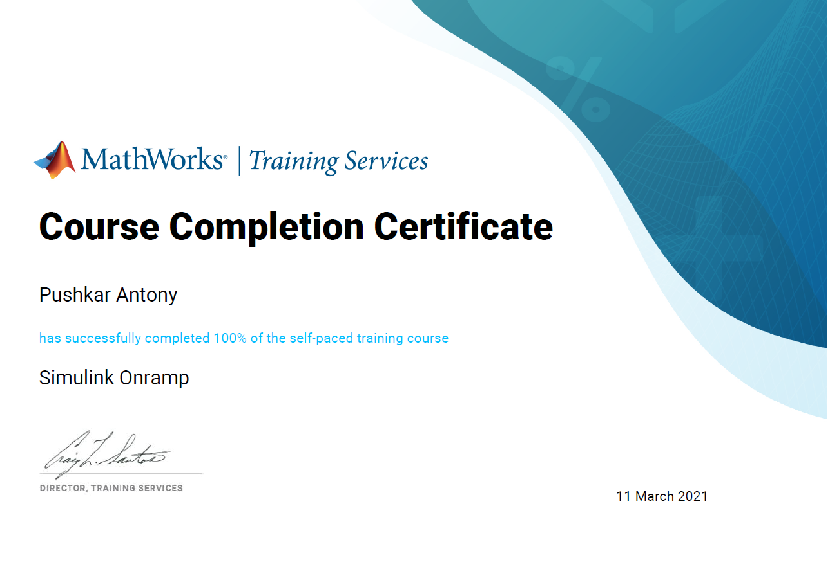

STATEFLOW ONRAMP CERTIFICATE:

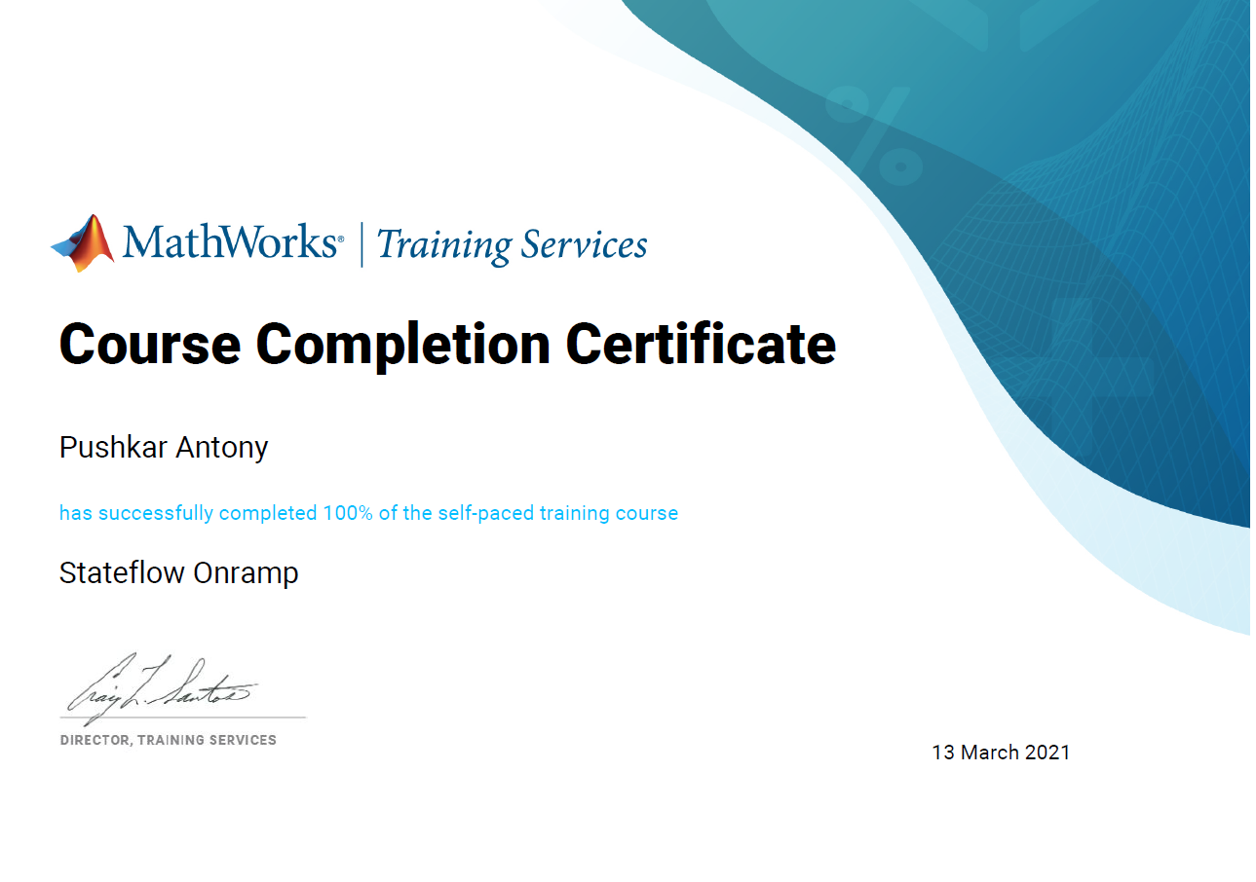

# ACTIVITY 2- DIFFERENCE EQUATIONS:

Difference equation I have taken is :

