./

Control Systems - Report



Version Number: 1.0

Name: Pushkar Antony

Module: Control Systems

|  |  |  |  |  |  |
| --- | --- | --- | --- | --- | --- |
| **Ver. Rel. No.** | **Release Date** | **Prepared. By** | **Reviewed By** | **Approved By** | **Remarks/Revision Details** |
| 1.0 | 14/04/2021 | Pushkar Antony | Shiva Kumar | Dr.Prithvi Sekhar | Individual report- Control Systems |

**Document History**

Contents

1(a) First Order Equation with open loop and without controller 5

Plant Description 5

Code………… 5

Math Analysis 10

Comparison Analysis:(Speed, Accuracy and stability): 10

1(b) First Order Equation with open loop and controller 10

Plant Description 10

Code…. 10

Math Analysis 14

Comparison Analysis:(Speed, Accuracy and stability): 14

1(c) First Order Equation 15

Plant Description 15

Code… 15

Math Analysis 24

Comparison Analysis:(Speed, Accuracy and stability): 24

2(a) Second Order MSD Equation 24

Plant Description 24

Code… 24

Math Analysis: 30

Comparison Analysis:(Speed, Accuracy and stability): 30

2(b) Second Order MSD Equation 31

Plant Description 31

Code… 31

Math Analysis: 35

Comparison Analysis:(Speed, Accuracy and stability): 36

2(c) Second Order MSD Equation 36

Plant Description 36

Code… 37

Math Analysis: 44

Comparison Analysis:(Speed, Accuracy and stability): 45

2(d) Movement of Poles. 46

Description: Movement of poles is shown along the real and imaginary axis 46

Analysis 47

2(e) Roots of the Standard Equation 47

Code… 47

Comparison Analysis: 54

2(f) PID Analysis 55

First Order System PID Analysis 55

Second Order System PID Analysis 56

Comparison Analysis: 57

3(a) Second Order Exponential Decay system 58

Plant Description 58

Without Controller 58

Open Loop with Controller (P) 60

Open Loop with Controller (I) 61

Closed Loop- Negative feedback with Controller (D) 63

Closed Loop- Positive feedback with Controller (D) 65

Math Analysis 67

Comparison Analysis 67

4(a) 1st Order Differential Equation Model 68

4(b) 2nd Order Differential Equation Model 69

4(c) Exponential Decay- Radioactive Material Model 69

5(a) Migration of Scripts to GNU Octave 70

5(b) Migration of Model to OpenModelica 71

# 1(a) First Order Equation with open loop and without controller

## Plant Description

The Mass-damper first order system is taken as Plant. Equation: f= Bv + M v' f = force; B= coefficient of friction; M = mass ; v= velocity. Values: B1= 0.4, M1=1000; B2= 0.5, M2= 500; B3= 1.7, M3= 340;

## Code

clc;  
B1= ([0.1 0.5 1.7]);  
M1=([1000 5 340]);  
for i=1:3  
 sys = tf([1/M1(i)],[1,B1(i)/M1(i)])  
 figure(i);  
 subplot(2,1,1);  
 impulse(sys);  
 title('Impulse Input');  
 subplot(2,1,2);  
 step(sys);  
 title('Step Input');  
 [z,p,k]= tf2zp([1/M1(i)],[1,B1(i)/M1(i)])  
 figure(4);  
 zplane(z,p);  
 xlim([-4*1e5 2*1e5]);  
 ylim([-4*1e5 2*1e5]);  
 hold on;  
 S = stepinfo(sys)  
end

sys =  
   
 0.001  
 ----------  
 s + 0.0001  
   
Continuous-time transfer function.  
  
  
z =  
  
 0×1 empty double column vector  
  
  
p =  
  
 -1.0000e-04  
  
  
k =  
  
 1.0000e-03  
  
  
S =   
  
 struct with fields:  
  
 RiseTime: 2.1970e+04  
 SettlingTime: 3.9121e+04  
 SettlingMin: 9.0450  
 SettlingMax: 9.9997  
 Overshoot: 0  
 Undershoot: 0  
 Peak: 9.9997  
 PeakTime: 1.0546e+05  
  
  
sys =  
   
 0.2  
 -------  
 s + 0.1  
   
Continuous-time transfer function.  
  
  
z =  
  
 0×1 empty double column vector  
  
  
p =  
  
 -0.1000  
  
  
k =  
  
 0.2000  
  
  
S =   
  
 struct with fields:  
  
 RiseTime: 21.9701  
 SettlingTime: 39.1207  
 SettlingMin: 1.8090  
 SettlingMax: 1.9999  
 Overshoot: 0  
 Undershoot: 0  
 Peak: 1.9999  
 PeakTime: 105.4584  
  
  
sys =  
   
 0.002941  
 ---------  
 s + 0.005  
   
Continuous-time transfer function.  
  
  
z =  
  
 0×1 empty double column vector  
  
  
p =  
  
 -0.0050  
  
  
k =  
  
 0.0029  
  
  
S =   
  
 struct with fields:  
  
 RiseTime: 439.4013  
 SettlingTime: 782.4149  
 SettlingMin: 0.5321  
 SettlingMax: 0.5882  
 Overshoot: 0  
 Undershoot: 0  
 Peak: 0.5882  
 PeakTime: 2.1092e+03

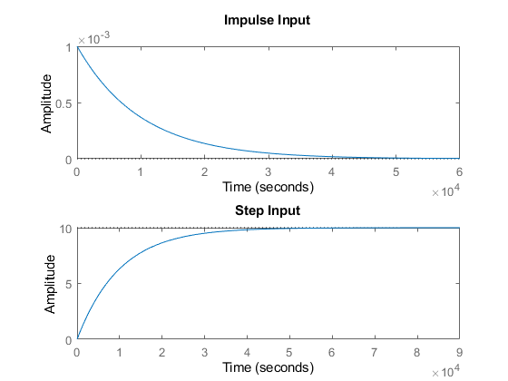

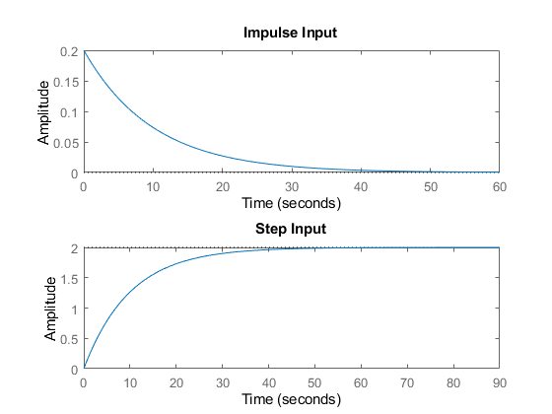

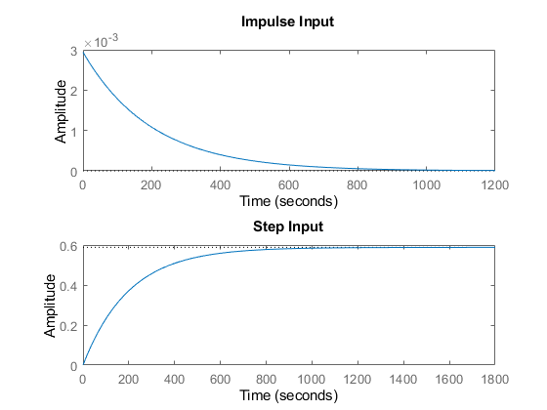

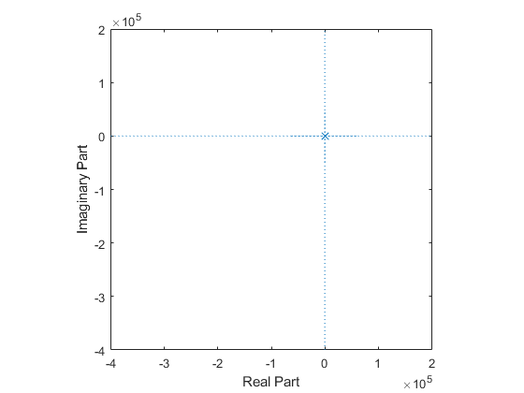

## Math Analysis

Independent: Time(t) Dependent: Velocity(v) and Force(f) Constant: Mass(M) and Frictional Coefficient(B)

% Roots:(-B)/M  
  
% IVT:  
% 1. For step input: 0  
% 2. For impulse input: 1/M  
  
% FVT:  
% 1. For step input: 1/B  
% 2. For impulse input: 0  
  
% Time Response Results:  
% Rise Time :4tau = (4M)/B; where tau = M/B

## Comparison Analysis:(Speed, Accuracy and stability):

1) s=0.001/(0.0001s+1)- a stable system as the poles are in the 2nd

%and 3rd quadrant.  
% 2) There is no overshoot since it’s a first order system.  
% 3) The rise time of 2nd system is least and hence it is the fastest  
%system.  
% 4) The settling time of 2nd system is least and hence making it more  
%accurate than the rest of them.  
% 5) The poles are moving farther away, the more the system becomes stable,  
%as we can see in 2nd system.

# 1(b) First Order Equation with open loop and controller

## Plant Description

The Mass-damper first order system is taken as Plant. Equation: f= Bv + M v' f = force; B= coefficient of friction; M = mass ; v= velocity. Values: B1= 0.4, M1=1000; B2= 0.5, M2= 500; B3= 1.7, M3= 340;

## Code

clc;  
B1= 0.5;  
M1= 5;  
P = 2;  
  
sys = tf([P/M1],[1,B1/M1])  
subplot(3,4,1);  
impulse(sys);  
title('Impulse Input for k');  
subplot(3,4,2);  
step(sys);  
title('Step Input for k');  
subplot(3,4,3);  
[z,p,k]= tf2zp([P/M1],[1,B1/M1])  
pzmap(sys)  
subplot(3,4,4);  
bode(sys)  
hold on;  
S = stepinfo(sys)  
  
sys = tf([P/M1],[1,B1/M1,0])  
subplot(3,4,5);  
impulse(sys);  
title('Impulse Input for 1/s');  
subplot(3,4,6);  
step(sys);  
title('Step Input for 1/s');  
subplot(3,4,7);  
[z,p,k]= tf2zp([P/M1],[1,B1/M1,0])  
pzmap(sys)  
subplot(3,4,8);  
bode(sys)  
hold on;  
S = stepinfo(sys)  
  
sys = tf([P/M1,0],[1,B1/M1])  
subplot(3,4,9);  
impulse(sys);  
title('Impulse Input for s');  
subplot(3,4,10);  
step(sys);  
title('Step Input for s');  
subplot(3,4,11);  
[z,p,k]= tf2zp([P/M1,0],[1,B1/M1])  
pzmap(sys)  
subplot(3,4,12);  
bode(sys)  
hold on;  
S = stepinfo(sys)

sys =  
   
 0.4  
 -------  
 s + 0.1  
   
Continuous-time transfer function.  
  
  
z =  
  
 0×1 empty double column vector  
  
  
p =  
  
 -0.1000  
  
  
k =  
  
 0.4000  
  
  
S =   
  
 struct with fields:  
  
 RiseTime: 21.9701  
 SettlingTime: 39.1207  
 SettlingMin: 3.6180  
 SettlingMax: 3.9999  
 Overshoot: 0  
 Undershoot: 0  
 Peak: 3.9999  
 PeakTime: 105.4584  
  
  
sys =  
   
 0.4  
 -----------  
 s^2 + 0.1 s  
   
Continuous-time transfer function.  
  
  
z =  
  
 0×1 empty double column vector  
  
  
p =  
  
 0  
 -0.1000  
  
  
k =  
  
 0.4000  
  
  
S =   
  
 struct with fields:  
  
 RiseTime: NaN  
 SettlingTime: NaN  
 SettlingMin: NaN  
 SettlingMax: NaN  
 Overshoot: NaN  
 Undershoot: NaN  
 Peak: Inf  
 PeakTime: Inf  
  
  
sys =  
   
 0.4 s  
 -------  
 s + 0.1  
   
Continuous-time transfer function.  
  
  
z =  
  
 0  
  
  
p =  
  
 -0.1000  
  
  
k =  
  
 0.4000  
  
  
S =   
  
 struct with fields:  
  
 RiseTime: 21.9701  
 SettlingTime: 39.1207  
 SettlingMin: 1.0521e-05  
 SettlingMax: 0.0382  
 Overshoot: 0  
 Undershoot: 7.2058e+17  
 Peak: 0.4000  
 PeakTime: 0

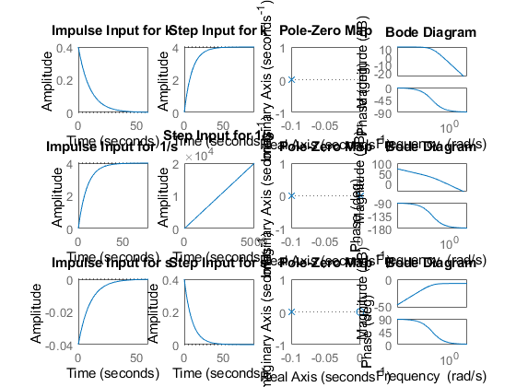

## Math Analysis

Independent: Time(t) Dependent: Velocity(v) and Force(f) Constant: Mass(M) and Frictional Coefficient(B)

% Roots:(-B)/M  
  
% IVT:  
% 1. For step input: 0  
% 2. For impulse input: 1/M  
  
% FVT:  
% 1. For step input: 1/B  
% 2. For impulse input: 0  
  
% Time Response Results:  
% Rise Time :4tau = (4M)/B; where tau = M/B

## Comparison Analysis:(Speed, Accuracy and stability):

1) when a Proportionality controller is introduced, only the amplitude

%is getting incremented and all other parameters like rise time, settling  
%time remain same as first order without controller.  
% 2) when an integrator controller is introduced, a pole gets added at the  
%origin and makes the system marginally stable.  
% 3) When a differentiator controller is introduced, a zero gets added to  
%the origin making any unstable system also stable.  
% 4) PID controllers control the whole system making them unstable to  
%stable, more stable, add poles, add zeros.

# 1(c) First Order Equation

## Plant Description

The Mass-damper first order system is taken as Plant. Equation: f= Bv + M v' f = force; B= coefficient of friction; M = mass ; v= velocity. Values: B1= 0.4, M1=1000; B2= 0.5, M2= 500; B3= 1.7, M3= 340;

## Code

%Negative Feedback using gain input  
clc;  
B1= 0.5;  
M1= 5;  
P = 2;  
sys = tf([P],[M1,B1+1])  
figure(1);  
subplot(2,2,1);  
impulse(sys);  
title('Impulse Input for k');  
subplot(2,2,2);  
step(sys);  
title('Step Input for k');  
subplot(2,2,3);  
[z,p,k]= tf2zp([P],[M1,B1+1])  
pzmap(sys)  
subplot(2,2,4)  
bode(sys)  
margin(sys)  
[Gm,Pm,Wcg,Wcp] = margin(sys)  
hold on;  
S = stepinfo(sys)  
  
B2= 0.5;  
M2= 5;  
P2 = 2;  
sys = tf([P2],[M2,B2+1,0])  
figure(2)  
subplot(2,2,1);  
impulse(sys);  
title('Impulse Input for Integrator controller');  
subplot(2,2,2);  
step(sys);  
title('Step Input for Integrator controller ');  
subplot(2,2,3);  
[z,p,k]= tf2zp([P2],[M2,B2+1,0])  
pzmap(sys)  
subplot(2,2,4)  
bode(sys)  
margin(sys)  
[Gm,Pm,Wcg,Wcp] = margin(sys)  
hold on;  
S = stepinfo(sys)  
  
%Positive Feedback using integral input  
B3= 0.8;  
M3= 5;  
sys = tf([1],[M3,B3-1,0])  
figure(3);  
subplot(2,2,1);  
impulse(sys);  
title('Step Input for Positive feedback');  
subplot(2,2,2);  
step(sys);  
title('Step Input for Positive feedback');  
subplot(2,2,3);  
[z,p,k]= tf2zp([1],[M3,B3-1,0])  
pzmap(sys)  
subplot(2,2,4)  
bode(sys)  
margin(sys)  
[Gm,Pm,Wcg,Wcp] = margin(sys)  
hold on;  
S = stepinfo(sys)  
  
%Positive Feedback using differentiator input  
B4= 0.8;  
M4= 5;  
sys = tf([1,0],[M4,B4-1])  
figure(4)  
subplot(2,2,1);  
impulse(sys);  
title('Step Input for Positive feedback');  
subplot(2,2,2);  
step(sys);  
title('Step Input for Positive feedback');  
subplot(2,2,3);  
[z,p,k]= tf2zp([1,0],[M4,B4-1])  
pzmap(sys)  
subplot(2,2,4)  
bode(sys)  
margin(sys)  
[Gm,Pm,Wcg,Wcp] = margin(sys)  
hold on;  
S = stepinfo(sys)

sys =  
   
 2  
 ---------  
 5 s + 1.5  
   
Continuous-time transfer function.  
  
  
z =  
  
 0×1 empty double column vector  
  
  
p =  
  
 -0.3000  
  
  
k =  
  
 0.4000  
  
  
Gm =  
  
 Inf  
  
  
Pm =  
  
 138.5925  
  
  
Wcg =  
  
 NaN  
  
  
Wcp =  
  
 0.2646  
  
  
S =   
  
 struct with fields:  
  
 RiseTime: 7.3234  
 SettlingTime: 13.0402  
 SettlingMin: 1.2060  
 SettlingMax: 1.3333  
 Overshoot: 0  
 Undershoot: 0  
 Peak: 1.3333  
 PeakTime: 35.1528  
  
  
sys =  
   
 2  
 -------------  
 5 s^2 + 1.5 s  
   
Continuous-time transfer function.  
  
  
z =  
  
 0×1 empty double column vector  
  
  
p =  
  
 0  
 -0.3000  
  
  
k =  
  
 0.4000  
  
  
Gm =  
  
 Inf  
  
  
Pm =  
  
 26.6470  
  
  
Wcg =  
  
 Inf  
  
  
Wcp =  
  
 0.5979  
  
  
S =   
  
 struct with fields:  
  
 RiseTime: NaN  
 SettlingTime: NaN  
 SettlingMin: NaN  
 SettlingMax: NaN  
 Overshoot: NaN  
 Undershoot: NaN  
 Peak: Inf  
 PeakTime: Inf  
  
  
sys =  
   
 1  
 -------------  
 5 s^2 - 0.2 s  
   
Continuous-time transfer function.  
  
  
z =  
  
 0×1 empty double column vector  
  
  
p =  
  
 0  
 0.0400  
  
  
k =  
  
 0.2000  
  
Warning: The closed-loop system is unstable.   
  
Gm =  
  
 Inf  
  
  
Pm =  
  
 -5.1214  
  
  
Wcg =  
  
 Inf  
  
  
Wcp =  
  
 0.4463  
  
  
S =   
  
 struct with fields:  
  
 RiseTime: NaN  
 SettlingTime: NaN  
 SettlingMin: NaN  
 SettlingMax: NaN  
 Overshoot: NaN  
 Undershoot: NaN  
 Peak: Inf  
 PeakTime: Inf  
  
  
sys =  
   
 s  
 ---------  
 5 s - 0.2  
   
Continuous-time transfer function.  
  
  
z =  
  
 0  
  
  
p =  
  
 0.0400  
  
  
k =  
  
 0.2000  
  
Warning: The closed-loop system is unstable.   
  
Gm =  
  
 Inf  
  
  
Pm =  
  
 Inf  
  
  
Wcg =  
  
 NaN  
  
  
Wcp =  
  
 NaN  
  
  
S =   
  
 struct with fields:  
  
 RiseTime: NaN  
 SettlingTime: NaN  
 SettlingMin: NaN  
 SettlingMax: NaN  
 Overshoot: NaN  
 Undershoot: NaN  
 Peak: Inf  
 PeakTime: Inf

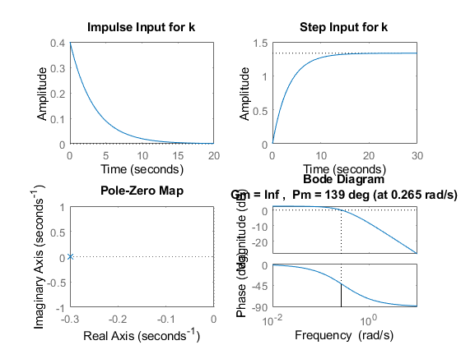

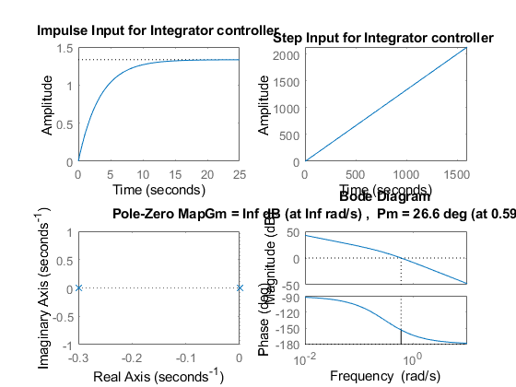

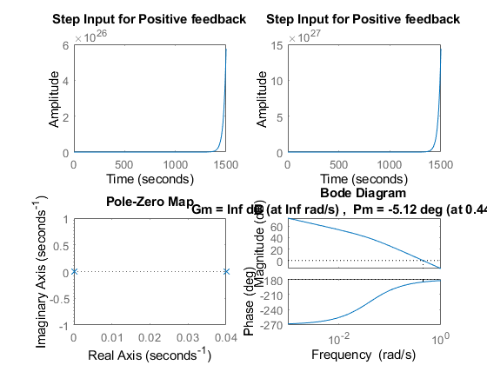

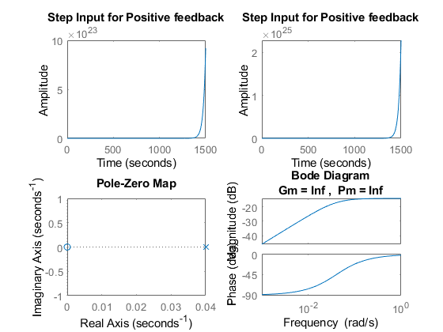

## Math Analysis

Independent: Time(t) Dependent: Velocity(v) and Force(f) Constant: Mass(M) and Frictional Coefficient(B)

% Roots:(-B)/M  
  
% IVT:  
% 1. For step input: 0  
% 2. For impulse input: 1/M  
  
% FVT:  
% 1. For step input: 1/B  
% 2. For impulse input: 0  
  
% Time Response Results:  
% Rise Time :4tau = (4M)/B; where tau = M/B

## Comparison Analysis:(Speed, Accuracy and stability):

1) When a P controller is introduced in a negative feedback system, the

%rise time and settling time decrease making the system more stable and  
%more faster.  
% 2) The P controller increases the amplitude of the entire system as well.  
% 3) The gain margin is infinity and phase margin is 139 deg indicating  
%that the loop never goes below 180 degree. The loop gain tf is a stable  
%low pass of first order.  
% 4) For positive feedback with controllers, the system becomes unstable.

# 2(a) Second Order MSD Equation

## Plant Description

The Mass-damper Spring Second order system is taken as Plant. It is used in as suspension. Equation: Mx''(t)+ Bx'(t) + Kx(t)= Kf(t). f = force; B= coefficient of friction; M = mass ; v= velocity; k=spring

%constant.  
% Values: K1= 0.9 B1= 0.4 M1=1000 Wn=0.03 ; K2= 1 B2= 0.5 M2= 500 Wn=0.44;  
%K3= 3 B3= 1.7 M3= 340 Wn=0.09;

## Code

clc;  
B1= ([0.1 0.5 1.7]);  
M1=([1000 5 340]);  
K1 = ([0.9 1 3]);  
for i=1:3  
 sys = tf([K1(i)/M1(i)],[1,B1(i)/M1(i),K1(i)/M1(i)])  
 figure(i);  
 subplot(2,1,1);  
 impulse(sys);  
 title('Impulse Input');  
 subplot(2,1,2);  
 step(sys);  
 title('Step Input');  
 [z,p,k]= tf2zp([K1(i)/M1(i)],[1,B1(i)/M1(i),K1(i)/M1(i)])  
 figure(4);  
 zplane(z,p);  
 xlim([-5*1e5 3*1e5]);  
 ylim([-5*1e5 3*1e5]);  
 hold on;  
 S = stepinfo(sys)  
end

sys =  
   
 0.0009  
 -----------------------  
 s^2 + 0.0001 s + 0.0009  
   
Continuous-time transfer function.  
  
  
z =  
  
 0×1 empty double column vector  
  
  
p =  
  
 -0.0001 + 0.0300i  
 -0.0001 - 0.0300i  
  
  
k =  
  
 9.0000e-04  
  
  
S =   
  
 struct with fields:  
  
 RiseTime: 34.7791  
 SettlingTime: 7.8226e+04  
 SettlingMin: 0.0104  
 SettlingMax: 1.9948  
 Overshoot: 99.4778  
 Undershoot: 0  
 Peak: 1.9948  
 PeakTime: 104.7198  
  
  
sys =  
   
 0.2  
 -----------------  
 s^2 + 0.1 s + 0.2  
   
Continuous-time transfer function.  
  
  
z =  
  
 0×1 empty double column vector  
  
  
p =  
  
 -0.0500 + 0.4444i  
 -0.0500 - 0.4444i  
  
  
k =  
  
 0.2000  
  
  
S =   
  
 struct with fields:  
  
 RiseTime: 2.5448  
 SettlingTime: 78.1524  
 SettlingMin: 0.5072  
 SettlingMax: 1.7021  
 Overshoot: 70.2118  
 Undershoot: 0  
 Peak: 1.7021  
 PeakTime: 7.0248  
  
  
sys =  
   
 0.008824  
 ------------------------  
 s^2 + 0.005 s + 0.008824  
   
Continuous-time transfer function.  
  
  
z =  
  
 0×1 empty double column vector  
  
  
p =  
  
 -0.0025 + 0.0939i  
 -0.0025 - 0.0939i  
  
  
k =  
  
 0.0088  
  
  
S =   
  
 struct with fields:  
  
 RiseTime: 11.3230  
 SettlingTime: 1.5426e+03  
 SettlingMin: 0.1540  
 SettlingMax: 1.9198  
 Overshoot: 91.9760  
 Undershoot: 0  
 Peak: 1.9198  
 PeakTime: 33.4448

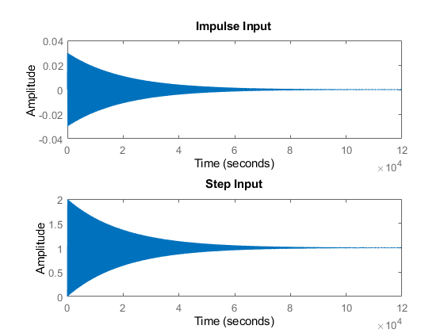

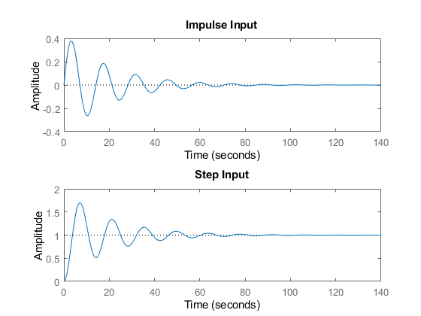

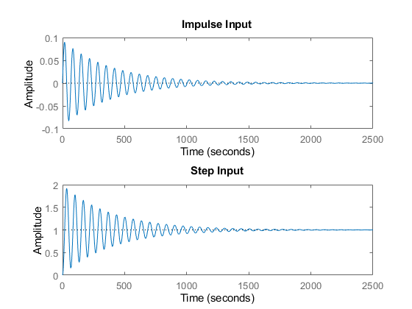

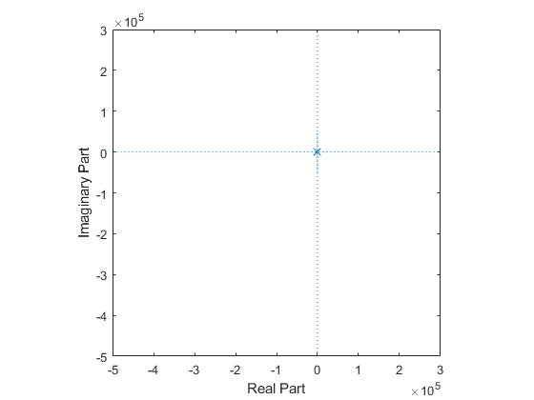

## Math Analysis:

Independent: Time(t) Dependent: Velocity(v) and Force(f) Constant: Mass(M), Frictional Coefficient(B), Spring constant(K) Roots:((-B/M)+-sqrt(sq(B/M)-4K/M))/2

% IVT:  
% 1. For step input: 0  
% 2. For impulse input: 0  
  
% FVT:  
% 1. For step input: 1  
% 2. For impulse input: K/M  
  
% Time Response Results:  
% RiseTime: 34.7791  
% SettlingTime: 7.8226e+04  
% SettlingMin: 0.0104  
% SettlingMax: 1.9948  
% Overshoot: 99.4778  
% Undershoot: 0  
% Peak: 1.9948  
% PeakTime: 104.7198  
  
%K2= 1 B2= 0.5 M2= 500  
% RiseTime: 2.5448  
% SettlingTime: 78.1524  
% SettlingMin: 0.5072  
% SettlingMax: 1.7021  
% Overshoot: 70.2118  
% Undershoot: 0  
% Peak: 1.7021  
% PeakTime: 7.0248  
  
%K3= 3 B3= 1.7 M3= 340  
% RiseTime: 11.3230  
% SettlingTime: 1.5426e+03  
% SettlingMin: 0.1540  
% SettlingMax: 1.9198  
% Overshoot: 91.9760  
% Undershoot: 0  
% Peak: 1.9198  
% PeakTime: 33.4448

## Comparison Analysis:(Speed, Accuracy and stability):

1) For sys 1 poles are on the LHS and they are complex conjugates which

%makes the system stable.  
% 2) For sys 2 poles are on LHS and they are complex conjugates which makes  
%the system stable.  
% 3) For sys 3 poles are on LHS and they are complex conjugates which makes  
%the system stable.  
% 4) Sys 2 has the least rising time and settling time making the system  
%fastest and most stable.

# 2(b) Second Order MSD Equation

## Plant Description

The Mass-damper Spring Second order system is taken as Plant. It is used in as suspension.

% Equation: Mx''(t)+ Bx'(t) + Kx(t)= Kf(t).  
% f = force; B= coefficient of friction; M = mass ; v= velocity; k=spring  
%constant.  
% Values: K1= 0.9 B1= 0.4 M1=1000 Wn=0.03 ; K2= 1 B2= 0.5 M2= 500 Wn=0.44;  
%K3= 3 B3= 1.7 M3= 340 Wn=0.09;

## Code

clc;  
B1= 0.5  
M1= 5;  
K1 =1;  
P=5;  
sys = tf([P*K1/M1],[1,B1/M1,K1/M1])  
subplot(4,3,1);  
impulse(sys);  
title('Impulse Input for k');  
subplot(4,3,2);  
step(sys);  
title('Step Input for k');  
subplot(4,3,3);  
[z,p,k]= tf2zp([P*K1/M1],[1,B1/M1,K1/M1])  
pzmap(sys)  
subplot(4,3,10);  
bode(sys)  
hold on;  
S = stepinfo(sys)  
  
sys = tf([P*K1/M1],[1,B1/M1,K1/M1,0])  
subplot(4,3,4);  
impulse(sys);  
title('Impulse Input for 1/s');  
subplot(4,3,5);  
step(sys);  
title('Step Input for 1/s');  
subplot(4,3,6);  
[z,p,k]= tf2zp([P*K1/M1],[1,B1/M1,K1/M1,0])  
pzmap(sys)  
subplot(4,3,11);  
bode(sys)  
hold on;  
S = stepinfo(sys)  
  
sys = tf([P*K1/M1,0],[1,B1/M1,K1/M1])  
subplot(4,3,7);  
impulse(sys);  
title('Impulse Input for s');  
subplot(4,3,8);  
step(sys);  
title('Step Input for s');  
subplot(4,3,9);  
[z,p,k]= tf2zp([P*K1/M1,0],[1,B1/M1,K1/M1])  
pzmap(sys)  
subplot(4,3,12);  
bode(sys)  
hold on;  
S = stepinfo(sys)

B1 =  
  
 0.5000  
  
  
sys =  
   
 1  
 -----------------  
 s^2 + 0.1 s + 0.2  
   
Continuous-time transfer function.  
  
  
z =  
  
 0×1 empty double column vector  
  
  
p =  
  
 -0.0500 + 0.4444i  
 -0.0500 - 0.4444i  
  
  
k =  
  
 1  
  
  
S =   
  
 struct with fields:  
  
 RiseTime: 2.5448  
 SettlingTime: 78.1524  
 SettlingMin: 2.5361  
 SettlingMax: 8.5106  
 Overshoot: 70.2118  
 Undershoot: 0  
 Peak: 8.5106  
 PeakTime: 7.0248  
  
  
sys =  
   
 1  
 ---------------------  
 s^3 + 0.1 s^2 + 0.2 s  
   
Continuous-time transfer function.  
  
  
z =  
  
 0×1 empty double column vector  
  
  
p =  
  
 0.0000 + 0.0000i  
 -0.0500 + 0.4444i  
 -0.0500 - 0.4444i  
  
  
k =  
  
 1  
  
  
S =   
  
 struct with fields:  
  
 RiseTime: NaN  
 SettlingTime: NaN  
 SettlingMin: NaN  
 SettlingMax: NaN  
 Overshoot: NaN  
 Undershoot: NaN  
 Peak: Inf  
 PeakTime: Inf  
  
  
sys =  
   
 s  
 -----------------  
 s^2 + 0.1 s + 0.2  
   
Continuous-time transfer function.  
  
  
z =  
  
 0  
  
  
p =  
  
 -0.0500 + 0.4444i  
 -0.0500 - 0.4444i  
  
  
k =  
  
 1  
  
  
S =   
  
 struct with fields:  
  
 RiseTime: 0  
 SettlingTime: 81.5509  
 SettlingMin: -1.3280  
 SettlingMax: 1.8877  
 Overshoot: Inf  
 Undershoot: Inf  
 Peak: 1.8877  
 PeakTime: 3.5124

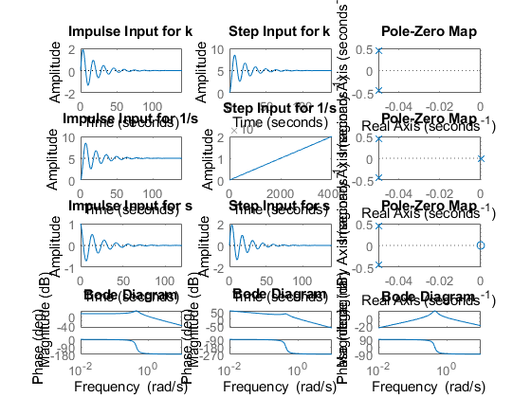

## Math Analysis:

Independent: Time(t) Dependent: Velocity(v) and Force(f) Constant: Mass(M), Frictional Coefficient(B), Spring constant(K)

% Roots:((-B/M)+-sqrt(sq(B/M)-4K/M))/2  
  
% IVT:  
% 1. For step input: 0  
% 2. For impulse input: 0  
  
% FVT:  
% 1. For step input: 1  
% 2. For impulse input: K/M  
  
% Time Response Results:  
% K1= 0.9 B1= 0.4 M1=1000  
% RiseTime: 2.5448  
% SettlingTime: 78.1524  
% SettlingMin: 2.5361  
% SettlingMax: 8.5106  
% Overshoot: 70.2118  
% Undershoot: 0  
% Peak: 8.5106  
% PeakTime: 7.0248  
  
  
%K2= 1 B2= 0.5 M2= 500  
% RiseTime: NaN  
% SettlingTime: NaN  
% SettlingMin: NaN  
% SettlingMax: NaN  
% Overshoot: NaN  
% Undershoot: NaN  
% Peak: Inf  
% PeakTime: Inf  
  
%K3= 3 B3= 1.7 M3= 340  
% RiseTime: 0  
% SettlingTime: 81.5509  
% SettlingMin: -1.3280  
% SettlingMax: 1.8877  
% Overshoot: Inf  
% Undershoot: Inf  
% Peak: 1.8877  
% PeakTime: 3.5124

## Comparison Analysis:(Speed, Accuracy and stability):

1) with proportionality controller, only the amplitude changes and all

%other stats are same as in 2nd order system without controller.  
% 2) On adding an integrator controller, a pole is getting added at the  
%origin and makes the system marginally stable.  
% 3) On adding a differentiator controller, a zero is added to the origin  
%making an unstable system stable.  
% 4) On adding a differentiator controller, the overshoot increases and  
%also the response time increase.

# 2(c) Second Order MSD Equation

## Plant Description

The Mass-damper Spring Second order system is taken as Plant. It is used in as suspension.

% Equation: Mx''(t)+ Bx'(t) + Kx(t)= Kf(t).  
% f = force; B= coefficient of friction; M = mass ; v= velocity; k=spring  
%constant.  
% Values: K1= 0.9 B1= 0.4 M1=1000 Wn=0.03 ; K2= 1 B2= 0.5 M2= 500 Wn=0.44;  
%K3= 3 B3= 1.7 M3= 340 Wn=0.09; B4= 9 M4= 5 K4=1;

## 

## Code

%For negative feedback  
clc;  
B1= 0.5  
M1= 5;  
K1 =1;  
P=5;  
  
sys = tf([P*K1],[M1,B1,2*K1])  
subplot(4,4,1);  
impulse(sys);  
title('Impulse Input for k');  
subplot(4,4,2);  
step(sys);  
title('Step Input for k');  
subplot(4,4,3);  
[z,p,k]= tf2zp([P*K1],[M1,B1,2*K1])  
pzmap(sys)  
subplot(4,4,4)  
bode(sys)  
margin(sys)  
[Gm,Pm,Wcg,Wcp] = margin(sys)  
hold on;  
S = stepinfo(sys)  
  
B2= -9  
M2= 5;  
K2=1;  
P2=5;  
  
sys = tf([P2*K2],[M2,B2,2*K2])  
subplot(4,4,5);  
impulse(sys);  
title('Impulse Input for k- Unstable');  
subplot(4,4,6);  
step(sys);  
title('Step Input for k- Unstable');  
subplot(4,4,7);  
[z,p,k]= tf2zp([P2*K2],[M2,B2,2*K2])  
pzmap(sys)  
subplot(4,4,8)  
bode(sys)  
margin(sys)  
[Gm,Pm,Wcg,Wcp] = margin(sys)  
hold on;  
S = stepinfo(sys)  
  
% For Positive feedback using I & D  
  
B3= 9  
M3= 5;  
K3=1;  
sys = tf([K3],[M3,B3,0,0])  
subplot(4,4,9);  
impulse(sys);  
title('Impulse Input for Positive feedback 1/s ');  
subplot(4,4,10);  
step(sys);  
title('Step Input for Positive feedback 1/s');  
subplot(4,4,11);  
[z,p,k]= tf2zp([K3],[M3,B3,0,0])  
pzmap(sys)  
subplot(4,4,12)  
bode(sys)  
margin(sys)  
[Gm,Pm,Wcg,Wcp] = margin(sys)  
hold on;  
S = stepinfo(sys)  
  
  
B4= 9  
M4= 5;  
K4=1;  
sys = tf([K4,0],[M4,B4,0])  
subplot(4,4,13);  
impulse(sys);  
title('Impulse Input for Positive feedback s ');  
subplot(4,4,14);  
step(sys);  
title('Step Input for Positive feedback s');  
subplot(4,4,15);  
[z,p,k]= tf2zp([K4,0],[M4,B4,0])  
pzmap(sys)  
subplot(4,4,16)  
bode(sys)  
margin(sys)  
[Gm,Pm,Wcg,Wcp] = margin(sys)  
hold on;  
S = stepinfo(sys)

B1 =  
  
 0.5000  
  
  
sys =  
   
 5  
 -----------------  
 5 s^2 + 0.5 s + 2  
   
Continuous-time transfer function.  
  
  
z =  
  
 0×1 empty double column vector  
  
  
p =  
  
 -0.0500 + 0.6305i  
 -0.0500 - 0.6305i  
  
  
k =  
  
 1  
  
  
Gm =  
  
 Inf  
  
  
Pm =  
  
 6.7782  
  
  
Wcg =  
  
 Inf  
  
  
Wcp =  
  
 1.1803  
  
  
S =   
  
 struct with fields:  
  
 RiseTime: 1.7526  
 SettlingTime: 75.6433  
 SettlingMin: 0.9814  
 SettlingMax: 4.4486  
 Overshoot: 77.9429  
 Undershoot: 0  
 Peak: 4.4486  
 PeakTime: 4.9673  
  
  
B2 =  
  
 -9  
  
  
sys =  
   
 5  
 ---------------  
 5 s^2 - 9 s + 2  
   
Continuous-time transfer function.  
  
  
z =  
  
 0×1 empty double column vector  
  
  
p =  
  
 1.5403  
 0.2597  
  
  
k =  
  
 1  
  
Warning: The closed-loop system is unstable.   
  
Gm =  
  
 Inf  
  
  
Pm =  
  
 -95.4008  
  
  
Wcg =  
  
 Inf  
  
  
Wcp =  
  
 0.5531  
  
  
S =   
  
 struct with fields:  
  
 RiseTime: NaN  
 SettlingTime: NaN  
 SettlingMin: NaN  
 SettlingMax: NaN  
 Overshoot: NaN  
 Undershoot: NaN  
 Peak: Inf  
 PeakTime: Inf  
  
  
B3 =  
  
 9  
  
  
sys =  
   
 1  
 -------------  
 5 s^3 + 9 s^2  
   
Continuous-time transfer function.  
  
  
z =  
  
 0×1 empty double column vector  
  
  
p =  
  
 0  
 0  
 -1.8000  
  
  
k =  
  
 0.2000  
  
Warning: The closed-loop system is unstable.   
  
Gm =  
  
 0  
  
  
Pm =  
  
 -10.4065  
  
  
Wcg =  
  
 0  
  
  
Wcp =  
  
 0.3306  
  
  
S =   
  
 struct with fields:  
  
 RiseTime: NaN  
 SettlingTime: NaN  
 SettlingMin: NaN  
 SettlingMax: NaN  
 Overshoot: NaN  
 Undershoot: NaN  
 Peak: Inf  
 PeakTime: Inf  
  
  
B4 =  
  
 9  
  
  
sys =  
   
 s  
 -----------  
 5 s^2 + 9 s  
   
Continuous-time transfer function.  
  
  
z =  
  
 0  
  
  
p =  
  
 0  
 -1.8000  
  
  
k =  
  
 0.2000  
  
Warning: The closed-loop system is unstable.   
  
Gm =  
  
 Inf  
  
  
Pm =  
  
 Inf  
  
  
Wcg =  
  
 NaN  
  
  
Wcp =  
  
 NaN  
  
  
S =   
  
 struct with fields:  
  
 RiseTime: 1.2206  
 SettlingTime: 2.1734  
 SettlingMin: 0.1005  
 SettlingMax: 0.1111  
 Overshoot: 0  
 Undershoot: 0  
 Peak: 0.1111  
 PeakTime: 5.8588

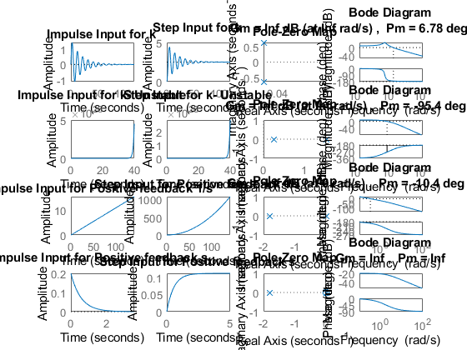

## Math Analysis:

Independent: Time(t) Dependent: Velocity(v) and Force(f) Constant: Mass(M), Frictional Coefficient(B), Spring constant(K)

% Roots:((-B/M)+-sqrt(sq(B/M)-4K/M))/2  
  
% IVT:  
% 1. For step input: 0  
% 2. For impulse input: 0  
  
% FVT:  
% 1. For step input: 1  
% 2. For impulse input: K/M  
  
% Time Response Results:  
% K1= 0.9 B1= 0.4 M1=1000  
% RiseTime: 1.7526  
% SettlingTime: 75.6433  
% SettlingMin: 0.9814  
% SettlingMax: 4.4486  
% Overshoot: 77.9429  
% Undershoot: 0  
% Peak: 4.4486  
% PeakTime: 4.9673  
  
%K2= 1 B2= 0.5 M2= 500  
% RiseTime: NaN  
% SettlingTime: NaN  
% SettlingMin: NaN  
% SettlingMax: NaN  
% Overshoot: NaN  
% Undershoot: NaN  
% Peak: Inf  
% PeakTime: Inf  
  
%K3= 3 B3= 1.7 M3= 340  
% RiseTime: NaN  
% SettlingTime: NaN  
% SettlingMin: NaN  
% SettlingMax: NaN  
% Overshoot: NaN  
% Undershoot: NaN  
% Peak: Inf  
% PeakTime: Inf  
  
%K4= 1 B4= 9 M4= 5;  
% RiseTime: 1.2206  
% SettlingTime: 2.1734  
% SettlingMin: 0.1005  
% SettlingMax: 0.1111  
% Overshoot: 0  
% Undershoot: 0  
% Peak: 0.1111  
% PeakTime: 5.8588

## Comparison Analysis:(Speed, Accuracy and stability):

%-ve feedback  
% 1) On adding a –ve feedback, the stability of the system reaches at a  
%faster speed.  
% 2) The gain margin is infinity and the phase margin is +ve value making  
%the system stable.  
% 3) When the gain margin is infinity and the phase margin is –ve value the  
%system becomes unstable.  
%+ve feedback  
% 1) When the gain margin is 0 and the phase margin is –ve value the  
%system becomes unstable.  
% 2) When both gain margin and phase margin are infinity, the errors get  
%accumulated and makes the system unstable.

# 2(d) Movement of Poles.

## Description: Movement of poles is shown along the real and imaginary axis

clc;  
poles = [-10+20i -10-20i -5+10i -5-10i -10+10i -10-10i 3+10i 3-10i -5+0i +5+0i -10+0i +10-0i ];  
zeros = [0 0];  
gain = 0.9;  
s=zpk(zeros,poles,gain);  
pzplot(s)  
[wn,zeta] = damp(s)

wn =  
  
 5.0000  
 5.0000  
 10.0000  
 10.0000  
 10.4403  
 10.4403  
 11.1803  
 11.1803  
 14.1421  
 14.1421  
 22.3607  
 22.3607  
  
  
zeta =  
  
 1.0000  
 -1.0000  
 1.0000  
 -1.0000  
 -0.2873  
 -0.2873  
 0.4472  
 0.4472  
 0.7071  
 0.7071  
 0.4472  
 0.4472

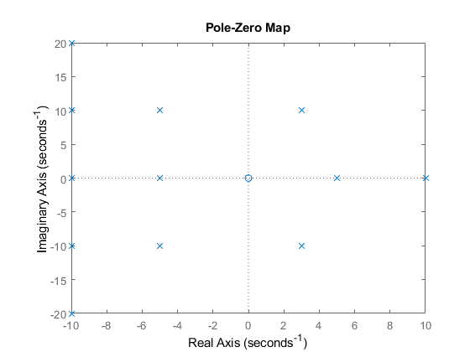

## Analysis

If we move along the roots along the wn, the frequency of the system increases. Overshoot remains same. If we move along the jw axis, overshoot of system increases. frequency of system increases. If we move along zeta wn axis or sigma, Overshoot increases, frequency decreases on right side movement. Overshoot decreases, frequency increases on left side movement.

# 2(e) Roots of the Standard Equation

## Code

clc;  
zeta=1;  
TF=tf([1],[1,(2*zeta),1])  
sys = tf([1],[1,(2*zeta),1])  
figure  
subplot(2,3,1)  
S = stepinfo(sys)  
[z,p,k]= tf2zp([1],[1,(2*zeta),1])  
zplane(z,p)  
  
zeta=0.7 ;  
TF=tf([1],[1,(2*zeta),1])  
sys = tf([1],[1,(2*zeta),1])  
subplot(2,3,2)  
S = stepinfo(sys)  
[z,p,k]= tf2zp([1],[1,(2*zeta),1])  
zplane(z,p)  
  
zeta=2;  
TF=tf([1],[1,(2*zeta),1])  
sys = tf([1],[1,(2*zeta),1])  
subplot(2,3,3)  
S = stepinfo(sys)  
[z,p,k]= tf2zp([1],[1,(2*zeta),1])  
zplane(z,p)  
  
zeta=-1.85;  
TF=tf([1],[1,(2*zeta),1])  
sys = tf([1],[1,(2*zeta),1])  
subplot(2,3,4)  
S = stepinfo(sys)  
[z,p,k]= tf2zp([1],[1,(2*zeta),1])  
zplane(z,p)  
  
zeta=-0.4;  
TF=tf([1],[1,(2*zeta),1])  
sys = tf([1],[1,(2*zeta),1])  
subplot(2,3,5)  
S = stepinfo(sys)  
[z,p,k]= tf2zp([1],[1,(2*zeta),1])  
zplane(z,p)  
  
zeta=-2.45;  
TF=tf([1],[1,(2*zeta),1])  
sys = tf([1],[1,(2*zeta),1])  
subplot(2,3,6)  
S = stepinfo(sys)  
[z,p,k]= tf2zp([1],[1,(2*zeta),1])  
zplane(z,p)

TF =  
   
 1  
 -------------  
 s^2 + 2 s + 1  
   
Continuous-time transfer function.  
  
  
sys =  
   
 1  
 -------------  
 s^2 + 2 s + 1  
   
Continuous-time transfer function.  
  
  
S =   
  
 struct with fields:  
  
 RiseTime: 3.3579  
 SettlingTime: 5.8339  
 SettlingMin: 0.9000  
 SettlingMax: 0.9994  
 Overshoot: 0  
 Undershoot: 0  
 Peak: 0.9994  
 PeakTime: 9.7900  
  
  
z =  
  
 0×1 empty double column vector  
  
  
p =  
  
 -1  
 -1  
  
  
k =  
  
 1  
  
  
TF =  
   
 1  
 ---------------  
 s^2 + 1.4 s + 1  
   
Continuous-time transfer function.  
  
  
sys =  
   
 1  
 ---------------  
 s^2 + 1.4 s + 1  
   
Continuous-time transfer function.  
  
  
S =   
  
 struct with fields:  
  
 RiseTime: 2.1268  
 SettlingTime: 5.9789  
 SettlingMin: 0.9001  
 SettlingMax: 1.0460  
 Overshoot: 4.5986  
 Undershoot: 0  
 Peak: 1.0460  
 PeakTime: 4.4078  
  
  
z =  
  
 0×1 empty double column vector  
  
  
p =  
  
 -0.7000 + 0.7141i  
 -0.7000 - 0.7141i  
  
  
k =  
  
 1  
  
  
TF =  
   
 1  
 -------------  
 s^2 + 4 s + 1  
   
Continuous-time transfer function.  
  
  
sys =  
   
 1  
 -------------  
 s^2 + 4 s + 1  
   
Continuous-time transfer function.  
  
  
S =   
  
 struct with fields:  
  
 RiseTime: 8.2308  
 SettlingTime: 14.8789  
 SettlingMin: 0.9017  
 SettlingMax: 0.9993  
 Overshoot: 0  
 Undershoot: 0  
 Peak: 0.9993  
 PeakTime: 27.3269  
  
  
z =  
  
 0×1 empty double column vector  
  
  
p =  
  
 -3.7321  
 -0.2679  
  
  
k =  
  
 1  
  
  
TF =  
   
 1  
 ---------------  
 s^2 - 3.7 s + 1  
   
Continuous-time transfer function.  
  
  
sys =  
   
 1  
 ---------------  
 s^2 - 3.7 s + 1  
   
Continuous-time transfer function.  
  
  
S =   
  
 struct with fields:  
  
 RiseTime: NaN  
 SettlingTime: NaN  
 SettlingMin: NaN  
 SettlingMax: NaN  
 Overshoot: NaN  
 Undershoot: NaN  
 Peak: Inf  
 PeakTime: Inf  
  
  
z =  
  
 0×1 empty double column vector  
  
  
p =  
  
 3.4064  
 0.2936  
  
  
k =  
  
 1  
  
  
TF =  
   
 1  
 ---------------  
 s^2 - 0.8 s + 1  
   
Continuous-time transfer function.  
  
  
sys =  
   
 1  
 ---------------  
 s^2 - 0.8 s + 1  
   
Continuous-time transfer function.  
  
  
S =   
  
 struct with fields:  
  
 RiseTime: NaN  
 SettlingTime: NaN  
 SettlingMin: NaN  
 SettlingMax: NaN  
 Overshoot: NaN  
 Undershoot: NaN  
 Peak: Inf  
 PeakTime: Inf  
  
  
z =  
  
 0×1 empty double column vector  
  
  
p =  
  
 0.4000 + 0.9165i  
 0.4000 - 0.9165i  
  
  
k =  
  
 1  
  
  
TF =  
   
 1  
 ---------------  
 s^2 - 4.9 s + 1  
   
Continuous-time transfer function.  
  
  
sys =  
   
 1  
 ---------------  
 s^2 - 4.9 s + 1  
   
Continuous-time transfer function.  
  
  
S =   
  
 struct with fields:  
  
 RiseTime: NaN  
 SettlingTime: NaN  
 SettlingMin: NaN  
 SettlingMax: NaN  
 Overshoot: NaN  
 Undershoot: NaN  
 Peak: Inf  
 PeakTime: Inf  
  
  
z =  
  
 0×1 empty double column vector  
  
  
p =  
  
 4.6866  
 0.2134  
  
  
k =  
  
 1

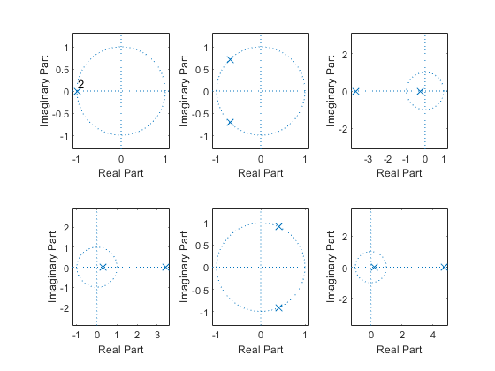

## Comparison Analysis:

1st value lise on negative x axis means: Critically-damped case & stable 2nd value lise in 2nd & 3rd quadrant means: Under-damp case & stable 3rd value lise on negative x axis means: Overdamped case & stable 4th value lise on positive x axis means: unstable 5th value lise on 1st & 4th quadrant means: unstable 6th value lise on positive x axis means: unstable

# 2(f) PID Analysis

## First Order System PID Analysis

clc;  
B1= 0.5;  
M1= 5;  
P1 = 2;  
sys1 = tf([P1],[M1,B1+1])  
pidTuner(sys1)

sys1 =  
   
 2  
 ---------  
 5 s + 1.5  
   
Continuous-time transfer function.

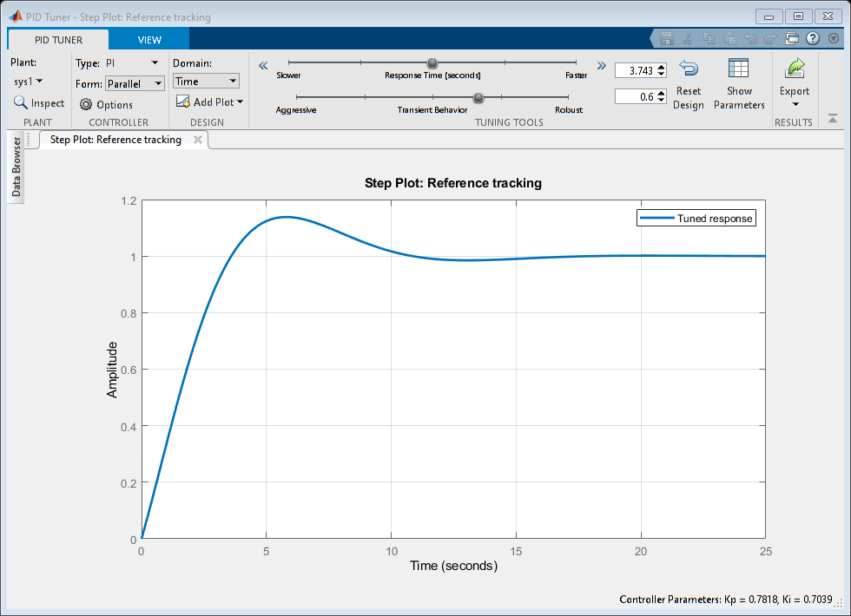

## Second Order System PID Analysis

B2= 0.5  
M2= 5;  
K2 =1;  
P2=5;  
sys2 = tf([P2*K2],[M2,B2,2*K2])  
pidTuner(sys2)

B2 =  
  
 0.5000  
  
  
sys2 =  
   
 5  
 -----------------  
 5 s^2 + 0.5 s + 2  
   
Continuous-time transfer function.

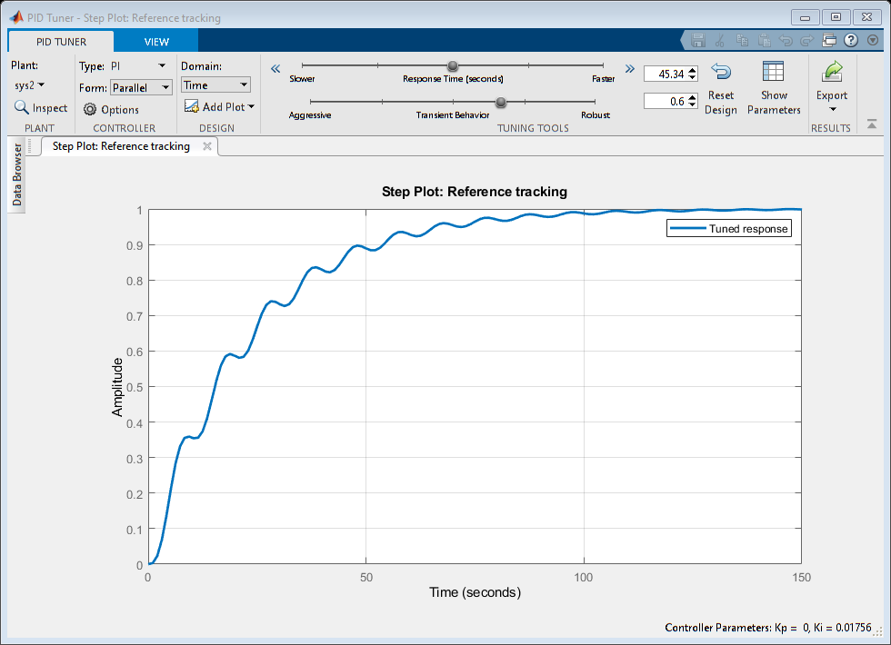

## Comparison Analysis:

First Order sys: PI: Ideal system: Kp= 0.78 (Un-Tuned) Ki= 0.7 Tr= 2.7 Ts= 9.87 Overshoot= 13.8%

Best system: Kp= 1.25  
 (After Tuning) Ki= 0.46  
 Tr= 3.59  
 Ts= 5.39  
 Overshoot= 1.33%

PD: Ideal system: Kp= 53.18  
 (Un-Tuned) Kd= 0  
 Tr= 0.102  
 Ts= 0.181  
 Overshoot= 0

Best system: Kp= 53.18  
 (After Tuning) Kd= 0  
 Tr= 0.102  
 Ts= 0.181  
 Overshoot= 0

PID: Ideal system: Kp= 1.07  
 (Un-Tuned) Ki= 0.53  
 Kd= 0  
 Tr= 3.04  
 Ts= 10.6  
 Overshoot= 6.08%

Best system: Kp= 1.07  
 (After Tuning) Ki= 0.53  
 Kd= 0  
 Tr= 3.04  
 Ts= 10.6  
 Overshoot= 6.08%

% Second Order sys:  
% PI: Ideal system: Tr= 51.1  
% (Un-Tuned) Ts= 94.3  
% Overshoot= 0%  
%  
% Best system: Tr= 50.4  
% (After Tuning) Ts= 93.4  
% Overshoot= 0.00235%  
%  
% PD: Ideal system: Kp= 2697.9  
% (Un-Tuned) Kd= 63.48  
% Tr= 0.0179  
% Ts= 0.13  
% Overshoot= 24.3%  
%  
% Best system: Kp= 27.35  
% (After Tuning) Kd= 6.251  
% Tr= 0.175  
% Ts= 1.35  
% Overshoot= 24.71%  
%  
% PID: Ideal system: Kp= 3.053  
% (Un-Tuned) Ki= 0.68  
% Kd= 2.66  
% Tr= 0.495  
% Ts= 9.3  
% Overshoot= 12.4%  
%  
% Best system: Kp= 3.053  
% (After Tuning) Ki= 0.68  
% Kd= 2.66  
% Tr= 0.495  
% Ts= 9.3  
% Overshoot= 12.4%

# 3(a) Second Order Exponential Decay system

## Plant Description

It is a exponential decay system of a radioactive material Equation- dM/dt=-kA(e^-kt) M=mass, k=constant, A= non zero constant, t=time Values- k=0.14, A=200

## Without Controller

clc;  
k= 0.14;  
A= 200;  
sys = tf([-k*A],[1,k,0])  
figure(1);  
subplot(3,1,1);  
impulse(sys);  
title('Impulse Input');  
subplot(3,1,2);  
step(sys);  
title('Step Input');  
[z,p,k] = tf2zp([-k*A],[1,k,0])  
subplot(3,1,3);  
zplane(z,p);  
S = stepinfo(sys)

sys =  
   
 -28  
 ------------  
 s^2 + 0.14 s  
   
Continuous-time transfer function.  
  
  
z =  
  
 0×1 empty double column vector  
  
  
p =  
  
 0  
 -0.1400  
  
  
k =  
  
 -28.0000  
  
  
S =   
  
 struct with fields:  
  
 RiseTime: NaN  
 SettlingTime: NaN  
 SettlingMin: NaN  
 SettlingMax: NaN  
 Overshoot: NaN  
 Undershoot: NaN  
 Peak: Inf  
 PeakTime: Inf

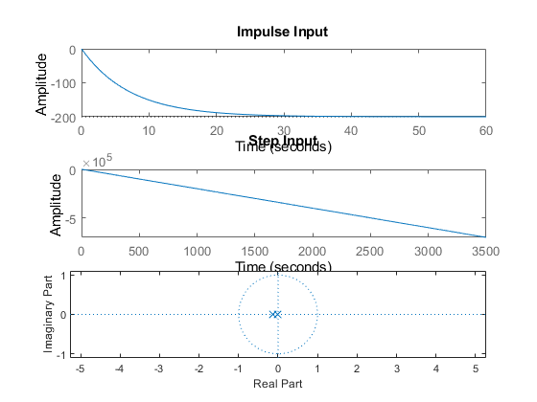

## Open Loop with Controller (P)

P= 2;  
sys = tf([P*(-k)*A],[1,k,0])  
figure(2);  
subplot(3,1,1);  
impulse(sys);  
title('Impulse Input');  
subplot(3,1,2);  
step(sys);  
title('Step Input');  
[z,p,k] = tf2zp([P*(-k)*A],[1,k,0])  
subplot(3,1,3);  
zplane(z,p);  
S = stepinfo(sys)

sys =  
   
 1.12e04  
 ----------  
 s^2 - 28 s  
   
Continuous-time transfer function.  
  
  
z =  
  
 0×1 empty double column vector  
  
  
p =  
  
 0  
 28.0000  
  
  
k =  
  
 1.1200e+04  
  
  
S =   
  
 struct with fields:  
  
 RiseTime: NaN  
 SettlingTime: NaN  
 SettlingMin: NaN  
 SettlingMax: NaN  
 Overshoot: NaN  
 Undershoot: NaN  
 Peak: Inf  
 PeakTime: Inf

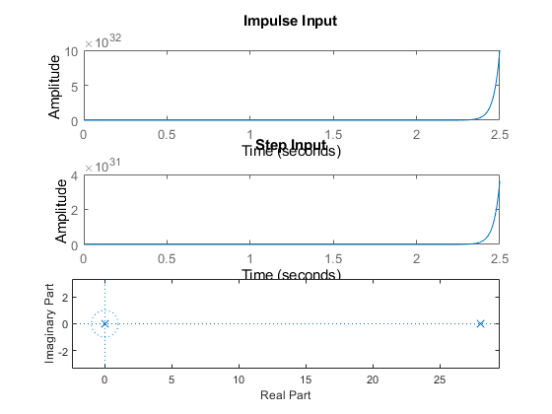

## Open Loop with Controller (I)

sys = tf([(-k)*A],[1,k,0,0])  
figure(3);  
subplot(3,1,1);  
impulse(sys);  
title('Impulse Input');  
subplot(3,1,2);  
step(sys);  
title('Step Input');  
[z,p,k] = tf2zp([-k*A],[1,k,0,0])  
subplot(3,1,3);  
zplane(z,p);  
S = stepinfo(sys)

sys =  
   
 -2.24e06  
 -----------------  
 s^3 + 1.12e04 s^2  
   
Continuous-time transfer function.  
  
  
z =  
  
 0×1 empty double column vector  
  
  
p =  
  
 1.0e+04 *  
  
 0  
 0  
 -1.1200  
  
  
k =  
  
 -2.2400e+06  
  
  
S =   
  
 struct with fields:  
  
 RiseTime: NaN  
 SettlingTime: NaN  
 SettlingMin: NaN  
 SettlingMax: NaN  
 Overshoot: NaN  
 Undershoot: NaN  
 Peak: Inf  
 PeakTime: Inf

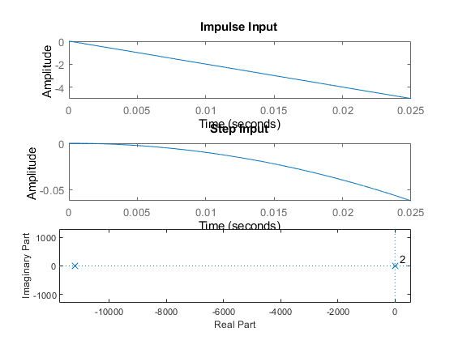

## Closed Loop- Negative feedback with Controller (D)

sys = tf([(-k)*A,0],[1,k,(-k)*A])  
figure(4);  
subplot(3,1,1);  
impulse(sys);  
title('Impulse Input');  
subplot(3,1,2);  
step(sys);  
title('Step Input');  
[z,p,k] = tf2zp([-k*A,0],[1,k,(-k)*A])  
subplot(3,1,3);  
zplane(z,p);  
S = stepinfo(sys)

sys =  
   
 4.48e08 s  
 -------------------------  
 s^2 - 2.24e06 s + 4.48e08  
   
Continuous-time transfer function.  
  
  
z =  
  
 0  
  
  
p =  
  
 1.0e+06 *  
  
 2.2398  
 0.0002  
  
  
k =  
  
 4.4800e+08  
  
  
S =   
  
 struct with fields:  
  
 RiseTime: NaN  
 SettlingTime: NaN  
 SettlingMin: NaN  
 SettlingMax: NaN  
 Overshoot: NaN  
 Undershoot: NaN  
 Peak: Inf  
 PeakTime: Inf

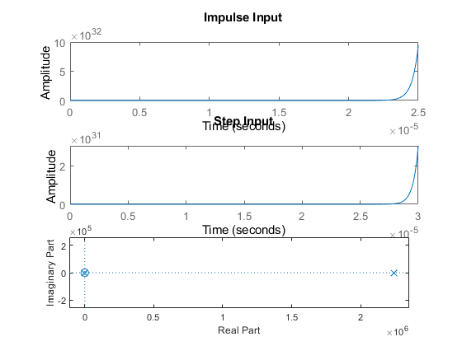

## Closed Loop- Positive feedback with Controller (D)

sys = tf([(-k)*A,0],[1,k,k*A])  
figure(5);  
subplot(3,1,1);  
impulse(sys);  
title('Impulse Input');  
subplot(3,1,2);  
step(sys);  
title('Step Input');  
[z,p,k] = tf2zp([-k*A,0],[1,k,k*A])  
subplot(3,1,3);  
zplane(z,p);  
S = stepinfo(sys)

sys =  
   
 -8.96e10 s  
 -------------------------  
 s^2 + 4.48e08 s + 8.96e10  
   
Continuous-time transfer function.  
  
  
z =  
  
 0  
  
  
p =  
  
 1.0e+08 *  
  
 -4.4800  
 -0.0000  
  
  
k =  
  
 -8.9600e+10  
  
  
S =   
  
 struct with fields:  
  
 RiseTime: 0  
 SettlingTime: 0.0196  
 SettlingMin: -199.9633  
 SettlingMax: -0.2598  
 Overshoot: Inf  
 Undershoot: Inf  
 Peak: 199.9633  
 PeakTime: 9.2103e-07

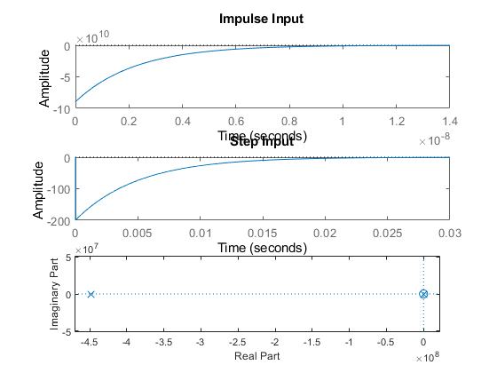

## Math Analysis

Independent: Time(t) Dependent: Mass(M) Constant: Non-zero constant(A), Constant(A)

## Comparison Analysis

1) System without controller behaves exactly like an exponential decay with the system decaying exponentially.

2) On adding a proportionality controller to system, the system becomes unstable.

3) On adding a Integrator controller to system, the response times have decreased hugely, making the system reach stability faster than a P controller.

4) Integrator controller adds a pole to zero also.

5) On addition of a differentiator controller in negative feedback the system becomes unstable.

6) A zero gets added at origin due to the differentiator.

7) On addition of a differentiator controller in positive feedback the system becomes stable.

# 4(a) 1st Order Differential Equation Model

This was done in Simulink of MATLAB R2020b.

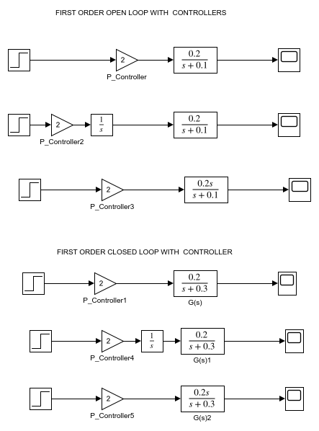

# 4(b) 2nd Order Differential Equation Model

This was done in Simulink of MATLAB R2020b.

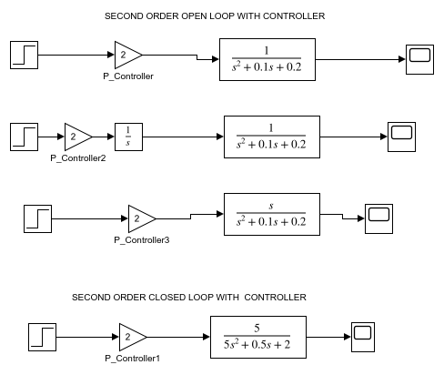

# 4(c) Exponential Decay- Radioactive Material Model

This was done in Simulink of MATLAB R2020b.

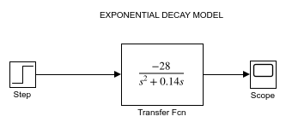

# 5(a) Migration of Scripts to GNU Octave

The results matched with the scripts executed in the MATLAB R2020b

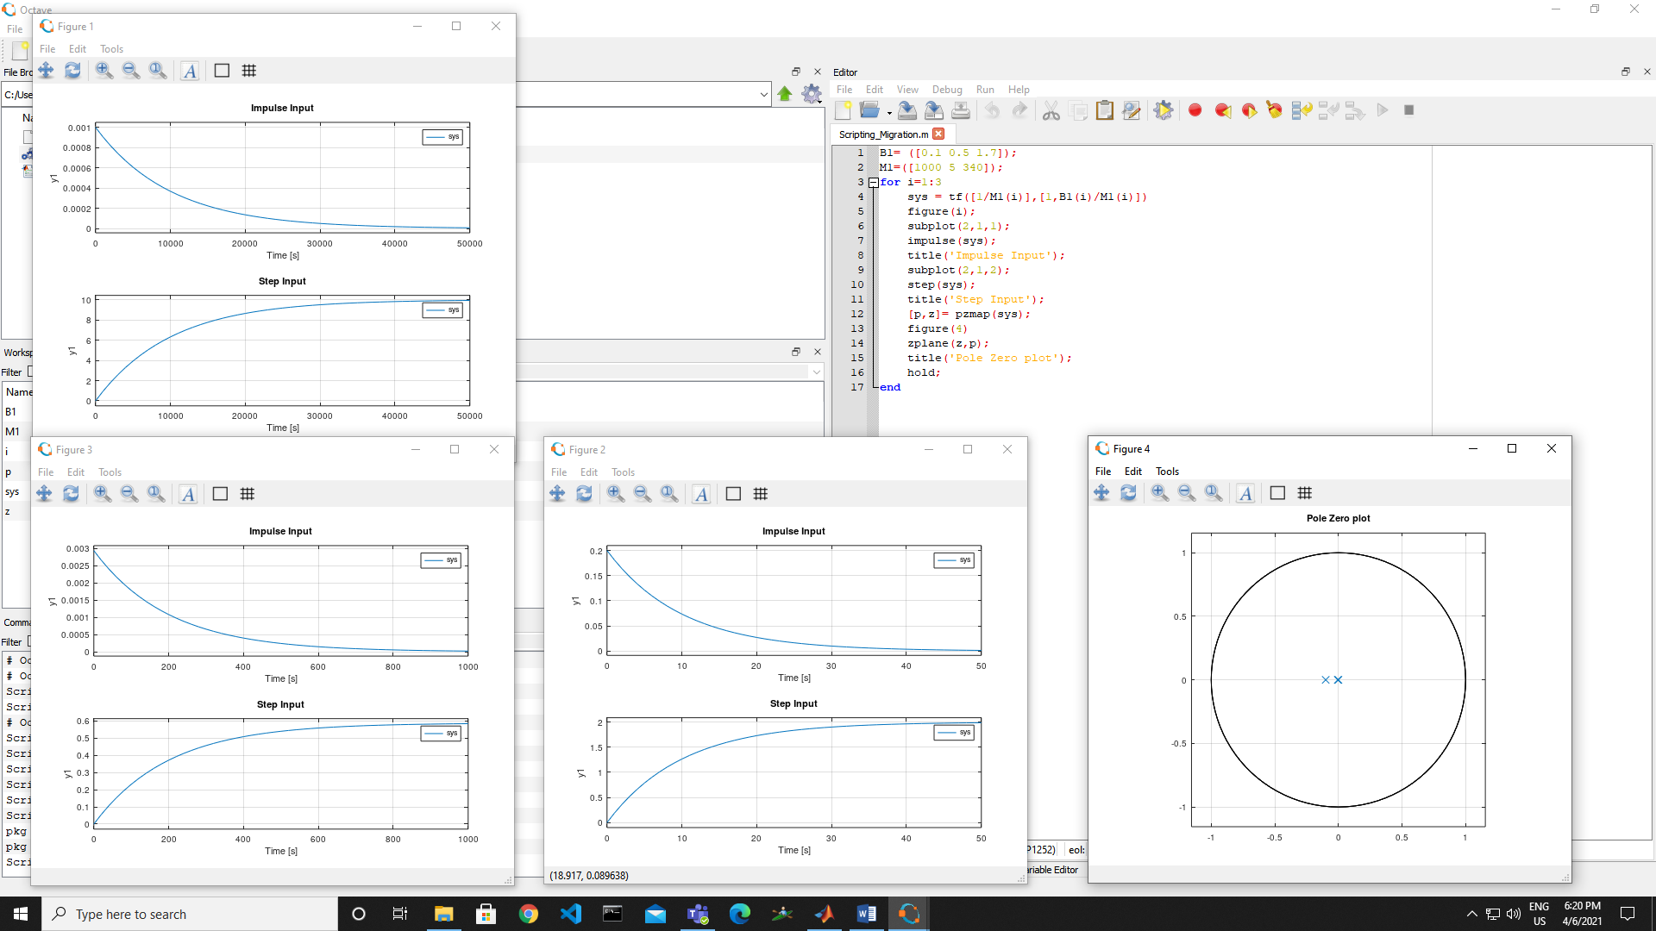

GNU Octave is software featuring a high-level programming language, primarily intended for numerical computations. Octave helps in solving linear and nonlinear problems numerically, and for performing other numerical experiments using a language that is mostly compatible with MATLAB.

# 5(b) Migration of Model to OpenModelica

The results matched with the models executed in Simulink of MATLAB R2020b.

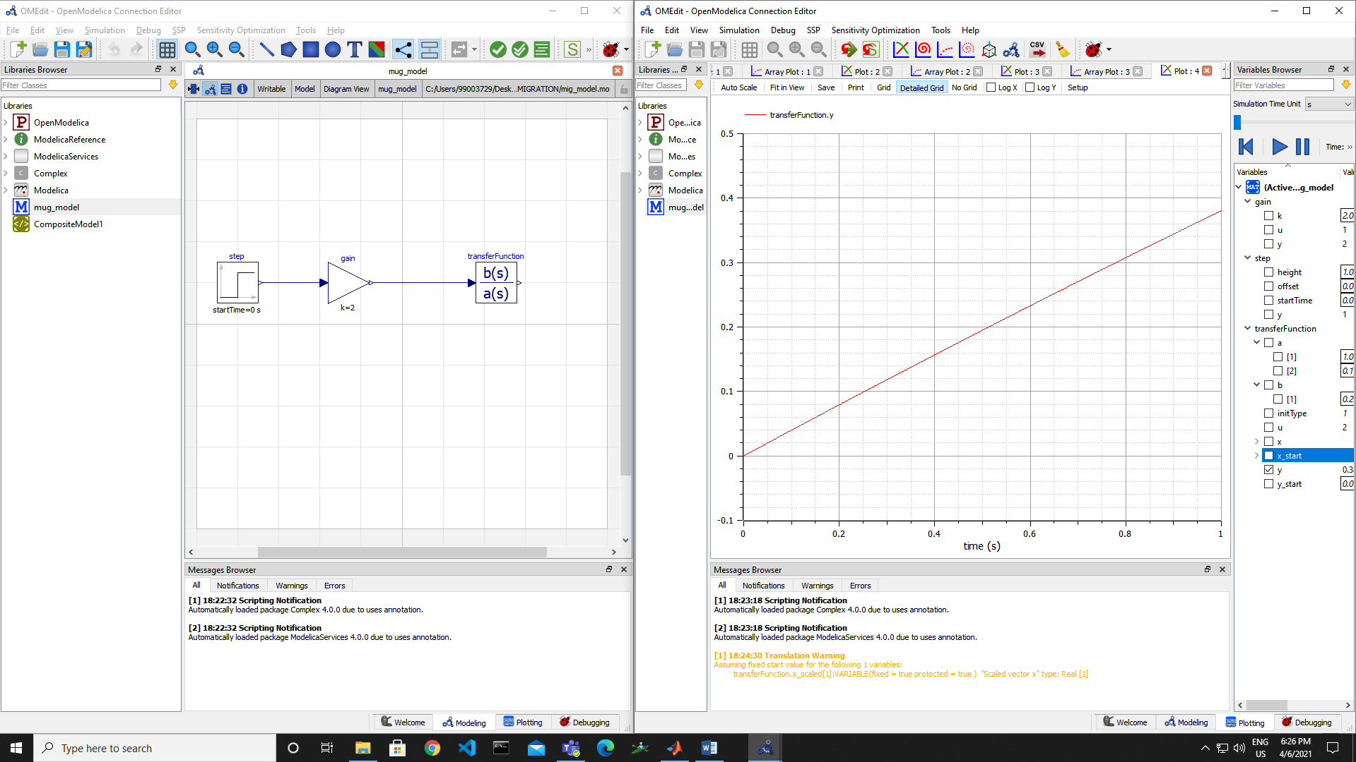

OpenModelica is a free and open source environment based on the Modelica modeling language for modeling, simulating, optimizing and analyzing complex dynamic systems. This software is actively developed by Open Source Modelica Consortium, a non-profit, non-governmental organization.