1(a) First Order Equation
Author: Pushkar Antony PS Number: 99003729 Date: 7th April 2021. Version: 1.0.
Plant Description 1
Code: 1
Math Analysis 6
Comparison Analysis:(Speed, Accuracy and stability): 6

Plant Description
The Mass-damper first order system is taken as Plant. Equation: f= Bv + M v' f = force; B= coefficient of friction; M = mass ; v= velocity. Values: B1= 0.4, M1=1000; B2= 0.5, M2= 500; B3= 1.7, M3= 340;

Code:
clc;
B1= ([0.1 0.5 1.7]);
M1=([1000 5 340]);
for i=1:3
sys = tf([1/M1(i)],[1,B1(i)/M1(i)])
figure(i);
subplot(2,1,1);
impulse(sys);
title('Impulse Input');
subplot(2,1,2);
step(sys);
title('Step Input');
[z,p,k]= tf2zp([1/M1(i)],[1,B1(i)/M1(i)])
figure(4);
zplane(z,p);
xlim([-4*1e5 2*1e5]);
ylim([-4*1e5 2*1e5]);
hold on;
S = stepinfo(sys)
end
sys =
0.001
----------
s + 0.0001
Continuous-time transfer function.
z =
0×1 empty double column vector
p =
-1.0000e-04
k =
1.0000e-03
S =
struct with fields:
RiseTime: 2.1970e+04
SettlingTime: 3.9121e+04
SettlingMin: 9.0450
SettlingMax: 9.9997
Overshoot: 0
Undershoot: 0
Peak: 9.9997
PeakTime: 1.0546e+05
sys =
0.2
-------
s + 0.1
Continuous-time transfer function.
z =
0×1 empty double column vector
p =
-0.1000
k =
0.2000
S =
struct with fields:
RiseTime: 21.9701
SettlingTime: 39.1207
SettlingMin: 1.8090
SettlingMax: 1.9999
Overshoot: 0
Undershoot: 0
Peak: 1.9999
PeakTime: 105.4584
sys =
0.002941
---------
s + 0.005
Continuous-time transfer function.
z =
0×1 empty double column vector
p =
-0.0050
k =
0.0029
S =
struct with fields:
RiseTime: 439.4013
SettlingTime: 782.4149
SettlingMin: 0.5321
SettlingMax: 0.5882
Overshoot: 0
Undershoot: 0
Peak: 0.5882
PeakTime: 2.1092e+03
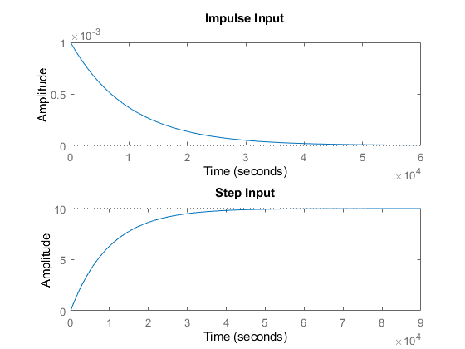
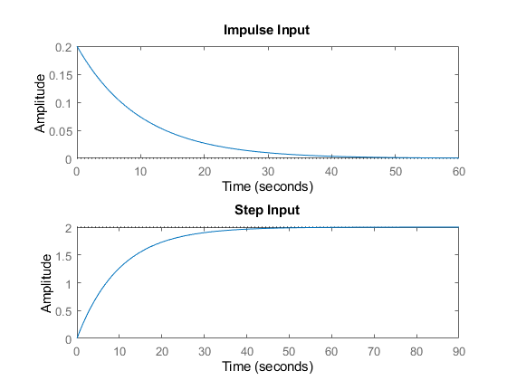
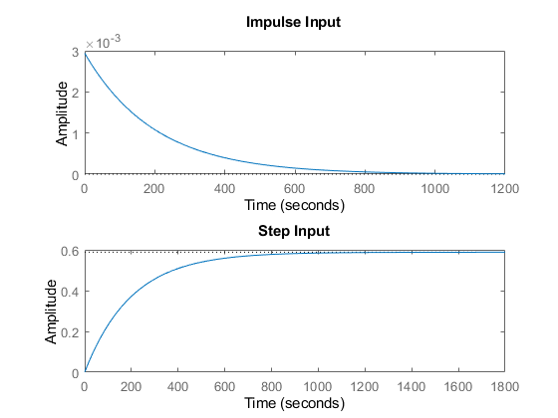
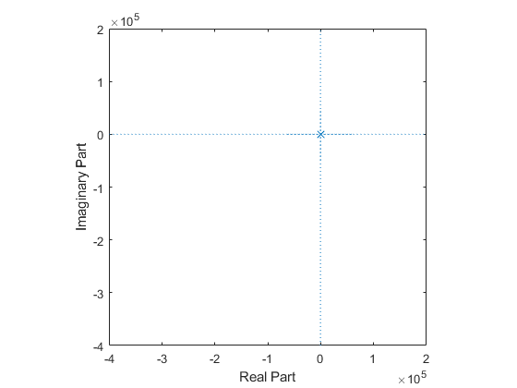

Math Analysis
Independent: Time(t) Dependent: Velocity(v) and Force(f) Constant: Mass(M) and Frictional Coefficient(B)
% Roots:(-B)/M
% IVT:
% 1. For step input: 0
% 2. For impulse input: 1/M
% FVT:
% 1. For step input: 1/B
% 2. For impulse input: 0
% Time Response Results:
% Rise Time :4tau = (4M)/B; where tau = M/B

Comparison Analysis:(Speed, Accuracy and stability):
1) s=0.001/(0.0001s+1)- a stable system as the poles are in the 2nd
%and 3rd quadrant.
% 2) There is no overshoot since it’s a first order system.
% 3) The rise time of 2nd system is least and hence it is the fastest
%system.
% 4) The settling time of 2nd system is least and hence making it more
%accurate than the rest of them.
% 5) The poles are moving farther away, the more the system becomes stable,
%as we can see in 2nd system.
Published with MATLAB® R2020b

