1(b) First Order Equation
Author: Pushkar Antony PS Number: 99003729 Date: 7th April 2021. Version: 1.0.
Plant Description 1
Code: 1
Math Analysis 4
Comparison Analysis:(Speed, Accuracy and stability): 5

Plant Description
The Mass-damper first order system is taken as Plant. Equation: f= Bv + M v' f = force; B= coefficient of friction; M = mass ; v= velocity. Values: B1= 0.4, M1=1000; B2= 0.5, M2= 500; B3= 1.7, M3= 340;

Code:
clc;
B1= 0.5;
M1= 5;
P = 2;
sys = tf([P/M1],[1,B1/M1])
subplot(3,4,1);
impulse(sys);
title('Impulse Input for k');
subplot(3,4,2);
step(sys);
title('Step Input for k');
subplot(3,4,3);
[z,p,k]= tf2zp([P/M1],[1,B1/M1])
pzmap(sys)
subplot(3,4,4);
bode(sys)
hold on;
S = stepinfo(sys)
sys = tf([P/M1],[1,B1/M1,0])
subplot(3,4,5);
impulse(sys);
title('Impulse Input for 1/s');
subplot(3,4,6);
step(sys);
title('Step Input for 1/s');
subplot(3,4,7);
[z,p,k]= tf2zp([P/M1],[1,B1/M1,0])
pzmap(sys)
subplot(3,4,8);
bode(sys)
hold on;
S = stepinfo(sys)
sys = tf([P/M1,0],[1,B1/M1])
subplot(3,4,9);
impulse(sys);
title('Impulse Input for s');
subplot(3,4,10);
step(sys);
title('Step Input for s');
subplot(3,4,11);
[z,p,k]= tf2zp([P/M1,0],[1,B1/M1])
pzmap(sys)
subplot(3,4,12);
bode(sys)
hold on;
S = stepinfo(sys)
sys =
0.4
-------
s + 0.1
Continuous-time transfer function.
z =
0×1 empty double column vector
p =
-0.1000
k =
0.4000
S =
struct with fields:
RiseTime: 21.9701
SettlingTime: 39.1207
SettlingMin: 3.6180
SettlingMax: 3.9999
Overshoot: 0
Undershoot: 0
Peak: 3.9999
PeakTime: 105.4584
sys =
0.4
-----------
s^2 + 0.1 s
Continuous-time transfer function.
z =
0×1 empty double column vector
p =
0
-0.1000
k =
0.4000
S =
struct with fields:
RiseTime: NaN
SettlingTime: NaN
SettlingMin: NaN
SettlingMax: NaN
Overshoot: NaN
Undershoot: NaN
Peak: Inf
PeakTime: Inf
sys =
0.4 s
-------
s + 0.1
Continuous-time transfer function.
z =
0
p =
-0.1000
k =
0.4000
S =
struct with fields:
RiseTime: 21.9701
SettlingTime: 39.1207
SettlingMin: 1.0521e-05
SettlingMax: 0.0382
Overshoot: 0
Undershoot: 7.2058e+17
Peak: 0.4000
PeakTime: 0
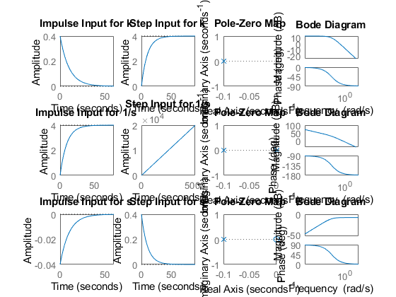

Math Analysis
Independent: Time(t) Dependent: Velocity(v) and Force(f) Constant: Mass(M) and Frictional Coefficient(B)
% Roots:(-B)/M
% IVT:
% 1. For step input: 0
% 2. For impulse input: 1/M
% FVT:
% 1. For step input: 1/B
% 2. For impulse input: 0
% Time Response Results:
% Rise Time :4tau = (4M)/B; where tau = M/B

Comparison Analysis:(Speed, Accuracy and stability):
1) when a Proportionality controller is introduced, only the amplitude
%is getting incremented and all other parameters like rise time, settling
%time remain same as first order without controller.
% 2) when an integrator controller is introduced, a pole gets added at the
%origin and makes the system marginally stable.
% 3) When a differentiator controller is introduced, a zero gets added to
%the origin making any unstable system also stable.
% 4) PID controllers control the whole system making them unstable to
%stable, more stable, add poles, add zeros.
Published with MATLAB® R2020b

