1(c) First Order Equation
Author: Pushkar Antony PS Number: 99003729 Date: 7th April 2021. Version: 1.0.
Plant Description 1
Code: 1
Math Analysis 9
Comparison Analysis:(Speed, Accuracy and stability): 9

Plant Description
The Mass-damper first order system is taken as Plant. Equation: f= Bv + M v' f = force; B= coefficient of friction; M = mass ; v= velocity. Values: B1= 0.4, M1=1000; B2= 0.5, M2= 500; B3= 1.7, M3= 340;

Code:
%Negative Feedback using gain input
clc;
B1= 0.5;
M1= 5;
P = 2;
sys = tf([P],[M1,B1+1])
figure(1);
subplot(2,2,1);
impulse(sys);
title('Impulse Input for k');
subplot(2,2,2);
step(sys);
title('Step Input for k');
subplot(2,2,3);
[z,p,k]= tf2zp([P],[M1,B1+1])
pzmap(sys)
subplot(2,2,4)
bode(sys)
margin(sys)
[Gm,Pm,Wcg,Wcp] = margin(sys)
hold on;
S = stepinfo(sys)
B2= 0.5;
M2= 5;
P2 = 2;
sys = tf([P2],[M2,B2+1,0])
figure(2)
subplot(2,2,1);
impulse(sys);
title('Impulse Input for Integrator controller');
subplot(2,2,2);
step(sys);
title('Step Input for Integrator controller ');
subplot(2,2,3);
[z,p,k]= tf2zp([P2],[M2,B2+1,0])
pzmap(sys)
subplot(2,2,4)
bode(sys)
margin(sys)
[Gm,Pm,Wcg,Wcp] = margin(sys)
hold on;
S = stepinfo(sys)
%Positive Feedback using integral input
B3= 0.8;
M3= 5;
sys = tf([1],[M3,B3-1,0])
figure(3);
subplot(2,2,1);
impulse(sys);
title('Step Input for Positive feedback');
subplot(2,2,2);
step(sys);
title('Step Input for Positive feedback');
subplot(2,2,3);
[z,p,k]= tf2zp([1],[M3,B3-1,0])
pzmap(sys)
subplot(2,2,4)
bode(sys)
margin(sys)
[Gm,Pm,Wcg,Wcp] = margin(sys)
hold on;
S = stepinfo(sys)
%Positive Feedback using differentiator input
B4= 0.8;
M4= 5;
sys = tf([1,0],[M4,B4-1])
figure(4)
subplot(2,2,1);
impulse(sys);
title('Step Input for Positive feedback');
subplot(2,2,2);
step(sys);
title('Step Input for Positive feedback');
subplot(2,2,3);
[z,p,k]= tf2zp([1,0],[M4,B4-1])
pzmap(sys)
subplot(2,2,4)
bode(sys)
margin(sys)
[Gm,Pm,Wcg,Wcp] = margin(sys)
hold on;
S = stepinfo(sys)
sys =
2
---------
5 s + 1.5
Continuous-time transfer function.
z =
0×1 empty double column vector
p =
-0.3000
k =
0.4000
Gm =
Inf
Pm =
138.5925
Wcg =
NaN
Wcp =
0.2646
S =
struct with fields:
RiseTime: 7.3234
SettlingTime: 13.0402
SettlingMin: 1.2060
SettlingMax: 1.3333
Overshoot: 0
Undershoot: 0
Peak: 1.3333
PeakTime: 35.1528
sys =
2
-------------
5 s^2 + 1.5 s
Continuous-time transfer function.
z =
0×1 empty double column vector
p =
0
-0.3000
k =
0.4000
Gm =
Inf
Pm =
26.6470
Wcg =
Inf
Wcp =
0.5979
S =
struct with fields:
RiseTime: NaN
SettlingTime: NaN
SettlingMin: NaN
SettlingMax: NaN
Overshoot: NaN
Undershoot: NaN
Peak: Inf
PeakTime: Inf
sys =
1
-------------
5 s^2 - 0.2 s
Continuous-time transfer function.
z =
0×1 empty double column vector
p =
0
0.0400
k =
0.2000
Warning: The closed-loop system is unstable.
Gm =
Inf
Pm =
-5.1214
Wcg =
Inf
Wcp =
0.4463
S =
struct with fields:
RiseTime: NaN
SettlingTime: NaN
SettlingMin: NaN
SettlingMax: NaN
Overshoot: NaN
Undershoot: NaN
Peak: Inf
PeakTime: Inf
sys =
s
---------
5 s - 0.2
Continuous-time transfer function.
z =
0
p =
0.0400
k =
0.2000
Warning: The closed-loop system is unstable.
Gm =
Inf
Pm =
Inf
Wcg =
NaN
Wcp =
NaN
S =
struct with fields:
RiseTime: NaN
SettlingTime: NaN
SettlingMin: NaN
SettlingMax: NaN
Overshoot: NaN
Undershoot: NaN
Peak: Inf
PeakTime: Inf
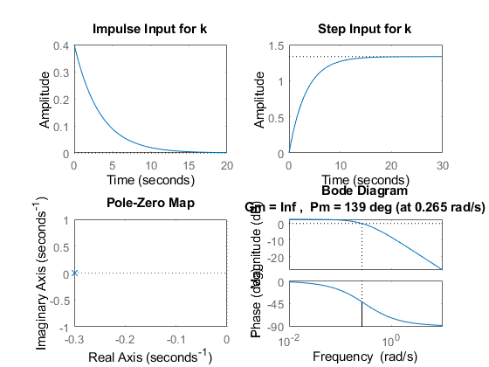
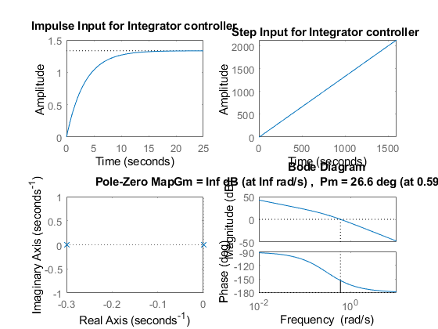
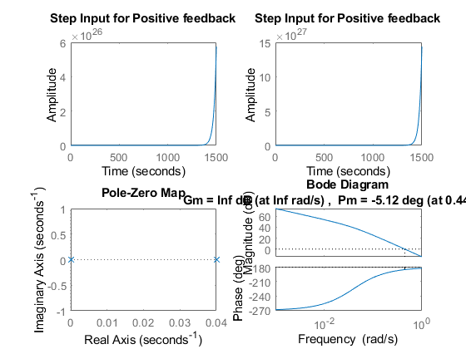
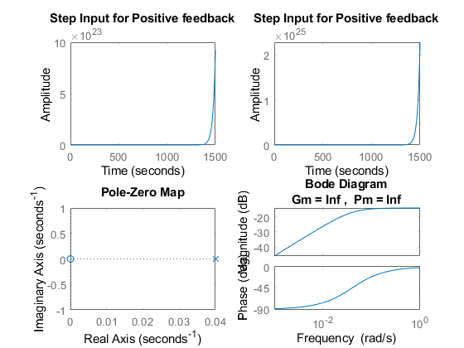

Math Analysis
Independent: Time(t) Dependent: Velocity(v) and Force(f) Constant: Mass(M) and Frictional Coefficient(B)
% Roots:(-B)/M
% IVT:
% 1. For step input: 0
% 2. For impulse input: 1/M
% FVT:
% 1. For step input: 1/B
% 2. For impulse input: 0
% Time Response Results:
% Rise Time :4tau = (4M)/B; where tau = M/B

Comparison Analysis:(Speed, Accuracy and stability):
1) When a P controller is introduced in a negative feedback system, the
%rise time and settling time decrease making the system more stable and
%more faster.
% 2) The P controller increases the amplitude of the entire system as well.
% 3) The gain margin is infinity and phase margin is 139 deg indicating
%that the loop never goes below 180 degree. The loop gain tf is a stable
%low pass of first order.
% 4) For positive feedback with controllers, the system becomes unstable.
Published with MATLAB® R2020b

