2(a) Second Order MSD Equation
Author: Pushkar Antony PS Number: 99003729 Date: 7th April 2021. Version: 1.0.
Plant Description 1
Code: 1
Math Analysis: 6
Comparison Analysis:(Speed, Accuracy and stability): 7

Plant Description
The Mass-damper Spring Second order system is taken as Plant. It is used in as suspension. Equation: Mx''(t)+ Bx'(t) + Kx(t)= Kf(t). f = force; B= coefficient of friction; M = mass ; v= velocity; k=spring
%constant.
% Values: K1= 0.9 B1= 0.4 M1=1000 Wn=0.03 ; K2= 1 B2= 0.5 M2= 500 Wn=0.44;
%K3= 3 B3= 1.7 M3= 340 Wn=0.09;

Code:
clc;
B1= ([0.1 0.5 1.7]);
M1=([1000 5 340]);
K1 = ([0.9 1 3]);
for i=1:3
sys = tf([K1(i)/M1(i)],[1,B1(i)/M1(i),K1(i)/M1(i)])
figure(i);
subplot(2,1,1);
impulse(sys);
title('Impulse Input');
subplot(2,1,2);
step(sys);
title('Step Input');
[z,p,k]= tf2zp([K1(i)/M1(i)],[1,B1(i)/M1(i),K1(i)/M1(i)])
figure(4);
zplane(z,p);
xlim([-5*1e5 3*1e5]);
ylim([-5*1e5 3*1e5]);
hold on;
S = stepinfo(sys)
end
sys =
0.0009
-----------------------
s^2 + 0.0001 s + 0.0009
Continuous-time transfer function.
z =
0×1 empty double column vector
p =
-0.0001 + 0.0300i
-0.0001 - 0.0300i
k =
9.0000e-04
S =
struct with fields:
RiseTime: 34.7791
SettlingTime: 7.8226e+04
SettlingMin: 0.0104
SettlingMax: 1.9948
Overshoot: 99.4778
Undershoot: 0
Peak: 1.9948
PeakTime: 104.7198
sys =
0.2
-----------------
s^2 + 0.1 s + 0.2
Continuous-time transfer function.
z =
0×1 empty double column vector
p =
-0.0500 + 0.4444i
-0.0500 - 0.4444i
k =
0.2000
S =
struct with fields:
RiseTime: 2.5448
SettlingTime: 78.1524
SettlingMin: 0.5072
SettlingMax: 1.7021
Overshoot: 70.2118
Undershoot: 0
Peak: 1.7021
PeakTime: 7.0248
sys =
0.008824
------------------------
s^2 + 0.005 s + 0.008824
Continuous-time transfer function.
z =
0×1 empty double column vector
p =
-0.0025 + 0.0939i
-0.0025 - 0.0939i
k =
0.0088
S =
struct with fields:
RiseTime: 11.3230
SettlingTime: 1.5426e+03
SettlingMin: 0.1540
SettlingMax: 1.9198
Overshoot: 91.9760
Undershoot: 0
Peak: 1.9198
PeakTime: 33.4448
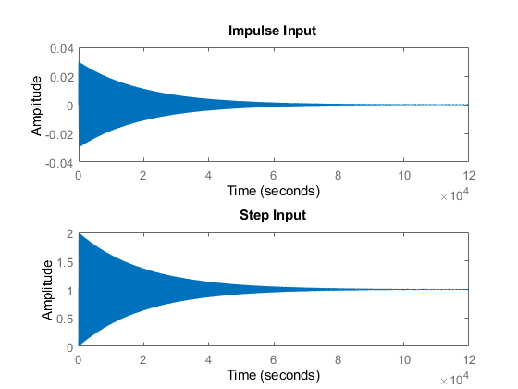
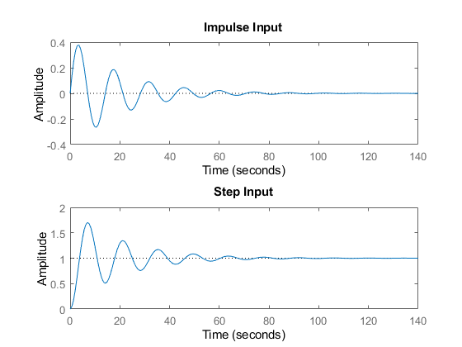
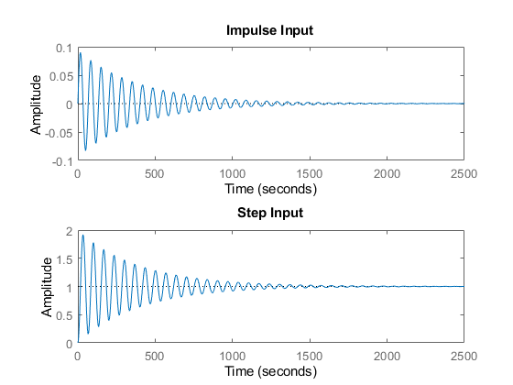
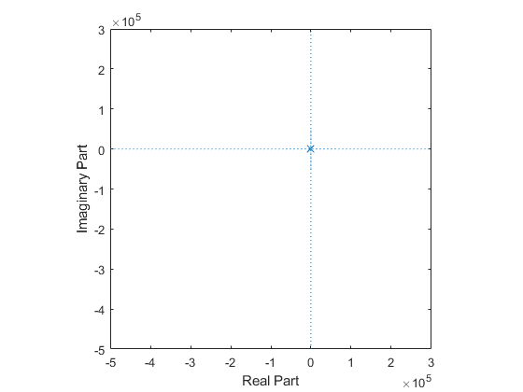

Math Analysis:
Independent: Time(t) Dependent: Velocity(v) and Force(f) Constant: Mass(M), Frictional Coefficient(B), Spring constant(K) Roots:((-B/M)+-sqrt(sq(B/M)-4K/M))/2
% IVT:
% 1. For step input: 0
% 2. For impulse input: 0
% FVT:
% 1. For step input: 1
% 2. For impulse input: K/M
% Time Response Results:
% RiseTime: 34.7791
% SettlingTime: 7.8226e+04
% SettlingMin: 0.0104
% SettlingMax: 1.9948
% Overshoot: 99.4778
% Undershoot: 0
% Peak: 1.9948
% PeakTime: 104.7198
%K2= 1 B2= 0.5 M2= 500
% RiseTime: 2.5448
% SettlingTime: 78.1524
% SettlingMin: 0.5072
% SettlingMax: 1.7021
% Overshoot: 70.2118
% Undershoot: 0
% Peak: 1.7021
% PeakTime: 7.0248
%K3= 3 B3= 1.7 M3= 340
% RiseTime: 11.3230
% SettlingTime: 1.5426e+03
% SettlingMin: 0.1540
% SettlingMax: 1.9198
% Overshoot: 91.9760
% Undershoot: 0
% Peak: 1.9198
% PeakTime: 33.4448

Comparison Analysis:(Speed, Accuracy and stability):
1) For sys 1 poles are on the LHS and they are complex conjugates which
%makes the system stable.
% 2) For sys 2 poles are on LHS and they are complex conjugates which makes
%the system stable.
% 3) For sys 3 poles are on LHS and they are complex conjugates which makes
%the system stable.
% 4) Sys 2 has the least rising time and settling time making the system
%fastest and most stable.
Published with MATLAB® R2020b

