2(b) Second Order MSD Equation
Author: Pushkar Antony PS Number: 99003729 Date: 7th April 2021. Version: 1.0.
Plant Description 1
Code: 1
Math Analysis: 5
Comparison Analysis:(Speed, Accuracy and stability): 6

Plant Description
The Mass-damper Spring Second order system is taken as Plant. It is used in as suspension.
% Equation: Mx''(t)+ Bx'(t) + Kx(t)= Kf(t).
% f = force; B= coefficient of friction; M = mass ; v= velocity; k=spring
%constant.
% Values: K1= 0.9 B1= 0.4 M1=1000 Wn=0.03 ; K2= 1 B2= 0.5 M2= 500 Wn=0.44;
%K3= 3 B3= 1.7 M3= 340 Wn=0.09;

Code:
clc;
B1= 0.5
M1= 5;
K1 =1;
P=5;
sys = tf([P*K1/M1],[1,B1/M1,K1/M1])
subplot(4,3,1);
impulse(sys);
title('Impulse Input for k');
subplot(4,3,2);
step(sys);
title('Step Input for k');
subplot(4,3,3);
[z,p,k]= tf2zp([P*K1/M1],[1,B1/M1,K1/M1])
pzmap(sys)
subplot(4,3,10);
bode(sys)
hold on;
S = stepinfo(sys)
sys = tf([P*K1/M1],[1,B1/M1,K1/M1,0])
subplot(4,3,4);
impulse(sys);
title('Impulse Input for 1/s');
subplot(4,3,5);
step(sys);
title('Step Input for 1/s');
subplot(4,3,6);
[z,p,k]= tf2zp([P*K1/M1],[1,B1/M1,K1/M1,0])
pzmap(sys)
subplot(4,3,11);
bode(sys)
hold on;
S = stepinfo(sys)
sys = tf([P*K1/M1,0],[1,B1/M1,K1/M1])
subplot(4,3,7);
impulse(sys);
title('Impulse Input for s');
subplot(4,3,8);
step(sys);
title('Step Input for s');
subplot(4,3,9);
[z,p,k]= tf2zp([P*K1/M1,0],[1,B1/M1,K1/M1])
pzmap(sys)
subplot(4,3,12);
bode(sys)
hold on;
S = stepinfo(sys)
B1 =
0.5000
sys =
1
-----------------
s^2 + 0.1 s + 0.2
Continuous-time transfer function.
z =
0×1 empty double column vector
p =
-0.0500 + 0.4444i
-0.0500 - 0.4444i
k =
1
S =
struct with fields:
RiseTime: 2.5448
SettlingTime: 78.1524
SettlingMin: 2.5361
SettlingMax: 8.5106
Overshoot: 70.2118
Undershoot: 0
Peak: 8.5106
PeakTime: 7.0248
sys =
1
---------------------
s^3 + 0.1 s^2 + 0.2 s
Continuous-time transfer function.
z =
0×1 empty double column vector
p =
0.0000 + 0.0000i
-0.0500 + 0.4444i
-0.0500 - 0.4444i
k =
1
S =
struct with fields:
RiseTime: NaN
SettlingTime: NaN
SettlingMin: NaN
SettlingMax: NaN
Overshoot: NaN
Undershoot: NaN
Peak: Inf
PeakTime: Inf
sys =
s
-----------------
s^2 + 0.1 s + 0.2
Continuous-time transfer function.
z =
0
p =
-0.0500 + 0.4444i
-0.0500 - 0.4444i
k =
1
S =
struct with fields:
RiseTime: 0
SettlingTime: 81.5509
SettlingMin: -1.3280
SettlingMax: 1.8877
Overshoot: Inf
Undershoot: Inf
Peak: 1.8877
PeakTime: 3.5124
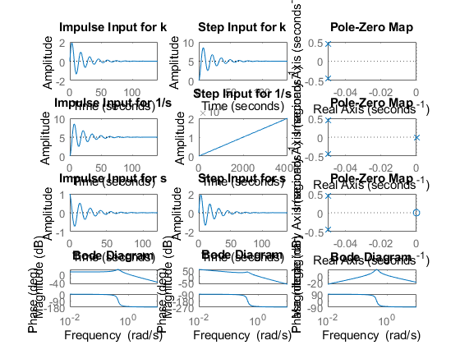

Math Analysis:
Independent: Time(t) Dependent: Velocity(v) and Force(f) Constant: Mass(M), Frictional Coefficient(B), Spring constant(K)
% Roots:((-B/M)+-sqrt(sq(B/M)-4K/M))/2
% IVT:
% 1. For step input: 0
% 2. For impulse input: 0
% FVT:
% 1. For step input: 1
% 2. For impulse input: K/M
% Time Response Results:
% K1= 0.9 B1= 0.4 M1=1000
% RiseTime: 2.5448
% SettlingTime: 78.1524
% SettlingMin: 2.5361
% SettlingMax: 8.5106
% Overshoot: 70.2118
% Undershoot: 0
% Peak: 8.5106
% PeakTime: 7.0248
%K2= 1 B2= 0.5 M2= 500
% RiseTime: NaN
% SettlingTime: NaN
% SettlingMin: NaN
% SettlingMax: NaN
% Overshoot: NaN
% Undershoot: NaN
% Peak: Inf
% PeakTime: Inf
%K3= 3 B3= 1.7 M3= 340
% RiseTime: 0
% SettlingTime: 81.5509
% SettlingMin: -1.3280
% SettlingMax: 1.8877
% Overshoot: Inf
% Undershoot: Inf
% Peak: 1.8877
% PeakTime: 3.5124

Comparison Analysis:(Speed, Accuracy and stability):
1) with proportionality controller, only the amplitude changes and all
%other stats are same as in 2nd order system without controller.
% 2) On adding an integrator controller, a pole is getting added at the
%origin and makes the system marginally stable.
% 3) On adding a differentiator controller, a zero is added to the origin
%making an unstable system stable.
% 4) On adding a differentiator controller, the overshoot increases and
%also the response time increase.
Published with MATLAB® R2020b

