2(d) Movement of Poles.
Author: Pushkar Antony PS Number: 99003729 Date: 7th April 2021. Version: 1.0.
Description: Movement of poles is shown along the real and img axis 1
Analysis 2

Description: Movement of poles is shown along the real and img axis
clc;
poles = [-10+20i -10-20i -5+10i -5-10i -10+10i -10-10i 3+10i 3-10i -5+0i +5+0i -10+0i +10-0i ];
zeros = [0 0];
gain = 0.9;
s=zpk(zeros,poles,gain);
pzplot(s)
[wn,zeta] = damp(s)
wn =
5.0000
5.0000
10.0000
10.0000
10.4403
10.4403
11.1803
11.1803
14.1421
14.1421
22.3607
22.3607
zeta =
1.0000
-1.0000
1.0000
-1.0000
-0.2873
-0.2873
0.4472
0.4472
0.7071
0.7071
0.4472
0.4472
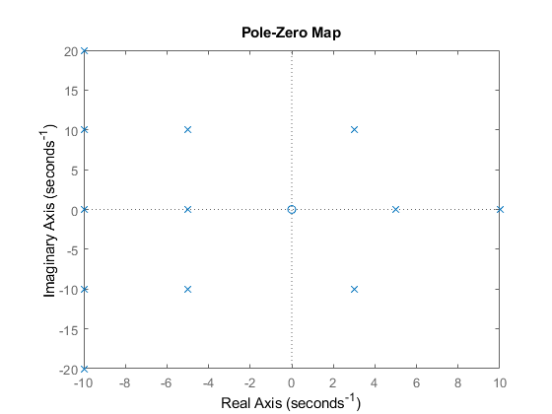

Analysis
If we move along the roots along the wn, the frequency of the system increases. Overshoot remains same. If we move along the jw axis, overshoot of system increases. frequency of system increases. If we move along zeta wn axis or sigma, Overshoot increases, frequency decreases on right side movement. Overshoot decreases, frequency increases on left side movement.
Published with MATLAB® R2020b

