2(e) Roots of the Standard Equation
Author: Pushkar Antony PS Number: 99003729 Date: 7th April 2021. Version: 1.0.
code 1
Comparison Analysis: 8

code
clc;
zeta=1;
TF=tf([1],[1,(2*zeta),1])
sys = tf([1],[1,(2*zeta),1])
figure
subplot(2,3,1)
S = stepinfo(sys)
[z,p,k]= tf2zp([1],[1,(2*zeta),1])
zplane(z,p)
zeta=0.7 ;
TF=tf([1],[1,(2*zeta),1])
sys = tf([1],[1,(2*zeta),1])
subplot(2,3,2)
S = stepinfo(sys)
[z,p,k]= tf2zp([1],[1,(2*zeta),1])
zplane(z,p)
zeta=2;
TF=tf([1],[1,(2*zeta),1])
sys = tf([1],[1,(2*zeta),1])
subplot(2,3,3)
S = stepinfo(sys)
[z,p,k]= tf2zp([1],[1,(2*zeta),1])
zplane(z,p)
zeta=-1.85;
TF=tf([1],[1,(2*zeta),1])
sys = tf([1],[1,(2*zeta),1])
subplot(2,3,4)
S = stepinfo(sys)
[z,p,k]= tf2zp([1],[1,(2*zeta),1])
zplane(z,p)
zeta=-0.4;
TF=tf([1],[1,(2*zeta),1])
sys = tf([1],[1,(2*zeta),1])
subplot(2,3,5)
S = stepinfo(sys)
[z,p,k]= tf2zp([1],[1,(2*zeta),1])
zplane(z,p)
zeta=-2.45;
TF=tf([1],[1,(2*zeta),1])
sys = tf([1],[1,(2*zeta),1])
subplot(2,3,6)
S = stepinfo(sys)
[z,p,k]= tf2zp([1],[1,(2*zeta),1])
zplane(z,p)
TF =
1
-------------
s^2 + 2 s + 1
Continuous-time transfer function.
sys =
1
-------------
s^2 + 2 s + 1
Continuous-time transfer function.
S =
struct with fields:
RiseTime: 3.3579
SettlingTime: 5.8339
SettlingMin: 0.9000
SettlingMax: 0.9994
Overshoot: 0
Undershoot: 0
Peak: 0.9994
PeakTime: 9.7900
z =
0×1 empty double column vector
p =
-1
-1
k =
1
TF =
1
---------------
s^2 + 1.4 s + 1
Continuous-time transfer function.
sys =
1
---------------
s^2 + 1.4 s + 1
Continuous-time transfer function.
S =
struct with fields:
RiseTime: 2.1268
SettlingTime: 5.9789
SettlingMin: 0.9001
SettlingMax: 1.0460
Overshoot: 4.5986
Undershoot: 0
Peak: 1.0460
PeakTime: 4.4078
z =
0×1 empty double column vector
p =
-0.7000 + 0.7141i
-0.7000 - 0.7141i
k =
1
TF =
1
-------------
s^2 + 4 s + 1
Continuous-time transfer function.
sys =
1
-------------
s^2 + 4 s + 1
Continuous-time transfer function.
S =
struct with fields:
RiseTime: 8.2308
SettlingTime: 14.8789
SettlingMin: 0.9017
SettlingMax: 0.9993
Overshoot: 0
Undershoot: 0
Peak: 0.9993
PeakTime: 27.3269
z =
0×1 empty double column vector
p =
-3.7321
-0.2679
k =
1
TF =
1
---------------
s^2 - 3.7 s + 1
Continuous-time transfer function.
sys =
1
---------------
s^2 - 3.7 s + 1
Continuous-time transfer function.
S =
struct with fields:
RiseTime: NaN
SettlingTime: NaN
SettlingMin: NaN
SettlingMax: NaN
Overshoot: NaN
Undershoot: NaN
Peak: Inf
PeakTime: Inf
z =
0×1 empty double column vector
p =
3.4064
0.2936
k =
1
TF =
1
---------------
s^2 - 0.8 s + 1
Continuous-time transfer function.
sys =
1
---------------
s^2 - 0.8 s + 1
Continuous-time transfer function.
S =
struct with fields:
RiseTime: NaN
SettlingTime: NaN
SettlingMin: NaN
SettlingMax: NaN
Overshoot: NaN
Undershoot: NaN
Peak: Inf
PeakTime: Inf
z =
0×1 empty double column vector
p =
0.4000 + 0.9165i
0.4000 - 0.9165i
k =
1
TF =
1
---------------
s^2 - 4.9 s + 1
Continuous-time transfer function.
sys =
1
---------------
s^2 - 4.9 s + 1
Continuous-time transfer function.
S =
struct with fields:
RiseTime: NaN
SettlingTime: NaN
SettlingMin: NaN
SettlingMax: NaN
Overshoot: NaN
Undershoot: NaN
Peak: Inf
PeakTime: Inf
z =
0×1 empty double column vector
p =
4.6866
0.2134
k =
1
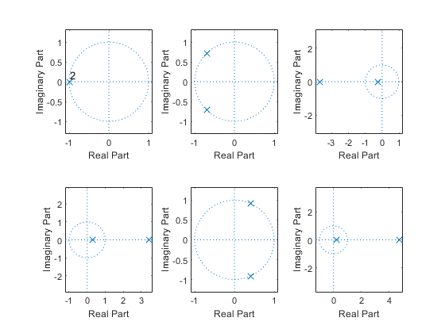

Comparison Analysis:
1st value lise on negative x axis means: Critically-damped case & stable 2nd value lise in 2nd & 3rd quadrant means: Under-damp case & stable 3rd value lise on negative x axis means: Overdamped case & stable 4th value lise on positive x axis means: unstable 5th value lise on 1st & 4th quadrant means: unstable 6th value lise on positive x axis means: unstable
Published with MATLAB® R2020b

