2(f) PID Analysis
Author: Pushkar Antony PS Number: 99003729 Date: 8th April 2021. Version: 1.0.
First Order System PID Analysis 1
Second Order System PID Analysis 2
Comparison Analysis: 3

First Order System PID Analysis
clc;
B1= 0.5;
M1= 5;
P1 = 2;
sys1 = tf([P1],[M1,B1+1])
pidTuner(sys1)
sys1 =
2
---------
5 s + 1.5
Continuous-time transfer function.
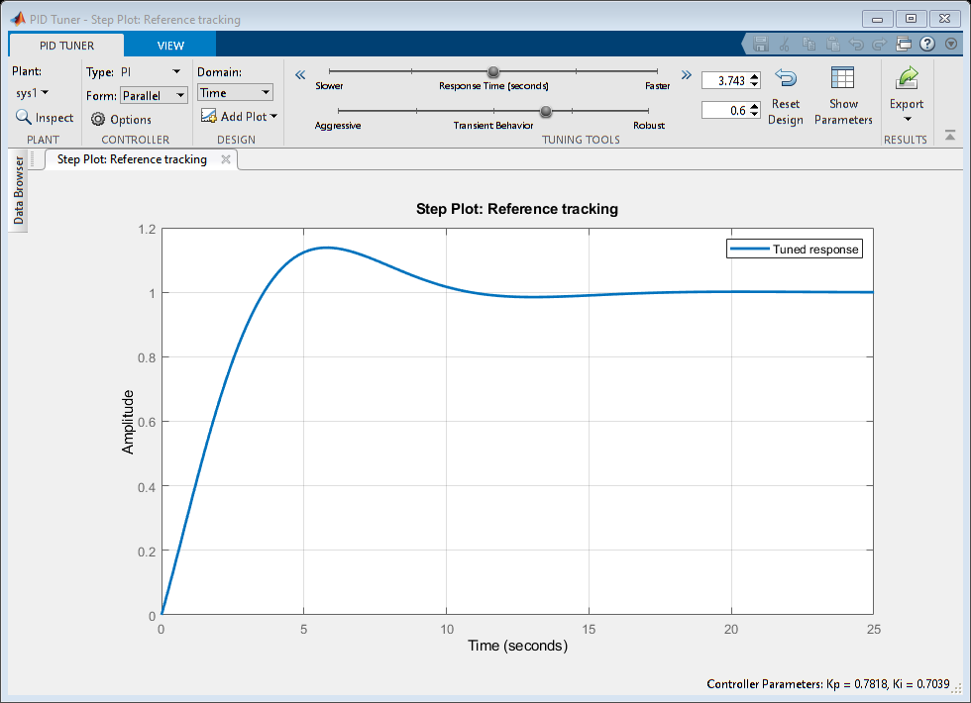

Second Order System PID Analysis
B2= 0.5
M2= 5;
K2 =1;
P2=5;
sys2 = tf([P2*K2],[M2,B2,2*K2])
pidTuner(sys2)
B2 =
0.5000
sys2 =
5
-----------------
5 s^2 + 0.5 s + 2
Continuous-time transfer function.
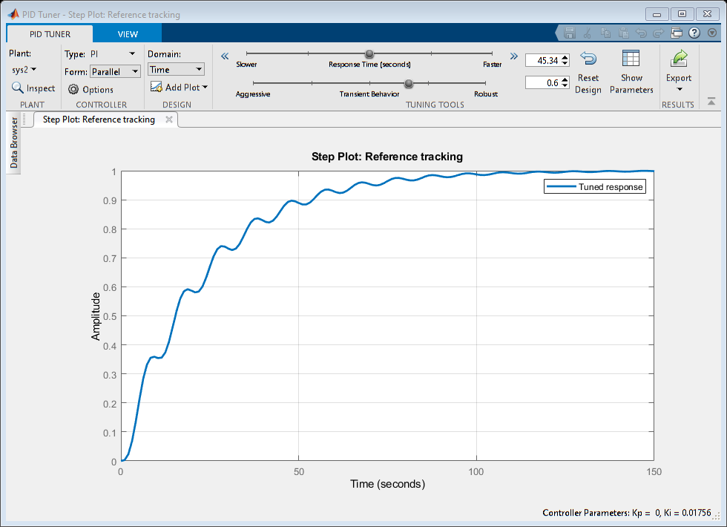

Comparison Analysis:
First Order sys: PI: Ideal system: Kp= 0.78 (Un-Tuned) Ki= 0.7 Tr= 2.7 Ts= 9.87 Overshoot= 13.8%
Best system: Kp= 1.25
(After Tuning) Ki= 0.46
Tr= 3.59
Ts= 5.39
Overshoot= 1.33%
PD: Ideal system: Kp= 53.18
(Un-Tuned) Kd= 0
Tr= 0.102
Ts= 0.181
Overshoot= 0
Best system: Kp= 53.18
(After Tuning) Kd= 0
Tr= 0.102
Ts= 0.181
Overshoot= 0
PID: Ideal system: Kp= 1.07
(Un-Tuned) Ki= 0.53
Kd= 0
Tr= 3.04
Ts= 10.6
Overshoot= 6.08%
Best system: Kp= 1.07
(After Tuning) Ki= 0.53
Kd= 0
Tr= 3.04
Ts= 10.6
Overshoot= 6.08%
% Second Order sys:
% PI: Ideal system: Tr= 51.1
% (Un-Tuned) Ts= 94.3
% Overshoot= 0%
%
% Best system: Tr= 50.4
% (After Tuning) Ts= 93.4
% Overshoot= 0.00235%
%
% PD: Ideal system: Kp= 2697.9
% (Un-Tuned) Kd= 63.48
% Tr= 0.0179
% Ts= 0.13
% Overshoot= 24.3%
%
% Best system: Kp= 27.35
% (After Tuning) Kd= 6.251
% Tr= 0.175
% Ts= 1.35
% Overshoot= 24.71%
%
% PID: Ideal system: Kp= 3.053
% (Un-Tuned) Ki= 0.68
% Kd= 2.66
% Tr= 0.495
% Ts= 9.3
% Overshoot= 12.4%
%
% Best system: Kp= 3.053
% (After Tuning) Ki= 0.68
% Kd= 2.66
% Tr= 0.495
% Ts= 9.3
% Overshoot= 12.4%
Published with MATLAB® R2020b

