./ ./

Learning Report – Automotive systems and overview

­­­

**Document History**

|  |  |  |  |  |  |
| --- | --- | --- | --- | --- | --- |
| **Ver. Rel. No.** | **Release Date** | **Prepared. By** | **Reviewed By** | **Approved By** | **Remarks/Revision Details** |
|  | 20-03-21 | Katherapalle Rama Subba Reddy |  |  |  |
|  |  |  |  |  |  |
|  |  |  |  |  |  |
|  |  |  |  |  |  |
|  |  |  |  |  |  |

**Table of contents:**

1.Inroduction ………………………………………….

1.1 Research …………………………………………

1.2 Literature Survey …………………………………

1.2.1 Inputs …………………………………………

1.2.2 Sensor Input ………………………………….

1.2.3 Outputs ………………………………………...

1.2.4 SWOT Analysis ………………………………..

1.2.5 Detailed Requirements …………………………

1.2.5.1 High Level Requirements …………………..

1.2.5.2 Low Level Requirements ……………………

1.3 Algorithm ……………………………………………

2. Design & Implementation ……………………………

2.1 High Level Design …………………………………

2.2 Low Level Design ………………………………….

3. Test Plan ………………………………………………

3.1 High Level Test Plan ………………………………..

3.2 Low Level Test Plan …………………………………

**1**. INTRODUCTION:

A sunroof is a movable panel that opens to uncover a window in an [automobile roof](https://en.wikipedia.org/wiki/Automobile_roof), allowing light and/or fresh air to enter the passenger compartment. Sunroofs can be manually operated or motor driven, and are available in many shapes, sizes and styles. While the term sunroof is now used generically to describe any glass panel in the roof, the term "moonroof" was historically used to describe stationary glass panes rigidly mounted in the roof panel over the passenger compartment. A moonroof has a glass panel that is transparent and usually tinted. Previous terms include Sunshine Roof, Sliding Head and Sliding Roof.

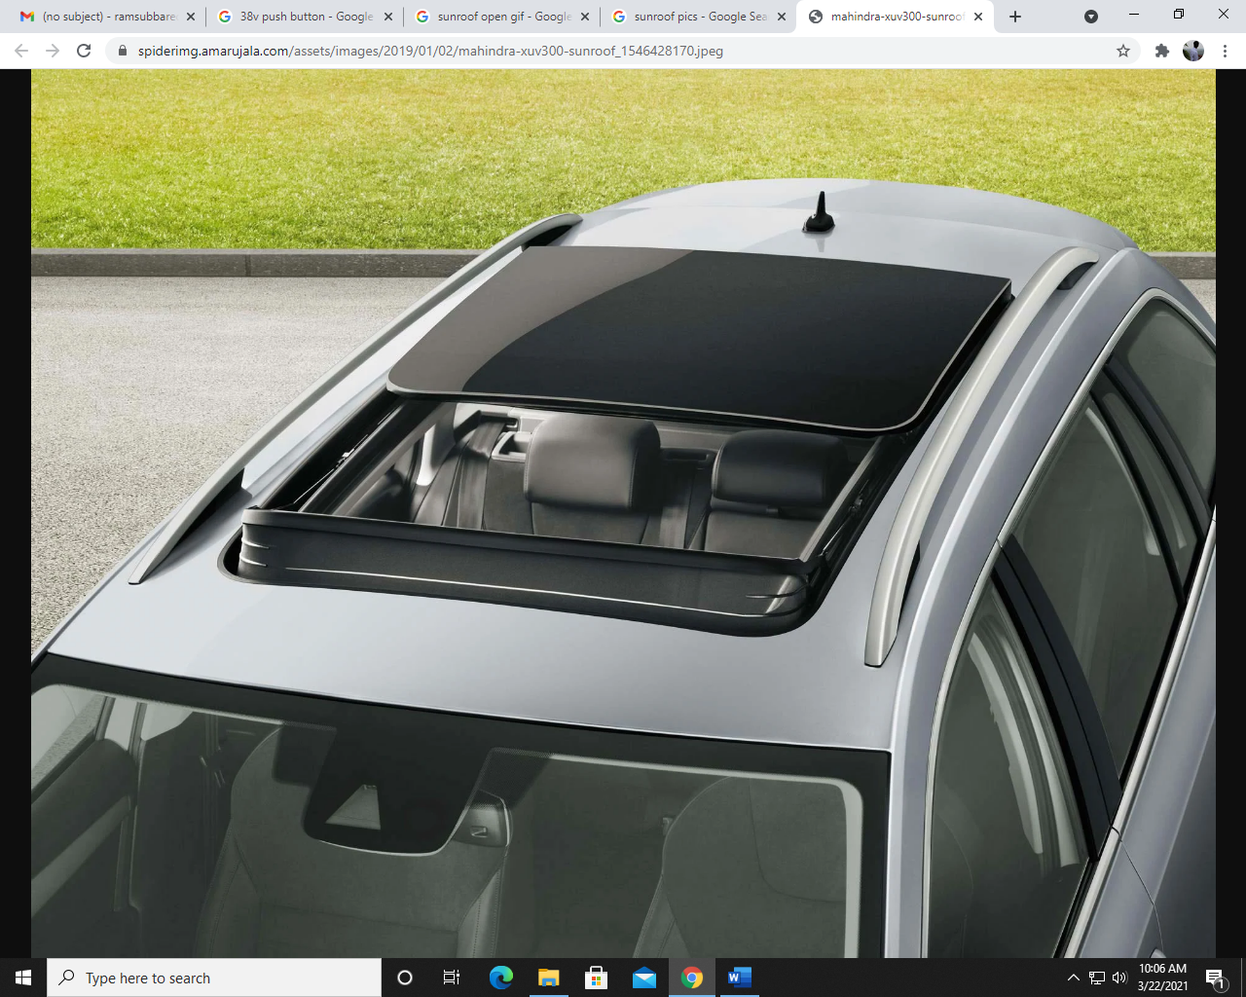

Source: Google image

Fig.1 : Sunroof image

**1.1**  RESEARCH :-

*The global automotive sunroof market size was valued at USD 6.2 billion in 2016. It is expected to expand at a CAGR of 6.9% over the forecast period. The demand for automotive sunroofs is increasing in line with shifting consumer preference towards enhanced driving experience. Growing trend among automakers to offer automotive sunroofs as an optional feature in majority of passenger cars is also one of the key trends benefiting the growth of the market. Rising automobile production and spiraling sales of premium & luxury vehicles are anticipated to provide a fillip to the market.*

Automakers and vendors are jointly trying to improve safety factors of various systems implemented in automobiles. For instance, Hyundai Mobis introduced a panorama sunroof airbag system, the first of its kind in the world, which can prevent passengers from getting thrown out of the automobile through the roof in event of an accident or a rollover. Automakers have also managed to integrate rain sensors within these systems. As a result, automotive sunroofs can be closed automatically as soon as it starts raining. Such innovations are estimated to bolster the growth of the market over the forecast period.

Initially, sunroofs were limited only to luxurious cars. However, they got immensely popular owing to their ability to maintain optimum levels of sunlight and ensure better visibility within the automobile, and eventually enhance the driving experience. Besides, the youth particularly found sunroofs appealing. This prompted automaker to install sunroofs in other segments as well.

However, sunroofs have several drawbacks. Sunroofs are highly costly to integrate and expensive to repair in case of a failure. They add extra weight, reduce the headroom, and obstruct the laminar airflow over the automobile. They also require regular maintenance. These factors are acting as roadblocks for rapid growth of the market.

1.2 LITERATURE SURVEY :

1.2.1 INPUTS :

* Sunroof open/close: Press push buttons open or close.
* Open: If open push button is pressed sunroof open.
* Close: If close push button is pressed sunroof close.

Two Input buttons:

Voltage 16v

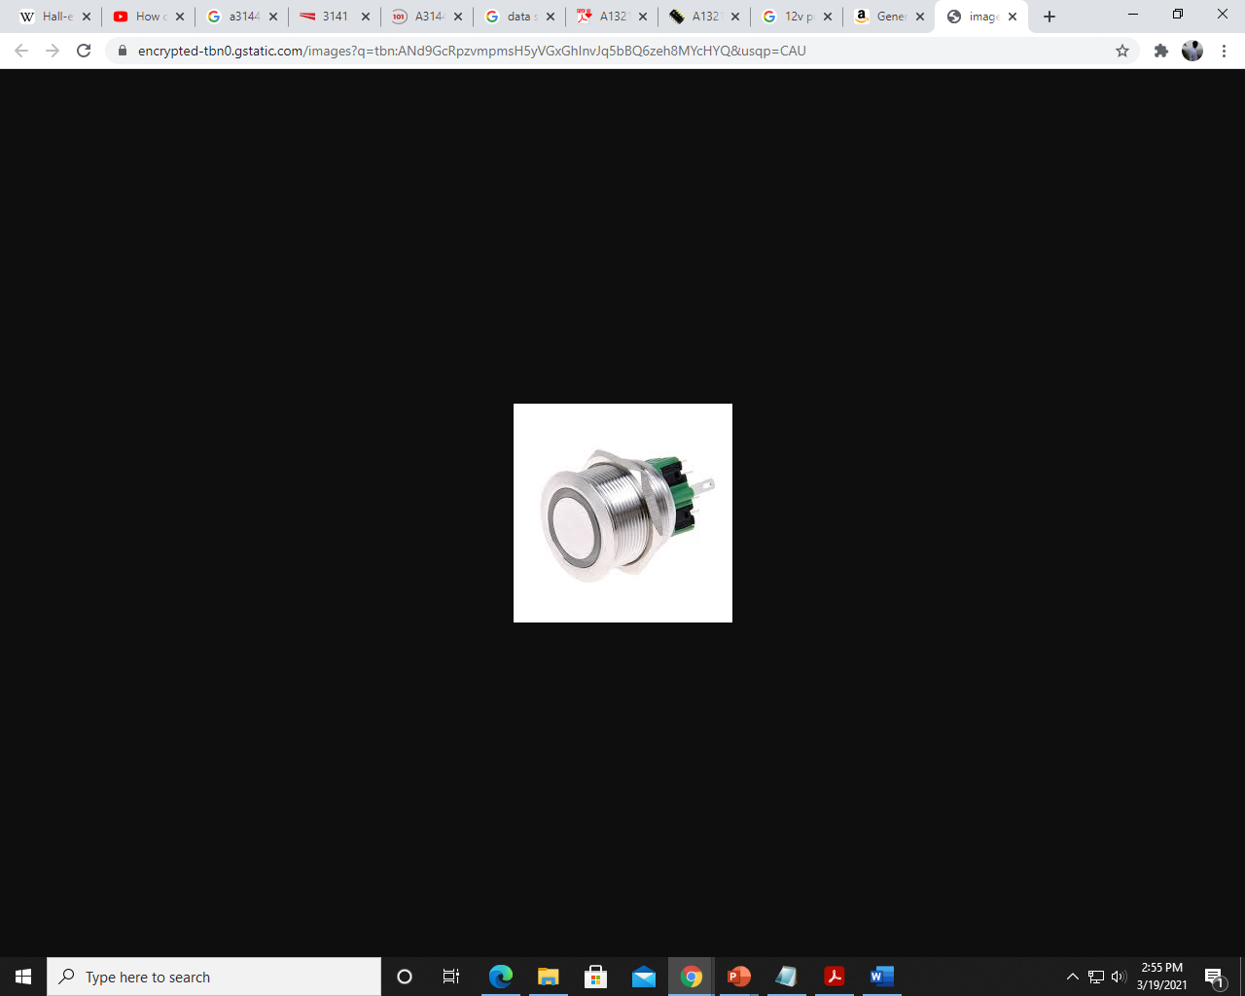



Fig.2 : Push buttons

1.2.2 SENSOR INPUT:

Hall effect Position sensor

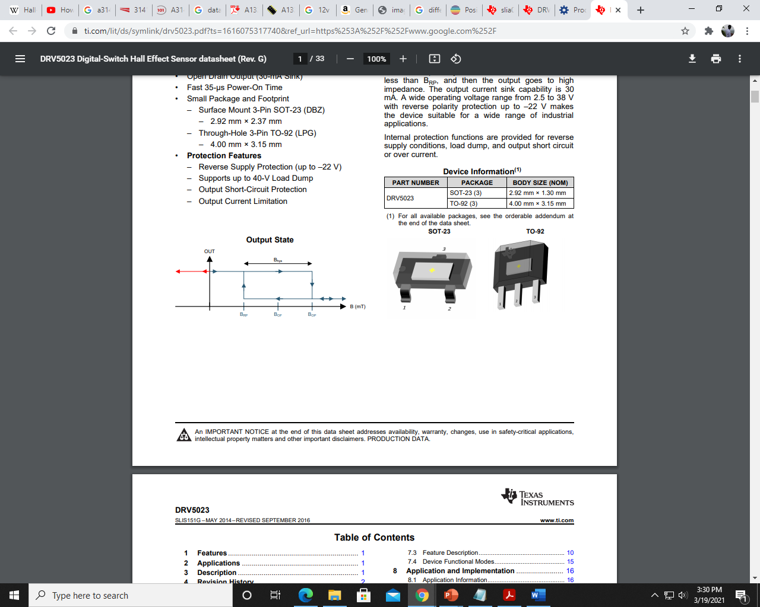

Fig.3 : Hall effect Sensor

DRV5023 Sensor

|  |  |
| --- | --- |
| Operating voltage | 2.5-38v |
| Operating Temperature | -40 - 125 ‘c |
| Operating Current | 2.7 – 3.5 mA |

Table.1: Sensor data table

Full Datasheet Link: <https://www.ti.com/lit/ds/symlink/drv5023.pdf?ts=1616321980928&ref_url=https%253A%252F%252Fwww.google.com%252F> .

Characteristics:

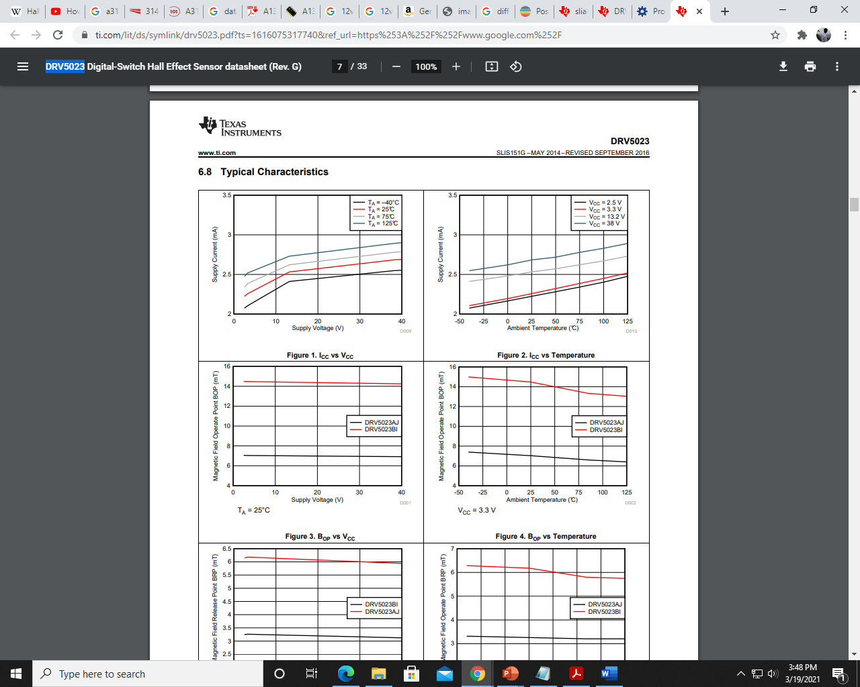

Two different sensor links:

Refer for DVR5055 Sensor: <https://www.ti.com/lit/ds/symlink/drv5055.pdf?ts=1616109475973&ref_url=https%253A%252F%252Fwww.ti.com%252Fproduct%252FDRV5055>

Refer for A1321, A1322, and A1323 Sensors: <https://datasheetspdf.com/pdf/157105/AllegroMicroSystems/A1321/1>

1.2.3 Output:

Motor rotation:

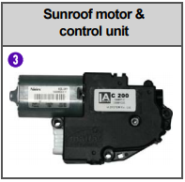

Fig.4: sunroof motor control unit

|  |  |  |  |
| --- | --- | --- | --- |
| Parameter | Min | Max | Unit |
| Operating voltage | 9 | 16 | V |
| Operating current | - | 6 | A |
| At no load | - | 3 | A |
| Roof motor operating speed |  | 1.4 ± 0.5 sec./100 mm |  |

Table.2: Motor specification

1.2.4 SWOT ANALYSIS:

|  |  |
| --- | --- |
| Strength | Weakness |
| 1.Better lighting in car  2.Better air permeability in traffic | 1.Too Expensive  2. High Maintainance |
| Opportunities | Threats |
| 1.Used in different type of weather conditions | 1.Creates noise and gets disturbance to the driver |

Table.3 : SWOT analysis table

1.2.5 DETAILED REQUIREMENTS:

1.2.5.1 HIGH LEVEL REQUIREMENTS:

|  |  |
| --- | --- |
| **Test ID** | **Description** |
| HLR_SUN_1 | Opening/Closing Sunroof |

Table.4 : High Level Requirements table

1.2.5.2 LOW LEVEL REQUIREMENTS:

|  |  |
| --- | --- |
| **Test ID** | **Description** |
| LLR_SUN_01 | Operating motor used for sunroof panels |

Table.5 : Low Level Requirements

1.3 ALGORITHM :- (FLOW CHART)

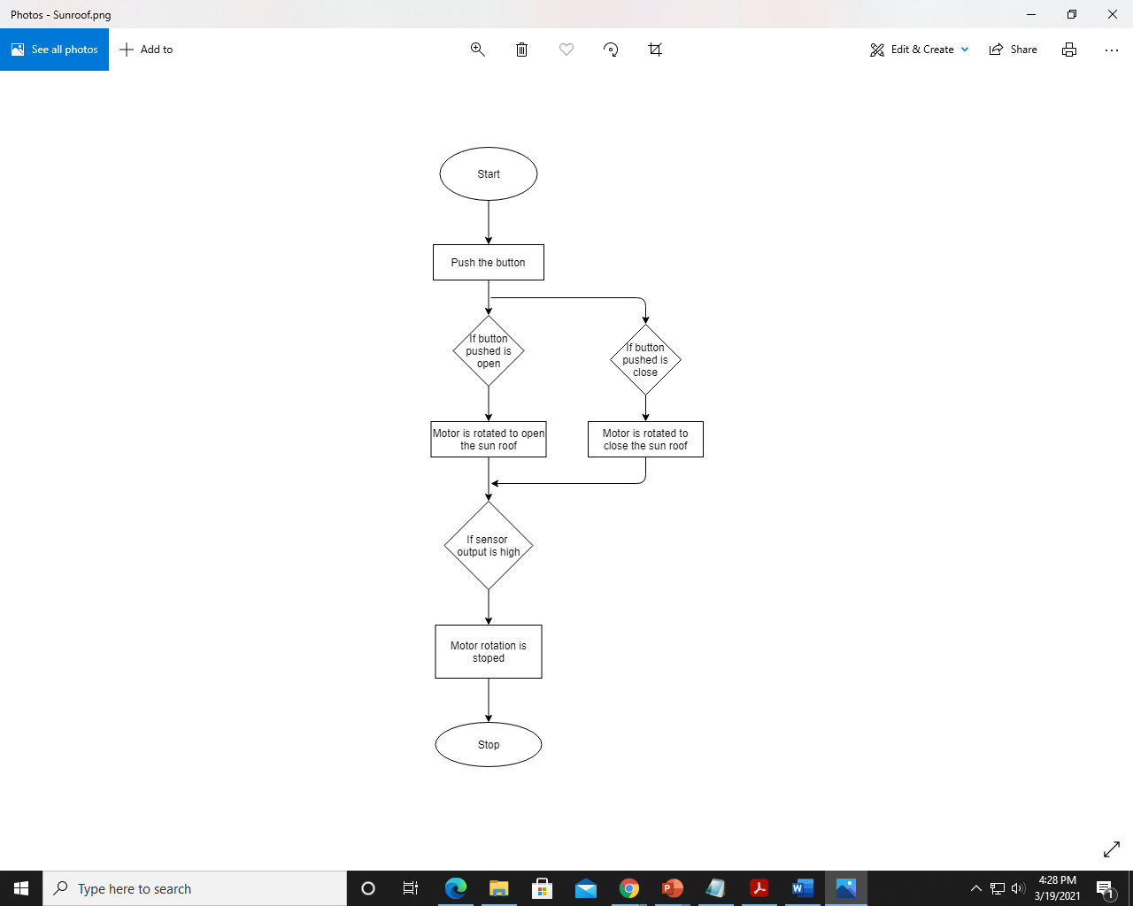

Fig.5 : Algorithm

**2. DESIGN & IMPLEMENTATION:**

**2.1 HIGH LEVEL DESIGN:**

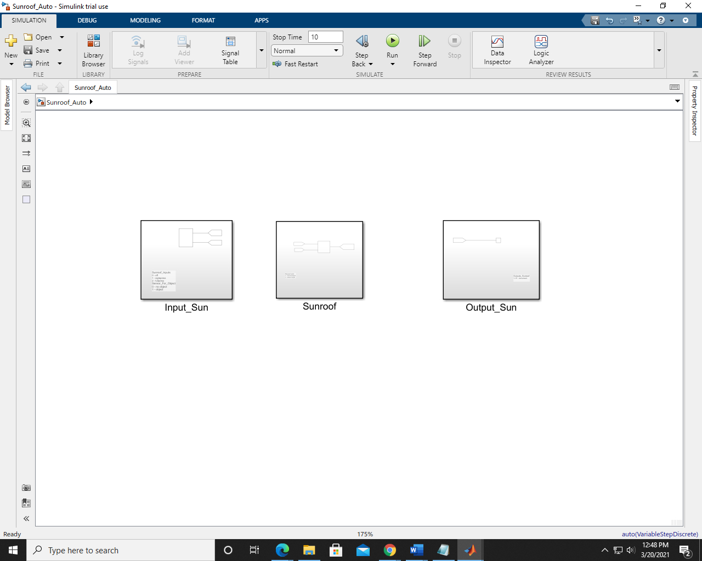

Fig.6: HLR

**2.2 LOW LEVEL REQUIREMENTS**

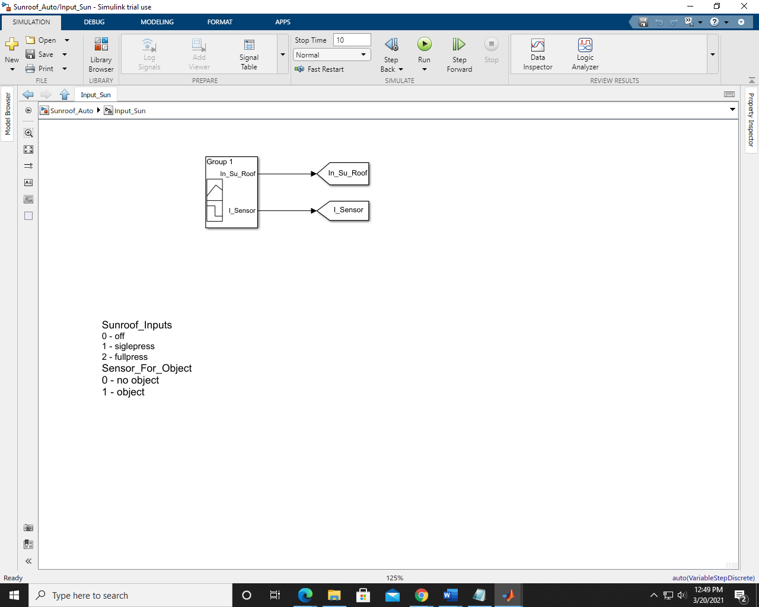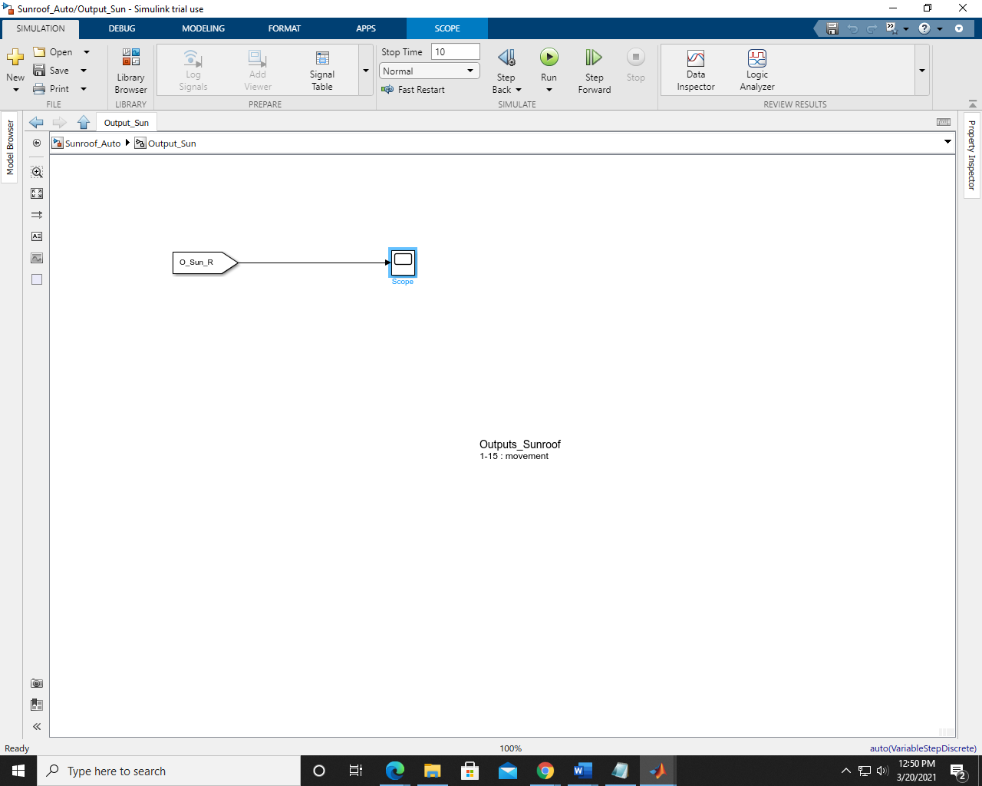

Fig.7 : LLR

**3. TEST PLAN:**

**3.1 HIGH LEVEL TEST PLAN:**

|  |  |  |  |  |  |  |
| --- | --- | --- | --- | --- | --- | --- |
| **Test ID** | **Description** | **Input given** | **Output expected** | **Actual output** |  |  |
| HLR_SUN_01 | Open push button pressed | 16v | Sunroof open | Sunroof open |  |  |
| HLR_SUN_02 | Close push button pressed | 16v | Sunroof close | Sunroof close |  |  |

**3.2 LOW LEVEL TEST PLAN:**

|  |  |  |  |  |  |  |
| --- | --- | --- | --- | --- | --- | --- |
| **Test ID** | **Description** | **Input given** | **Output expected** | **Actual output** |  |  |
| LLR_SUN_01 | Open push button pressed | 16v | Motor rotates forward | Motor rotates forward |  |  |
| LLR_SUN_02 | Close push button pressed | 16v | Motor rotates reverse | Motor rotates reverse |  |  |