3(a) Second Order Population Growth system
Author: Mohammed Ijaz PS Number: 99003728 Date: 11th April 2021. Version: MATLAB 2020b.
Plant Description 1
Without Controller 1
Open Loop with Controller (P) 3
Open Loop with Controller (I) 4
Closed Loop- Negative feedback with Controller (D) 6
Closed Loop- Positive feedback with Controller (D) 8
Math Analysis 10
Comparison Analysis 10

Plant Description
It is a exponential increasing system of a Population Growth Equation- dN(t)/dt=kN(t) N=Population a time t, k=constant, t=time Values- k=0.14, A=200

Without Controller
clc;
k= 0.14;
A= 200;
sys = tf([k*A],[1,k,0])
figure(1);
subplot(3,1,1);
impulse(sys);
title('Impulse Input');
subplot(3,1,2);
step(sys);
title('Step Input');
[z,p,k] = tf2zp([k*A],[1,k,0])
subplot(3,1,3);
zplane(z,p);
S = stepinfo(sys)
sys =
28
------------
s^2 + 0.14 s
Continuous-time transfer function.
z =
0×1 empty double column vector
p =
0
-0.1400
k =
28.0000
S =
struct with fields:
RiseTime: NaN
SettlingTime: NaN
SettlingMin: NaN
SettlingMax: NaN
Overshoot: NaN
Undershoot: NaN
Peak: Inf
PeakTime: Inf
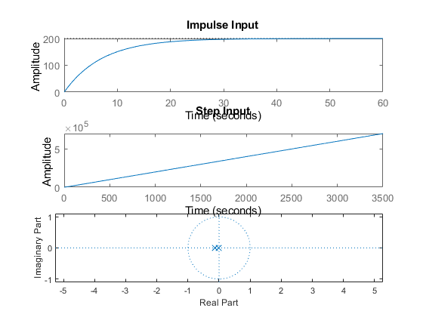

Open Loop with Controller (P)
P= 2;
sys = tf([P*(k)*A],[1,k,0])
figure(2);
subplot(3,1,1);
impulse(sys);
title('Impulse Input');
subplot(3,1,2);
step(sys);
title('Step Input');
[z,p,k] = tf2zp([P*k*A],[1,k,0])
subplot(3,1,3);
zplane(z,p);
S = stepinfo(sys)
sys =
1.12e04
----------
s^2 + 28 s
Continuous-time transfer function.
z =
0×1 empty double column vector
p =
0
-28.0000
k =
1.1200e+04
S =
struct with fields:
RiseTime: NaN
SettlingTime: NaN
SettlingMin: NaN
SettlingMax: NaN
Overshoot: NaN
Undershoot: NaN
Peak: Inf
PeakTime: Inf
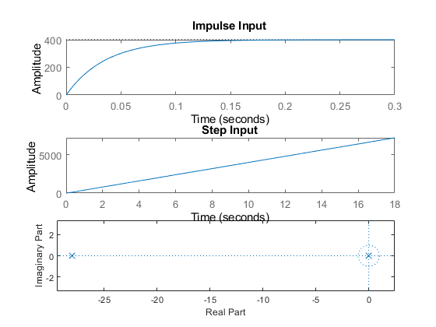

Open Loop with Controller (I)
sys = tf([k*A],[1,k,0,0])
figure(3);
subplot(3,1,1);
impulse(sys);
title('Impulse Input');
subplot(3,1,2);
step(sys);
title('Step Input');
[z,p,k] = tf2zp([k*A],[1,k,0,0])
subplot(3,1,3);
zplane(z,p);
S = stepinfo(sys)
sys =
2.24e06
-----------------
s^3 + 1.12e04 s^2
Continuous-time transfer function.
z =
0×1 empty double column vector
p =
1.0e+04 *
0
0
-1.1200
k =
2.2400e+06
S =
struct with fields:
RiseTime: NaN
SettlingTime: NaN
SettlingMin: NaN
SettlingMax: NaN
Overshoot: NaN
Undershoot: NaN
Peak: Inf
PeakTime: Inf
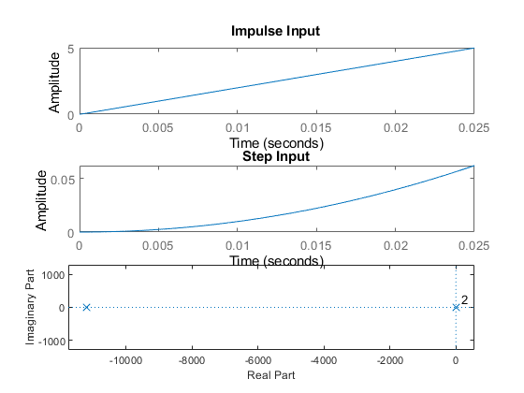

Closed Loop- Negative feedback with Controller (D)
sys = tf([k*A,0],[1,k,(-k)*A])
figure(4);
subplot(3,1,1);
impulse(sys);
title('Impulse Input');
subplot(3,1,2);
step(sys);
title('Step Input');
[z,p,k] = tf2zp([k*A,0],[1,k,(-k)*A])
subplot(3,1,3);
zplane(z,p);
S = stepinfo(sys)
sys =
4.48e08 s
-------------------------
s^2 + 2.24e06 s - 4.48e08
Continuous-time transfer function.
z =
0
p =
1.0e+06 *
-2.2402
0.0002
k =
4.4800e+08
S =
struct with fields:
RiseTime: NaN
SettlingTime: NaN
SettlingMin: NaN
SettlingMax: NaN
Overshoot: NaN
Undershoot: NaN
Peak: Inf
PeakTime: Inf
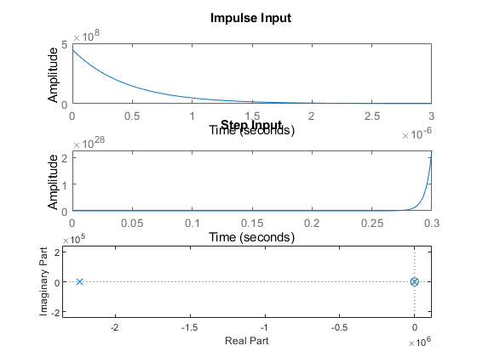

Closed Loop- Positive feedback with Controller (D)
sys = tf([k*A,0],[1,k,k*A])
figure(5);
subplot(3,1,1);
impulse(sys);
title('Impulse Input');
subplot(3,1,2);
step(sys);
title('Step Input');
[z,p,k] = tf2zp([k*A,0],[1,k,k*A])
subplot(3,1,3);
zplane(z,p);
S = stepinfo(sys)
sys =
8.96e10 s
-------------------------
s^2 + 4.48e08 s + 8.96e10
Continuous-time transfer function.
z =
0
p =
1.0e+08 *
-4.4800
-0.0000
k =
8.9600e+10
S =
struct with fields:
RiseTime: 0
SettlingTime: 0.0196
SettlingMin: 0.2598
SettlingMax: 199.9633
Overshoot: Inf
Undershoot: 0
Peak: 199.9633
PeakTime: 9.2103e-07
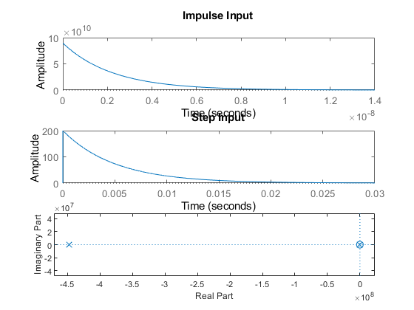

Math Analysis
Independent: Time(t) Dependent: Population(N) Constant: Constant(A)

Comparison Analysis
1) System without controller behaves exactly like an exponential Growth. with the system growing exponentially. 2) On adding a proportionality controller to system , the system becomes unstable. 3) On adding a Integrator controller to system, the response times have decreased hugely, making the system reach stablity faster than a P controller. 4) Integrator controller adds a pole to zero also. 5) On addition of a differentiator controller in negative feedback the system becomes unstable. 6) A zero gets added at origin due to the differentiator. 7) On addition of a differentiator controller in positive feedback the system becomes stable.
Published with MATLAB® R2020b

