./

Report

**JENKINS SOFTWARE**

|  |  |  |  |  |  |
| --- | --- | --- | --- | --- | --- |
| **Ver. Rel. No.** | **Release Date** | **Prepared. By** | **Reviewed By** | **To be approved By** | **Remarks/Revision Details** |
| 1 |  | Name/PS No | Name/PS No | Module Owner Name | Comments |
| 2 |  | 99003733/Aditya Mewara |  |  |  |

**Document History**

Table of Contents

Table of Contents 3

1. INTRODUCTION TO JENKINS SOFTWARE: 4

1.1. How to Install JENKINS Software: 4

1.2. Configuring the JENKINS Software: 7

2. How to Install Plugins in Jenkins: 7

3. How To configure the project: 10

4. How To build the project: 14

# INTRODUCTION TO JENKINS SOFTWARE:

* Jenkins is a free and open source automation server.
* It helps automate the parts of software development related to building, testing and deploying.
* Plugins have been released for Jenkins that extend its use to projects written in languages other than Java.

## **How to Install JENKINS Software:**

* Before Installing the Jenkins software, you need to make sure that the Java is installed on your system
* You can check that java is installed on your system by typing the command in the cmd/terminal.
* The command to check is: *java -version* or *java -v* or *java --version*

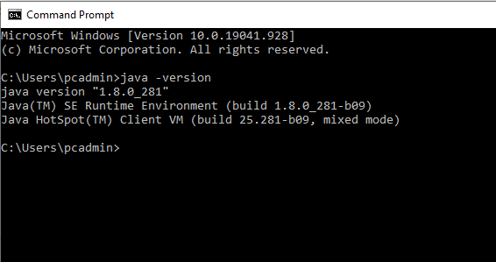

**Fig-1: Java version**

* After you successfully check that java is installed in your system you can proceed by installing the Jenkins software.
* There are two options while installing Jenkins:
  + First is to install on local machine with available local port (generally 8080)

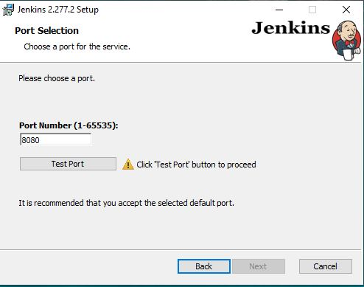

**Fig-2: Jenkins Installation**

* + Second is the using it on server by logging into Jenkins account by entering id and password.

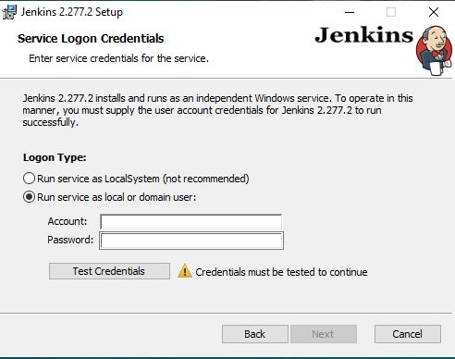

**Fig-3: Jenkins Different methods**

* We choose to install in local machine with the port number 8080 and click on Test port to check the port is available or not.
* Then click Next to continue the Installation.

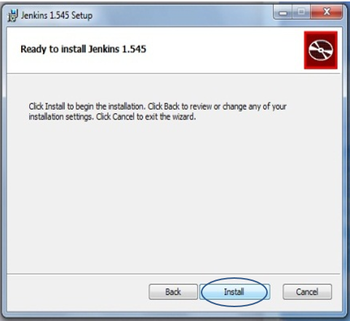

**Fig-4: Jenkins Installation**

* And then finally click on Install.
* Once the installation completed the browser window open you need to enter the security key stored in computer itself to unlock the Jenkins.
* The path of security key (where it is located) is provided by the Jenkins window itself.

*C:\Program files (x86) \Jenkins\secrets\initialAdminPassword*

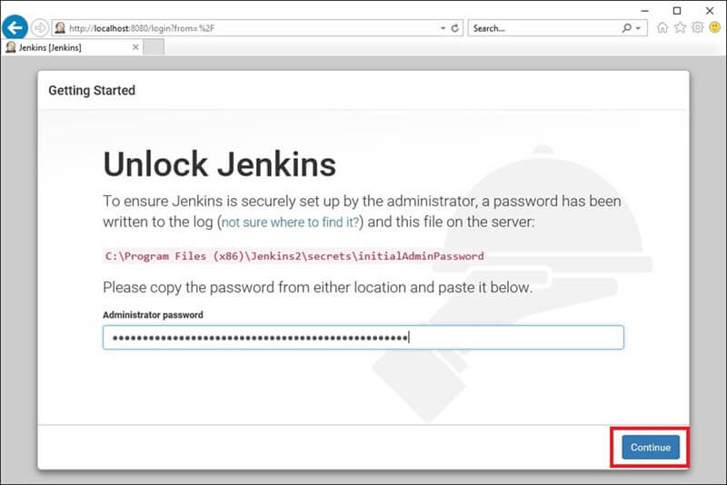

**Fig-5: Unlocking Jenkins**

* Now you are ready to go and open the Jenkins.

## **Configuring the JENKINS Software:**

* You can run the JENKINS by typing **localhost:8080** in the browser windows it will display the JENKINS dashboard where you can create new project.
* New item -> Freestyle Project
* Now you can write the code in the project and after that we can configure based on the requirements.

# How to Install Plugins in Jenkins:

***METHOD 1:***

* **Step 1:** Go to Jenkins Dashboard on the top left side you will see the manage Jenkins menu as shown here.

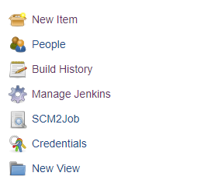

**Fig-6: Dashboard Menu**

* **Step 2**: Now click on Manage Jenkins menu after you get this window.

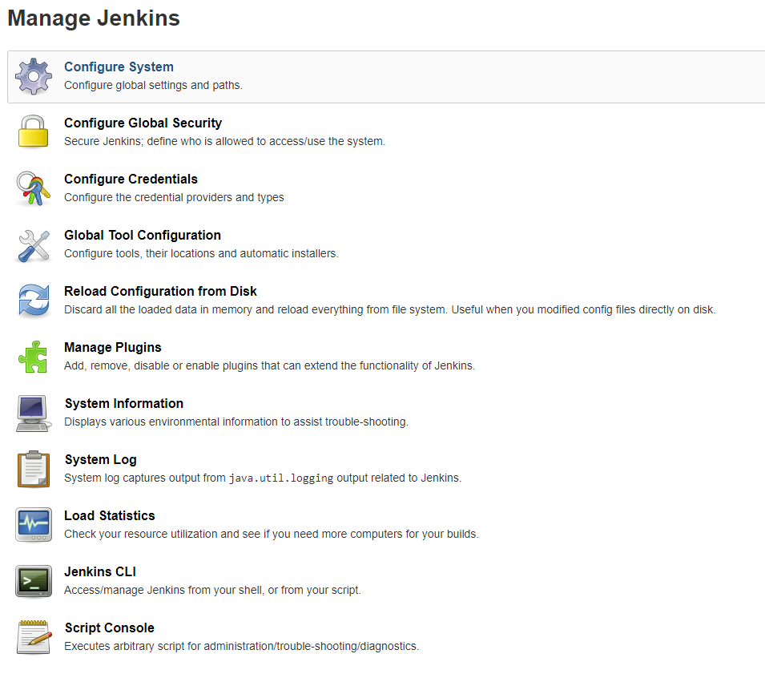

**Fig-7: Plugins Menu**

* **Step 3:** Now click on Manage plugins and after that go to Available tab where you can search for FS Trigger and you need to check the box and click on Install the plugin.

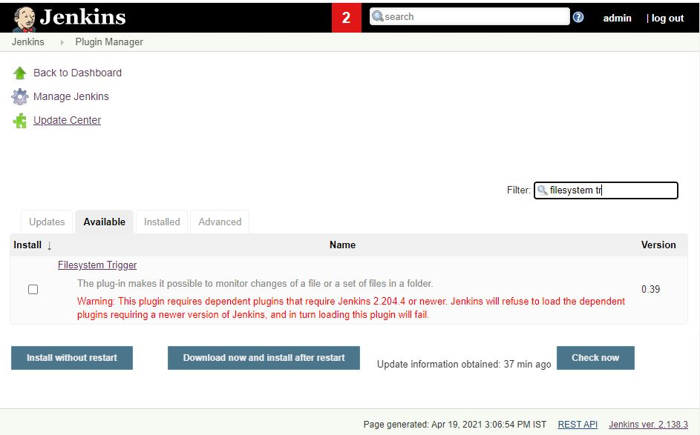

**Fig-8: Plugins window**

* **Step 4:** Now you can check under installed tab that the file system plugin is installed correctly or not.
* **Step 5:** Now you need to restart the Jenkins Software after the plugin install to apply the changes.
* **Step 6:** In this way, you can install any plugin based on the requirement.

***METHOD 2:***

* If you are unable to install via above method then you need to follow these steps.
  + **STEP-1**: Go to plugins menu by Manage Jenkins -> Manage Plugins and after that head over to Advanced Tab.

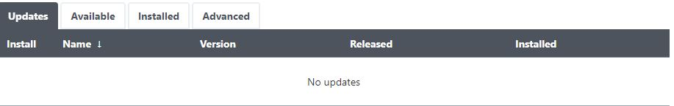

**Fig-9: Advanced Tab under manage plugins**

* + **STEP-2:** After advanced tab, you will see a section known as upload plugin here where you need to upload the (. hpi) file of the plugin.
  + You can download (.hpi) file via this link : <http://mirrors.jenkins-ci.org/plugins/>there are different versions pick the suitable one.
  + **STEP-3:** Now click on upload and you will see that plugin is successfully installed.

C:\Users\99003733\AppData\Local\Microsoft\Windows\INetCache\Content.Word\Capture8.jpg

**Fig-10: Fstrigger plugin installation success**

* + **STEP-4:** You can verify that if plugin is successfully installed or not is by going to installed tab and type the name of the plugin.

**Fig-11: 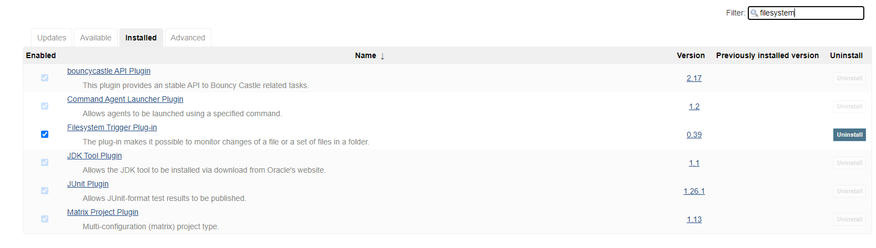FS trigger Successfully installed**

# How To configure the project:

* In the Jenkins dashboard, you can view your project. You can see below how Jenkins dashboard looks like

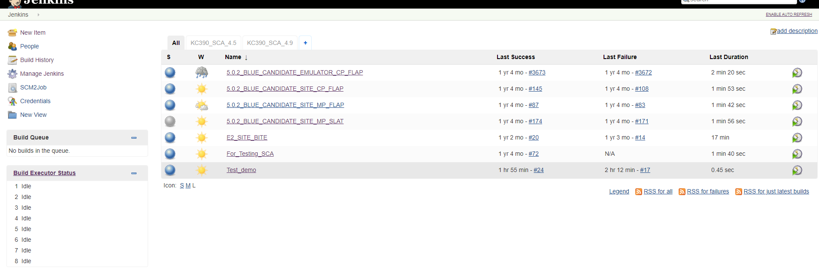

**Fig-12: Jenkins Dashboard**

* It has all the project on the right side and menu on the left-hand side
* Before configuring the project, you need to install the plugin i.e. Filesystem Trigger.
* After you have installed the necessary plugin we now need to configure the project.
* Click on the project you want to configure and then several options appear. Choose configure option in the dropdown.

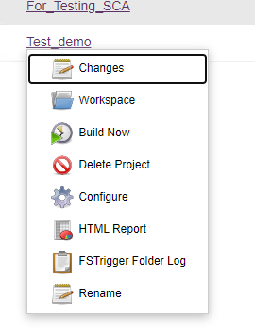

**Fig-13: Project drop down menu**

* Now after clicking on the configure a new window open with several options to be set.
  + **Step 1:** Under General Tab click on Advanced and check use custom workspace dialog box and enter the directory name where folder/project is present.

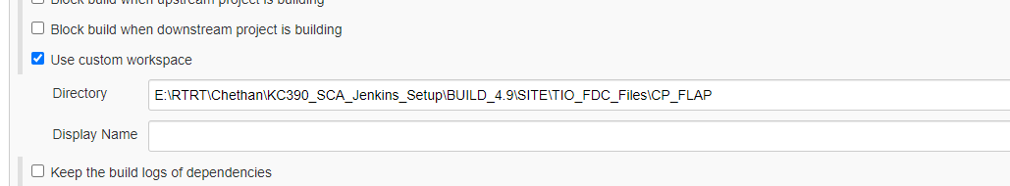

**Fig-14: Custom Workspace dialog box**

* + **Step 2:** Under Source code management there are three options depending on the requirement and applications they need to be selected.
    - **None** is selected if folder is present in the local machine
    - **Git** is selected if the project is present on the SVN
    - **Subversion**

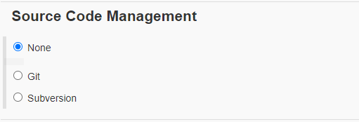

**Fig-15: Source code management tab**

* + **Step 3:** Under tab Build Triggers the [FSTrigger] - Monitor folder dialog box should be selected to monitor any changes that took place in the directory.
    - **FS Trigger** takes two arguments first is the path of the directory to monitor the changes and other is the Schedule to run the changes every 2 minutes or depending on the user requirements.

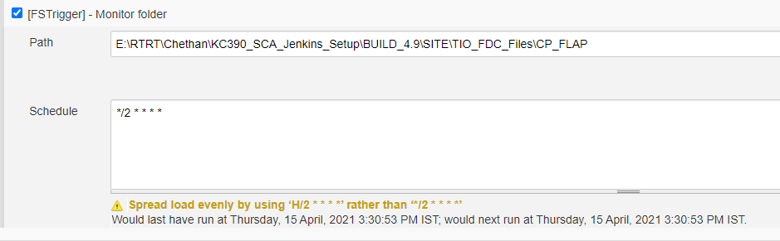

**Fig-16: FS trigger tab with Path and Schedule**

* + **Step 4:** Under Build tab choose the option Execute windows Batch command and provide it with directory where the project is stored.
  + **Step 5(optional):** Under Post Build Actions tab click on Publish HTML Report to see the changes present in the folder or directory.
    - It takes several arguments like path of the directory and the index page where you can type the index.html
  + **Step 6:** Click Apply and then save to save the changes.

# How To build the project:

* After Configuring the project and saving the changes you are taken into the dashboard where on the left side you see menu of lot of the options.

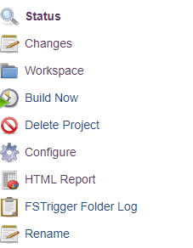

**Fig-17: Build now button**

* Now click on Build Now option to build the project. After successful build, it shows blue dot otherwise red cross.

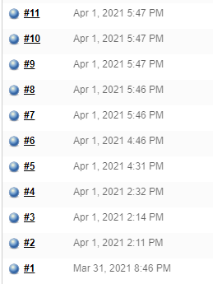

**Fig-18: Successfully Build**

* You can check the output by clicking on the FS Trigger Folder log on the left-hand side of the menu.

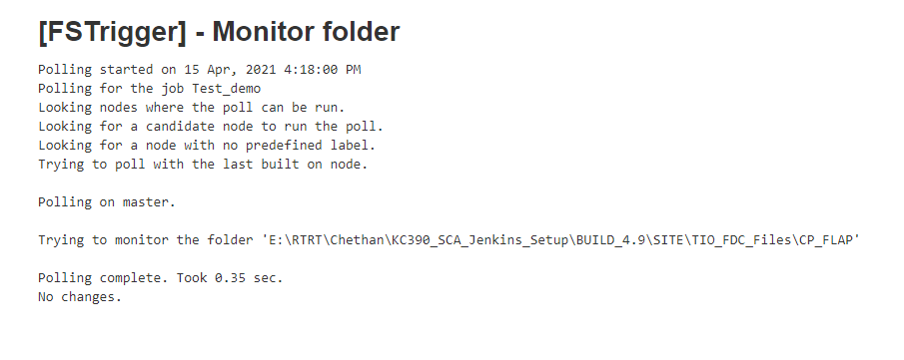

**Fig-19: FS Trigger Changes**