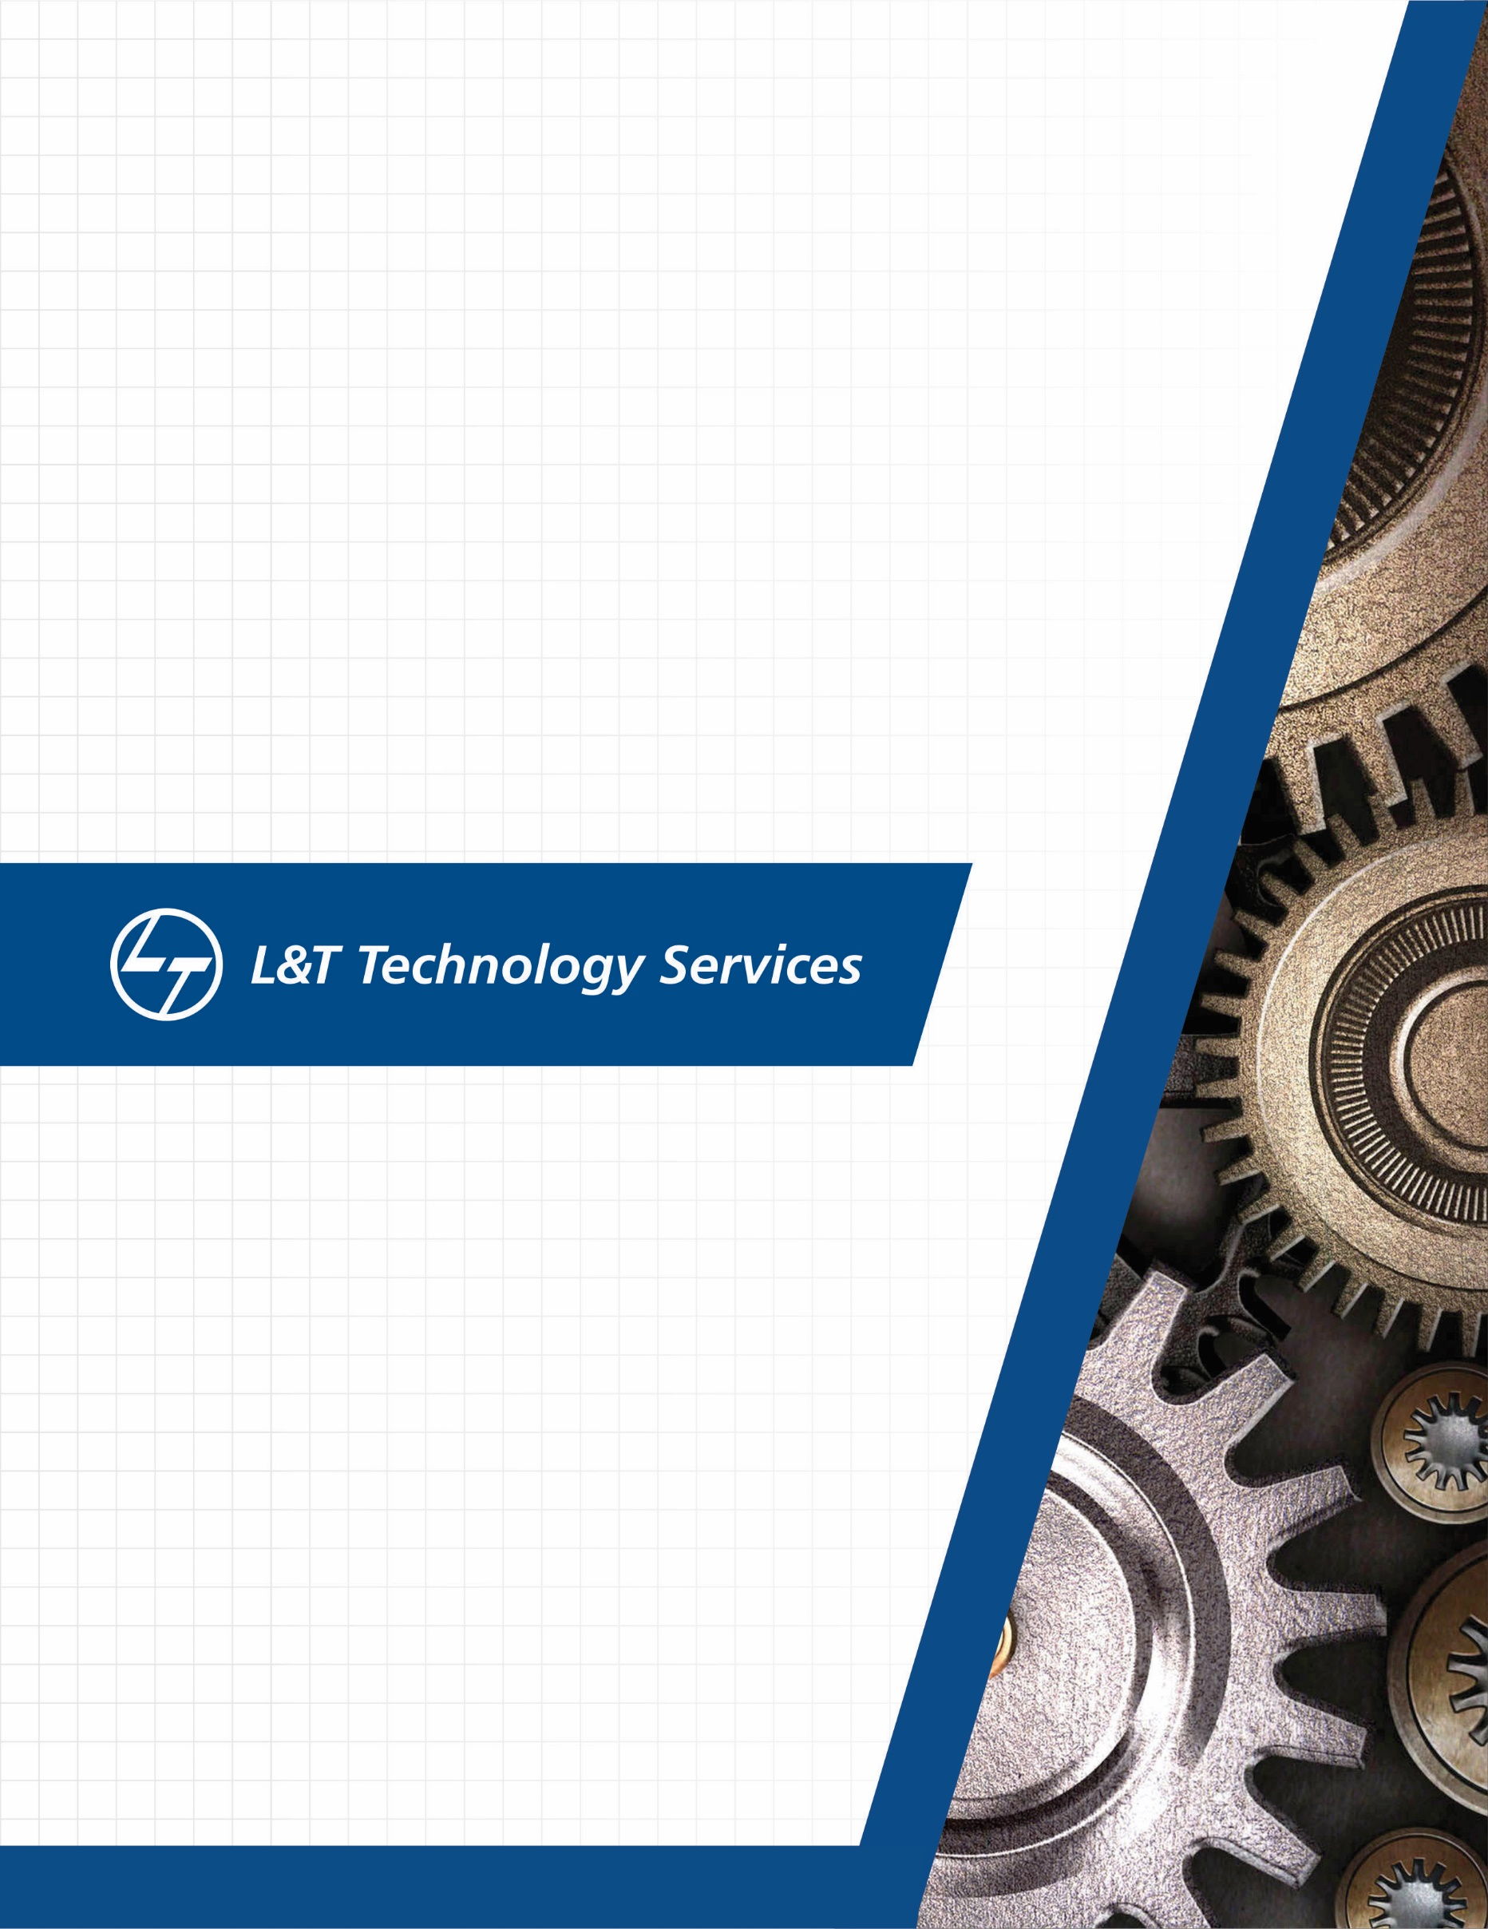./

Learning Report – **Computer Networks**



|  |  |  |  |  |  |
| --- | --- | --- | --- | --- | --- |
| **Ver. Rel. No.** | **Release Date** | **Prepared. By** | **Reviewed By** | **To be approved By** | **Remarks/Revision Details** |
| 1 |  | Name/PS No | Name/PS No | Module Owner Name | Comments |
| 2 | 15/02/21 |  |  |  |  |
| 3 |  |  |  |  |  |
|  |  |  |  |  |  |
|  |  |  |  |  |  |

**Document History**

Table of Contents

Table of Figures 3

Table of Tables 4

ACTIVITY 1: SYSTEM/ SOFTWARE DEVELOPMENT 4

**INTRODUCTION** 4

**MY PRODUCT: “Name ”** 6

**SWOT ANALYSIS** 7

**REQUIREMENTS** 7

**DESIGN** 8

HIGH LEVEL DESIGN 8

LOW LEVEL DESIGN 11

**TEST PLANS** 13

**REFERENCES** 15

ACTIVITY 2: AGILE METHODOLOGY 15

**THEME** 15

**EPIC** 15

**USER STORY** 16

**REFERENCES** 17

APPENDIX: 17

## Table of Figures

Figure 1 CLASS DIAGRAM(HIGH LEVEL) 10

Figure 2 USE CASE DIAGRAM (HIGH LEVEL) 11

Figure 3 ACTIVITY DIAGRAM (HIGH LEVEL) 12

Figure 4 USE CASE DIAGRAM (LOW LEVEL) 12

Figure 5 ACTVITY DIAGRAM (LOW LEVEL) 13

Figure 6 BLOCK DIAGRAM 13

Figure 7 COMPONENT DIAGRAM (HIGH LEVEL) 22

Figure 8 ACTIVITY DIAGRAM (high level) 23

[Figure 9 ACTIVITY DIAGRAM (LOW LEVEL) 24](https://lnttsgroup.sharepoint.com/sites/GEA/Global%20Engineering%20Academy/GEA%20Insights/Genesis/Shared%20Documents/Submission/MYSORE/2009MYSEMB/Foundation/Applied%20SDLC%20with%20Software%20Testing/99002439/FINAL.docx#_Toc52177322)

Figure 10- ACTIVITY DIAGRAM (LOW LEVEL) 24

Figure 11 TEST PLAN 25

Figure 12 GIT 27

Figure 13 GIT ISSUES 28

Figure 14 GIT COMMITS 1 28

Figure 15 GIT COMMIT 2 29

Figure 16 GIT 30

Figure 17 GIT MAKE 31

Figure 18 GIT MAKE 2 31

Figure 19 GIT BUILD 32

Figure 20 GIT CODE QUALITY 32

## Table of Tables

Table 1 AGING 6

Table 2 GRADING COST 6

Table 3 REQUIREMENTS 8

Table 4 HIGH LEVEL TEST PLAN 15

Table 5 LOW LEVEL TEST PLAN 16

Table 6 USER STORIES 17

Table 7 AGING 19

Table 8 GRADING COST 19

Table 9 REQUIREMENTS 21

Table 10 USER STORIES 27

**OVERVIEW OF NETWORKS**

A computer network is a group of devices linked to each other that enables the device will communicate with another device and share their data, applications and resources. Group of devices connected with each other through wires, optical fibers or optical links so that various devices can interact with each other through a network.

Computer Networks support many applications and services, such as access to the World Wide Web, Digital video, Digital audio, shared use of application and storage servers, printers, fax machines, and use of email and instant messaging applications.

**COMPONENTS OF COMPUTER NETWORK**

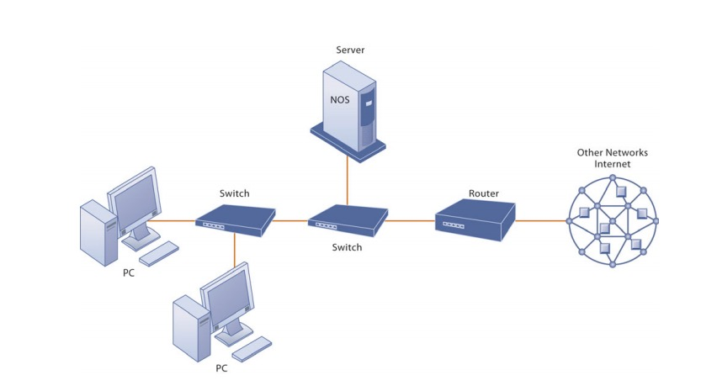

**COMPONENTS OF A SIMPLE COMPUTER NETWORK**

In an Ethernet network, there are some networking devices that play their roles at various levels such as hubs, switches and routers. The functions of the three devices are all quite different from one another, even if sometimes they are all integrated into a single device. due to that, many people feel confused about the differences between the hub, switch, and router. The following part will focus on the topic

hub vs switch vs router, aiming to clarify differences among them.

**HUB**

Hub is a central device that splits the network connection into multiple devices. When computer requests for information from a computer, it sends the request to the Hub. Hub distributes this request to all the interconnected computers.

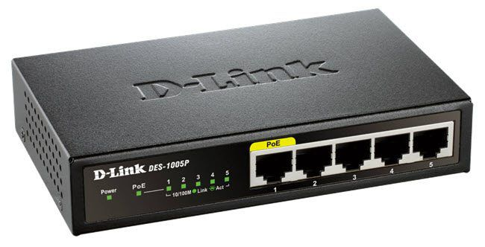

**TYPES OF HUB**

* **Active Hub:** These are the hubs which have their own power supply and can clean, boost and relay the signal along with the network. These are used to extend the maximum distances between the modes.
* **Passive Hub:** These are the hubs which collect wiring from nodes and power supply from active hub. These hubs relay signals on to the network without cleaning and boosting then and can’t be used to extend the distance between nodes.
* **Intelligent Hub:** It work like active hubs and include remote management capabilities. They also provide flexible data rates to network devices. It also enables an administrator to monitor the traffic passing through the hub

**SWITCHES**

Switch is a networking device that groups all the devices over the network to transfer the data to another device. A switch is better than Hub as it does not broadcast the message over the network, i.e., it sends the message to the device for which it belongs to. Therefore, we can say that switch sends the message directly from source to the destination.

**Routers**

A router is s device like a switch that routes data packets based on their IP address. Router is mainly a Network layer device. Routers normally connect LANs and WANs together and have a dynamically updating routing table based on which they make decisions on routing the data packets.

**Bridge**

A bridge operates at data link layer. A bridge is a repeater, with add on the functionality of filtering content by reading the MAC addresses

Of source and destination and it also used for the interconnecting two local area networks on the same protocol. It has a single input and output port.

**Hub vs Switch vs Router**

In network equipment and devices, data is usually transmitted in the form of a frame. When a frame is received, it is amplified and then transmitted to the port of the destination PC (Personal Computer). The big difference between hub and switch is in the method in which frames are being delivered.

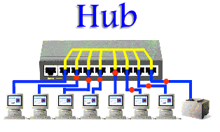

In a hub, a frame is passed along or "broadcast" to every one of its ports. It doesn't matter that the frame is only destined for one port. The hub has no way of distinguishing which port a frame should be sent to. Additionally, a 10/100Mbps hub must share its bandwidth with each and every one of its ports.

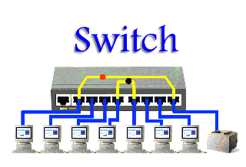

Unlike an Ethernet hub or switch that is concerned with transmitting frames, a router is to route packets to other networks until that packet ultimately reaches its destination. One of the key features of a packet is that it not only contains data but the destination addresses of where it's going. What's more, router is the only one of these three devices that will allow you to share a single IP (Internet Protocol) address among multiple network clients.

**Conclusion**

The differences between hub, switch and router is a confusing term for users. Understanding these distinctions among them can be helpful to find the most appropriate device for your network.

|  |  |  |  |
| --- | --- | --- | --- |
| **Template** | **HUB** | **SWITCH** | **ROUTER** |
| Layer | Physical Layer | Data Link Layer | Network layer |
| Function | To connect a network of personal computers together, they can be joined through a central hub | Allow connections to multiple devices, manage ports, manage VLAN security settings | Direct data in a network |
| Port | 4/12 ports | multi-port, usually between 4 and 48 | 2/4/5/8 ports |
| Device type | Non-intelligent device | Intelligent device | Intelligent device |
| Used in (LAN, MAN, WAN) | LAN | LAN | LAN, MAN, WAN |
| Transmission mode | Half duplex | Half/Full duplex | Full duplex |
| Speed | 10Mbps | 10/100Mbps, 1Gbps | 1-100Mbps(wireless); 100Mbps- |
| Address used for data transmission | MAC address | MAC address | IP address |
| Data Transmission form | electrical signal or bits | frame & packet | packet |

**Topology**

The physical arrangement of the computer system/node which is connected to each other via communication medium is called Topology

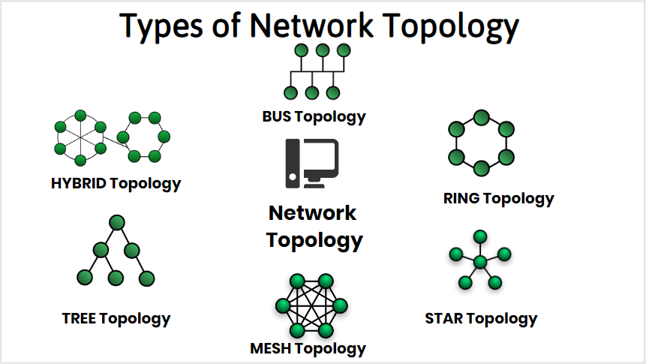

**Bus Topology**

In BUS Topology, one long cable acts as a Single Communication Channel & all the devices are connected to this cable

**Advantage**

* Easy to add / remove nodes in a network
* Required only cable
* It is less expensive
* It broadcast the messages to each device which are connected through the cable.
* It is easy to maintain.
* In case of any computer failure, there will be no effect on other devices.

**Dis-Advantage**

* If cable is fail then the entire network will be failed.
* The messages are broadcast So, we can’t send private messages.
* It takes more time to pass the messages from one place to another place.
* The length cable is limited.
* In this topology data is transmitted only one direction.

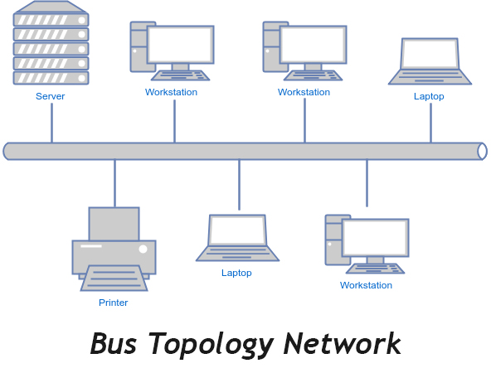

**Ring Topology**

It is called ring topology because it forms a ring. In this Topology each node is strongly connected with is adjacent node.

**Advantage**

* It forms a strong network.
* Each an every node can share data with another node connected through a ring topology.
* Transmission rate of data is very speed.
* The data send through ring topology will be broadcast.

**Dis-Advantage**

* It is very difficult task to add some new computer.
* If we want to send data from a source to destination machine then data will un-necessary passed to all nodes.
* Single point of failure, that means if a node goes down entire network goes down.
* It is very difficult to recover the ring topology if any particular machine is not working properly.
* We can’t send private messages

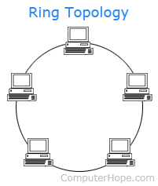

**Star Topology**

In star topology all the nodes are connected with a central device called Hub. And the sharing of data is only possible through HUB

**Advantage**

* It broadcast the messages.
* It is less expensive due to less cable.
* Easy to connect new nodes without affecting rest of the network.
* If one node is failed, then it would not be failure entire network.

**Dis-Advantage**

* In star topology we must required a network device like HUB, SWITCH etc.
* If two nodes want to share the data sharing is only possibly through HUB.
* If HUB is failed the entire network will be failed.
* We can’t send private data.

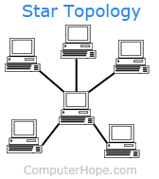

**Mesh Topology**

In this topology each an every computer is directly connected with each-other, So we can directly send the data to the destination machine without going to intermediate machine.

**Advantage**

* It is very good topology to send the private messages.
* All nodes are directly associated with another node so it provide point to point connection
* Un-like ring topology, if a particular machine is failed then entire network will not fail.
* Multiple devices can send or receive data Simultaneously.

**Dis-Advantage**

* It is very difficult to add some new node because each an every computer directly connected with another one.
* If a particular machine not working then, we can’t send or receive data from the failure machine.

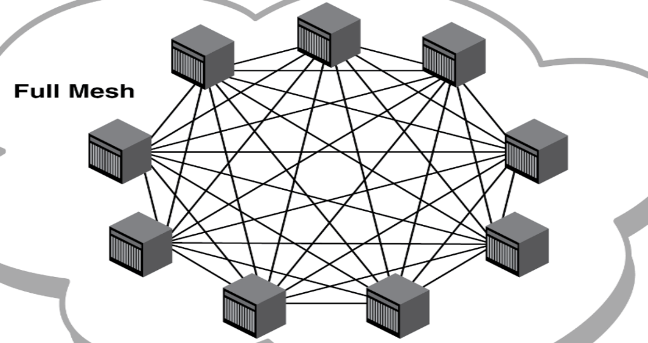

**Hybrid Topology**

Combination of various different topology is called Hybrid topology. A hybrid topology is a type of network topology that uses two or more differing network topologies. These topologies can include a mix of bus topology, mesh topology, ring topology, star topology, and tree topology.

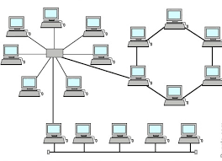

**Tree Topology**

In this topology, all the nodes are connected like a branches of tree the Combination of BUS & STAR topology is called Tree Topology

