./

Learning Report – Applied System Development Life Cycle and Software Testing



|  |  |  |  |  |  |
| --- | --- | --- | --- | --- | --- |
| **Ver. Rel. No.** | **Release Date** | **Prepared. By** | **Reviewed By** | **To be approved By** | **Remarks/Revision Details** |
| 1 |  | Name/PS No | Name/PS No | Module Owner Name | Comments |
| 2 | 15/02/21 |  |  |  |  |
| 3 |  |  |  |  |  |
|  |  |  |  |  |  |
|  |  |  |  |  |  |

**Document History**

Table of Contents

Table of Figures 3

Table of Tables 4

ACTIVITY 1: SYSTEM/ SOFTWARE DEVELOPMENT 4

**INTRODUCTION** 4

**MY PRODUCT: “Name ”** 6

**SWOT ANALYSIS** 7

**REQUIREMENTS** 7

**DESIGN** 8

HIGH LEVEL DESIGN 8

LOW LEVEL DESIGN 11

**TEST PLANS** 13

**REFERENCES** 15

ACTIVITY 2: AGILE METHODOLOGY 15

**THEME** 15

**EPIC** 15

**USER STORY** 16

**REFERENCES** 17

APPENDIX: 17

## Table of Figures

Figure 1 CLASS DIAGRAM(HIGH LEVEL) 10

Figure 2 USE CASE DIAGRAM (HIGH LEVEL) 11

Figure 3 ACTIVITY DIAGRAM (HIGH LEVEL) 12

Figure 4 USE CASE DIAGRAM (LOW LEVEL) 12

Figure 5 ACTVITY DIAGRAM (LOW LEVEL) 13

Figure 6 BLOCK DIAGRAM 13

Figure 7 COMPONENT DIAGRAM (HIGH LEVEL) 22

Figure 8 ACTIVITY DIAGRAM (high level) 23

[Figure 9 ACTIVITY DIAGRAM (LOW LEVEL) 24](https://lnttsgroup.sharepoint.com/sites/GEA/Global%20Engineering%20Academy/GEA%20Insights/Genesis/Shared%20Documents/Submission/MYSORE/2009MYSEMB/Foundation/Applied%20SDLC%20with%20Software%20Testing/99002439/FINAL.docx#_Toc52177322)

Figure 10- ACTIVITY DIAGRAM (LOW LEVEL) 24

Figure 11 TEST PLAN 25

Figure 12 GIT 27

Figure 13 GIT ISSUES 28

Figure 14 GIT COMMITS 1 28

Figure 15 GIT COMMIT 2 29

Figure 16 GIT 30

Figure 17 GIT MAKE 31

Figure 18 GIT MAKE 2 31

Figure 19 GIT BUILD 32

Figure 20 GIT CODE QUALITY 32

## Table of Tables

Table 1 AGING 6

Table 2 GRADING COST 6

Table 3 REQUIREMENTS 8

Table 4 HIGH LEVEL TEST PLAN 15

Table 5 LOW LEVEL TEST PLAN 16

Table 6 USER STORIES 17

Table 7 AGING 19

Table 8 GRADING COST 19

Table 9 REQUIREMENTS 21

Table 10 USER STORIES 27

## **Introduction**

Now days calculator is contributing in each and every one of us life, some of us using for very basic arithmetic calculation and some of using for calculating such a complex problem which take so many hours to calculate by manually. Hence in market there are various categories of calculator available based on your requirements. Some of them are made to be very specific in term of their using and some of them are used by different-different class of people who are using it. Like students, graduate students, business man, local shops and etc. If define this device in very short then we can say it is a device that performs arithmetic operations on numbers. The simplest calculators can do only addition, subtraction, multiplication, and division. More sophisticated calculators can handle exponential operations, roots, logarithms, trigonometric functions, and hyperbolic functions. Internally, some calculators actually perform all of these functions by repeated processes of addition. Most calculators these days require electricity to operate. Portable, battery-powered calculators are popular with engineers and engineering students.

## **Research**

Calculators are valuable instructional tools and are a necessary element in the modern mathematics classroom. Students need to use calculators frequently in order to develop confidence in the use of the machine. At what point in the learning of mathematical concepts should students be allowed to use calculators? Does calculator use have a negative impact on student acquisition of basic mathematical skills?

In the market dynamics part of global calculator market, the users in different sector such as IT, banking and financial institutions, accounting firm, educational institutions, hospitals, government, retail, general public etc. where the use of calculators is so much through which the market has grown so fast and there are immense opportunities to grow in several region across the globe. As per the analysis, the calculator market in North America, Eastern Europe, Japan has grown very rapidly due to the large number of established and key player industries such as information technology, banking and financial institutions, accounting firm, educational institutions and many more, where the use of different types calculators are very high. Also in the particular segment of students calculators have become an important part in their studies which has also become the growth factors in global calculators market.

Various key players present in global calculators market include Casio, Citizen, Orpat, Canon, Flair, Texas Instruments, Hawlett-Packard Development, Liquidware, Orbit Research, Sharp Electronics, Desmos, Claro Calculators.

**EXAMPLE OF SOME CALCULATOR TRENDING THE MARKET**

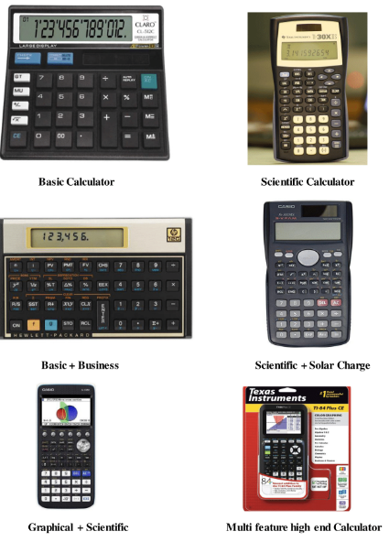

**Cost and Features**