./

Learning Report – Applied System Development Life Cycle and Software Testing



|  |  |  |  |  |  |
| --- | --- | --- | --- | --- | --- |
| **Ver. Rel. No.** | **Release Date** | **Prepared. By** | **Reviewed By** | **To be approved By** | **Remarks/Revision Details** |
| 1 |  | Name/PS No | Name/PS No | Module Owner Name | Comments |
| 2 | 15/02/21 | 99003746 |  |  |  |
| 3 |  |  |  |  |  |
|  |  |  |  |  |  |
|  |  |  |  |  |  |

**Document History**

Table of Contents

Table of Figures 3

Table of Tables 4

ACTIVITY 1: SYSTEM/ SOFTWARE DEVELOPMENT 4

**INTRODUCTION** 4

**MY PRODUCT: “Name ”** 6

**SWOT ANALYSIS** 7

**REQUIREMENTS** 7

**DESIGN** 8

HIGH LEVEL DESIGN 8

LOW LEVEL DESIGN 11

**TEST PLANS** 13

**REFERENCES** 15

ACTIVITY 2: AGILE METHODOLOGY 15

**THEME** 15

**EPIC** 15

**USER STORY** 16

**REFERENCES** 17

## **Introduction**

Now days calculator is contributing in each and every one of us life, some of us using for very basic arithmetic calculation and some of using for calculating such a complex problem which take so many hours to calculate by manually. Hence in market there are various categories of calculator available based on your requirements. Some of them are made to be very specific in term of their using and some of them are used by different-different class of people who are using it. Like students, graduate students, business man, local shops and etc. If define this device in very short then we can say it is a device that performs arithmetic operations on numbers. The simplest calculators can do only addition, subtraction, multiplication, and division. More sophisticated calculators can handle exponential operations, roots, logarithms, trigonometric functions, and hyperbolic functions. Internally, some calculators actually perform all of these functions by repeated processes of addition. Most calculators these days require electricity to operate. Portable, battery-powered calculators are popular with engineers and engineering students.

## **Research**

Calculators are valuable instructional tools and are a necessary element in the modern mathematics classroom. Students need to use calculators frequently in order to develop confidence in the use of the machine. At what point in the learning of mathematical concepts should students be allowed to use calculators? Does calculator use have a negative impact on student acquisition of basic mathematical skills?

In the market dynamics part of global calculator market, the users in different sector such as IT, banking and financial institutions, accounting firm, educational institutions, hospitals, government, retail, general public etc. where the use of calculators is so much through which the market has grown so fast and there are immense opportunities to grow in several regions across the globe. As per the analysis, the calculator market in North America, Eastern Europe, Japan has grown very rapidly due to the large number of established and key player industries such as information technology, banking and financial institutions, accounting firm, educational institutions and many more, where the use of different types calculators are very high. Also in the particular segment of students’ calculators have become an important part in their studies which has also become the growth factors in global calculator’s market.

Various key players present in global calculator’s market include Casio, Citizen, Or pat, Canon, Flair, Texas Instruments, Hewlett-Packard Development, Liquid ware, Orbit Research, Sharp Electronics, Demos, Claro Calculators.

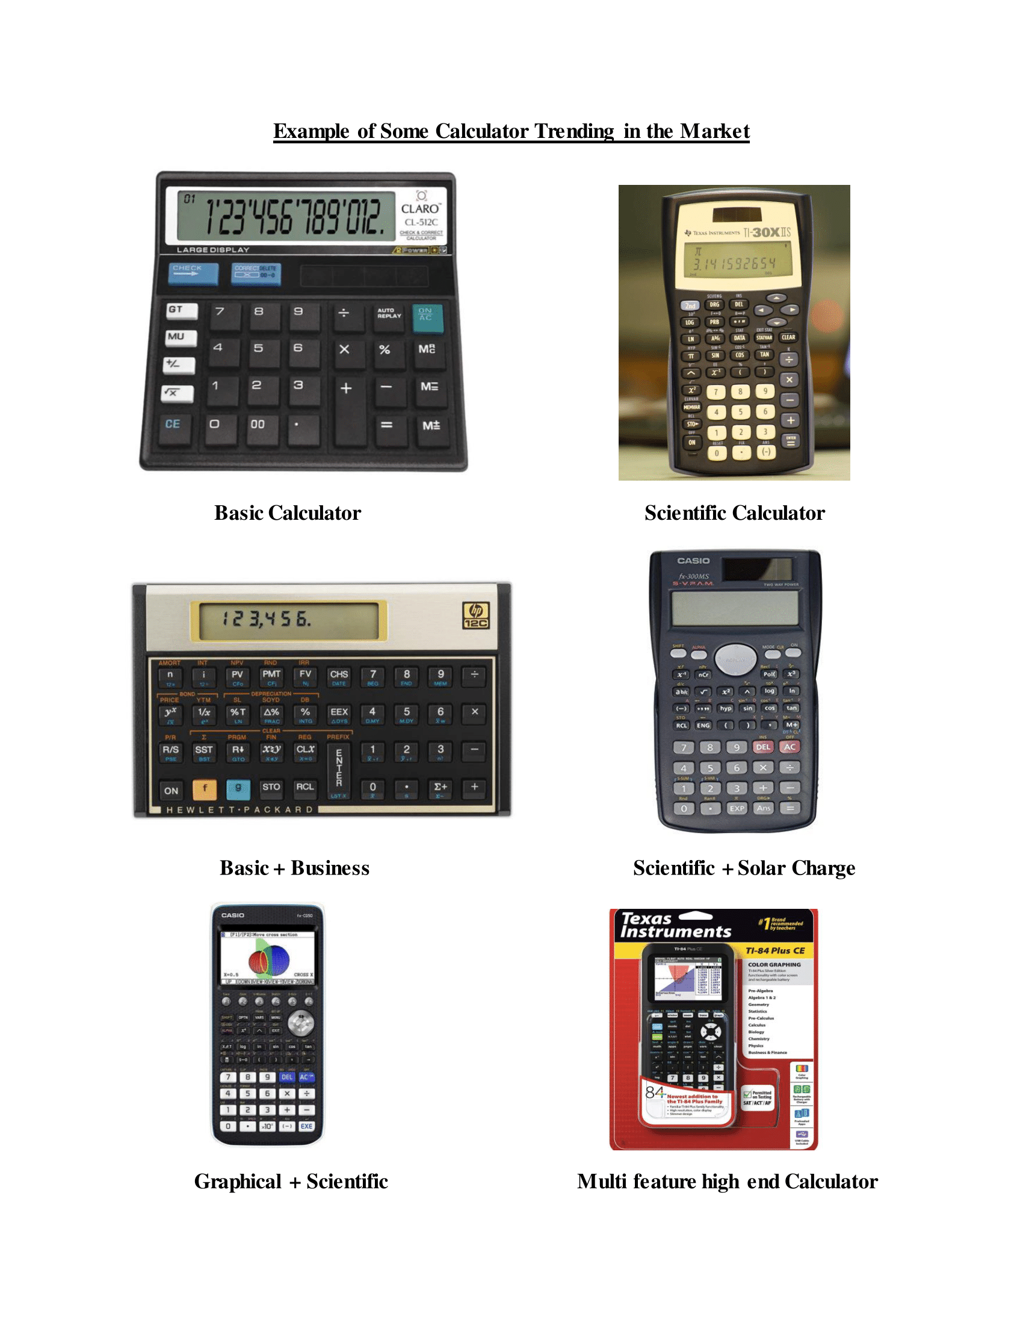

## **Cost and Features**

## **Defining Our System**

Proposed System ##In the proposed system we are trying to build a calculator which can have the features, which are frequently used in all domain of work. ##Motive: • A calculator having very compact size for easy handling. • This calculator is very specific in terms of operation or the features included. • To reduce the over burden and complexity of function which hardly used by the users. • Making the calculator specific to their role of operation. • Reducing the overlapping of the function on the front panel.

Key Features: • Keeping the front panel very simple and less button for easy to use.

* For this we are giving selection choices on the screen itself and can be navigate by the user through the navigation button. • Color LCD screen.
* To make the calculator very attractive and help to distinguish between the different options available on the screen. • Sequence Input
* This feature makes the calculator very easy to use in terms of giving inputs through the panel. • Operation specific.
* Below table shows that section wise operation available inside the calculator.

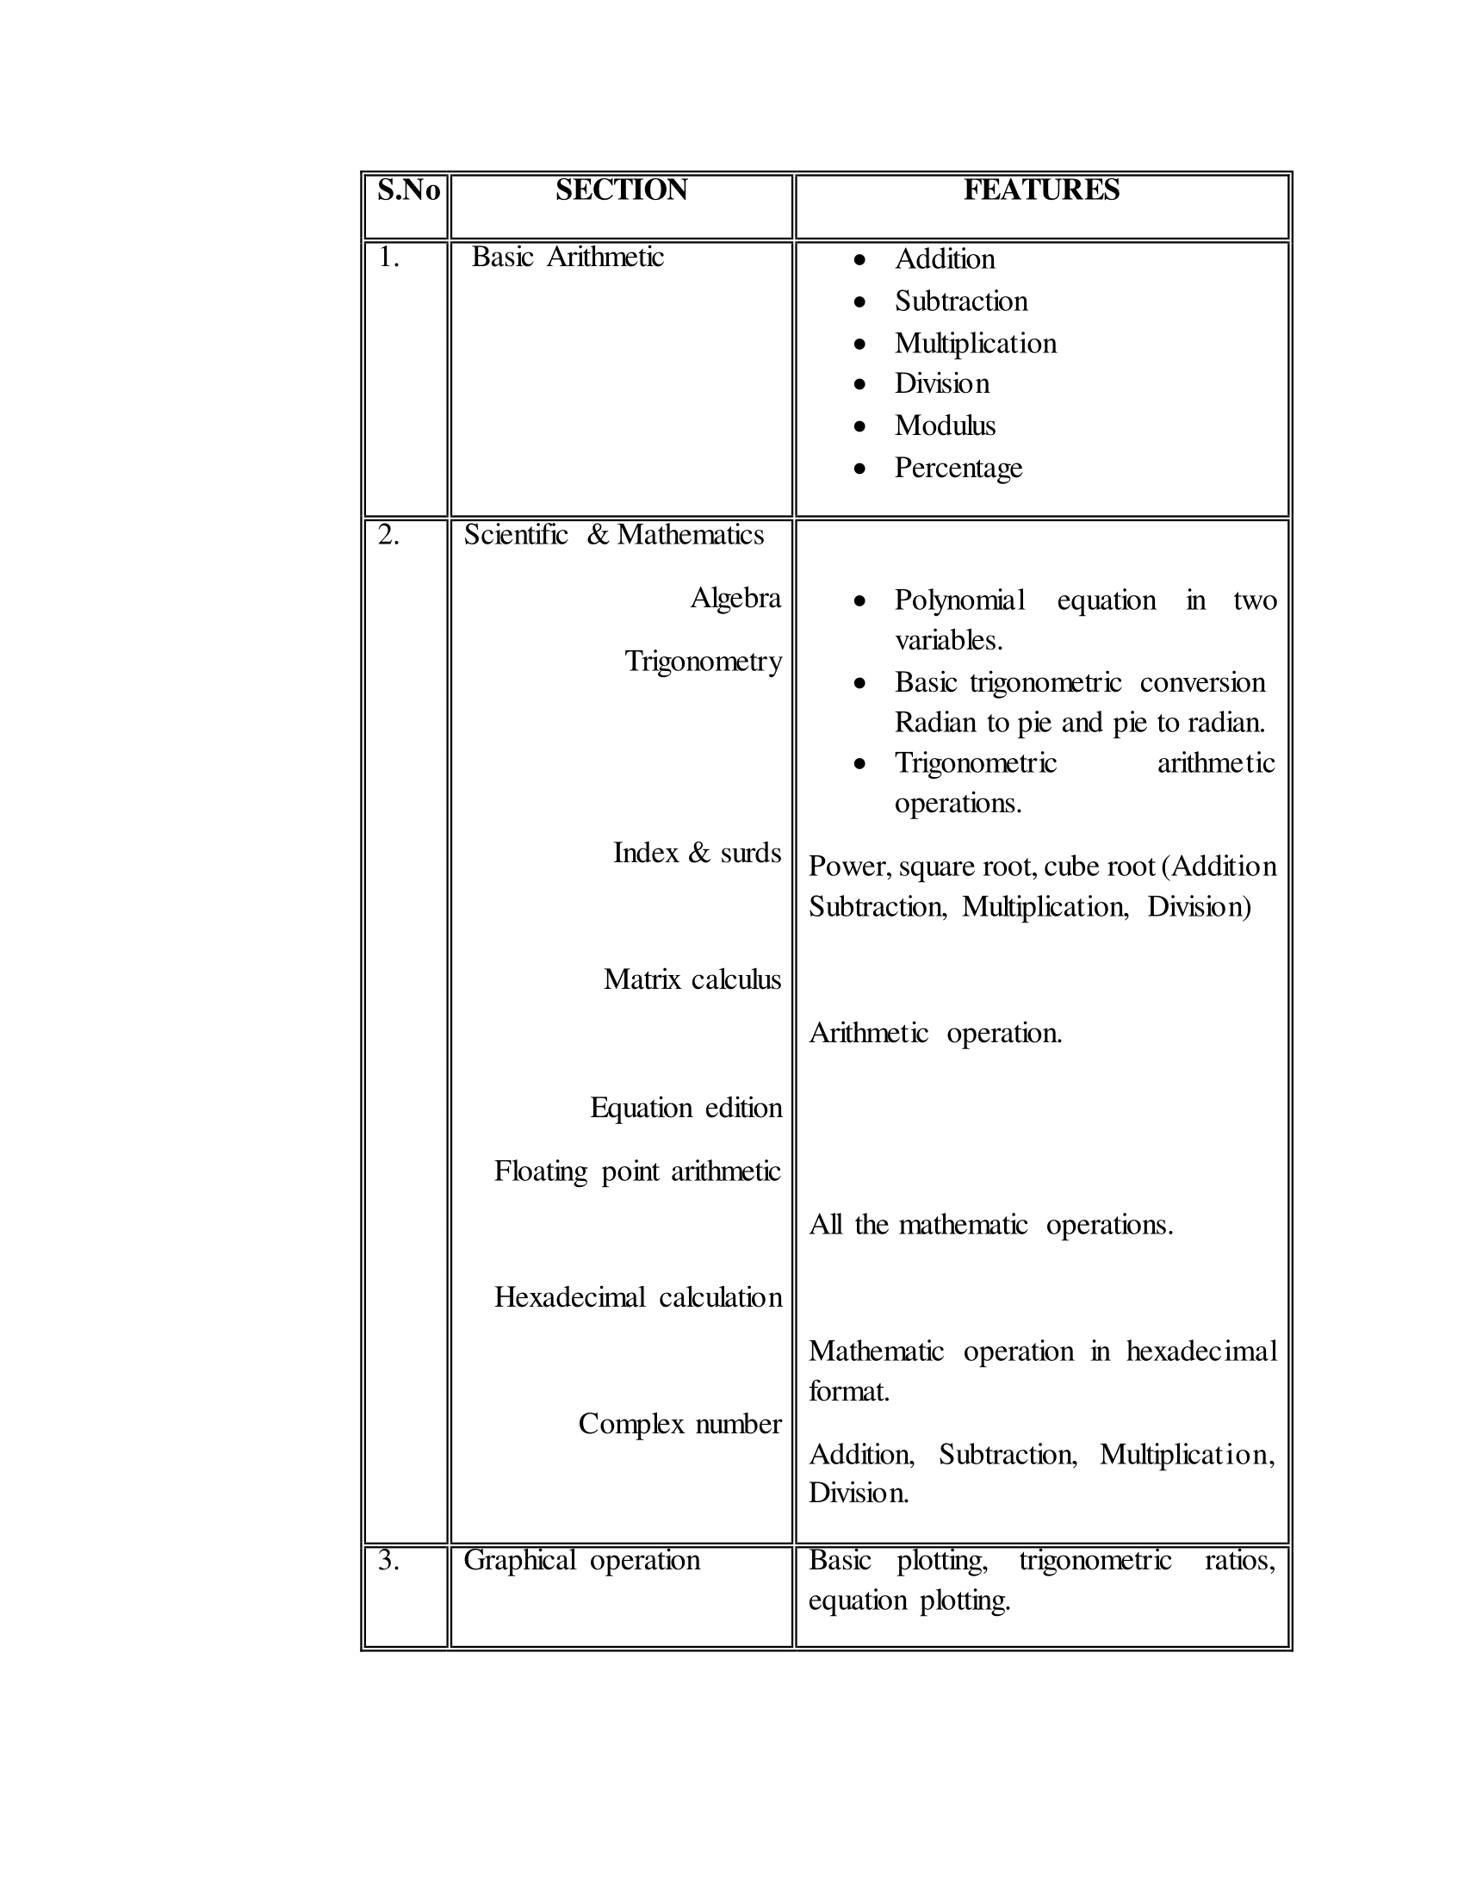**TABLE**

## **SWOT ANALYSIS**

|  |  |  |  |
| --- | --- | --- | --- |
| Strength | Weakness | Opportunities | Threats |
| * Innovative | * Water Repellent | * Provides more opportunities for students, Shopkeepers etc.   [Calculations will be easier] | * Strong Competitors   Ex: -Casio, Texas instruments |
| * User Friendly | * Fire Repellent | * Educational Improvement Campaign |  |
| * They are not Fragile |  |  |  |
| * Switch Mode is   Available |  |  |  |
| * Power Saving |  |  |  |
| * Feature   >Basic Operations  >Scientific >Graphical |  |  |  |

## **REQUIREMENTS**

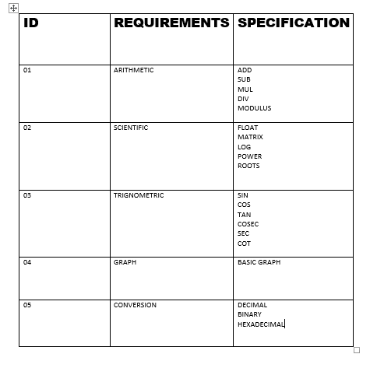

# 4W's and 1'H

## Who:

* 10Th,11th,12Th Students can use basic and some additional features
* Engineering Students can use more features like Graphical Evaluation
* For Basic Calculations (ex Shopkeepers)

## What:

* We are building a calculator with having features of basic, scientific and graphical calculator.
* Providing mode Selector Switch for power Management.
* We are adding activity tracker feature.

## When:

* Labs
* Colleges
* Examination hall
* Shops

## Where:

* To solve Mathematical equations [basics or complex]
* Very Needful in colleges to solve equations like Trigonometric. Logarithms etc.…
* We can also use it for basic calculations where Shopkeeper can use for basic Calculations

## How:

* Input: - Tiny plastic keys with rubber membrane underneath and touch sensitive circuit underneath
* Processor: - A controller that does all the hard work
* Output: -we are using LCD for Showing all the inputs and shows the results.
* Power source: - A long life battery, using solar chargeable battery

# Detail requirements

## High Level Requirements:

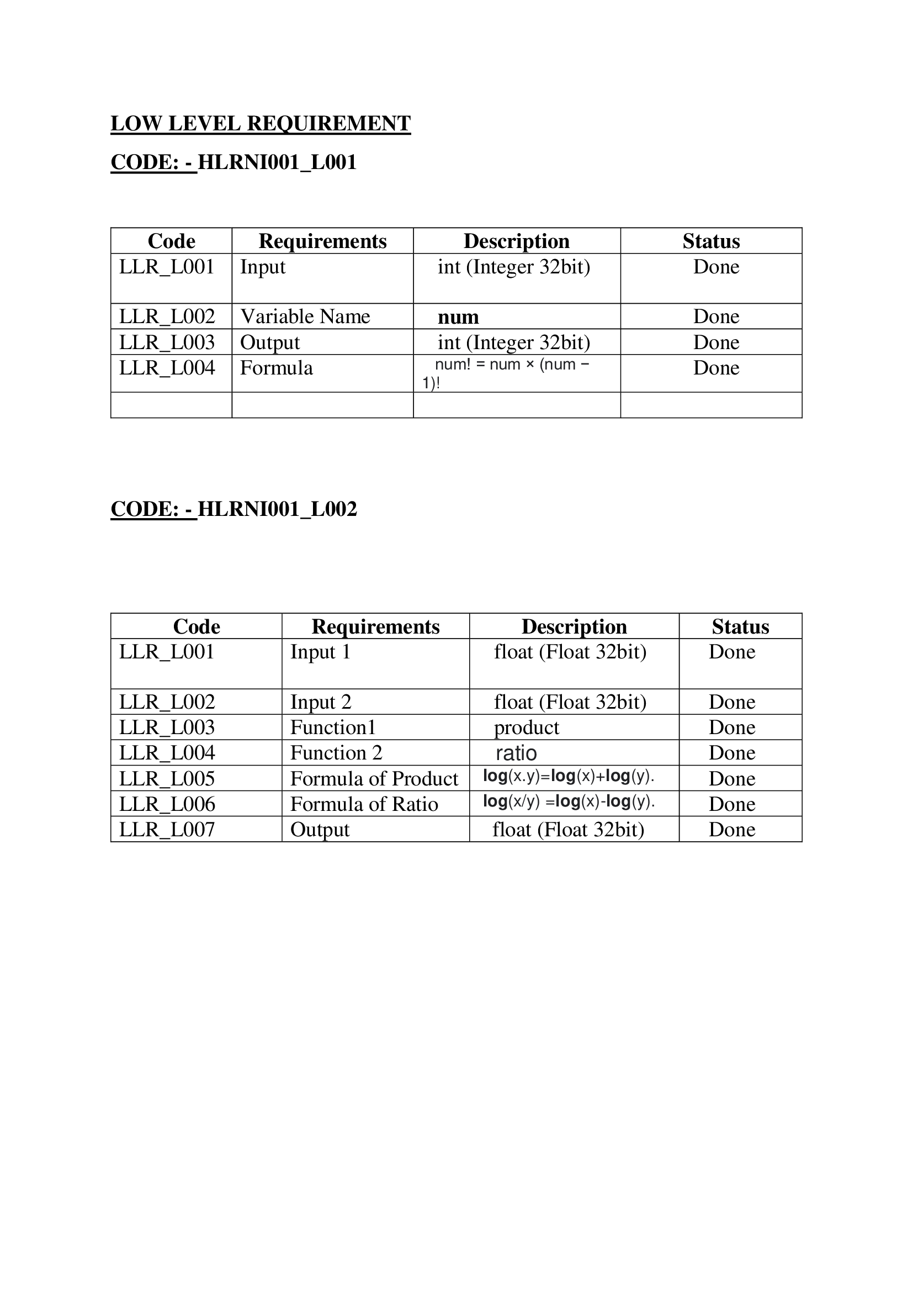

## **Low level Requirements:**

# Design

## High Level Design

## Structural Diagram:-HLR9003746

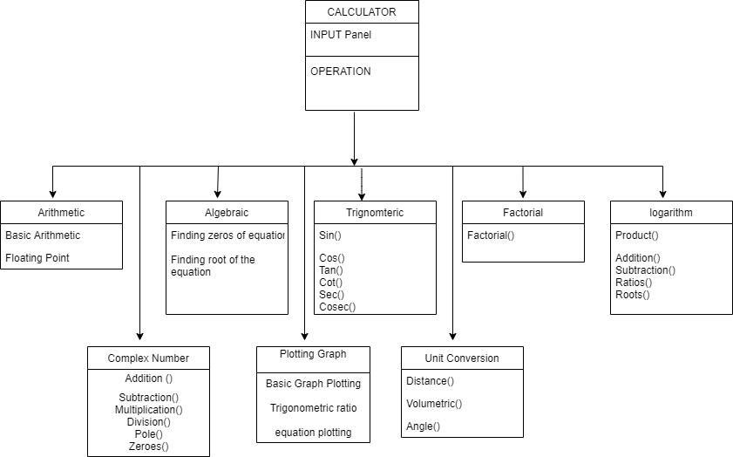

## **Low Level Design**

* Logarithm Structural

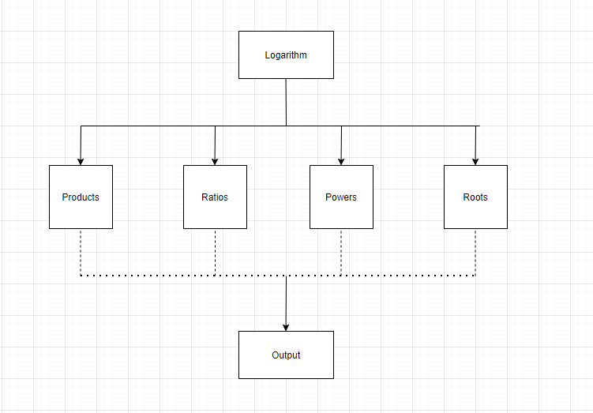

* **Factorial**

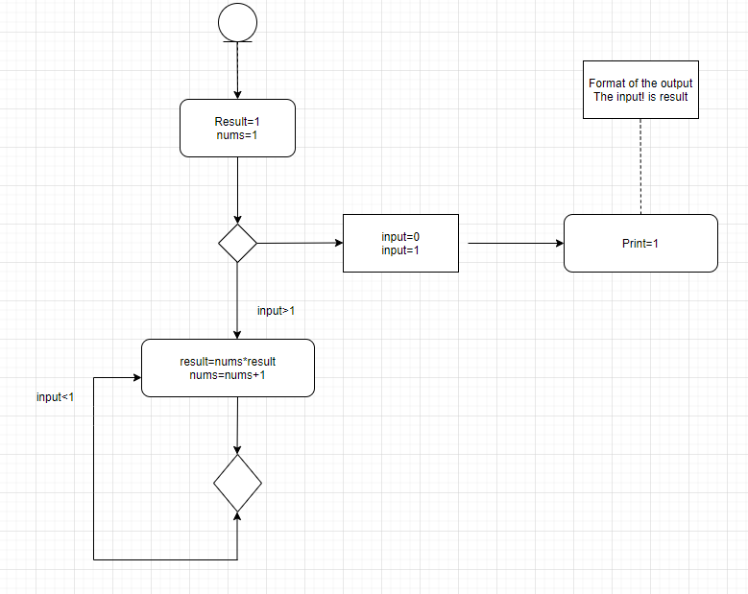

* Logarithm Behavioral

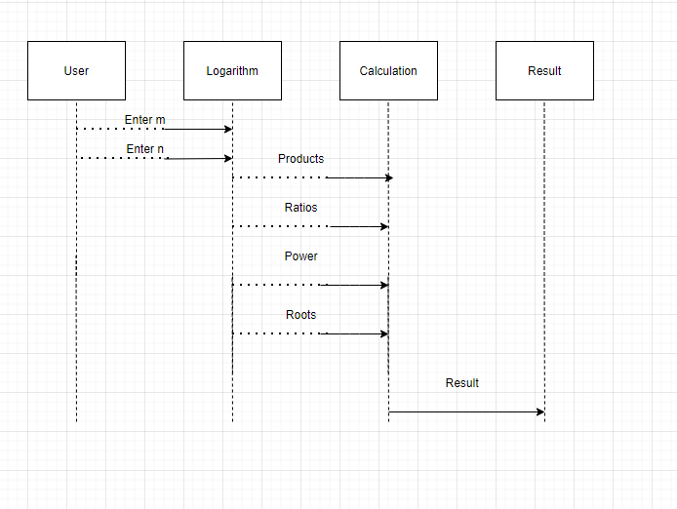

* Factorial Behavioral

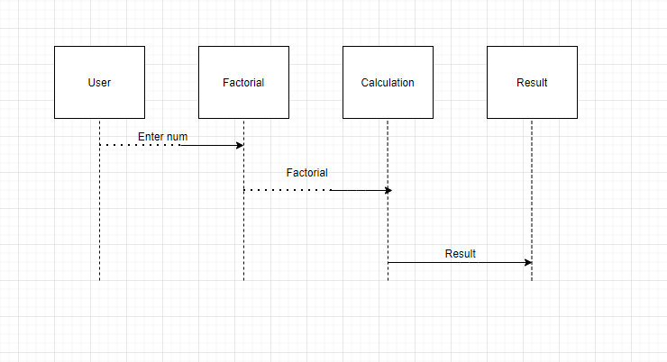

`

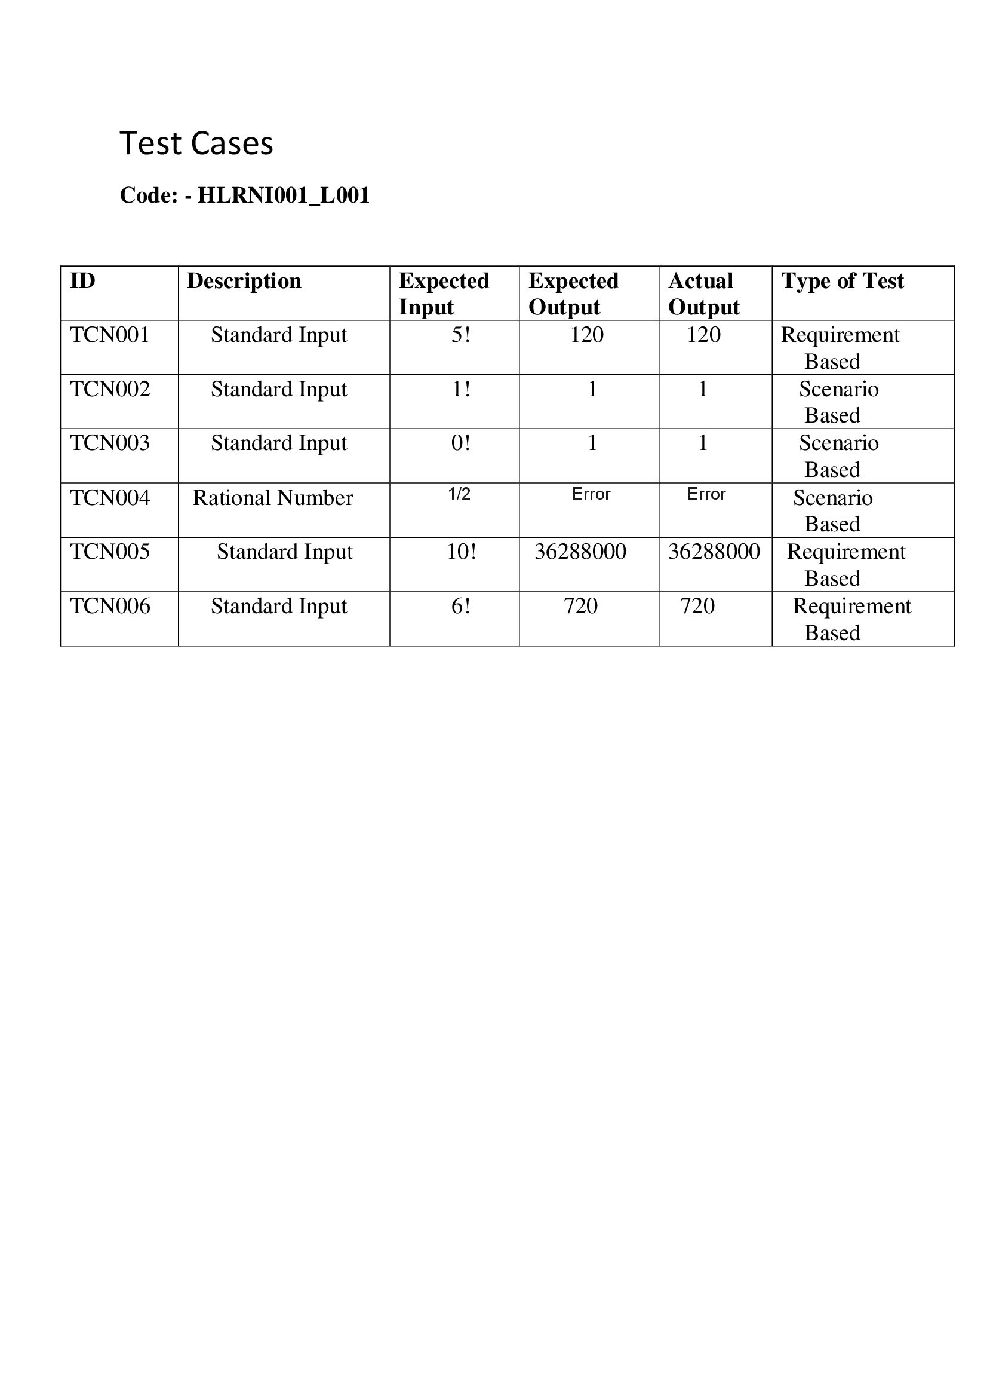

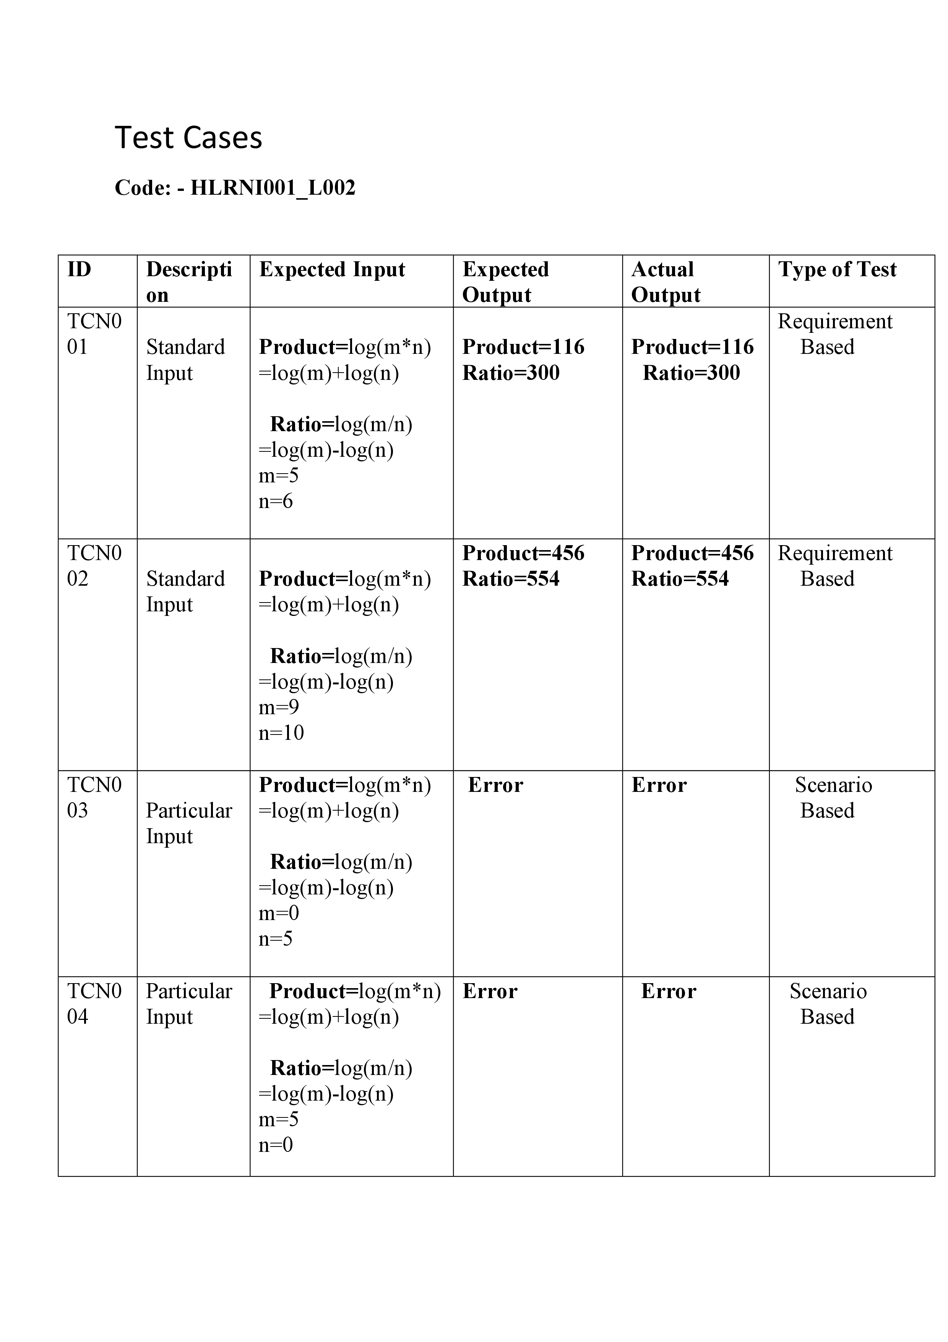

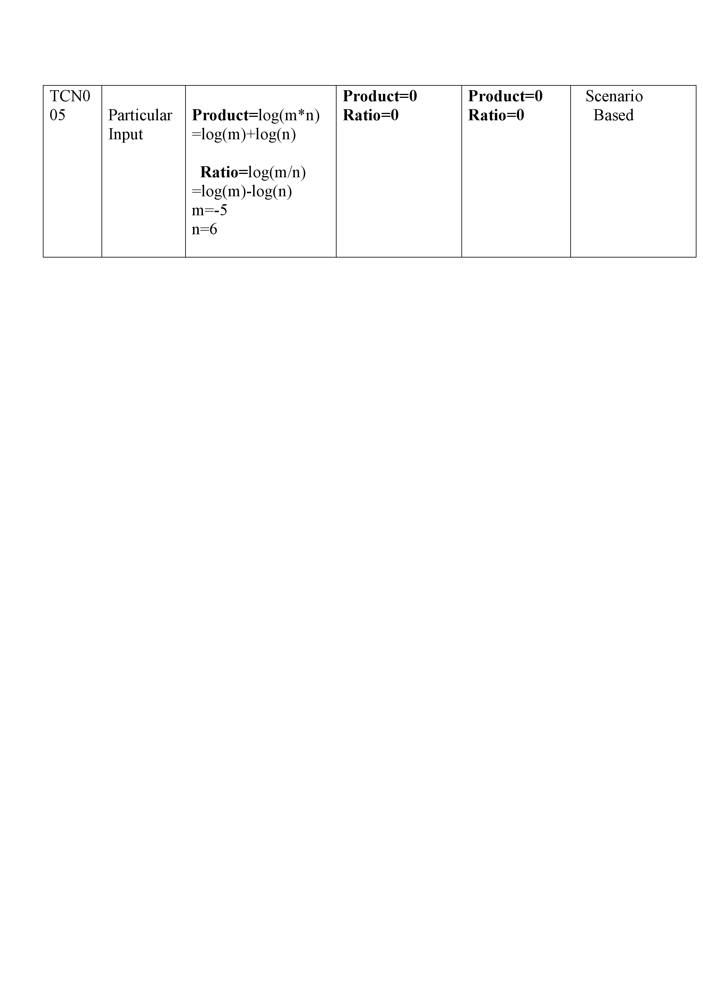

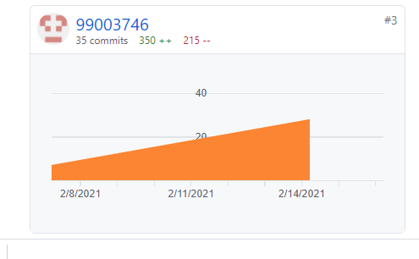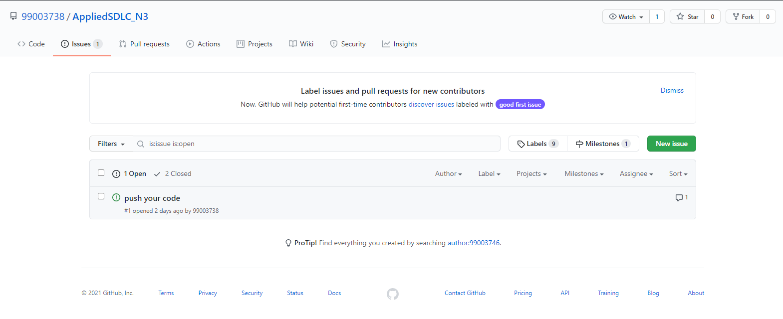**GIT Commit**

**GIT Issue**

**GIT Cppcheck**

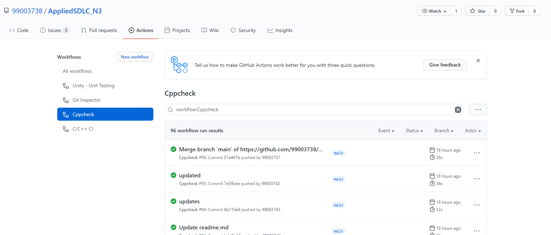

**Agile Methodology: -**

**Theme**: - Developing Calculator Functionality

**Epic**: -Basic operations, Logarithm, Factorial, Complex Number, Plotting Graph

**User Story: -**As a user, I would like to have a Calculator which has Factorial

and Logarithm operations.

